Neeraj Asthana
First run:


Second run:
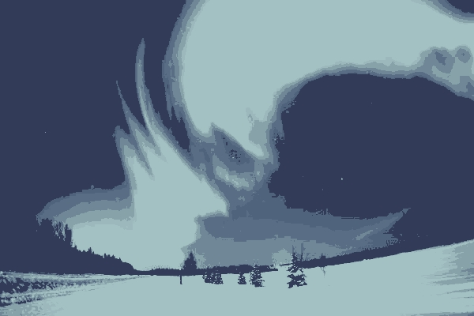

Third run:
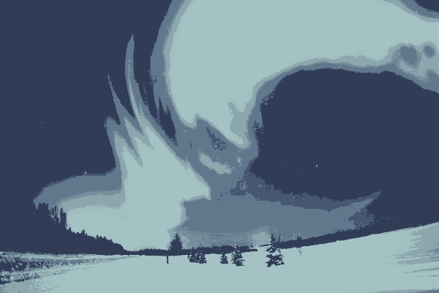

Fourth run:
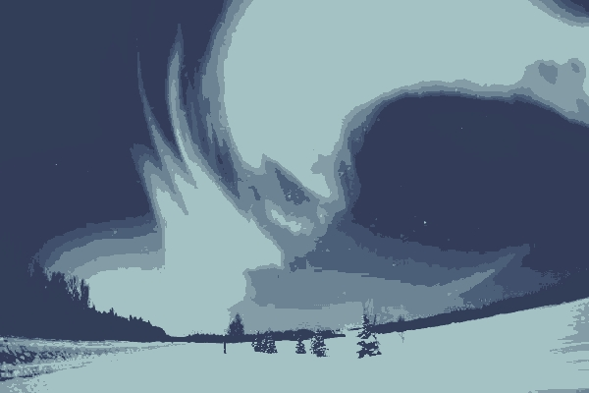

Fifth run:


These images are all extremely similar (almost exactly the same image) even though the start points for the EM algorithm were extremely different. This means that the EM algorithm clustered points similarly across each of the 5 trials even even though the start points were different.

