APPENDIX

Testing Checklist

1. Homepage - Complete
2. Register New user – Complete
   1. – Date of birth Validation – Complete
   2. - Email Validation - Complete
   3. – Pass word don’t match- Complete
   4. – Register new user Successful- Complete

3.0 Contact Form - Complete

3.1 - different type of contact options- Complete

3.2- Contact message Sent- Complete

3.3- Staff receiving contact- Complete

3.4- update Contact refresh information- Complete

4.0 Search Properties - Complete

4.1 Search Parameters no results- Complete

4.2 Search with Specific results- Complete

4.3 Search all results - Complete

4.4 add property form- Complete

4.5 individual properties with map- Complete

4.6 book individual property inspections Complete

4.7 book inspections completed Complete

5.0 Log in / different types of users - Complete

5.1 log in with client - Complete

5.1.1 client access - Complete

5.2 log in with staff - Complete

5.2.1 staff access - Complete

5.3 log in with admin - Complete

5.3.1 admin access- Complete

5.4 log in with owner/David- Complete

5.4.1 David/Owner access - Complete

6.0 Users page that logged in users can Access – Complete

6.1 insert new user- Complete

6.2 logged in users can view users- Complete

6.3 logged in users can choose users to edit- Complete

6.3.1 editing chosen user Complete

6.4 logged in users can delete user Complete

6.4.1 user has been deleted Complete

6.4.2 page after user has been deleted Complete

7.0 Users with applicable access can modify properties Complete

7.1 Editing users Complete

8.0 Log out returns to home page Complete

8.1 logged out Complete

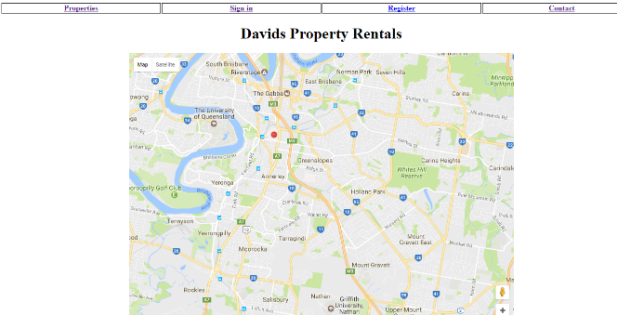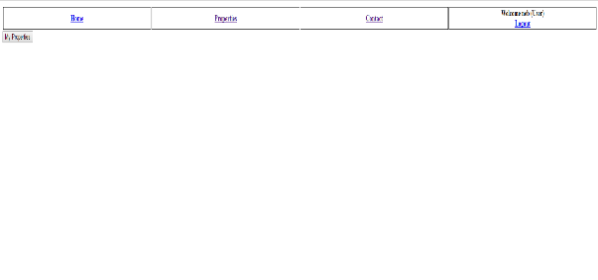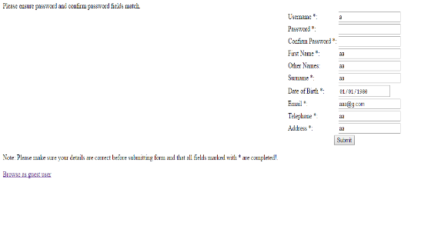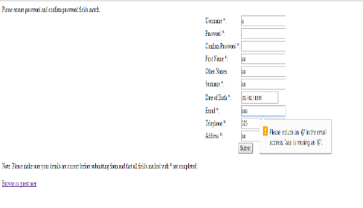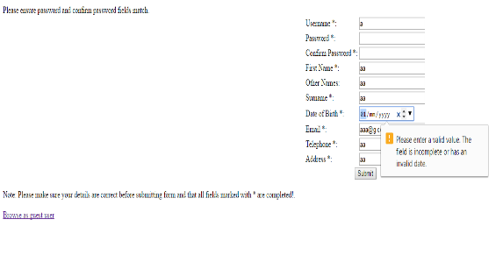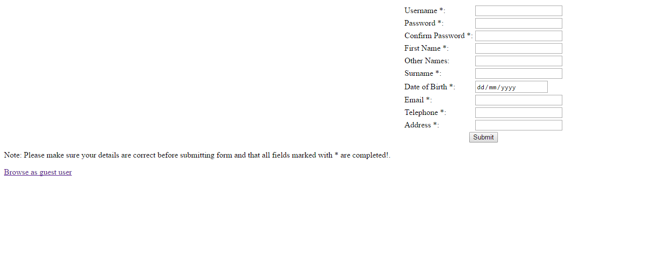

**2.2** Email Validation

**2.1** Date of birth Validation

**2.4** Register new user completion

**2.3** Passwords don’t match validation

**2.0** Register New user page

**1.0** Front home page

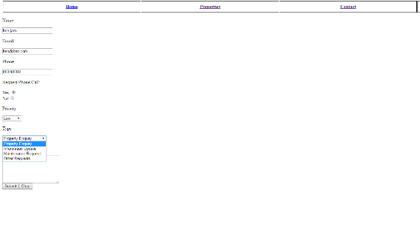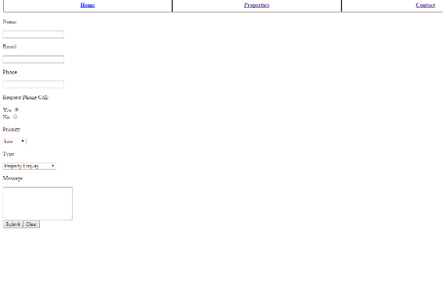

**3.1** different type of contact options

**3.0** Contact form

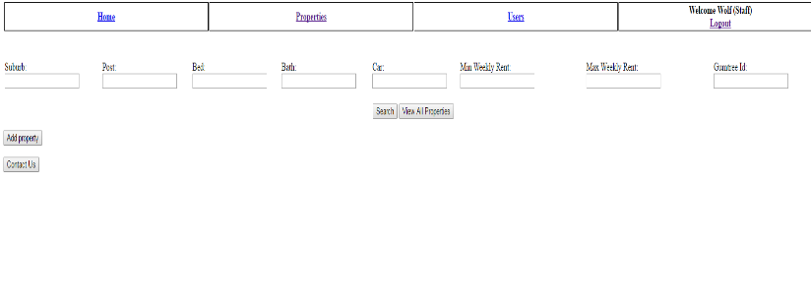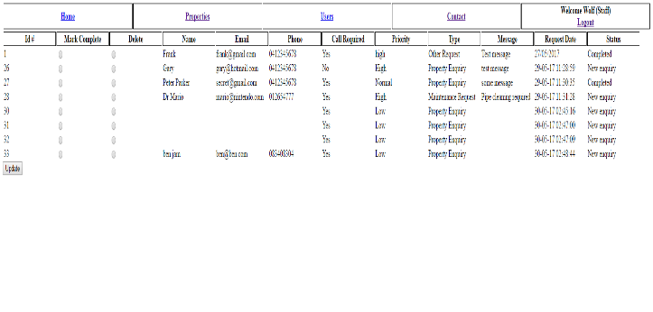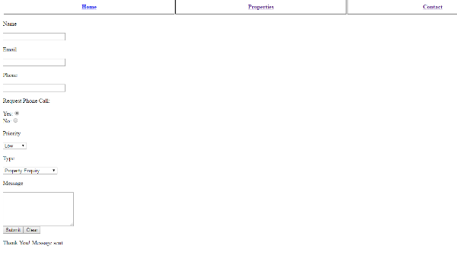

**4.0** Search properties page

**3.4** Update Contacts refresh information

**3.2** Contact Message Sent

**3.3** Staff receiving the contact requests

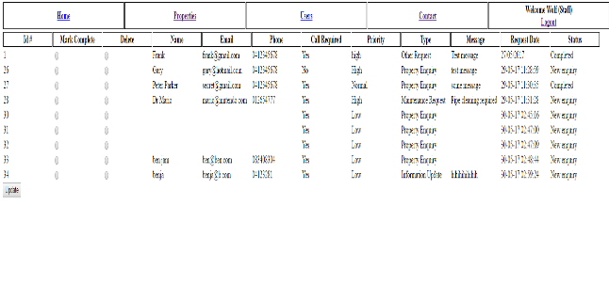

**4.2** Search with specific results

**4.1** Search parameter with no results

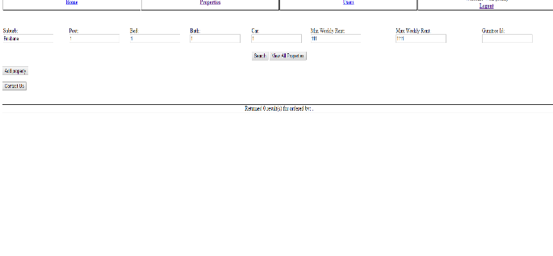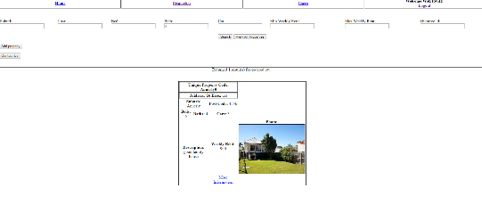

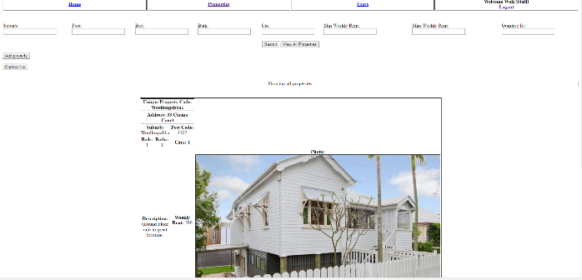

**4.4** add property form

**4.3** Search all results

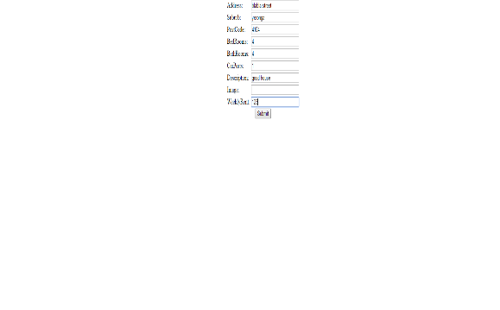

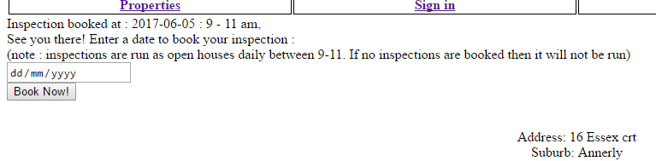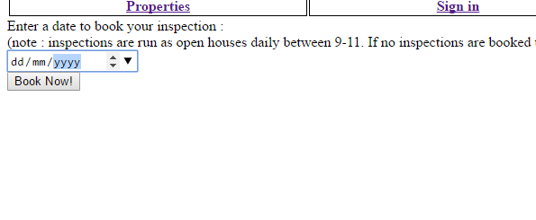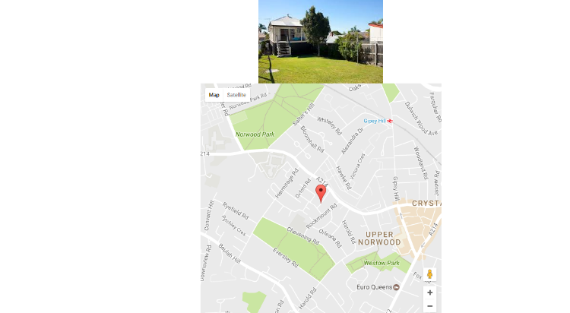

**4.5** Individual properties with map

**4.7** Booked inspections complete

**4.6** Book individual property inspections

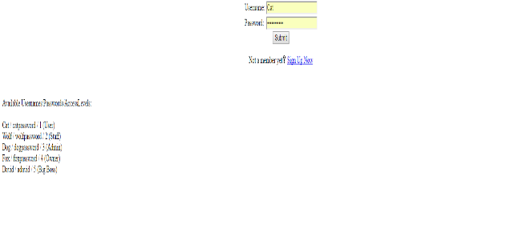 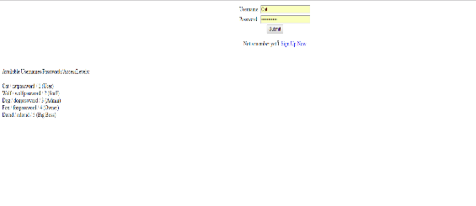

**5.1** Login user

**5.0** Log in page

**5.1.1** User logged in with minimal access

`

**5.2**Staff log in

**5.2.1**Staff logged in some access

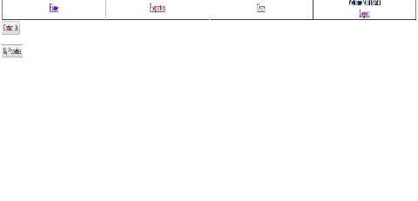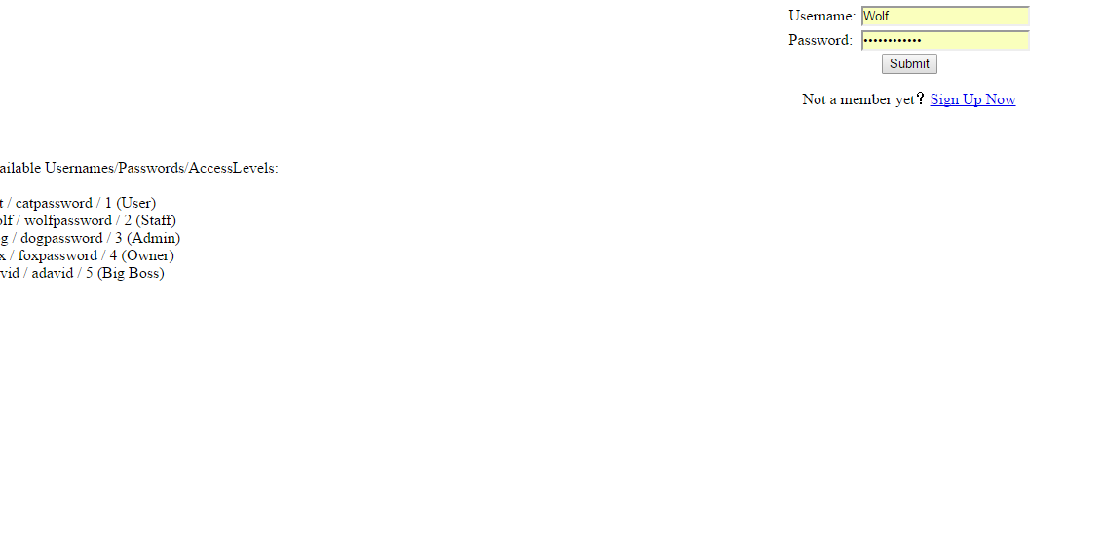

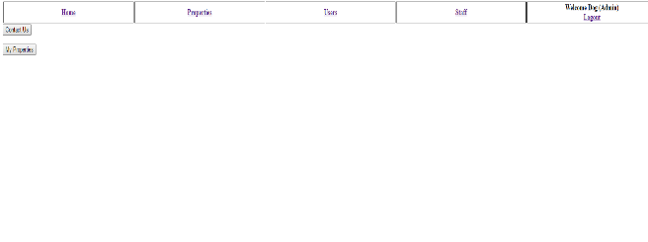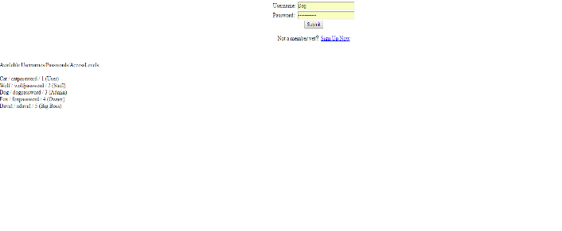

**5.3** Admin login

**5.3.1** Admin logged in more access

**5.4.1**David/owner access

**5.4**David/owner log in

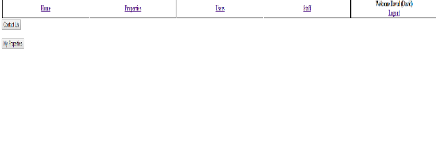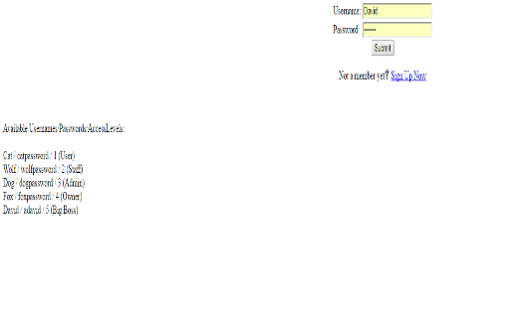

**6.1**Insert new user

**6.0**Users/navigation

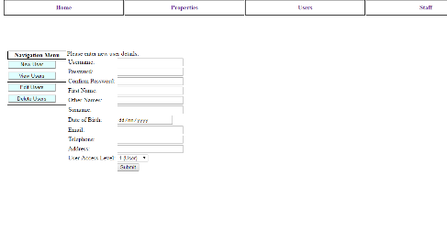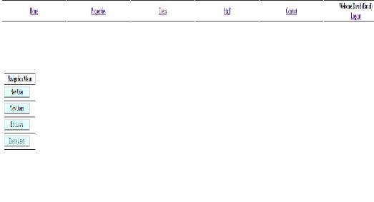

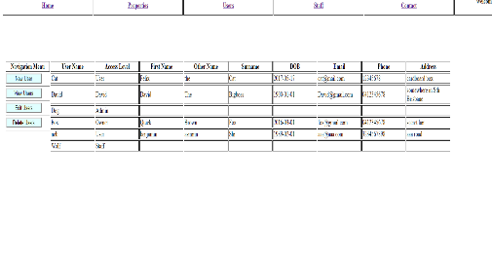

**6.3** Can choose user to edit

**6.2**Logged in user can view users

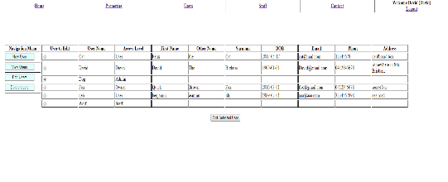

**6.4** Choose user to delete

**6.3.1**Editing chosen user

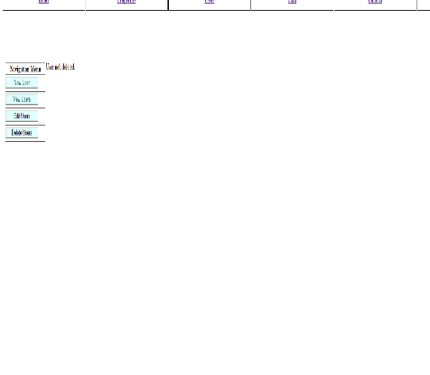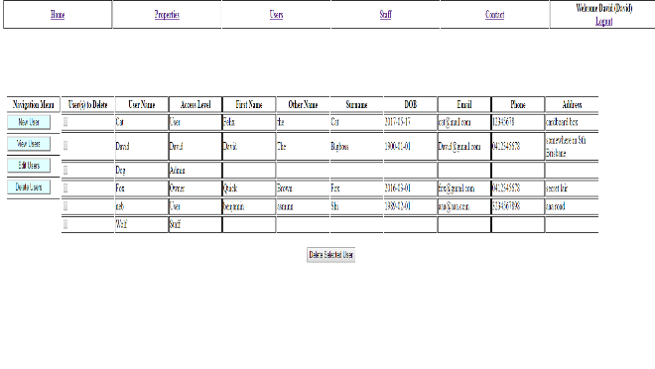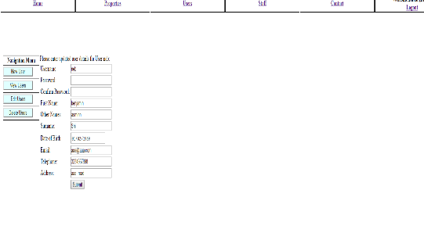

**6.4.2**User deleted and not on list

**6.4.1** User been deleted

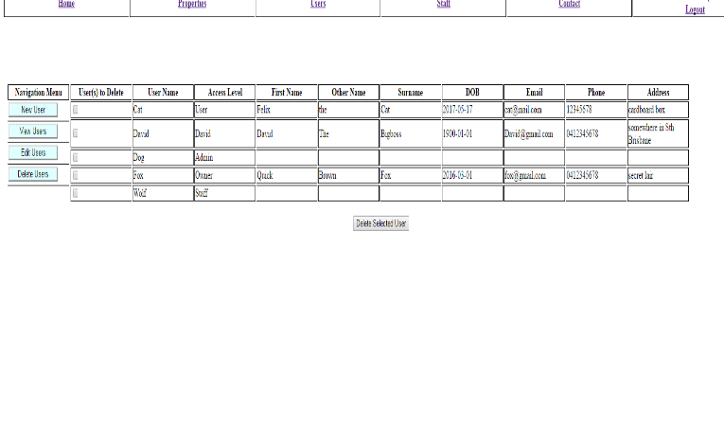

**7.1** Users with applicable access editing a property

**7.0** Users with applicable access can modify properties and can verify the property before its added, can also delete the properties from the page this is user friendly and easy to use

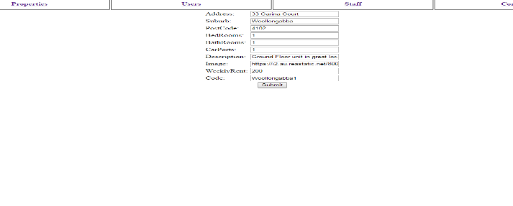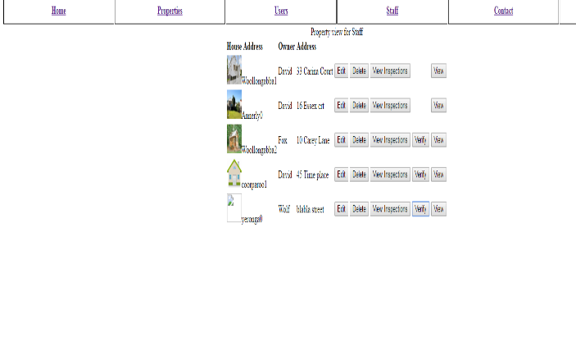

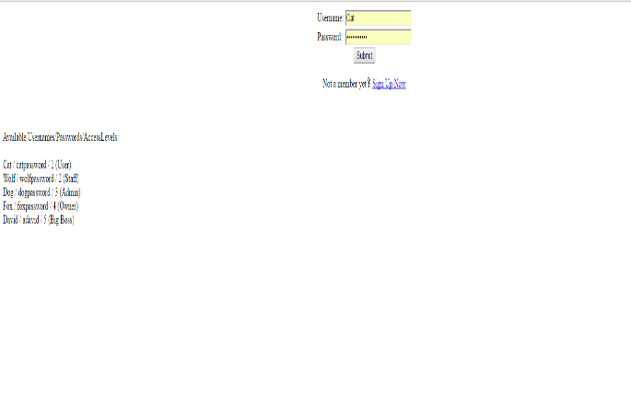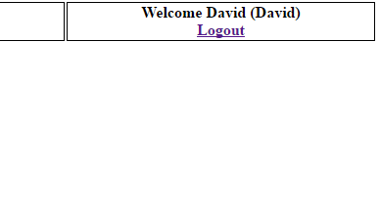

**8.1** logged out page return to signin

**8.0** Logging out