You have to create a one page **text to image** app by using this SDK: <https://github.com/Stability-AI/stability-sdk/tree/main/src/js>

Please check this link: <https://getimg.ai/>

The app should work like this app.

Following 3 RESOLUTION options will be available for each ASPECT RATIO:

Aspect Ratio = Resolution Options

1:1 = 512*512px - 640*640px - 896*896px

3:4 = 384*576px - 512*704px - 768*1024px

4:3 = 576*384px - 704*512px - 1024*768px

16:9 = 640*384px - 832*448px - 1152*640px

9:16 = 384*640px - 448*832px- 640*1152px

App should be built in Laravel/php and typescript will be used to connect to Dream Studio’s API to convert text to image.

**Instructions to get DreamStudio's API key:**  
1- Create an account on <https://beta.dreamstudio.ai/>  
2- Visit this page after logging-in to get API key: <https://beta.dreamstudio.ai/membership?tab=apiKeys>

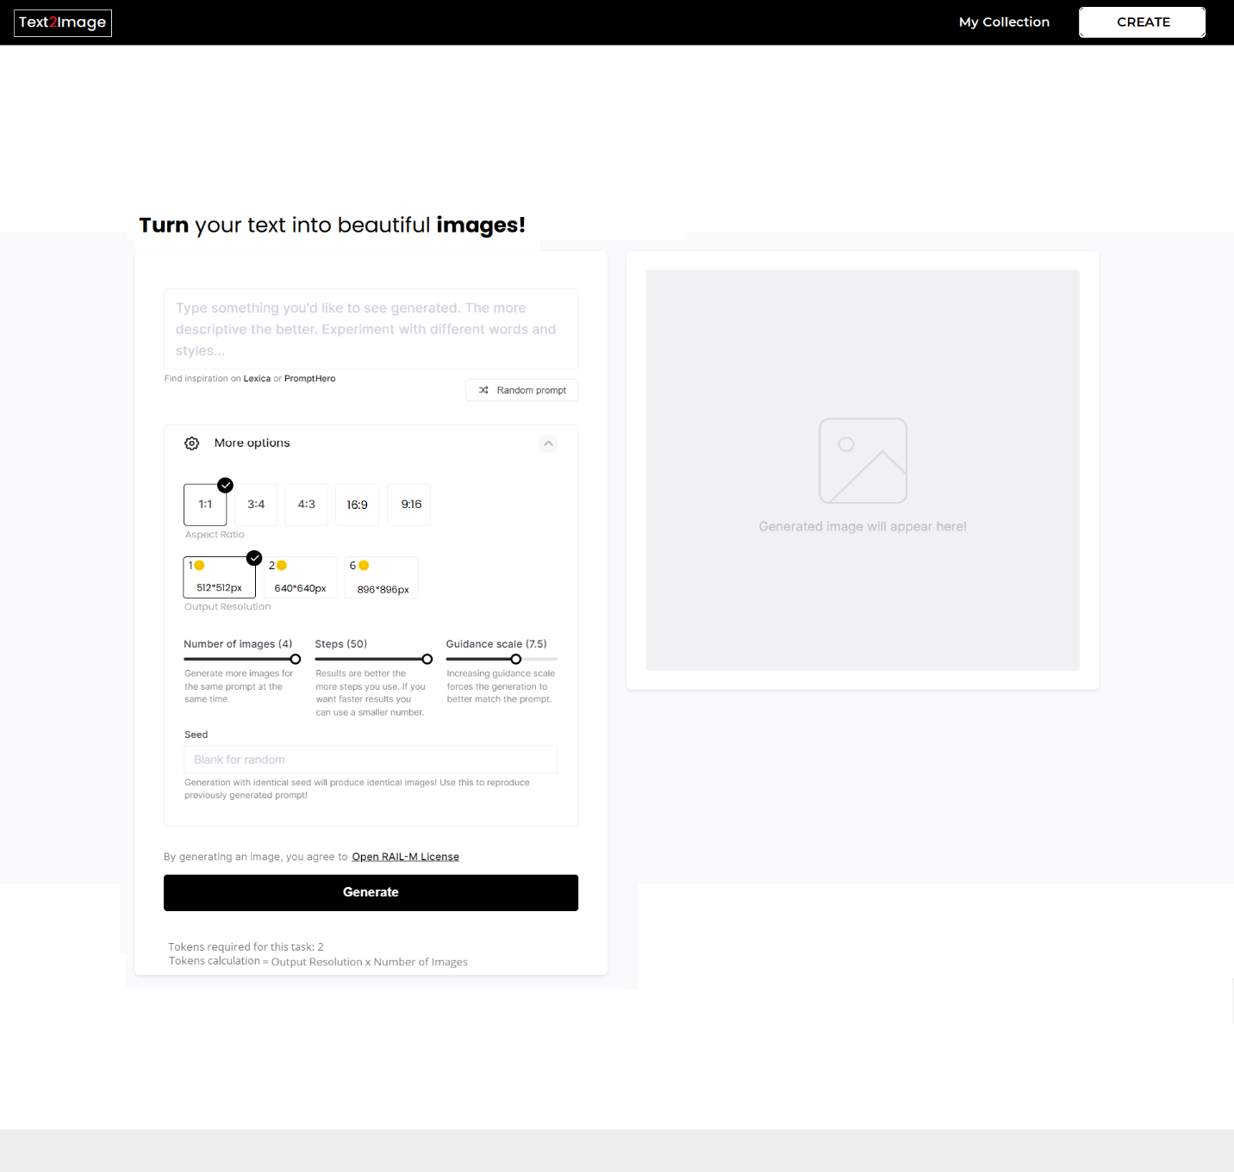

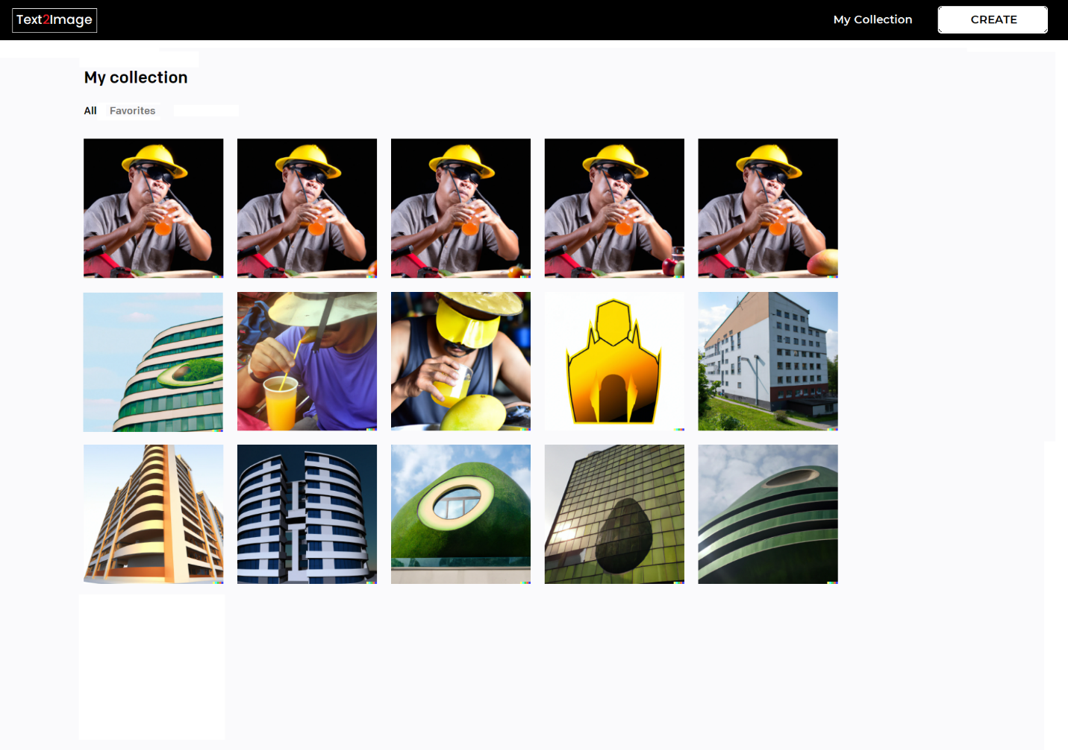

The generated images should be listed in the page.