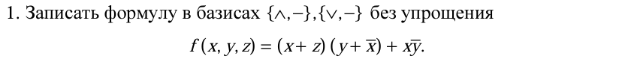

Ответ:

2. Для заданной логической формулы построить таблицу истинности и записать совершенную дизъюнктивную нормальную форму



|  |  |  |  |  |  |  |  |
| --- | --- | --- | --- | --- | --- | --- | --- |
| x | y | z | x+z | $$y+\overline{x}$$ | $$(x+z)(y+\overline{x})$$ | $$\overline{x}y$$ | f |
| 0 | 0 | 0 | 0 | 0 | 0 | 0 | 0 |
| 0 | 0 | 1 | 1 | 0 | 0 | 0 | 0 |
| 0 | 1 | 0 | 0 | 1 | 0 | 1 | 1 |
| 0 | 1 | 1 | 1 | 1 | 1 | 1 | 1 |
| 1 | 0 | 0 | 1 | 0 | 0 | 0 | 0 |
| 1 | 0 | 1 | 1 | 0 | 0 | 0 | 0 |
| 1 | 1 | 0 | 1 | 1 | 1 | 0 | 1 |
| 1 | 1 | 1 | 1 | 1 | 1 | 0 | 1 |

$$f\left(x,y,z\right)=\overline{x}y\overline{z}+\overline{x}yz+xy\overline{z}+xyz$$

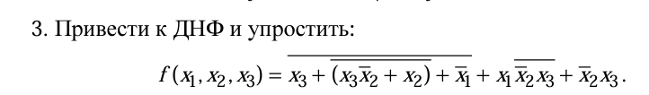

$$f_{1}=$$