

**Software Construction and Development**

**LAB 07**

Submitted By Adeel Bin Asghar

Submitted To Mam Zainab Tahir

Department BS-SE (Green)

Reg ID B22F0196SE009

Date 18 March 2025

**DEPARTMENT OF SOFTWARE ENGINEERING**

**Vehicle Booking Services API**

**GitHub Link:** [**https://github.com/Adeel-Bin-Asghar/SCD_Lab-07.git**](https://github.com/Adeel-Bin-Asghar/SCD_Lab-07.git)

**Introduction**

In this lab, we developed RESTful APIs using Java Spring Boot to manage Emplyee Management System using JPA and MySQL. This assignment aimed to help us understand how to create backend services that handle CRUD (Create, Read, Update, Delete) operations. Additionally, we practiced using GitHub for version control, including branching, committing, pushing, and merging.

**Testing the API with Postman**

To verify the implementation, we tested the API endpoints using Postman:

**Question 1:**

**POST /api/department/add**

Add a new department in the system, like HR or IT, so you can assign employees later.

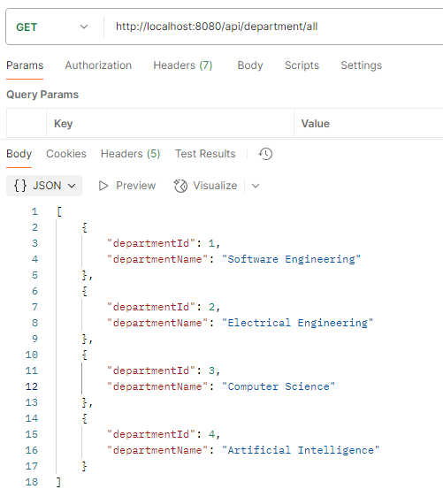**GET /api/department/all**

Get a list of all departments currently saved in the system.

**POST /api/project/add**

Add a new project so employees can be assigned to it.

**GET /api/project/all**

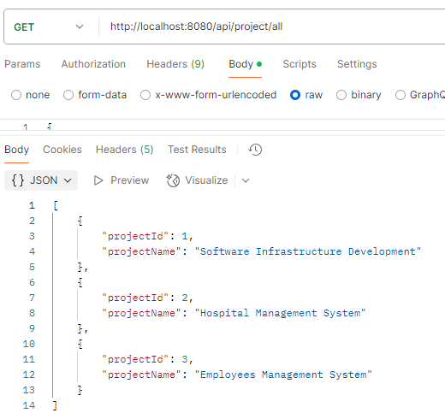View all the projects that are available in the system.

**POST /api/employee/add**

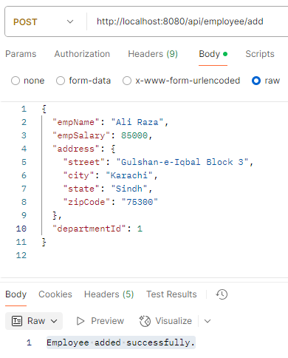Add a new employee with their personal details, salary, address, and assign a department.

**POST/api/employee/assignProject?empId=1&projectId=1**

Assign a specific employee to a project by giving both their ids.

**GET /api/employee/all**

Get a list of all employees along with their department and project info.

**GET /api/employee/details/{id}**

Get full information about a single employee using their ID (including projects and department).

**Question 2**

**GET /api/employee/salaryGreaterThan?**

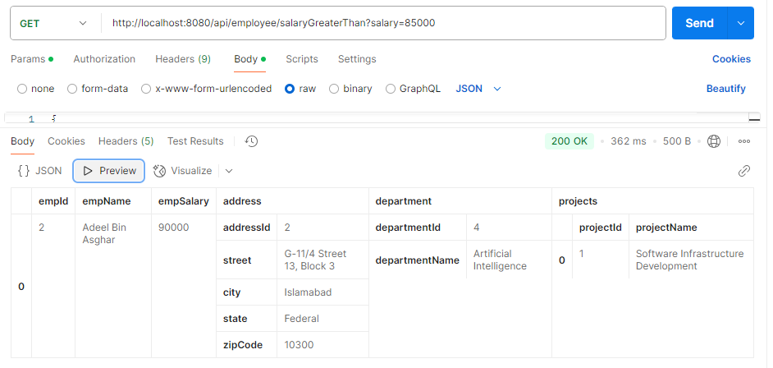Show all employees whose salary is more than a certain amount (e.g., 80000).

**PUT /api/employee/updateSalary**

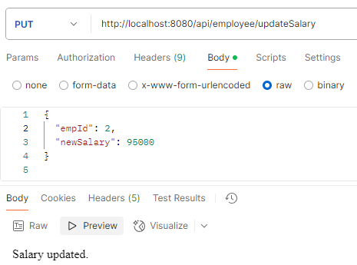Update the salary of an employee by entering their ID and new salary amount.

**DELETE /api/employee/delete/{id}**

Remove or delete an employee from the system by using their ID.

**GET /api/employee/searchByName?**

Search for employees by typing part of their name.

