

**Software Construction and Development**

**LAB 08**

Submitted By Adeel Bin Asghar

Submitted To Mam Zainab Tahir

Department BS-SE (Green)

Reg ID B22F0196SE009

Date 20 March 2025

**DEPARTMENT OF SOFTWARE ENGINEERING**

**Creational Design Pattern**

**GitHub Link:** [**https://github.com/Adeel-Bin-Asghar/SCD_Lab-08.git**](https://github.com/Adeel-Bin-Asghar/SCD_Lab-08.git)

**Testing the API with Postman**

To verify the implementation, we tested the API endpoints using Postman:

**Question 1:**

**GET**

**

**Question 2**

**POST**

**Question 3**

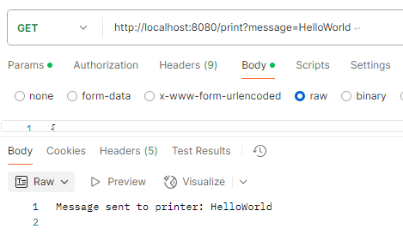**GET**

