

**Software Construction and Development**

**LAB 10**

Submitted By Adeel Bin Asghar

Submitted To Mam Zainab Tahir

Department BS-SE (Green)

Reg ID B22F0196SE009

Date 03 April 2025

**DEPARTMENT OF SOFTWARE ENGINEERING**

**Proxy Pattern**

**GitHub Link:** [**https://github.com/Adeel-Bin-Asghar/SCD-Lab-10.git**](https://github.com/Adeel-Bin-Asghar/SCD-Lab-10.git)

**Testing the API with Postman**

To verify the implementation, we tested the API endpoints using Postman:

**Task:**

**Question 1:**

**GET** [**http://localhost:8080/documents/view?fileName=example.docx&isAdmin=true**](http://localhost:8080/documents/view?fileName=example.docx&isAdmin=true)

Admin access

Non-admin access

**Question 2:**

**POST** http://localhost:8080/payment/process?account=1234567890123456&amount=100.50

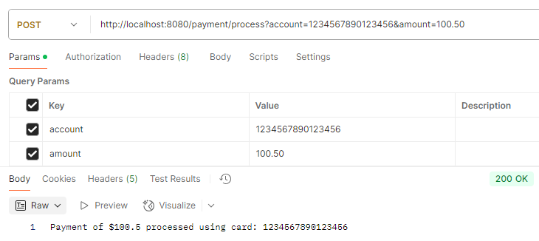

**Question 3:**

1. 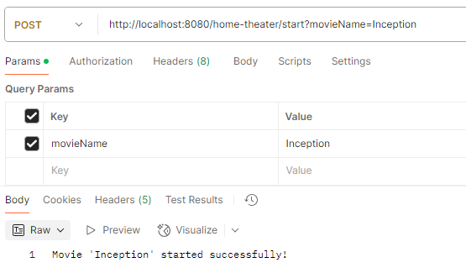**Start the Movie**
2. **Stop the Movie**

