Hosting Link

Purpose of Website:

This website is mainly used to share information with anyone who visits and finds the pages interesting.

Home - consists of a welcome message and picture of myself that when clicked, opens an email client

Professional - includes a vision statement, mission statement, and curriculum vitae

Portfolio - showcasing my likes, dislikes, and hobbies as well as a screenshot of a personality test

Development – describing my strengths and summary of Twelve Pillars by Jim Rohn and Chris Widener

Reference – source code used in the project

**Navigation Buttons**

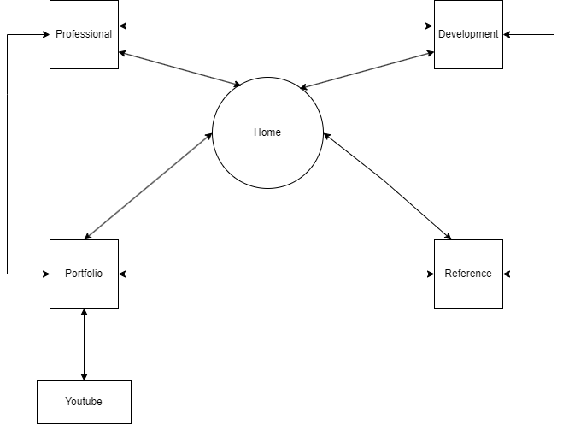

**Home**

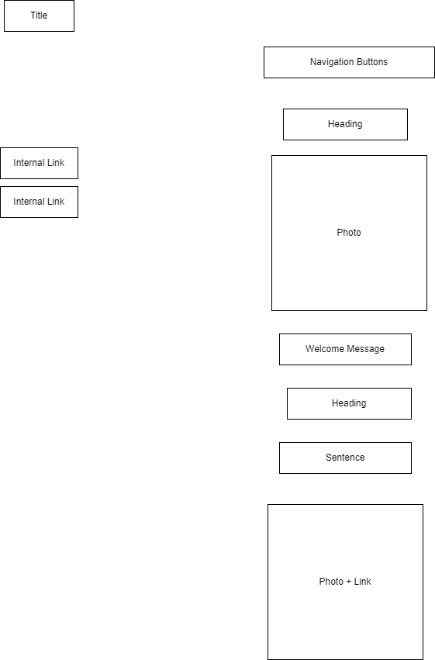

**Professional**

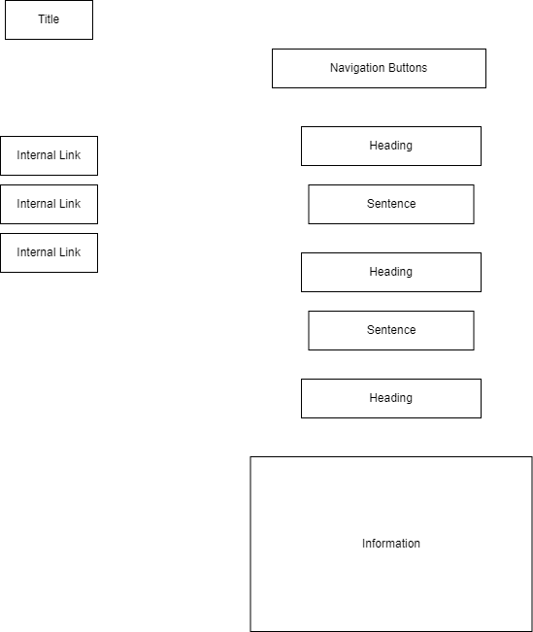

**Portfolio**

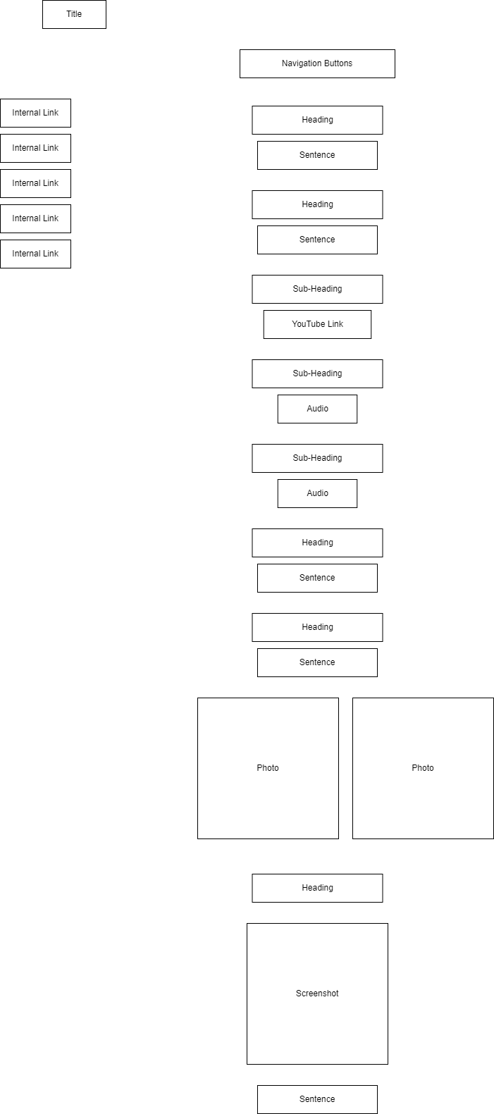

**Development**

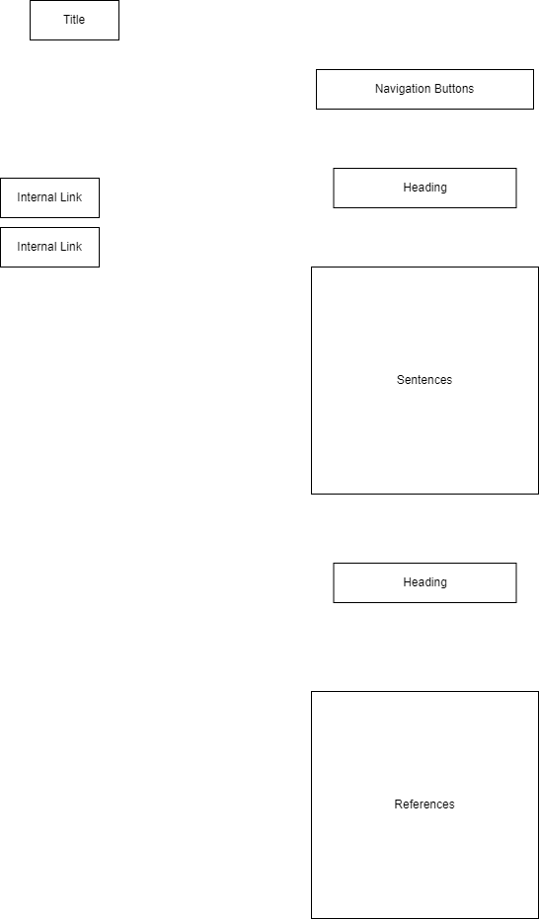

**Reference**

