Bring The Weeknd to India

Fan Demand Campaign Platform

STATUS  Draft |  | OWNER  Campaign owner (TBD) |  | LAST UPDATED  August 27, 2026

Authors | Campaign founder (TBD)
Reviewers | Event promoter and privacy reviewer (TBD)
Related docs | Campaign landing page: theweeknd.co.in
Scope | India-only fan demand collection, consented reporting, and campaign operations.

1. Abstract
This document defines the production-ready campaign platform behind the fan-led India demand site. It collects consented city and ticket-intent signals, protects participant data, and produces aggregated evidence for future conversations with professional event partners. The campaign is independent and does not handle payments, tickets, or artist booking.
The present webpage is a visual prototype; votes are retained only in each visitor browser. This proposal adds a shared, privacy-aware backend before paid promotion. It is limited to India-only interest registration and is designed to avoid implying official affiliation or confirmed performance.

2. Goals and Non-Goals
Goals | Non-goals
Create a credible, shared count of India-only interest. | No claim of official artist affiliation or confirmed show.
Record consent and support deletion or withdrawal. | No ticket sales, donations, payment collection, or refunds.
Produce city and budget aggregates for professional outreach. | No artist, venue, or promoter booking workflow in phase one.
Launch paid traffic only after durable backend safeguards exist. | No guarantee that fan demand results in a concert.

3. Background and Problem Statement
A browser-local counter cannot show genuine national demand, prevent repeat submissions, support consent management, or provide promoter-ready city insights. Once advertising begins, the campaign needs a durable source of truth and an explicit path for deletion, moderation, and reporting.
The public website remains a storytelling and sign-up surface. The backend validates consent and India-city inputs, records an auditable vote, and exposes aggregates only to campaign operators. The design principle is simple: collect the minimum data needed to evidence demand, and do not create a commercial transaction.

4. Proposed Architecture

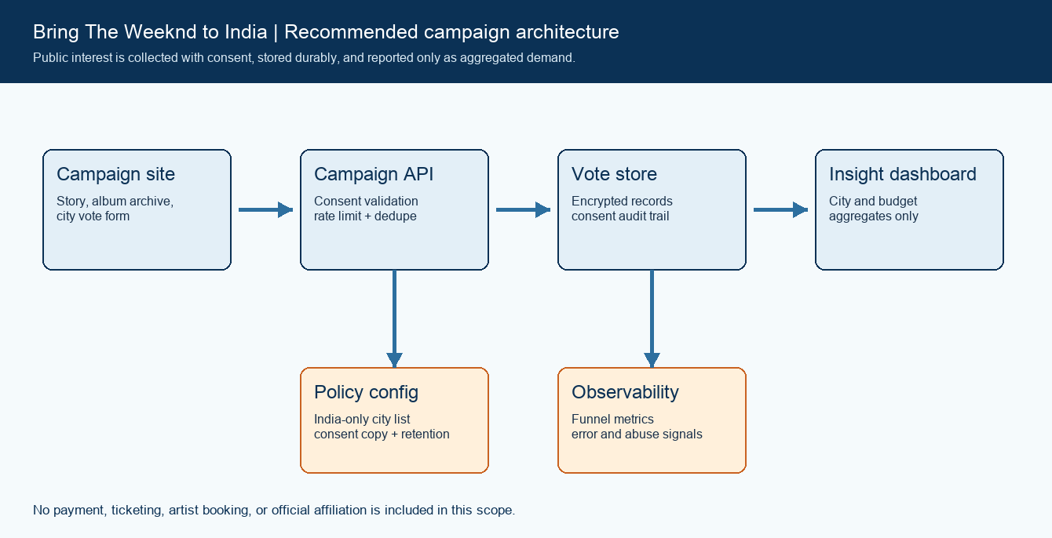
Figure 1. Recommended campaign platform architecture.

Core components

Component | Responsibility | Primary storage | Failure behavior
Campaign site | Campaign story, licensed/original visuals, album links, and interest form. | Static hosting + content assets | If unavailable, visitors cannot submit; no data is lost server-side.
Campaign API | Validate consent, normalize inputs, rate limit, and assign idempotency. | Policy configuration | Fail closed; do not claim a vote was recorded.
Vote store | Durable consented interest records and audit data. | Encrypted relational database | Write failure returns retryable error; no downstream side effects.
Insights service | Aggregate city and budget data for operator reporting. | Read replica or warehouse | Dashboard may be delayed; raw vote record remains authoritative.
Observability | Funnel metrics, error rates, audit events, and abuse signals. | Telemetry backend | Alert operators; keep campaign form behavior separate from analytics.

5. Request Lifecycle
- A visitor opens the campaign site and submits first name, email, preferred India city, likely ticket budget, and an explicit updates consent choice.
- The submission is validated for required fields, approved city values, consent, basic rate limits, and a stable idempotency key. Invalid requests receive no stored vote.
- The service loads the active consent wording, India-city catalogue, retention policy, and rate-limit configuration before accepting the record.
- The API normalizes the input, creates or updates one consented interest record, and prepares a confirmation response without claiming ticket access or event confirmation.
- The vote record and consent version are written durably before any confirmation email, analytics event, or dashboard aggregate is emitted.
- Optional confirmation email and analytics adapters use bounded retries and timeouts. Their failure must not silently erase a successfully stored record.
- The visitor receives a clear registration status. Operators receive aggregate funnel, city, budget, and abuse metrics with no email address in routine dashboards.

6. API and Data Contracts

Primary data contract

Field | Type | Required | Description
vote_id | UUID | Yes | Server-generated durable identifier for one interest record.
email | string | Yes | Used for consented updates and verification; not shown in reports.
preferred_city | enum | Yes | Approved India city value, stored with catalogue version.
budget_range | enum | Yes | Self-reported likely ticket range; aggregate reporting only.
consent | boolean | Yes | Explicit acceptance of campaign update wording and version.
submitted_at | timestamp | Yes | Server time used for audit, retention, and campaign reporting.
source_tag | string | No | Ad or landing-page source label used for campaign comparison.

Contract guarantees

- A response may say that interest was registered only after the consented record is durably stored; otherwise it must report a retryable failure.
- Every submission carries a server-generated vote ID and an idempotency key so retries can resolve to the same record rather than inflate demand.
- Record the consent text version, timestamp, source campaign tag, city catalogue version, and the supplied budget range for audit and reporting.
- The vote store is the source of truth for interest records. It is not evidence of an official artist commitment, ticket reservation, donation, or concert confirmation.
The campaign schema is maintained with the backend source and operator runbook.
Version the contract whenever consent, city options, or reporting fields change.

7. Consistency, Idempotency, and Replay

The public count should be derived from verified, consented records only. Retries must be idempotent; delayed analytics may be eventually consistent. Operators may correct fraudulent or withdrawn records, with a reason retained in the audit log.
Scenario | Expected behavior | Reasoning
Duplicate or retried submission | Return the prior stable registration outcome. | Idempotency avoids inflated demand.
Vote-store write fails | Show retryable failure; do not send confirmation. | No claim precedes durable storage.
Email or analytics adapter fails | Keep the vote; retry separately with a bounded queue. | The core record stays auditable.
Policy wording changes | Apply the version read at request start and record it. | Each consent has a traceable policy version.

8. Security and Privacy Considerations

- Use HTTPS, an authenticated operator console, least-privilege roles, and separate production credentials. Public visitors never access raw campaign records.
- Collect only first name, email, city, budget range, consent, and technical abuse signals. Do not place email addresses, full request bodies, or tokens in analytics or application logs.
- Store service credentials and email-provider secrets in a managed secret store. Do not embed them in the landing-page source or client-side configuration.
- Admin exports are restricted, time-limited, and logged. Local demo storage is never treated as a production source of truth.
- Publish a privacy notice and retention period before launch. Support withdrawal and deletion requests, while retaining minimal audit evidence where legally necessary.

9. Operational Readiness
Signal | SLO or alert | Owner | Launch gate
Registration completion | Alert on failed durable writes | Campaign owner | Required
API error rate | Alert on sustained validation or server errors | Campaign owner | Required
Abuse / duplicate rate | Review unusual submission spikes | Campaign owner | Recommended
Consent policy drift | Block deploy when policy and UI versions differ | Campaign owner | Required
Deletion request test | Run a monthly recovery and deletion check | Campaign owner | Required
Rollout constraint: use a small India-only pilot, verify durable records and dashboard totals, test rollback and deletion, then increase paid acquisition.

10. Alternatives Considered

Alternative | Why it was considered | Why it was not selected
Browser-local demo votes | Fast prototype with no backend. | Cannot create shared, verifiable campaign demand.
Manual spreadsheet collection | Low setup cost for a small group. | Poor consent controls, dedupe, and operator visibility.
Payments or donations first | Could appear to signal commitment. | Creates financial, consumer, and legal obligations before any booking.
Promoter outreach without data | Fastest possible outreach. | Lacks credible city and ticket-intent evidence.

11. Open Questions
- Which verification level should qualify a record for public counters: email confirmation only, phone OTP, or a phased approach?
- Which legal entity and privacy owner will operate the campaign before paid acquisition begins?
- Which hosting, database, and email provider meet the India-focused rollout and operator budget?
- Who can export aggregated demand reports, and what minimum threshold prevents small-group identification?

12. Decision and Next Steps
Approve the production backend before buying traffic. First replace browser-local voting with a consented API and durable store, then test moderation, deletion, and reporting with a small India-only audience. Broaden advertising only after the dashboard reports reliable aggregate demand and the campaign disclaimer, privacy notice, and recovery path are live.
Milestone | Deliverable | Exit criteria
M1 | Consent copy, privacy notice, and production form API. | Test submission and no false-success response.
M2 | Durable vote store, operator dashboard, and deletion workflow. | Sample records and aggregates reconcile.
M3 | Limited India-only campaign traffic and abuse monitoring. | Stable records, clear disclaimer, and support path.
M4 | Scaled acquisition and promoter-ready aggregate report. | Metrics stable; privacy and operational review complete.

Use footnotes for definitions, assumptions, or terms that need precision without interrupting the main narrative.

