Simply Plural Token Revocation and Creation Steps
Standalone guide for invalidating an exposed token and creating a replacement token
Security note: API tokens should be treated like passwords. Do not post tokens publicly, do not commit them to Git, and do not place them in screenshots unless the token text is fully obscured. The screenshots that show token text in this guide use blurred token regions.
Recommended permissions: Read is required for export and preservation workflows. Write is optional and should be used only if future tooling needs write operations. Delete is not recommended for data preservation exports.

Step 1: Open the main menu
Click the hamburger menu in the upper-left corner.
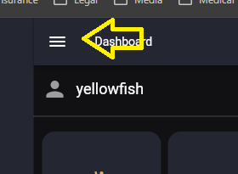
1_click_hamburger_menu.png

Step 2: Open Settings
Click the settings gear.
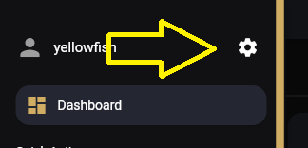
2_click_settings.png

Step 3: Open Account
Click Account in the settings panel.
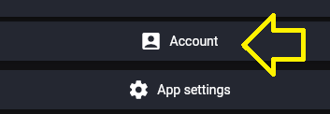
3_click_Account.png

Step 4: Open Tokens
Click Tokens in the account settings list.
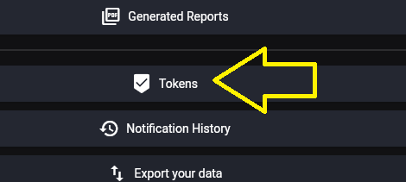
4_click_Tokens.png

Step 5: Revoke an existing token when rotating credentials
If you are invalidating an old token or replacing an exposed token, click the delete icon for the existing token. The token text in this screenshot is intentionally blurred.
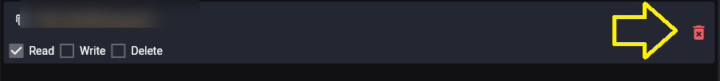
5_delete_any_existing_tokens_if_invalidating_and_recreating_token_blurred.png

Step 6: Add a new token
Click Add Token from the token list area.
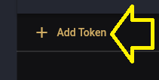
6_add_new_token.png

Step 7: Confirm Add Token
Click Add Token again on the token creation control.
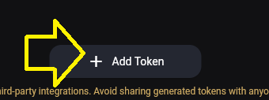
7_add_new_token.png

Step 8: Select token permissions
For export/preservation work, Read permission is required. Write should only be selected if future tooling needs write operations. Delete is not recommended for preservation exports.
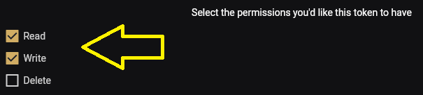
8_select_new_token_permissions.png

Step 9: Copy the new token
Long-press or select the generated token value when you need to copy it. Store it only in a local environment variable such as SP_TOKEN. The token text in this screenshot is intentionally blurred.
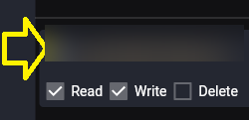
9_long_press_copy_new_token_when_needed_token_blurred.png

Quick Reference
Task | Action
Open token settings | Menu → Settings → Account → Tokens
Invalidate exposed token | Delete the old token from the Tokens screen.
Create replacement token | Click Add Token and select permissions.
Recommended export permission | Read
Permissions to avoid for preservation-only export | Delete
Store token locally | Use an environment variable such as SP_TOKEN.
Never publish | Token text, exported JSON, notes, avatar images, or screenshots containing private data.
Git Bash environment variable example:
read -s -p "Paste Simply Plural token: " SP_TOKEN
echo
export SP_TOKEN
printf 'Token length: %s\n' "${#SP_TOKEN}"

