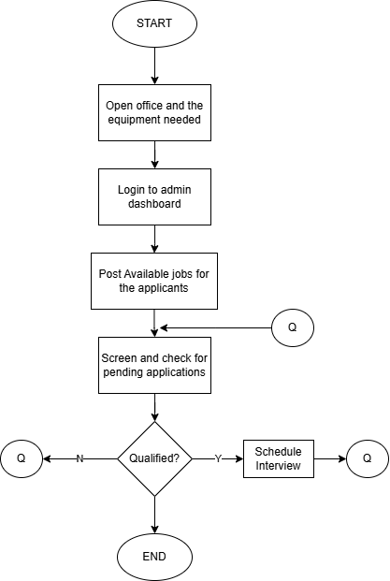

**Open office and the equipment needed**

The company will open at 7:00am from Monday to Saturday. It is where the HR staff start their day by preparing their workspace and opening their computers.

**Login to admin dashboard**

After preparing the computer that the hr staff will be needed. They will login to the system using their accounts to directly access the admin dashboard, where they can screen, post jobs, and schedule applicants for the respective jobs

**Post available jobs for the applicants**

While having an access to the admin’s dashboard, the hr staff can post the jobs that the company is offering to the applicants.

**Screen and check for pending application**

They can also screen the applicants through the system if it is qualified for the interview or will be rejected.

**Qualified?**

**Y:** for the qualified applicants, they will proceed to the schedule of their interview.

**N:** if not, they will be rejected.

This process will continue until the end of their shifts. They will screen, schedule, post jobs and interview for the rest of the day.

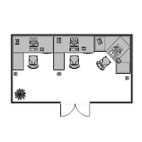**Floor Plan**

This image shows the simple floor plan of the company’s human resource office. It consists of 3 computers for the hr staff who will facilitate the office.