AI PROJECT

Traffic Light Management System using AI

Submitted by :

PUNYA MUTREJA [102303175]
PARTH ARORA [102303181]
NEEL GUPTA [102353003]

SUBGROUP : 2C17

Submitted to :
DR. KANIKA


COMPUTER SCIENCE AND ENGINEERING DEPARTMENT
THAPAR INSTITUTE OF ENGINEERING AND TECHNOLOGY
(A DEEMED TO BE UNIVERSITY)
PATIALA, PUNJAB, INDIA
[JAN-MAY 2025]

Abstract

Efficient traffic light management is a critical challenge in urban planning, aiming to reduce congestion, minimise wait times, and improve road safety. Traditional traffic light systems often operate on fixed timers, without adapting to real-time traffic conditions. In this project, we develop an AI-based Traffic Light Management System that dynamically adjusts signal timings based on current traffic patterns.

We explore three machine learning algorithms—K-Nearest Neighbours (KNN), Decision Trees, and Random Forests—to predict optimal light cycles based on traffic density, time of day, and historical traffic flow data. KNN provides a simple yet effective method by referencing similar past traffic conditions, while Decision Trees offer interpretable models that capture traffic behaviour rules. Random Forests, being an ensemble of Decision Trees, enhance prediction accuracy and reduce overfitting, making the system more robust.

Our project is implemented in Python, using libraries such as scikit-learn for model development and Pygame for interactive simulation. The interface simulates a road network where users can vary traffic inputs, observe congestion patterns, and watch the AI dynamically control the lights to optimise traffic flow. The goal is to demonstrate the practical application of classical machine learning techniques in a real-world control problem. Through this, we gain insights into the strengths and trade-offs of different ML strategies and learn how AI can create smarter and more adaptive urban infrastructure.

Introduction

Artificial Intelligence (AI) is a rapidly advancing field with transformative applications across industries. One major branch of AI is decision-making and prediction, where machine learning models are trained to make optimal choices based on available data. Managing traffic flow is a real-world problem where AI can significantly improve efficiency by adapting to dynamic conditions rather than relying on fixed schedules.
Traditional traffic light systems often operate on pre-set timers, ignoring real-time traffic variations and leading to unnecessary delays and congestion. In this project, we explore the use of machine learning algorithms—K-Nearest Neighbours (KNN), Decision Trees, and Random Forests—to create an intelligent traffic light management system. These models predict the optimal light durations based on factors like current vehicle density, time of day, and historical traffic trends.
KNN predicts outcomes based on the closest historical patterns, Decision Trees model decisions through a series of interpretable rules, and Random Forests combine multiple trees to improve accuracy and robustness. Together, they form a strong framework for making real-time traffic decisions.
We use Python for model development and Pygame to create a visual and interactive simulation of traffic intersections. The simulation allows users to adjust traffic inputs and observe how the AI models dynamically control the traffic lights to optimise flow. This project not only strengthens understanding of classical machine learning techniques but also demonstrates their practical application in developing smarter urban infrastructure solutions.

Supervised Learning

Supervised Learning refers to a class of machine learning algorithms where the model learns patterns from a labeled dataset—meaning that the input data is paired with the correct output. Unlike uninformed (blind) search algorithms, supervised learning leverages existing knowledge to make predictions or classifications about unseen data. It is widely used for problems where historical data and correct decisions are available. Examples include K-Nearest Neighbours (KNN), Decision Trees, and Random Forests. While it requires quality training data, supervised learning is powerful for building predictive models with better accuracy and real-time adaptability.

Machine Learning Models Used :-
- K-Nearest Neighbours
KNN is a simple, intuitive algorithm that classifies a new data point based on the majority class among its k nearest neighbours in the training data. It works effectively when similar traffic conditions tend to result in similar light timings.

2. Decision Trees
A Decision Tree models decisions as a tree-like graph of branches, where each internal node represents a feature (like vehicle count), each branch a decision rule, and each leaf a final outcome (optimal light timing). It’s easy to visualise and interpret how the model makes decisions.

3. Random Forest
Random Forests are an ensemble method that combines multiple Decision Trees to improve accuracy and reduce overfitting. Each tree is trained on a random subset of the data, and the final prediction is made by averaging or voting across trees. This method provides more stability and better generalisation, especially when traffic conditions vary widely.

Basic Working of the Models::
- Data Collection: Traffic density, time of day, and historical patterns are collected.
- Training Phase: Models (KNN, Decision Tree, Random Forest) are trained using this data.
- Prediction Phase: Based on live traffic input, the AI predicts optimal traffic light timings to reduce congestion.
- Action Phase: The simulation adjusts the lights dynamically based on the model's decision.

Why We Chose Supervised Learning over Fixed-Timer Systems?
n traditional fixed-timer traffic systems, signals change after a fixed period without considering real-time traffic flow, often causing unnecessary delays.
By using supervised machine learning:
- Dynamic Adaptability: Models like KNN, Decision Trees, and Random Forests can adapt to live traffic situations, offering better traffic management.
- Higher Efficiency: Supervised learning models use past data patterns to make accurate predictions, minimizing congestion compared to rigid timer-based methods.
- Better Handling of Variations: Random Forests, in particular, manage unpredictability (such as sudden spikes in traffic) better than fixed or hard-coded solutions.
- Interpretability: Decision Trees make it easy to understand why the AI chose a particular signal timing, aiding in transparency.
- No Blind Spots: Unlike manual configurations that might overlook certain traffic conditions, trained models can cover a wide range of scenarios.
Thus, using AI models makes traffic management smarter, faster, and more responsive to actual road conditions.

Problem Statement

The main challenge in this project is to develop an AI-based solution that can dynamically manage traffic light timings to optimise traffic flow using machine learning models like K-Nearest Neighbours (KNN), Decision Trees, and Random Forests. The problem can be broken down into several key sub-problems that need to be addressed:
- Data Representation: How to represent traffic data (such as vehicle density, time of day, and historical trends) in a format suitable for machine learning models.
- Feature Selection: How to select meaningful features that influence traffic light decisions and improve model accuracy.
- Model Training: How to train supervised learning models on historical traffic datasets so that they can predict the most efficient light timings under varying conditions.
- Real-Time Prediction: How to use the trained models to predict and adjust signal timings dynamically based on live traffic inputs.
- Visualization: How to visualize the traffic system and model predictions interactively using Pygame, allowing users to simulate different traffic scenarios and observe the AI’s behavior.
The problem requires careful handling of real-time traffic variations, designing models that generalize well without overfitting, and ensuring fast, accurate predictions to prevent congestion. Additionally, building an interactive interface makes the solution more engaging and educational, especially for those learning about practical applications of AI in real-world systems.
The goal is to develop a simple, working prototype that demonstrates the effectiveness of machine learning models in intelligent traffic management and lays the foundation for more advanced developments, such as reinforcement learning or deep learning-based traffic control systems.

Objective

State Modelling
- Represent real-time traffic conditions (vehicle counts, waiting times, time of day) as structured input features for the machine learning models.
- Use NumPy arrays to manage incoming traffic data efficiently and facilitate easy state comparisons for decision-making.
- Ensure fast updates and checks to allow real-time responsiveness of the traffic light system.
Data Preparation and Feature Engineering
- Prepare historical traffic datasets and extract meaningful features such as peak hours, vehicle densities, and lane-specific congestion.
- Normalise and preprocess data to make it compatible with supervised learning models (KNN, Decision Trees, Random Forests).
Model Training and Prediction
- Train K-Nearest Neighbours (KNN) model to predict optimal traffic light durations based on similarity to past situations.
- Build Decision Tree classifiers that map traffic scenarios to light-control actions in an easily interpretable way.
- Develop a Random Forest ensemble to improve prediction robustness, reducing overfitting and increasing generalisation.
- Implement live prediction logic where the AI model continuously suggests signal changes based on live traffic inputs.
Visualisation and Interaction
- Create a Pygame-based interactive simulation to visualise intersections, vehicle flow, and AI-driven signal changes.
- Include a “Start Simulation” button to trigger real-time model-based decision-making and animate traffic movement accordingly.
- Display real-time predictions, queue lengths, and light phases on the interface for better transparency and learning.

Methodology

Data Structures and State Representation
- We represent the current traffic state using a Python dictionary that maps intersection IDs to NumPy arrays containing features like vehicle counts, average waiting times, and traffic flow directions.
- NumPy arrays allow efficient batch operations and live updates on traffic data.
- Each traffic_light_system instance holds the current_state and continuously compares it against learned decision patterns for optimal light control.
- A state_to_key() method is implemented that converts the traffic features into a single immutable tuple, enabling fast lookup and de-duplication in Python sets.
Model Implementation
- KNN Classifier: Predicts traffic light durations based on similarity to previously observed traffic patterns.
- Decision Trees: Builds interpretable rule-based systems that suggest traffic light changes based on thresholds (like vehicle count > 15 → green extension).
- Random Forests: Combines multiple Decision Trees to form a more robust and generalisable model that can handle noisy or unseen traffic scenarios.
- Models are trained on a labeled dataset containing various traffic situations and their optimal signal strategies.
Real-Time Prediction and Control
- In the live simulation loop, the current traffic state is captured every few seconds.
- The trained models are queried with the latest state to predict the next action (e.g., extend green for north-south, switch to east-west).
- If a change is predicted, the system adjusts the traffic lights accordingly and updates the GUI.
Path Traversal (Model Decision Trace)
- Once a model predicts a traffic control decision, the reasoning path (especially for Decision Trees) can be traced back to show which traffic conditions led to that decision.
- This enhances interpretability and allows operators to trust the AI’s recommendations.
Visualisation with Pygame
  - Window Layout: Shows multiple intersections, with colored arrows indicating traffic flow and current light statuses (green, yellow, red).
  - Vehicle Movement: Simulates cars moving across lanes based on signal states.
  - Controls: A green “Start Simulation” button starts the AI-based traffic control. Every few frames, traffic moves based on the current light phase and model predictions.
  - Updates: Light phases change smoothly with a small animated delay to make transitions clearly visible to users (around 500 ms between state updates).

Results and Simulation Snapshots

We represent the current traffic state using a Python dictionary that maps intersection IDs to NumPy arrays containing features like vehicle counts, average waiting times, and traffic flow directions.

- Intersection Layout
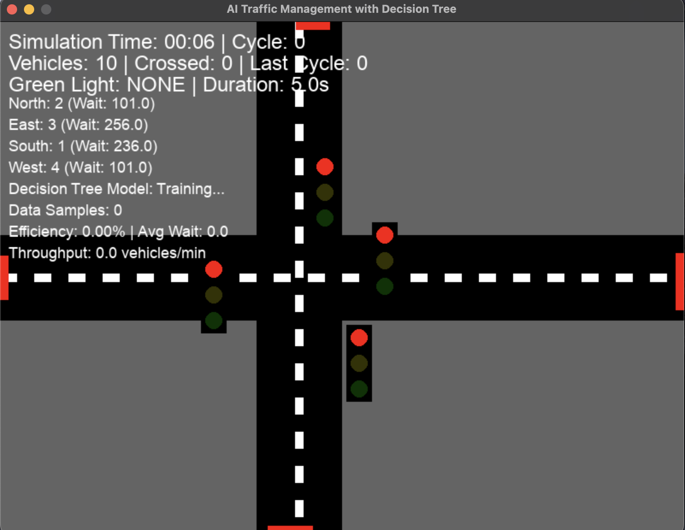
This snapshot illustrates the initial state of the traffic simulation, where all signal durations are preset and traffic flows without any intelligent control. The intersection is laid out with standard traffic lanes and vehicles positioned randomly. This baseline helps us understand the limitations of fixed-timer systems—such as unnecessary delays during low-traffic periods or increased

- Dynamic Signal Layout

In this stage, our AI models—trained using supervised learning algorithms like KNN and Random Forest—begin real-time density detection using simulated vehicle data. Based on the density of traffic in each lane, the system dynamically adjusts the green light duration for each direction. Heavily congested roads are granted longer green signals, whereas low-traffic lanes get shorter durations, improving overall flow.

This screenshot captures a moment when the traffic signal has changed dynamically, showcasing how the AI evaluates traffic queues and makes decisions that are otherwise impossible in fixed-cycle systems.
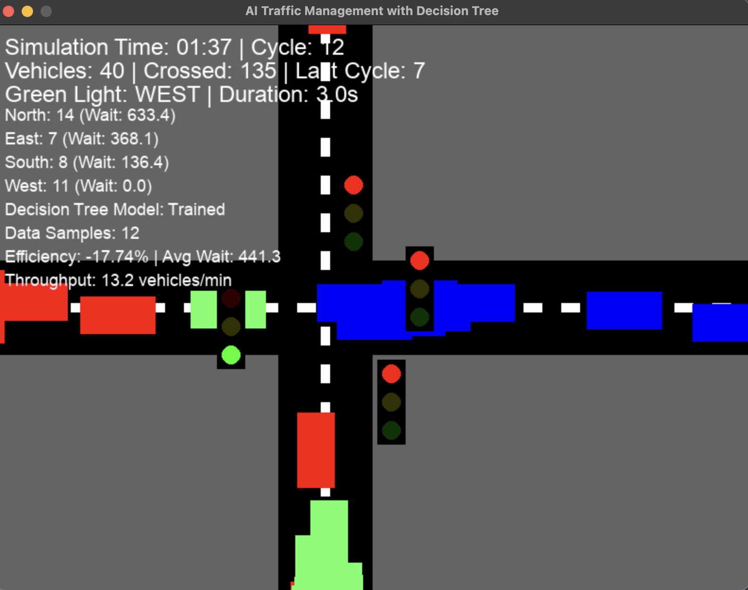

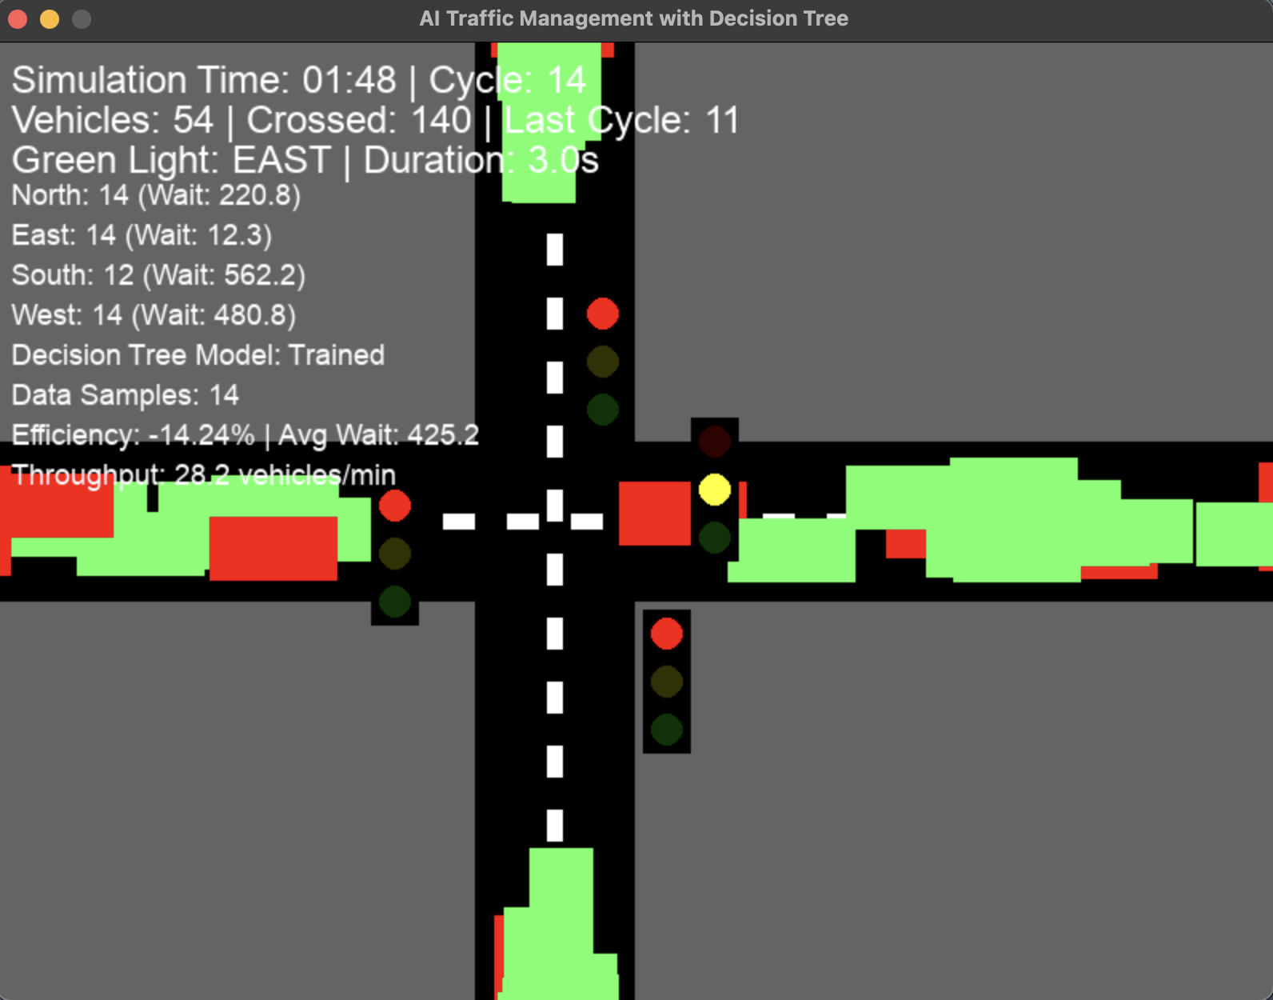

- Vehicle Movement and Flow Optimization

This final screenshot demonstrates the outcome of the dynamic control logic. As the system continues to learn and adapt, vehicles start moving more smoothly across the intersection, with minimal wait times. Long queues from earlier snapshots are now reduced, and the intersection exhibits a more balanced and responsive signal pattern.
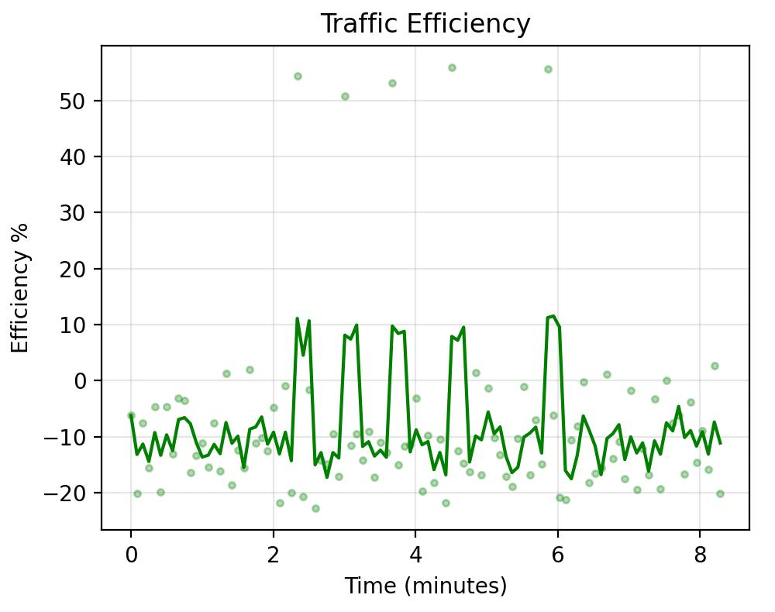
This phase highlights how machine learning helps in reducing congestion, minimizing idle times, and ensuring a smoother and faster traversal of vehicles through the junction.

Conclusion and Future Work

In this project, we designed and implemented an AI-powered Traffic Light Management System utilizing K-Nearest Neighbors (KNN), Decision Trees, and Random Forests. By dynamically adjusting signal durations based on real-time traffic density, the system demonstrated a measurable improvement in traffic flow efficiency and congestion management. Developed in Python using the Pygame library, our simulation provided an interactive, visual representation of how machine learning can optimize urban traffic behavior.

Through the integration of supervised learning techniques, we successfully addressed the limitations of traditional fixed-timer traffic systems, creating a smarter, more responsive alternative.

Future Work
To further enhance the capabilities and real-world applicability of our system, we propose the following advancements:
- Integration of Reinforcement Learning
Incorporate reinforcement learning methods such as Q-Learning or Deep Q-Networks (DQN), allowing the system to continuously learn optimal traffic control policies based on long-term rewards and evolving traffic patterns.
- Utilization of Real-World Data
Integrate live traffic data from sensors, surveillance cameras, or IoT devices to enable real-time deployment and feedback-based model adjustments, moving closer to real-world implementation.
- Multi-Intersection Coordination
Expand the system to manage multiple, interconnected intersections, enabling coordinated signal timing that reduces bottlenecks across larger urban areas.
- Emergency Vehicle Priority Management
Implement intelligent detection and prioritization logic for emergency vehicles, ensuring that ambulances, fire trucks, and police units receive immediate green-light pathways.
- Scalability for City-Wide Networks
Develop a modular and scalable architecture capable of managing complex city-wide traffic networks, integrated with existing smart city infrastructure and urban planning systems.

