Screenshots of the project output
1) Get the list of routers as per given IP range values - screenshot on Postman

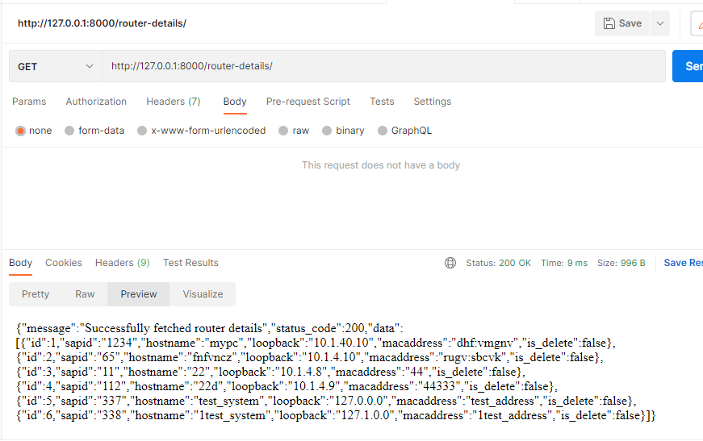

2) Create new router details with unique Sapid, Hostname, Loopback and Mac address – Screenshot on Postman

