# Release Information

|  |  |
| --- | --- |
| *Release* | *Deployment* |
| *Leader* | *Sarah Higgens* |
| *SVN Revision Number* | *69731* |

There was no new functionality this release due to this being deployment. Instead of implementation, we worked on improving code coverage, documentation, and polishing code as much as possible.

# Progress Summary

|  |  |  |  |
| --- | --- | --- | --- |
| **Stories and spike solutions planned for this release** | | | |
| **Story, Spike** | **Description** | **% Impl.** | **Notes, plan for completion** |
| *N/A* | *N/A* | *N/A* | *N/A* |

|  |  |  |
| --- | --- | --- |
| **Accomplishments by engineer** | | |
| **Team Member** | **Total Time (hrs)** | **Stories, Spikes implemented** |
| *Noah* | *9* | *Code coverage, class diagram, documentation.* |
| *Zack* | *10* | *Code coverage, storybook, class/method comments* |
| *Xinyi* | *8* | *Code coverage, documentation* |
| *Mike* | *8* | *Code coverage, documentation, class/method comments* |
| *Sarah* | *9* | *GUI Test, documentation* |
| TEAM TOTAL | ***46.0*** |  |

|  |  |
| --- | --- |
| **Document updates** | |
| **Document** | **Changes** |
| *ReadMe* | *Reformatted and added sections describing files required, known bugs, design deficiencies, and test coverage.* |
| *GroupA4StoryBook* | *Updated story book, mark all unimplemented stories in orange and partially implemented stories in tan.* |
| *Class Diagram* | *Changed the diagram to fully reflect the state of the software at the deployment stage.* |

# Issues

|  |  |  |  |  |
| --- | --- | --- | --- | --- |
| **Issue Number** | **Discovery**  **Date** | **Resolution**  **Date (Est.–Act.)** | **Responsible Person** | **Description (Prob / Resolution)** |
| 1 | 5/7/18 | 5/7/18 | Sarah | The GUI sometimes flickers. We know how to fix it we just do not have enough time. We would have to restructure all of parent form. |
|  |  |  |  |  |
|  |  |  |  |  |
|  |  |  |  |  |

# Screen Shots

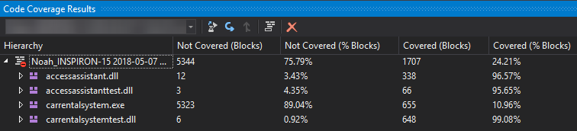

This displays the code coverage for our entire system. As you can see, the majority of our code was covered and the blocks that weren't are reported in Section 5 of this document. As for "carrentalsystem.exe", we never tested code coverage for Forms, so that is why only 10.96% was covered.

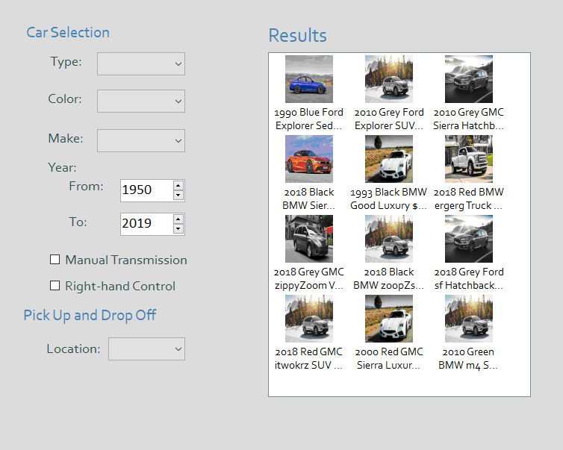

This displays our car search page. An issue that was reported was that this page did not update when the undo button was clicked. We were able to fix this issue and the page now updates whenever undo/redo is clicked.

 Inserting image... 

We implemented a feature where whenever the undo/redo button was hovered over, regardless of whether it was disabled or not, still displayed a message depending on the undo/redo button hovered over.

# Test Coverage Report

AccessAssistant:

* DBController: 96.54% covered
  + Not Fully Covered:
    - Delete(DBObject) - 80.95% covered
      * Block catching an OleDbException isn't tested
    - GetAllRecords(Type) - 96.88% covered
      * Block catching an OleDbException isn't tested
    - Save(DBObject, SaveType) - 80.00% covered
      * Default switch case is not reached since SaveType shouldn't ever not be Insert or Update
* DBObject: 95.65% covered
  + Not Fully Covered:
    - NextAvailablePrimaryKey() - 92.31% covered
      * Case of empty database not tested, since test database is the actual used database
    - SetPrimaryKey(value) - 0.00% covered
      * Primary keys are set by the database, and thus cannot be set in the tests
* SchemaField: 100.00% covered

CarRentalSystem:

* AddCarCommand: 100.00% covered
* CommandHistory: 78.57% covered
  + Not Fully Covered:
    - ExecuteCommand(ICommand) - 75.00% covered
      * Does not recognize any subscriptions to StackChangedEvent.
    - GetStack(StackType) - 57.14% covered
      * Default switch case is not reached since StackType shouldn't ever not be UNDO or REDO
    - Redo() - 75.00% covered
      * Does not recognize any subscriptions to StackChangedEvent.
    - Undo() - 75.00% covered
      * Does not recognize any subscriptions to StackChangedEvent.
* PurchaseControl: 100.00% covered
* RentalControl: 100.00% covered
* UserControl: 100.00% covered
* VehicleControl: 100.00% covered
* VehicleIssueControl: 100.00% covered
* Admin: 100.00% covered
* Customer: 100.00% covered
* Purchase: 100.00% covered
* Rental: 100.00% covered
* User: 100.00% covered
* Vehicle: 100.00% covered
* VehicleIssue: 100.00% covered
* Forms: 0.00% covered
  + Forms aren't part of the test cases