# Release Information

|  |  |
| --- | --- |
| *Release* | *0* |
| *Leader* | *Noah Moss* |
| *SVN Revision Number* | *61428* |

In this release, we were able to establish a core, MVC-like design for our car rental system. Currently, we do not have any implementation (save the GUI for spike0) and we plan to perform that during Release 1.

# Progress Summary

|  |  |  |  |
| --- | --- | --- | --- |
| **Stories and spike solutions planned for this release** | | | |
| **Story, Spike** | **Description** | **% Impl.** | **Notes, plan for completion** |
| *Spike 0* | *Throw-away prototype of the key screens.* | *100* | *These screens have given us a step ahead for GUI implementation.* |

|  |  |  |
| --- | --- | --- |
| **Accomplishments by engineer** | | |
| **Team Member** | **Total Time (hrs)** | **Stories, Spikes implemented** |
| *Noah* | *10* | *Assisted in creating the class diagram. Worked with the team to create user stories and establish an initial design.* |
| *Michael* | *10* | *Helped create the class diagram, and worked on creation of user stories.* |
| *Zack* | *10* | *Worked on making the GUI, wrote multiple user stories, and helped with the finalization of the class diagram.* |
| *Xinyi* | *10* | *Helped create the GUI. Worked on the user stories.* |
| *Sarah* | *10* | *Worked with Noah and Michael to create the class diagram. Also, assisted in making the user stories.* |
| TEAM TOTAL | ***50.0*** |  |

|  |  |
| --- | --- |
| **Document updates** | |
| **Document** | **Changes** |
| *GroupA4StoryBook* | *Created our story book this release and updated it twice to put in subtasks and other minor story changes.* |
| *GroupA4ClassDiagram* | *Created the class diagram this release. Did not update it at all.* |
|  |  |

# Plan for Next Release

Give a one to two sentence description of functionality planed for the next release.

|  |  |  |  |
| --- | --- | --- | --- |
| **Stories and spike solutions planned for upcoming release** | | | |
| **Story, Spike** | **Description** | **Est. Hours** | **Notes, plan for completion** |
| *S.1* | *This story is going to allow admins to add cars to the database.* | *8* | *For all stories in this next release, we are planning to implement these in consecutive order based on how they are ordered in this table.* |
| *S.21* | *This story is going to create the GUI and functionality of a customer creating an account.* | *1* |  |
| *S.22* | *This story is going to allow the user to choose the car they want from the selection of cars.* | *2* |  |
| *S.6* | *This story will allow the user pay the payment.* | *4* |  |
| *S.4* | *This story will allow the user to specify a pick-up location for the rented car.* | *2* |  |
| *S.18* | *This story is going to allow the user to specify a drop off location when they are finished renting the car.* | *1* |  |
| *S.23* | *This story will allow the user to view the rate for the car they are renting.* | *2* |  |
| *S.15* | *This story allows an admin to verify that the car was returned.* | *3* |  |
| *Spike 1* | *This story is going to assist us in designing the database for our system.* | *3* |  |
|  |  | *26* | Total |

|  |  |  |  |
| --- | --- | --- | --- |
| **Assignments** | | | |
| **Team Member** | **Stories, Spikes implemented** | | **Tot. Hrs.** |
| *Sarah Higgens* | *S.1* *Spike 1* | *Add Cars (w/ Noah, Michael)* *Database Design (w/ Noah, Michael)* | *11* |
| *Noah Moss* | *S.1*  *Spike 1*  *S.4* | *Add Cars (w/ Sarah, Michael)* *Database Design (w/ Sarah, Michael)* *Pay for the Rental (w/ Xinyi)* | *13* |
| *Zackary Neefe* | *S.21*  *S.22*  *S.18*  *S.6*  *S.23* | *Create a user account*  *Choose a car*  *Specify drop off location*  *Pay for the rental*  *Determine amount owed* | *10* |
| *Michael Serino* | *S.1*  *Spike 1* | *Add Cars (w/ Sarah, Noah)*  *Database Design(w/ Sarah, Noah)* | *11* |
| *Xinyi Lyu* | *S.22* *S.4*  *S.15*  *S.6* | *Add Cars to Customer*  *Specify pick up location*  *Is Car return in the Database*  *Pay for the rental (w/ Noah)* | *11* |
|  |  | **Total** | **56** |

# Issues

Document anything that is not decided yet and needs to be resolved at some point.

|  |  |  |  |  |
| --- | --- | --- | --- | --- |
| **Issue Number** | **Discovery**  **Date** | **Resolution**  **Date (Est.–Act.)** | **Responsible Person** | **Description (Prob / Resolution)** |
| I.1 | 2/12 | We decided to have a Rental Control Class. | Sarah | Was unsure whether to add a rental control class. After a day of thinking, we decided to have one. |
|  |  |  |  |  |
|  |  |  |  |  |
|  |  |  |  |  |

# Screen Shots

*Insert screen shots of functionality added for this release along with screen shots from spike solutions. Add short descriptions of all screen shots along with a short of list features illustrated by each. The goal is to convince your instructor that you completed the work documented above.*

*Main form of the system for entering location info, login button for users not logged in, and a report button for users logged in.*

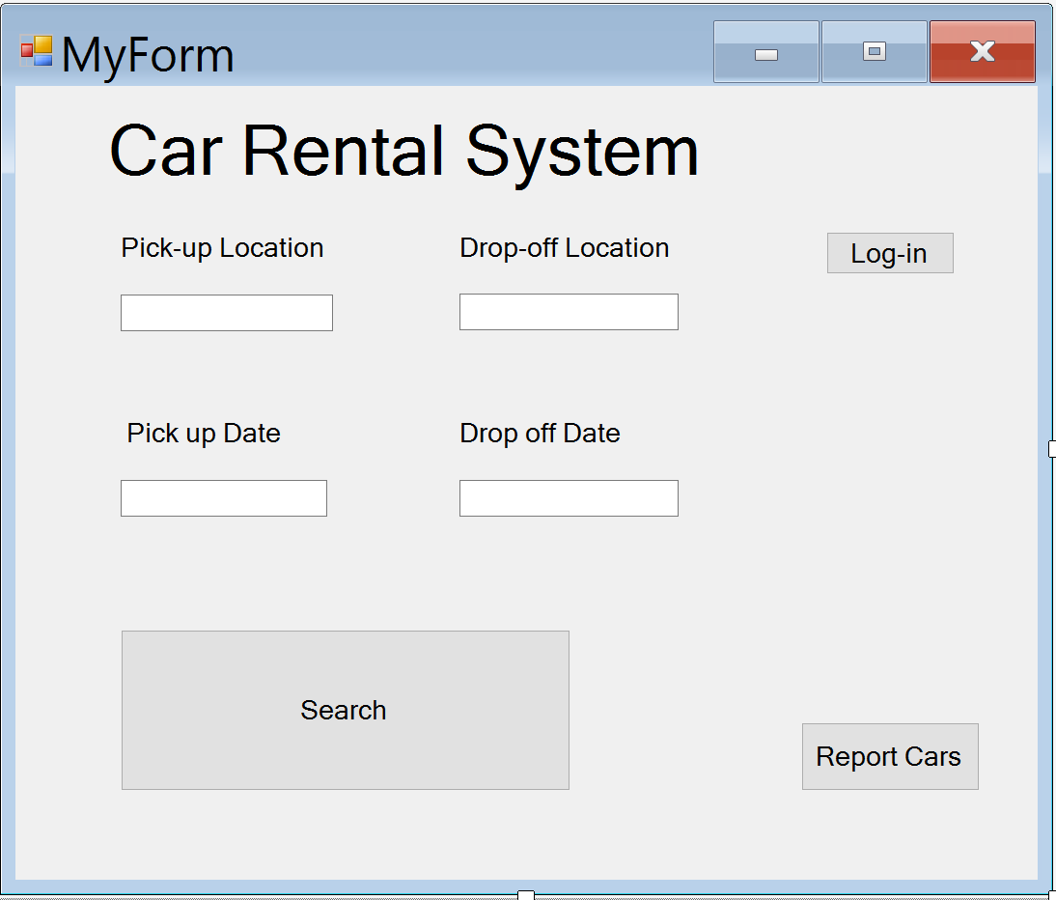

*Search page for the cars in the system. Left side of the screen will have a list of cars (with pictures), while the right side contains the options in order to narrow the search.*

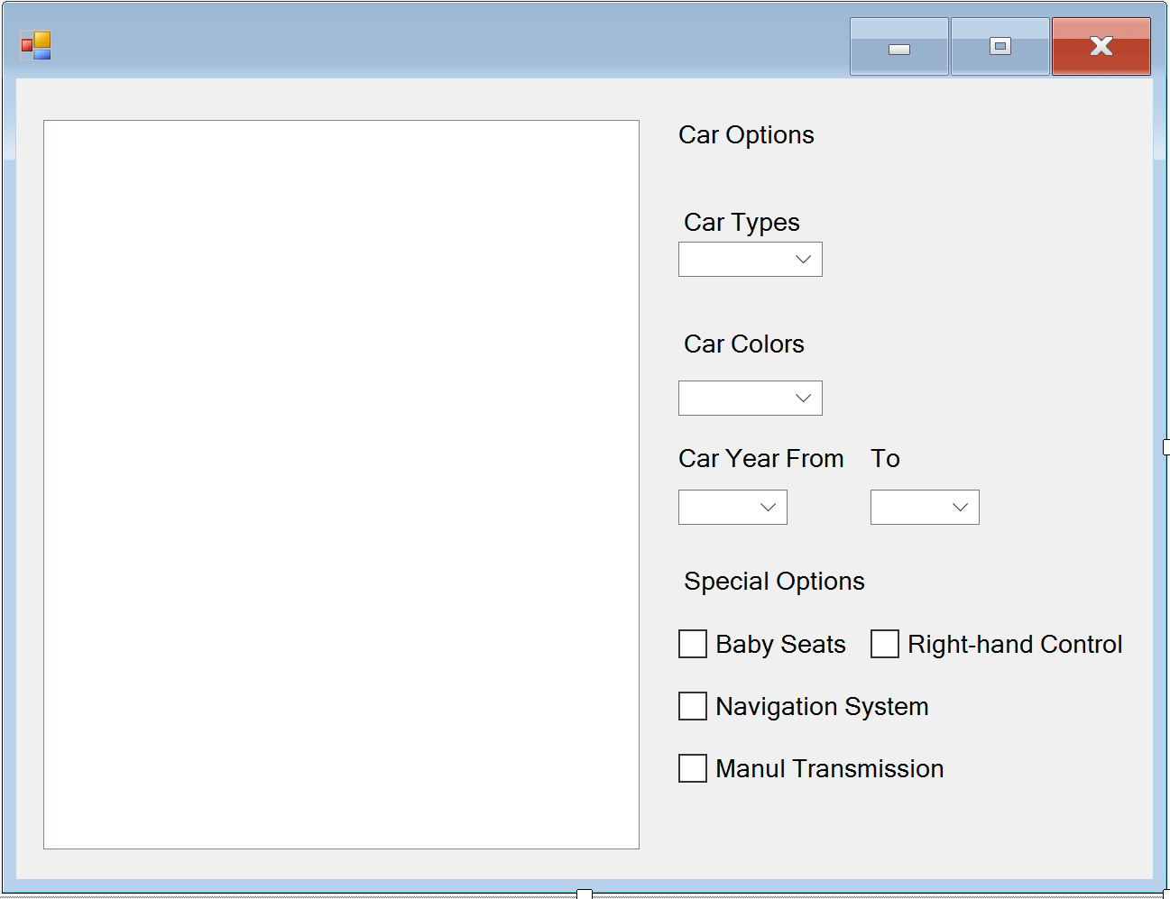

*The page displayed when a car is selected. The box in the top left corner shows a picture of the car, while the box in the bottom left has the car information in text form.*

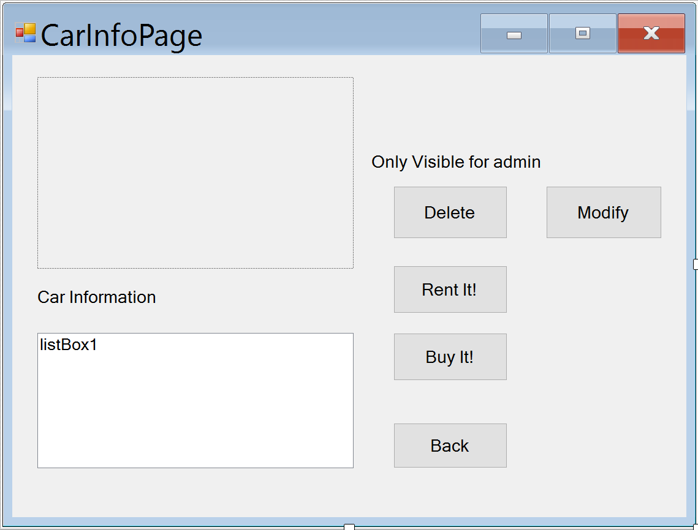

*Payment page where the total price of the rental is shown based on the rate for the car selected and the days it will be rented for. Customer can select a payment type in order to pay.*

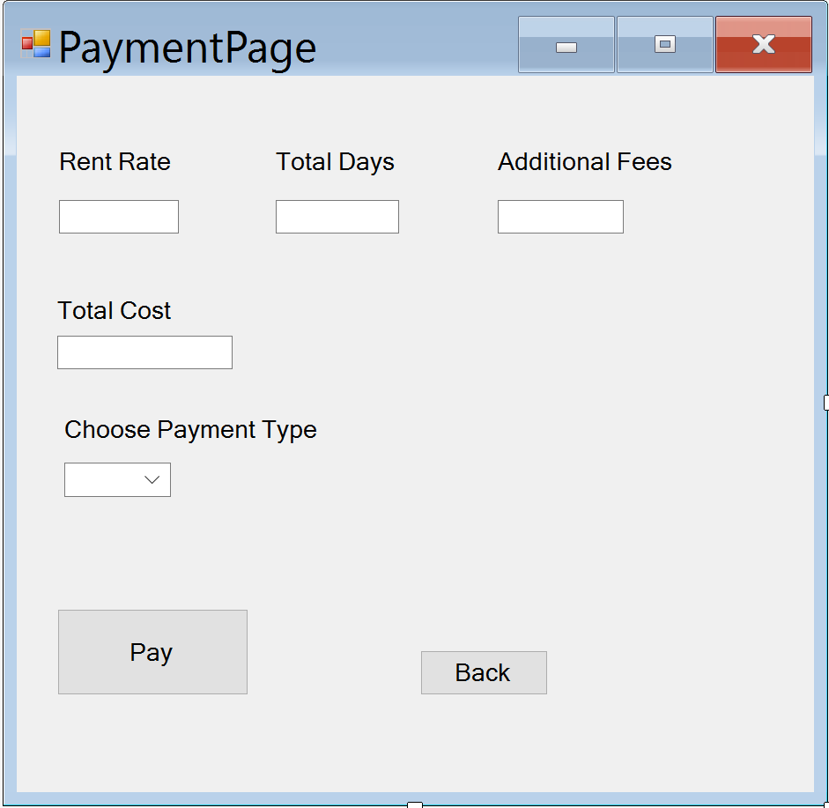

*Customer can report a problem with the car on this page. The car must be selected in order for the customer to fill out the text field.*

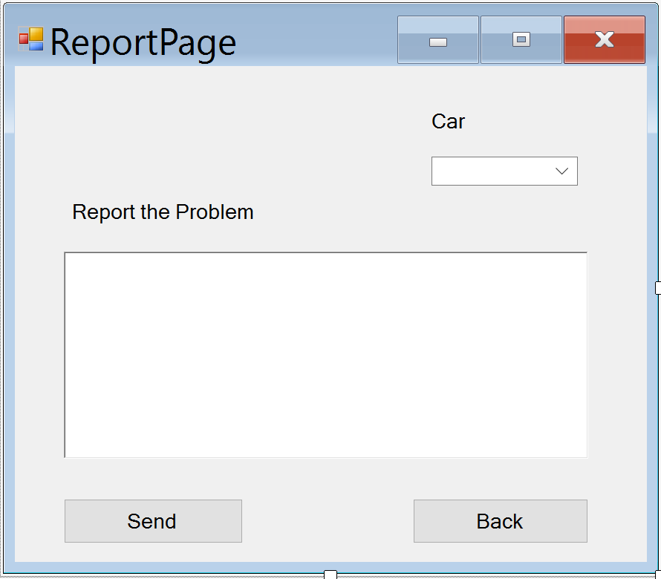

*The car addition page that is accessible by an admin. The admin gets to upload a photo of the car, enter the info about it, and select its options.*

