# Release Information

|  |  |
| --- | --- |
| *Release* | *2* |
| *Leader* | *Zackary Neefe* |
| *SVN Revision Number* | *63253* |

The GUI has been massively overhauled to have a much more user-friendly and clean design. Searching for cars in the system now allows the user to narrow down the search. Users can filter search results by categories such as color, make, model, and year.

# Progress Summary

|  |  |  |  |
| --- | --- | --- | --- |
| **Stories and spike solutions planned for this release** | | | |
| **Story, Spike** | **Description** | **% Impl.** | **Notes, plan for completion** |
| *Spike 2* | *This spike is going to assist us in filtering the database for our system* | *100%* | *We found that filtering was easy with the where() function in c#, to more easily find the correct search results* |
| *S.IO.01* | *Admin is able to modify an existing car in the database* | *100%* |  |
| *S.UI.04* | *User is able to choose car by components* | *100%* |  |
| *S.SO.02* | *User is able to browse for cars* | *100%* | *We decided to merge this with the search story since both had similar functionality and implementation.* |
| *S.UI.05* | *Admin is able to delete a car from the database* | *100%* |  |
| *S.UI.08* | *Making other admin accounts* | *100%* |  |
| *S.SO.04* | *Track number of rental days* | *70%* | *The user is presented how many days they have for the rental, but can not go back and track how many are left.* |
| *S.IO.05* | *Search car categories* | *100%* | *As for the above browse for cars. The search works the same way.* |

|  |  |  |
| --- | --- | --- |
| **Accomplishments by engineer** | | |
| **Team Member** | **Total Time (hrs)** | **Stories, Spikes implemented** |
| *Zackary Neefe* | *12* | S.IO.01, S.UI.04, S.UI.08, S.SO.04, S.IO.05 |
| *Sarah* | *24* | S.IO.01,S.SO.02,S.UI.08,S.SO.04,S.IO.05 |
| *Michael Serino* | *12* | *S.IO.01, S.IO.05, Spike2* |
| *Xinyi* | *12* | *Spike2,* S.UI.05 |
| *Noah* | *11* | *Spike2,* S.UI.04 |
| TEAM TOTAL | 71.***0*** |  |

|  |  |
| --- | --- |
| **Document updates** | |
| **Document** | **Changes** |
| *Story Book* | *We marked the browse story as removed, and have updated the implementation for all stories.* |
| *Class Diagram* | *Updated the class diagram to follow our new GUI logic as well as to follow the new design with access assistant.* |
| *Status Document* | *Updated since the beginning of 4/3* |

# Plan for Next Release

Admins and users will get more features to interact with the system and the cars and rentals in it. Cars will have pictures associated with them to make them easier to identify.

|  |  |  |  |
| --- | --- | --- | --- |
| **Stories and spike solutions planned for upcoming release** | | | |
| **Story, Spike** | **Description** | **Est. Hours** | **Notes, plan for completion** |
| *S.SO.03* | Admins can apply fees to a customer account if they have caused some grievance. | *6* |  |
| *S.UI.06* | Admins can modify cars to be unavailable for repairs or whatnot. | *6* |  |
| *S.UI.02* | Customers can report a vehicle they are renting as needing repairs. | *6* |  |
| *S.UI.07* | Customers can purchase a vehicle, which will remove it from the database. | *6* |  |
| *S.IO.03* | Admins can blacklist customers so they will no longer be able to rent cars. | *9* |  |
| *S.SO.01* | Customers will be shown a confirmation page with the rental data with the final confirm button. | *4* |  |
| *S.IO.04* | Customers' credit scores will be maintained in order to determine their eligibility to rent. | *4* | *Will be implemented in a simplified way.* |
| *S.SO.05* | A calendar will be maintained for each location for admins to view the rentals set for each day. | *8* |  |
| *Spike3* | This spike will help us understand how to associate database objects with images. | *4* | *Each car will have a picture of it that will saved along with its information.* |
|  |  | 53.***0*** | Total |

|  |  |  |  |
| --- | --- | --- | --- |
| **Assignments** | | | |
| **Team Member** | **Stories, Spikes implemented** | | **Tot. Hrs.** |
| *Zackary Neefe* | *S.UI.07*  *S.IO.03*  *S.SO.01*  *S.SO.05* | *Purchase car*  *Blacklist*  *Review rental*  *Calendar view* | *12* |
| *Noah Moss* | *S.SO.03*  *S.UI.02*  *S.SO.01*  *S.IO.04* | *Apply fees*  *Report an issue*  *Review rental*  *Review customer credit* | *10* |
| *Michael Serino* | *S.UI.06*  *S.UI.07*  *S.SO.05* | *Report crashed car*  *Purchase car*  *Calendar view* | *10* |
| *Xinyi Lyu* | *S.SO.03*  *S.UI.02*  *S.IO.03*  *Spike3* | *Apply fees*  *Report an issue*  *Blacklist*  *Spike3* | *11* |
| *Sarah Higgens* | *S.UI.06*  *S.IO.03*  *S.IO.04*  *Spike3* | *Report crashed car*  *Blacklist*  *Review customer credit*  *Spike3* | *10* |
|  |  | **Total** | 53.**0** |

# Issues

|  |  |  |  |  |
| --- | --- | --- | --- | --- |
| **Issue Number** | **Discovery**  **Date** | **Resolution**  **Date (Est.–Act.)** | **Responsible Person** | **Description (Prob / Resolution)** |
| 1 | 3/7 | 4/4 | Sarah | Our GUI was not suitable for user use, so Sarah went through and overhauled our entire GUI, giving it some color and character. |
| 2 | 3/7 | 3/25 | Noah | Noah redesigned our DB controller to not be so functional, so he made the access assistant to be the controlling layer, and the dbobject to be a data layer. |
|  |  |  |  |  |
|  |  |  |  |  |

# Screen Shots

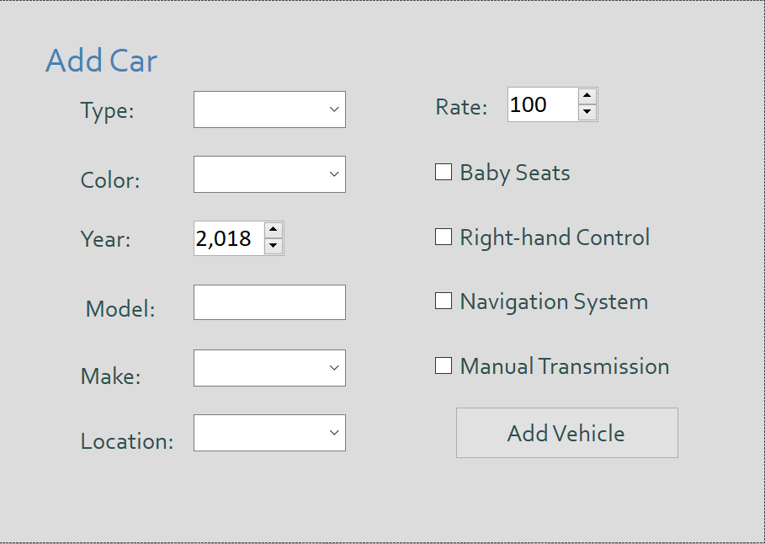

AdminPage

This is the admin-accessible create car page. Rate field was added as well as the options for the admin to create a new admin account and to check that a car was returned.

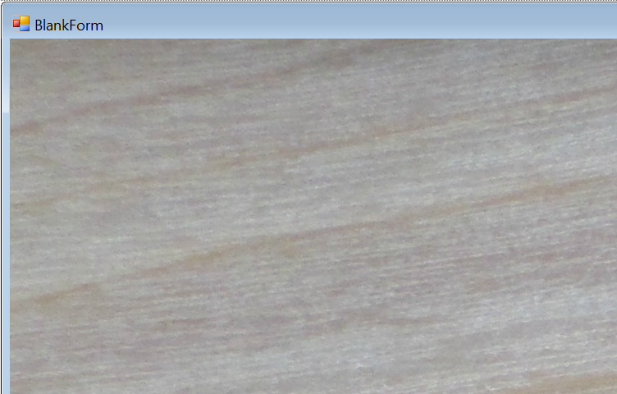

BlankForm

When you log out, this page will be shown.

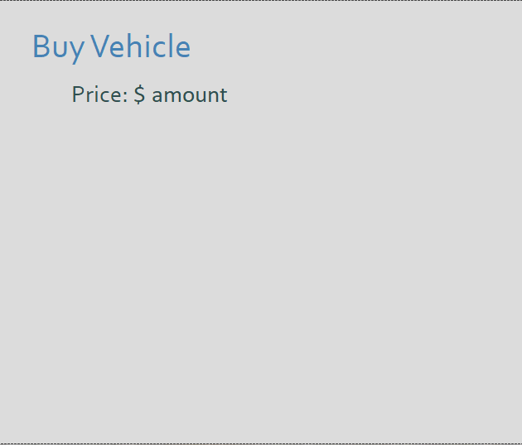

BuyPage

This page has not done yet.

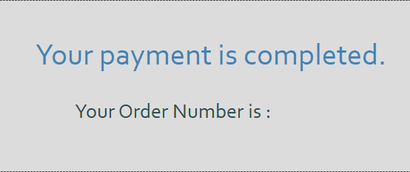

ConfirmationPage

This page is when you hit the rent button then it will show up. It tells your order number.

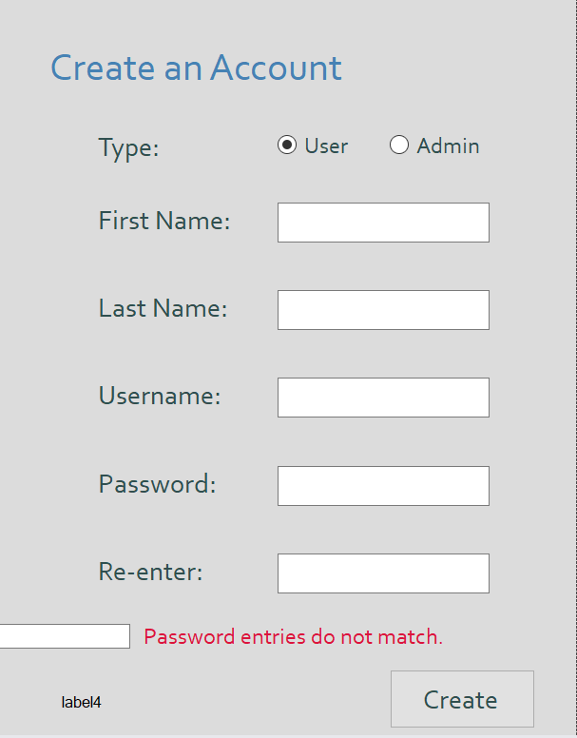

CreateUserPage

This page appears when the user clicks "create account" on the main page. If all the fields are filled and the password check matches, the account is added to the database.

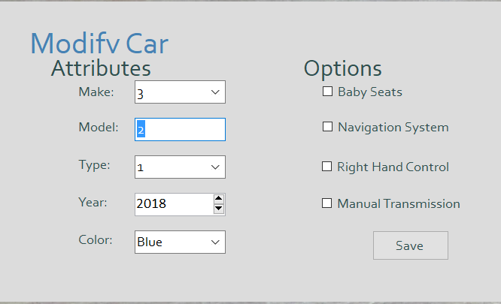

ModifyPage

This page appears when admin clicks the modify button on the parent page. Admin can change the attribute of the car.

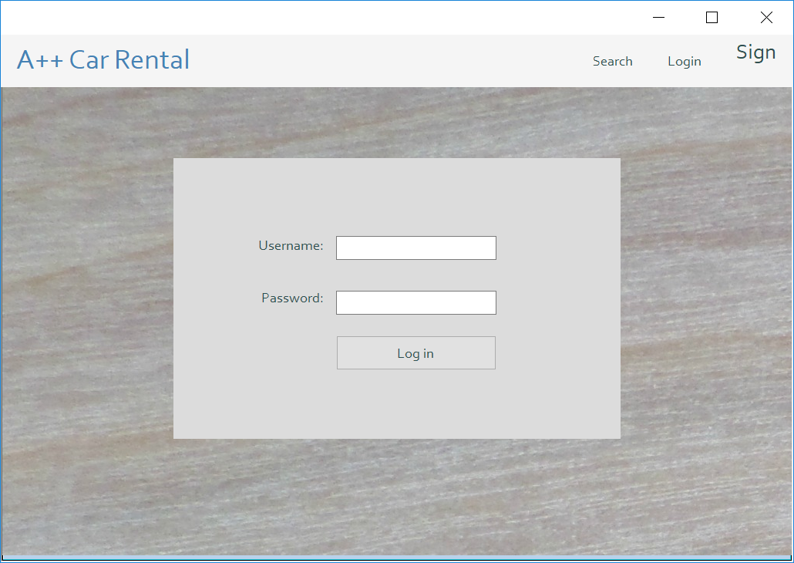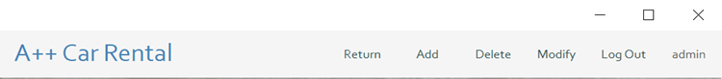

ParentForm

This page will show all the time.

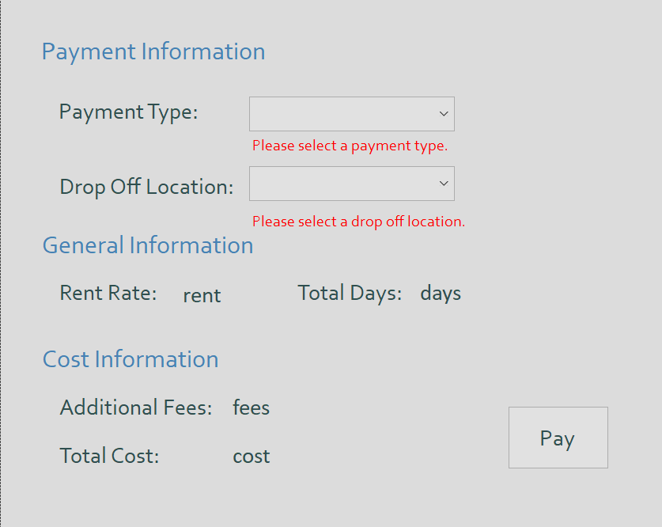

PaymentPage

This page shows after a customer elects to rent a car they have viewed. The information from the various forms and database objects is displayed. The user can choose to "pay" in either cash or card.

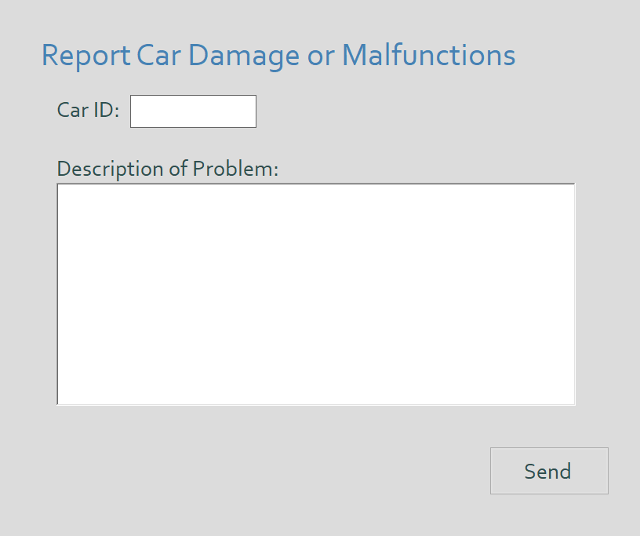

ReportPage

This page will appear when a costumer logs in and click the report button.

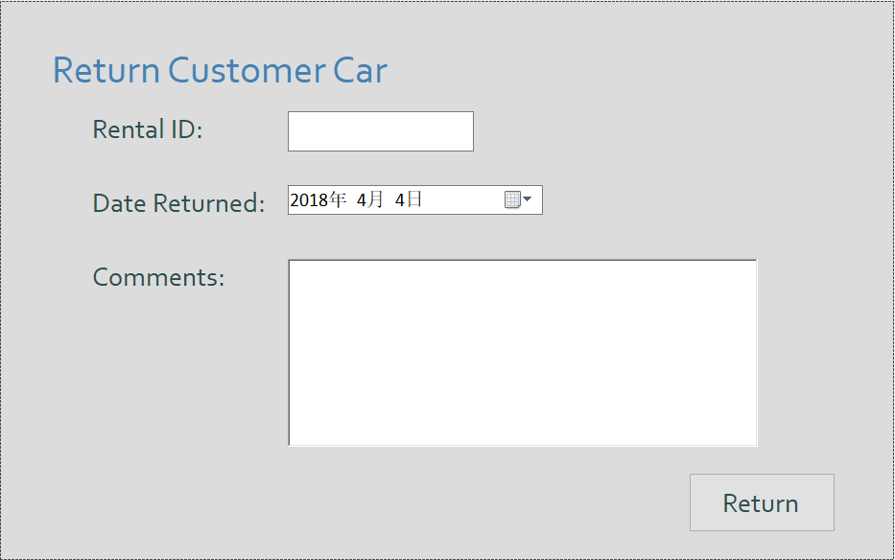

ReturnCarPage

This page will appear when a admin logs in and click the return bottum.

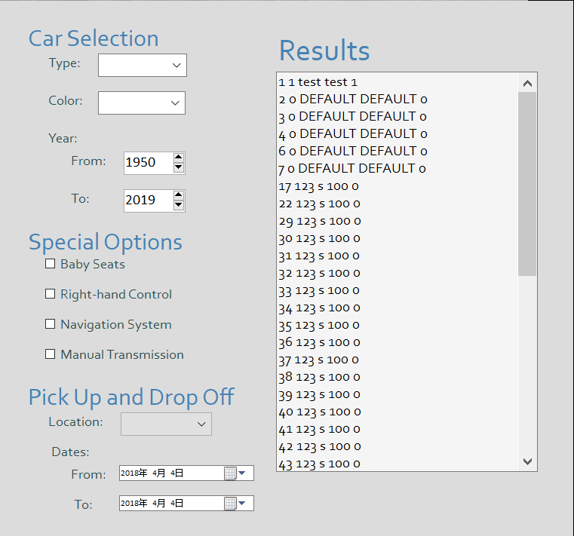

SearchCarPage

This page will allow user to choose the car options and select cars.