Commands to run the VHDL code with GHDL simulator:
- Compile : ghdl –a file_name.vhdl
- Elaborate: ghdl –e entity_name ex: ghdl –e NOR_Gate
- Run simulator: ghdl –r entity_name —wave=<name>.ghw —stop-time=100ns
- GTKwaveform: gtkwave <name>.ghw
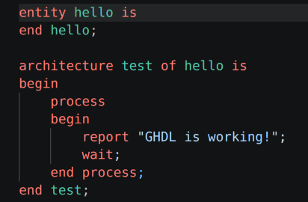
“entity” – inputs and outputs for a module
“architecture” — logic and algorithm. Architecture body —-> Skeleton. The process are the tasks which contain most of our code.

Project 01:
NAND: is the universal gate. We will be building all logic gates with this nand gate.
NOT Gate:
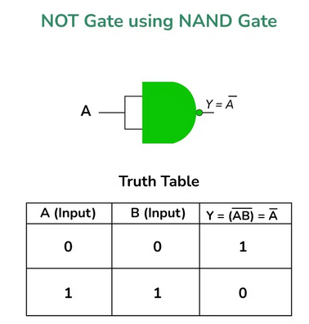
AND Gate:
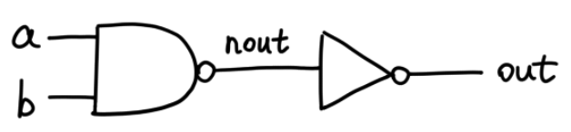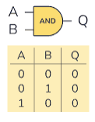
OR Gate:
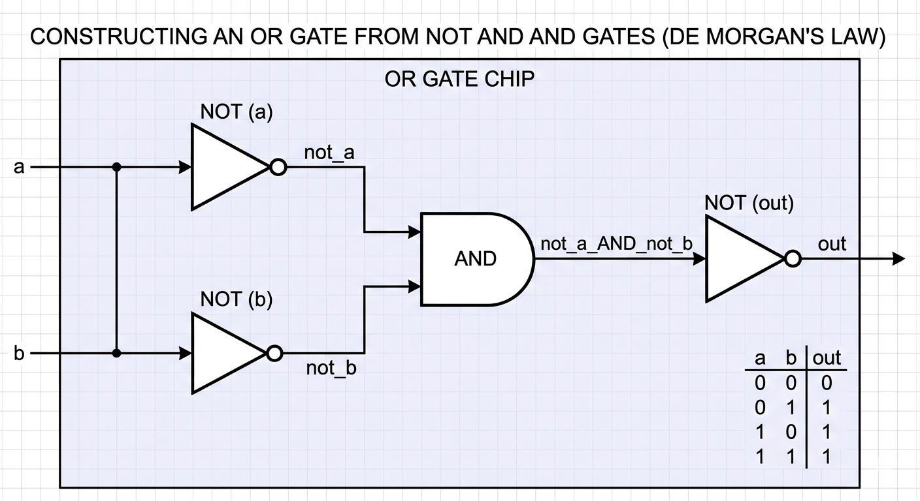
XOR Gate:
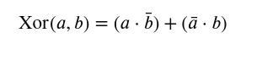
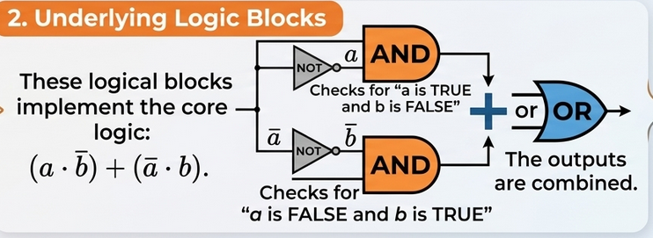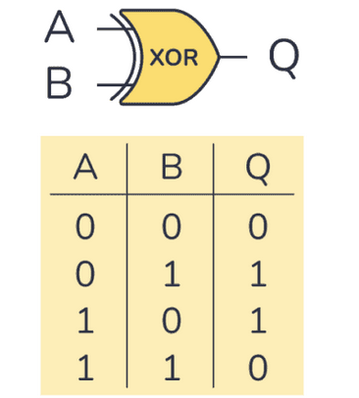
MUX Gate:
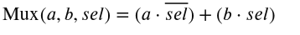
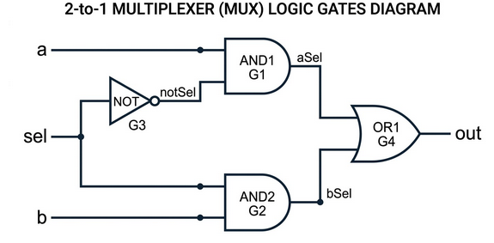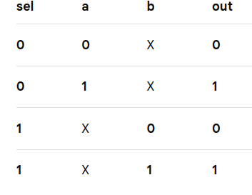
DEMUX:
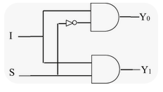
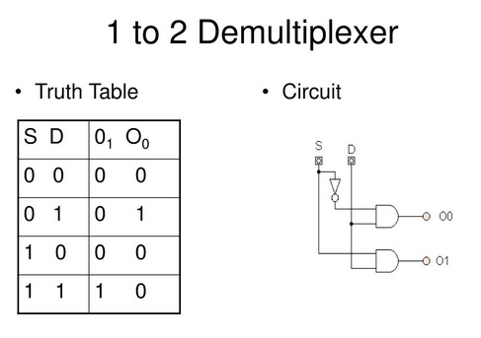

OR8WAY:
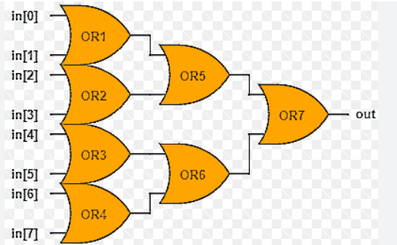

MUX4Way16:
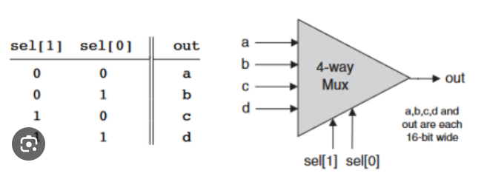
MUX8Way16:
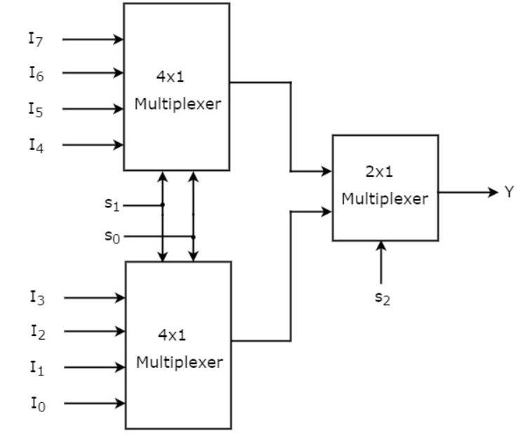
DEMUX4WAY:
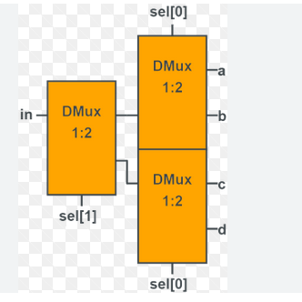

PROJECT 02:
HalfAdder:
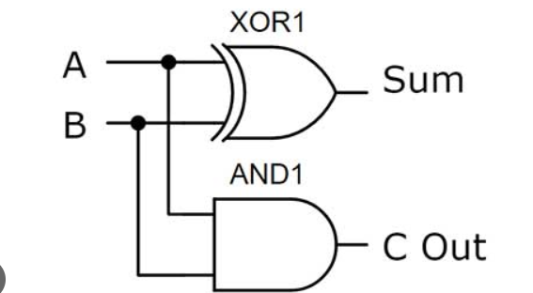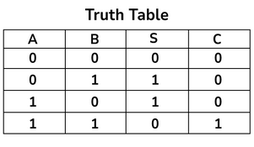
FullAdder
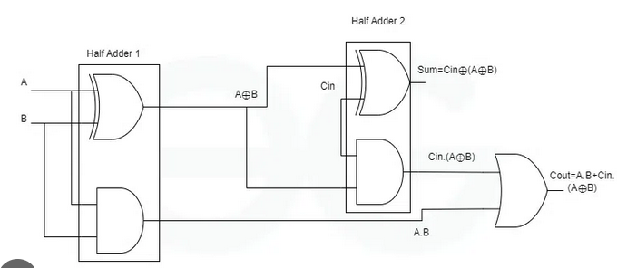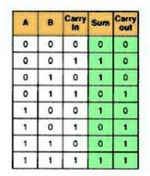
INC16
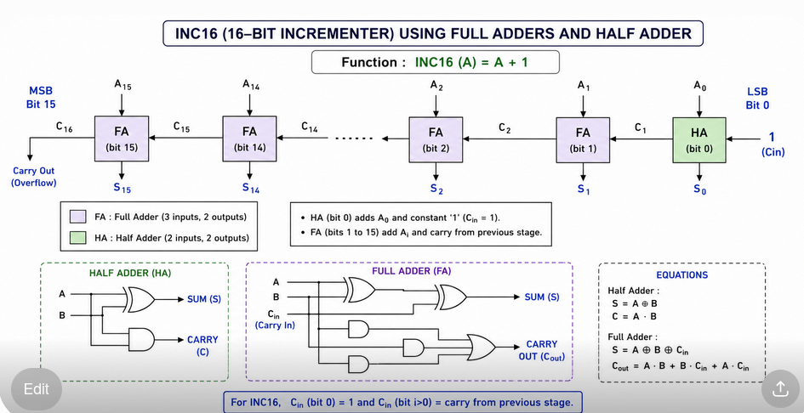

ADD16:
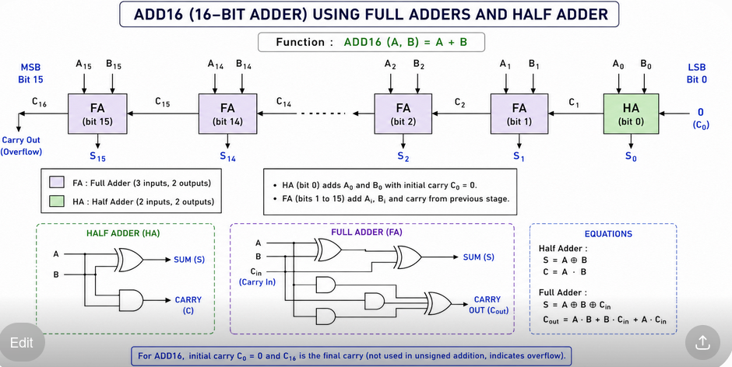

ALU:
