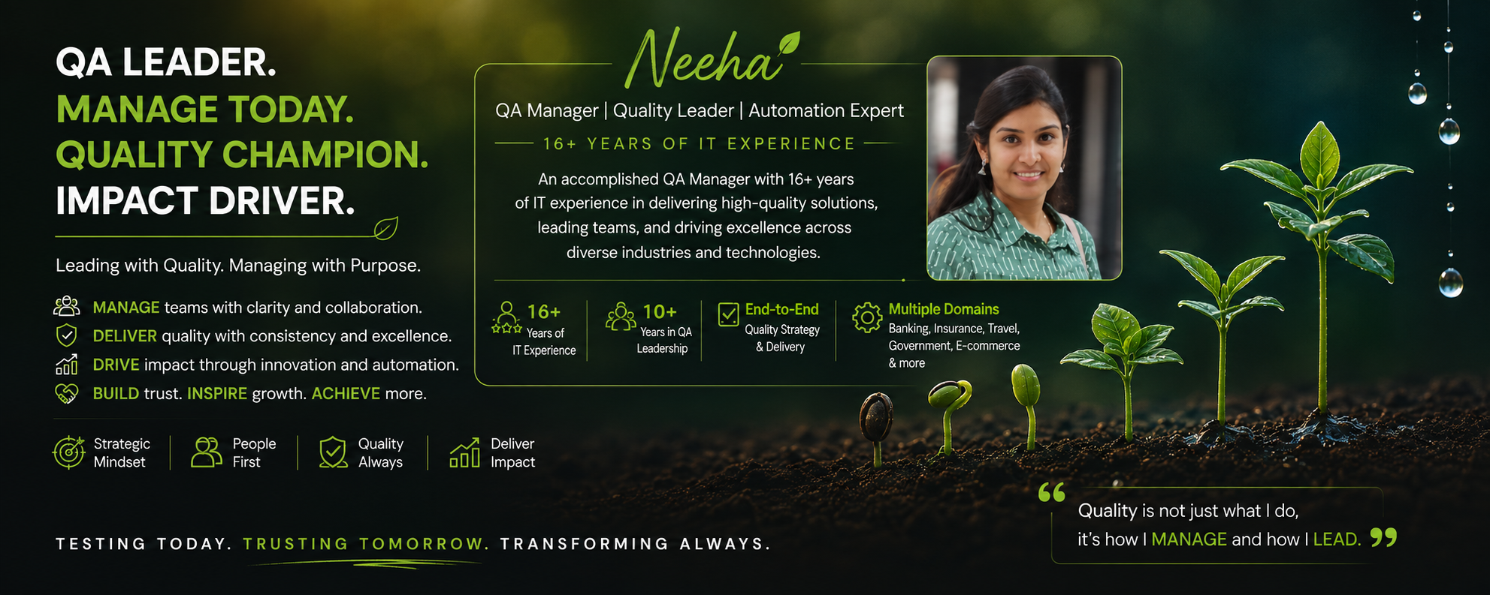

NEEHARIKA GARG (Neeha)

QA Associate Manager | QA Manager | Quality Engineering Leader
Travel | BFSI (Wells Fargo, Allstate) | Insurance (Great American) | Government Identity (MOSIP) | Life Sciences (LexisNexis USA)

📍 Pune, Maharashtra, India | Remote/Hybrid | Immediate Joiner | 16+ Experience
📞 +91 81972 01901 | ✉️ neeharika.goyal@gmail.com | 🌐 Portfolio: neehagarg.github.io/portfolio-website/
🔗 LinkedIn: linkedin.com/in/neeharika-garg | 💻 GitHub: github.com/neehagarg
PROFESSIONAL PROFILE
Quality Engineering Manager with 16+ years of experience leading enterprise Quality Assurance and Test Management initiatives across Travel, BFSI, Government, Identity Management, Insurance, Retail, E-commerce, and Life Sciences domains.
Proven expertise in QA Strategy, Test Management, Release Management, Test Automation, Agile Delivery, Stakeholder Management, Risk Management, and Continuous Improvement, delivering high-quality software solutions through effective leadership, governance, and collaboration.
Brings 4 years of onsite experience in the USA, partnering with clients, business stakeholders, and engineering teams to deliver mission-critical enterprise applications.
Hands-on expertise in Selenium, Java, REST Assured, JMeter, API Testing, CI/CD, DevOps, and Quality Engineering, enabling scalable automation and predictable software delivery.
KEY ACHIEVEMENTS

- Led end-to-end Quality Engineering for the Uganda National Identity & Civil Registry Platform (MOSIP).
- Brought 4 years of onsite experience in the USA, partnering with clients and global teams.
- Led cross-functional Quality Engineering teams across QA, Development, DevOps, Business Analysis, and UAT.
- Delivered enterprise releases through effective test strategy, release planning, SIT, UAT, and production readiness.
- Built automation frameworks using Selenium, Java, REST Assured, Jenkins, and CI/CD.
- Strengthened software quality through test governance, risk-based testing, and Root Cause Analysis (RCA).
- Drove automation and continuous improvement across Government, Travel, BFSI, Insurance, Retail, and Identity Management domains.
- Partnered with business stakeholders and engineering teams to deliver business-critical enterprise applications.

CORE COMPETENCIES
Delivery & Release Management: Project Planning & Execution, Delivery Governance, Release Management, Release Planning, Production Readiness, Risk & Issue Management, Delivery Metrics & Reporting, Go/No-Go Support
Leadership & Stakeholder Management: Team Leadership & Mentoring, People Management, Cross-functional Leadership, Executive & Client Stakeholder Management, Resource Planning, Offshore–Onsite Delivery Model, Agile Delivery, Executive Communication
Quality Engineering & Test Management: Quality Engineering, QA Strategy & Planning, Test Management, Test Governance, End-to-End (E2E) Testing, System Integration Testing (SIT), User Acceptance Testing (UAT), Risk-Based Testing, Defect Management, Quality Gates, Root Cause Analysis (RCA)
Automation & DevOps: Architect, Framework designer ,Automation Strategy, Selenium WebDriver, Playwright, REST Assured, Java, API Testing, CI/CD, Jenkins, Maven, Docker, Git
Tools & Technologies: Jira, Azure DevOps (VSTS), Postman, Swagger, Oracle SQL, Informatica, ETL Testing, JMeter, AI-Assisted Engineering
PROFESSIONAL EXPERIENCE
Organization | Designation | Domain / Client | Duration
Technoforte Software Pvt. Ltd. | QA Associate Manager | Government Identity (MOSIP) | Dec 2020 – Jun 2026
Datamatics Global Services | Lead Consultant | Sabre Corporation – Travel | Jul 2019 – Dec 2020
Great American Insurance Group | Senior Quality Assurance Lead | Insurance | Dec 2017 – Jan 2019
Infosys Ltd. | Senior System Engineer | LexisNexis, Wells Fargo, Allstate | Mar 2012 – Dec 2017
Baddi University | Assistant Professor | Computer Science | Nov 2011 – Mar 2012
Ganpati Institute of Technology & Management | Lecturer | Computer Science | Aug 2008 – Aug 2009

Industry Experience: 15+ Years
Academic Experience: 1+ Year
USA Onsite: 4 Years
Technoforte Software Pvt. Ltd. (Latest Company)
QA Associate Manager (Delivery & Quality Engineering Leadership)
Bengaluru, India | Dec 2020 – Jun 2026
Project: Uganda National Identity & Civil Registry Platform (MOSIP)
Domain: Government Identity Management
Key Responsibilities & Achievements
- Led end-to-end Quality Engineering for the Uganda National Identity & Civil Registry Platform (MOSIP), delivering National ID, Birth Registration, Death Registration, and Civil Registry solutions using Agile methodologies.
- Owned QA strategy, test planning, release management, SIT, UAT, release governance, production readiness, and Go-Live support, ensuring predictable, high-quality releases.
- Led and mentored cross-functional teams across QA, Development, DevOps, Business Analysis, Product Management, and UAT while driving quality governance, risk-based testing, quality metrics, and Root Cause Analysis (RCA).
- Architected and implemented enterprise automation frameworks from scratch using Selenium WebDriver, REST Assured, JMeter, Java, Jenkins, Maven, Git, Docker, and CI/CD, improving regression coverage, execution efficiency, and release quality.
- Directed end-to-end testing across Web, Mobile, API, ETL/Data Warehouse, Integration, Regression, Performance, and UAT, collaborating with government stakeholders and engineering teams to ensure successful cloud-native deployments and production releases.
LexisNexis (USA – Dayton OH) | Great American Insurance Group (USA Cincinnati OH)
Worked on enterprise applications for LexisNexis (USA), supporting quality assurance for large-scale legal and information services platforms, with a focus on functional, API, regression, and end-to-end testing in Agile environments.
Worked on enterprise Property & Casualty (P&C) insurance applications for Great American Insurance Group, ensuring the quality of policy administration, underwriting, claims, billing, and integration services through functional, API, regression, and end-to-end testing in Agile environments.
Sabre Travel ( Bangalore)
Worked on Sabre travel applications, ensuring quality across airline reservation, booking, ticketing, and travel services. Performed functional, API, integration, regression, and end-to-end testing to validate booking workflows, PNR management, pricing, and third-party system integrations in Agile environments.Worked on enterprise Property & Casualty (P&C) insurance applications for Great American Insurance Group, ensuring the quality of policy administration, underwriting, claims, billing, and integration services through functional, API, regression, and end-to-end testing in Agile environments.
Wells Fargo and Allstates (Mysore)
Worked on enterprise banking and insurance applications for Wells Fargo and Allstate, contributing to functional, API, integration, regression, and end-to-end testing. Validated core business workflows including digital banking, customer onboarding, policy administration, claims processing, billing, and secure third-party integrations in Agile environments.

AWARDS & RECOGNITION
MOSIP Pillar Award – Uganda National Identity & Civil Registry Platform
Recognized for significant contribution to the successful delivery and quality engineering initiatives of the MOSIP-based Government Identity and Civil Registry platform, supporting digital transformation and mission-critical national identity services.
CERTIFICATIONS
Project Management Certification Great Learning | July 2026 Credential ID: LCNRYQFC
Microsoft CSS JavaScript HTML
PMP getting scheduled in September 2026

ACADEMIC PROJECT / THESIS
M.Tech Thesis – Artificial Intelligence
Panjab University | 2009 – 2011
Title: Semantic Rank Based Industrial Document Retrieval
- Developed an AI-based semantic ranking model to improve industrial document retrieval accuracy and search relevance.
- Conducted research on information retrieval, semantic analysis, and ranking algorithms.

PROFESSIONAL AND ACADEMIC QUALIFICATION

M.Tech ME Masters of Engineering– Computer Science & Engineering

University Institute of Engineering & Technology, Panjab University | 2011 | 72.66%

B.Tech – Computer Science & Engineering

Maharishi Markandeshwar Engineering College, Kurukshetra University | 2008 | 79.27%

Diploma – Information Technology

Seth Jai Parkash Polytechnic | 2005 | 76.77%

