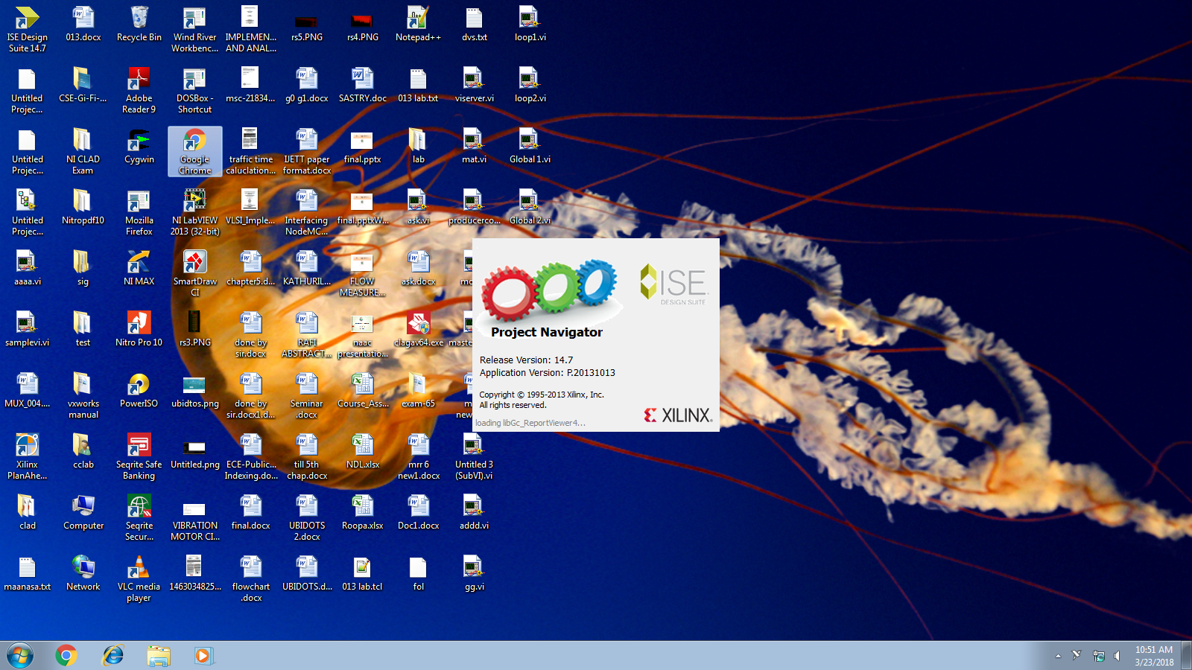

**3 IP MAC FSM Executions:**

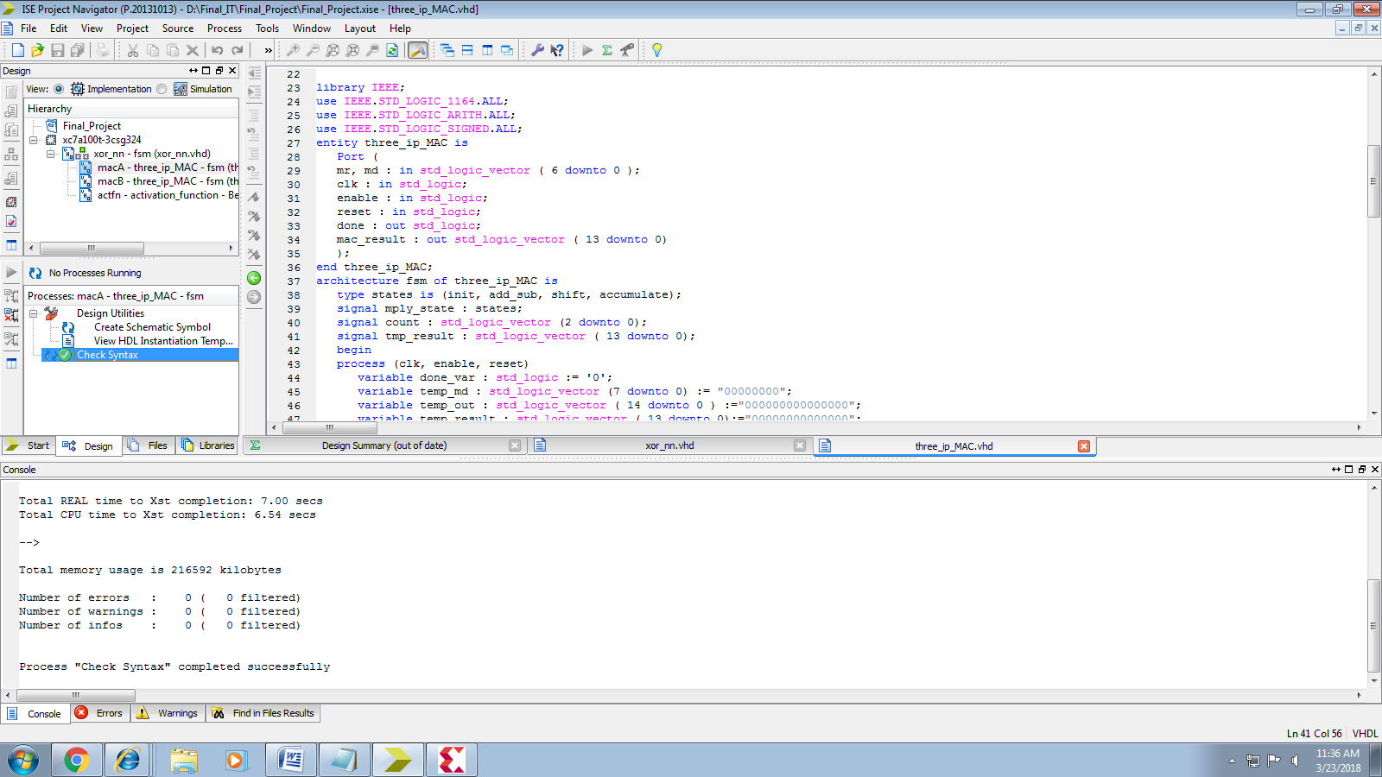

**Activation Function Execution:**

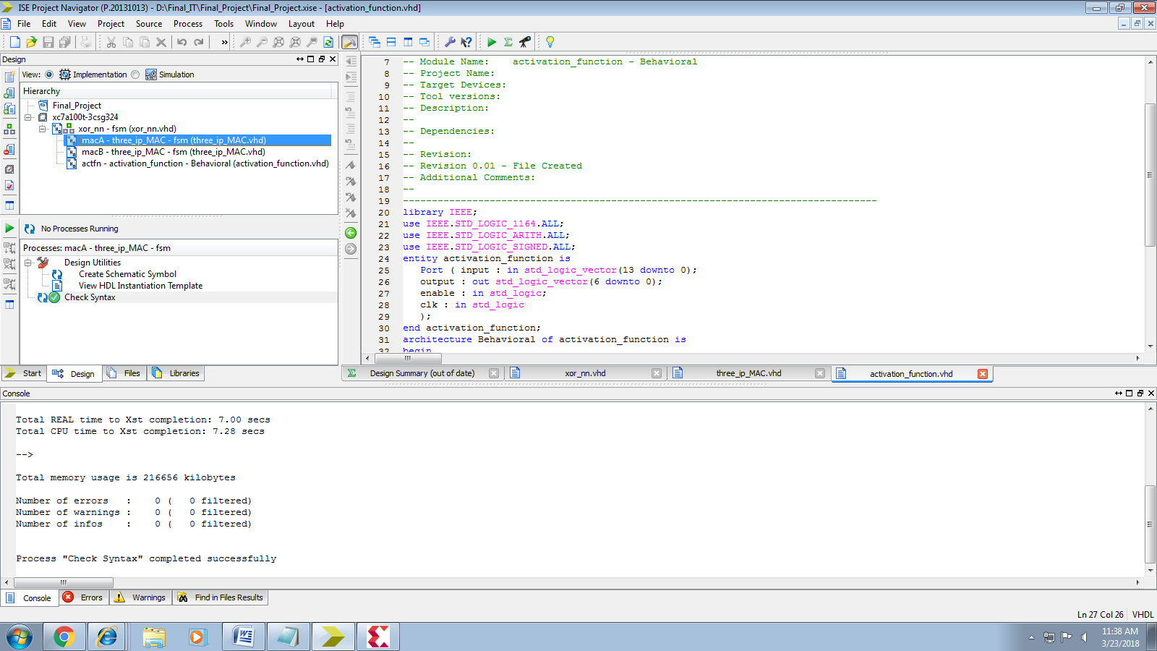

**XOR-FSM:** Successful Completion of Execution

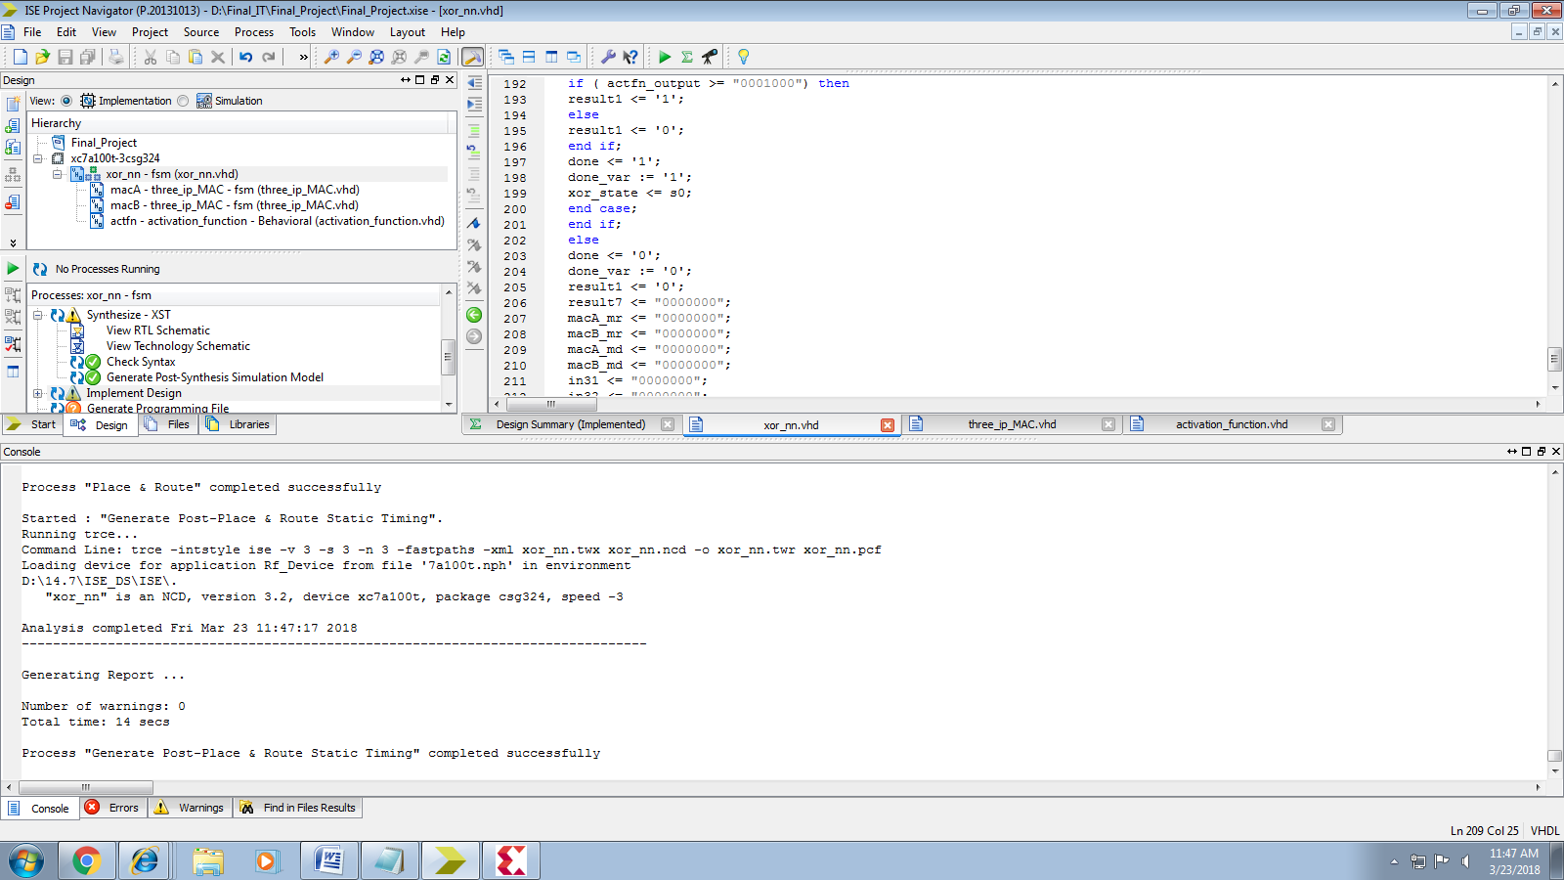

Ini

**Initial Stage Output:**

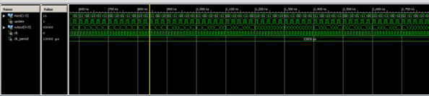

**Training Output:**

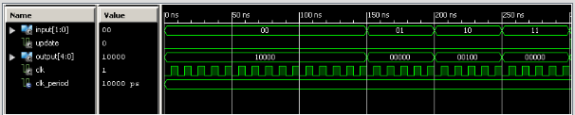

**Result Output:**

