**Project Progress Report**

**Date:** October 26, 2023

**Project:** Machine Failure Prediction

**Contributors:** Neehanth Reddy Maramreddy, Sandeep Rao Gandra

**1. Introduction**

This report details the progress in developing a machine learning model to predict machine failures, using sensor data and machine parameters. The project aims to accurately classify whether a machine will fail (binary classification: 0 = No, 1 = Yes). The successful prediction of machine failures can help reduce unplanned downtimes. This work aligns with the problem statement and objectives outlined in the project proposal.

**2. Model Evaluation and Results**

The following table summarizes the performance of the evaluated models:

|  |  |  |  |  |  |  |  |
| --- | --- | --- | --- | --- | --- | --- | --- |
| **Model** | **Train AUC** | **Val AUC** | **Train Accuracy** | **Val Accuracy** | **Precision (Class 1)** | **Recall (Class 1)** | **F1-Score (Class 1)** |
| Logistic Regression | 0.935559 | 0.931188 | 0.973121 | 0.973043 | 0.28 | 0.79 | 0.41 |
| Random Forest | 0.981244 | 0.951709 | 0.985696 | 0.984242 | 0.42 | 0.77 | 0.54 |
| Neural Network | 0.959288 | 0.945948 | 0.994665 | 0.994263 | 0.76 | 0.77 | 0.76 |

**2.1 Logistic Regression**

* **Results:** Logistic Regression achieved a Train AUC of 0.936 and a Validation AUC of 0.931. Training and validation accuracies were both 0.973. However, the precision for class '1' (machine failure) is low (0.28), while recall is 0.79.
* **Justification:** Logistic Regression was selected as the baseline model, as indicated in the proposal. It offers a straightforward and understandable beginning to start. The findings support the original hypothesis that, despite its high overall accuracy, logistic regression has trouble with the issue of class imbalance. Class '1' precision is low, indicating a high rate of false positives. False alarms can result in excessive maintenance and expenses, making them unwanted for anticipating machine faults.

**2.2 Random Forest**

* **Results:** The Random Forest model shows a Train AUC of 0.981 and a Validation AUC of 0.952. Training accuracy is 0.986, and validation accuracy is 0.984. The precision for class '1' improved to 0.42, and recall is 0.77.
* **Justification:** As stated in the "Methods" part of the proposal, Random Forest, a tree-based model, was investigated as a possible enhancement over the linear Logistic Regression model. The findings show that Random Forest performs better by modelling non-linear correlations in the data. The improvement in precision (0.42) compared to Logistic Regression (0.28) suggests that it is better at correctly identifying machine failures. However, there's still room for improvement.

**2.3 Neural Network**

* **Results:** The Neural Network model achieved a Train AUC of 0.959 and a Validation AUC of 0.946. It has the highest training (0.995) and validation (0.994) accuracies among the three models. Critically, it significantly improved the precision for class '1' to 0.76, while maintaining a recall of 0.77.
* **Justification:** As part of investigating "other machine learning models" referenced in the proposal, Neural Networks, a more sophisticated model, were assessed to see if they may yield additional performance improvements. The outcomes show that the Neural Network performs noticeably better on this task than Random Forest and Logistic Regression. One significant improvement is the notable rise in precision for class '1' (0.76). This increased precision in machine failure prediction results in fewer false alarms, which improves maintenance scheduling and lowers costs.

**3. Conclusion**

The Neural Network model demonstrates the best performance in predicting machine failures, particularly in terms of precision for the minority class (1). This aligns with the project's objective of accurately predicting whether a machine would fail. While Logistic Regression provides a baseline, and Random Forest offers improvement, the Neural Network is the most promising model for this task.

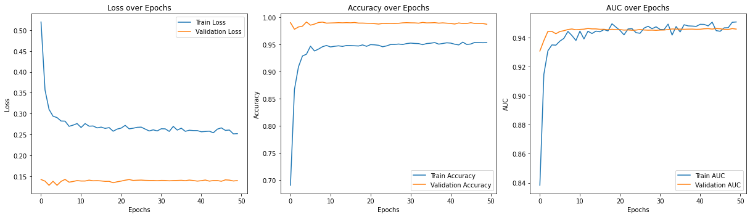

The model is learning and improving over time. It's performing well on both the data it was trained on and new, unseen data. There isn't a sign of overfitting.

**4. Next Steps**

* Address the class imbalance problem as outlined in the proposal's "Pre-processing challenges" section (e.g., using SMOTE) and evaluate the models on the SMOTE pre-processes data.
* Perform feature importance analysis to identify which features have more impact in classifying the Machine failure.