Project Title: Machine Failure Prediction

Final Report
Contributors: Neehanth Reddy Maramreddy (U00924209), Sandeep Rao Gandra (U00911593)

1. Introduction

1.1 Project Overview
Machine failure prediction is an important issue in industrial operations. Unexpected failures cause costly downtime, wasteful consumption of resources, and safety risks. This project employs machine learning (ML) to create a predictive model that can identify impending machine failures from historical sensor and operational data. The model will reduce unexpected outages and enhance maintenance schedules by enabling proactive maintenance.

1.2 Problem Statement
Traditional maintenance strategies, such as scheduled or reactive maintenance, are either inefficient or risky. Scheduled maintenance can lead to unnecessary part replacements and labor costs, while reactive maintenance results in unscheduled downtime and potentially catastrophic failures. The objective of this project is to develop a binary classification model that predicts whether a machine will fail (1) or not (0) in the near term, based on real-time and historical data inputs.

1.3 Objectives
- Develop and compare machine learning models for predicting machine failures.
- Identify and justify the most influential features contributing to failures.
- Provide actionable insights and recommendations for maintenance planning.
- Demonstrate the real-world value of predictive maintenance through cost, safety, and efficiency improvements.

2. Dataset Description

2.1 Data Sources
- Training set: 136,429 samples, 14 columns (features + target).
- Test set: 90,954 samples, 13 columns (features only).
- Source: Kaggle Playground Series S3E17.

2.2 Features
- Product ID: Unique identifier for each product.
- Type: Categorical variable indicating machine type (L, M, H).
- Air temperature [K], Process temperature [K]: Environmental and operational metrics.
- Rotational speed [rpm], Torque [Nm], Tool wear [min]: Key operational parameters.
- TWF, HDF, PWF, OSF, RNF: Binary indicators for specific failure modes.
- Machine failure: Target variable (0/1).

2.3 Data Exploration
Exploratory analysis revealed that the dataset is highly imbalanced, with only about 1.6% of samples labeled as failures. This justifies the need for specialized techniques to handle imbalance, such as resampling or cost-sensitive learning.
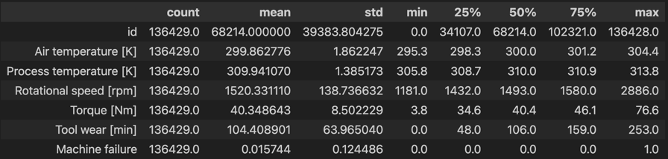
Statistical summaries and feature distributions indicate that operational parameters like tool wear and torque may have significant predictive value. Understanding these distributions is crucial for model selection and preprocessing decisions.

3. Exploratory Data Analysis
What proportion of machines malfunction, and what proportion do not?
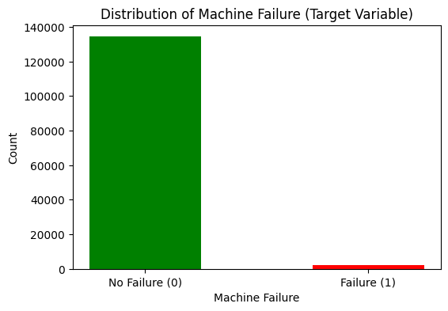
From the plot, about 134281 machines do not fail, and 2148 machines do fail, indicating there’s a huge class imbalance in the data.

How do different machine types compare in terms of failure rates?
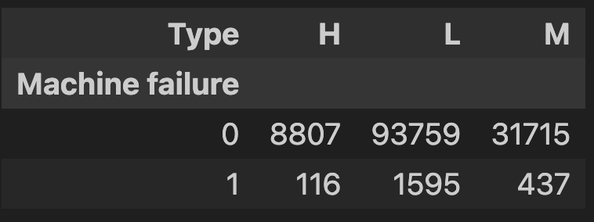
There are three different machine types:
- L = Low-performance machine
- M = Medium performance machine
- H = High-performance machine
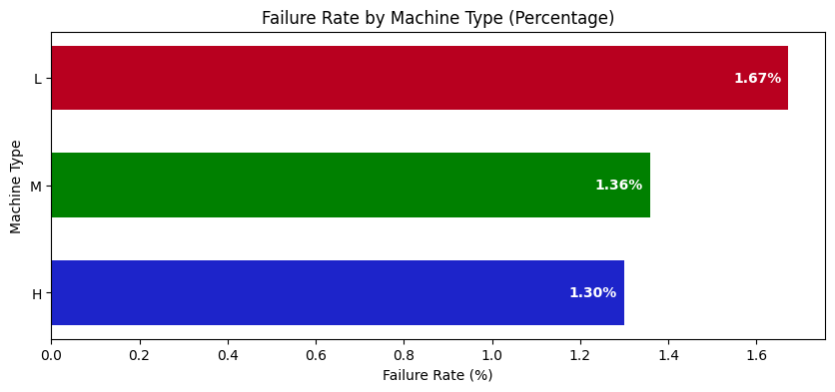
More failure rate is observed for the Machine Type `L` (1.67%) compared to `M` (1.36%) and `H` (1.30%).
Distribution of continuous features
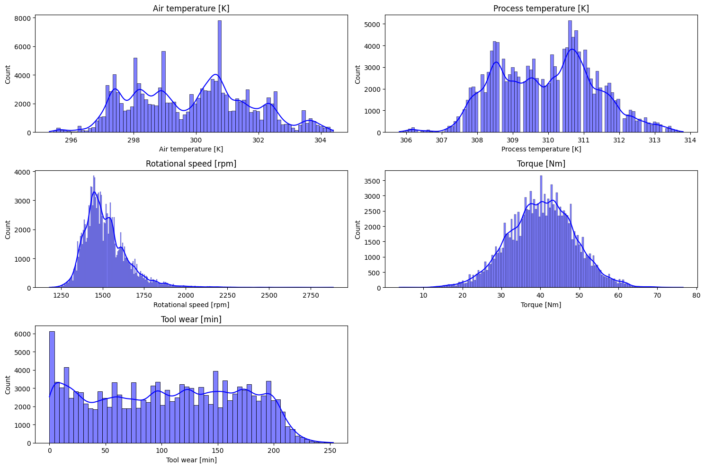
- Rotational speed [rpm] and Tool wear [min]: Distribution is highly skewed to the right, with a peak at low values and a tail extending towards higher values.
- Process temperature [K]: Distribution is somewhat Normal or Gaussian but with slight right skew.
- Torque [Nm]: Distribution appears to be normal or Gaussian.
- Air Temperature [K]: The features show a bimodal distribution, meaning it has two distinct peaks.
Outlier detection
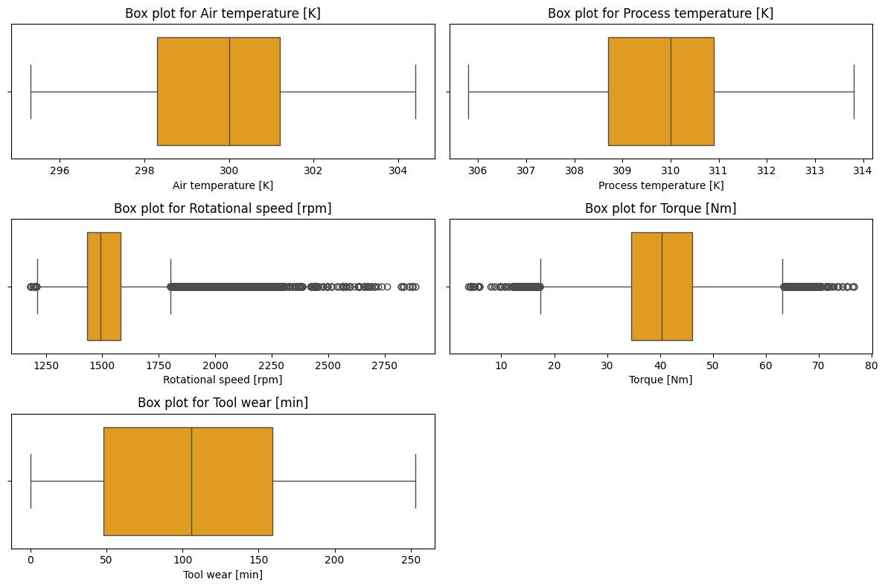
From the outlier analysis, `Rotational speed [rpm]` and `Torque [Nm]` were found to have outliers.
Which features are most correlated with the target variable?
Feature | Correlation
Machine failure | 1.000000
HDF | 0.611487
OSF | 0.492818
TWF | 0.346378
PWF | 0.202539
Torque [Nm] | 0.119524
Air temperature [K] | 0.070210
Tool wear [min] | 0.055379
Process temperature [K] | 0.033435
RNF | 0.003919
id | 0.000437
Rotational speed [rpm] | -0.110739

- `HDF` (Heat Dissipation Failure): Failure related to the machine's ability to dissipate heat.
- `OSF` (Overstrain Failure): Failures caused by excessive stress or strain on machine components.
- `PWF` (Power Failure): Failures related to the machine's power supply.
- `TWF` (Tool Wear Failure): Failures resulting from excessive wear and tear on tools or cutting implements used in the machine.
- `RNF`: Random failures
`HDF`, `OSF`, `PWF`, `TWF`: These features (likely representing specific failure modes or flags) show a moderate to strong positive correlation with "Machine failure." This means that when these features are present (or increase), the likelihood of machine failure also increases.
`Torque`, `Air temperature [K]`, `Tool wear [min]`, and `Process temperature [K]` have some influence, but it's relatively weak.
`Rotational speed [rpm]` has a very small effect on machine failure.
`id` and `RNF` have a negligible effect on machine failure.

4. Feature Engineering and Preprocessing
The data fed into the models is ensured to be clean and suitable for machine learning techniques through efficient pre-treatment. To minimize bias and maximize forecast accuracy, this step is essential.
- The 'Type' variable was encoded into dummies to allow ML models to interpret categorical information numerically, which is essential for algorithms that cannot handle non-numeric data directly.
- Split the train data into a training and validation set to train and evaluate the models for building robust and accurate machine learning models.
- Standardization of numerical features ensures that all features contribute equally to the model, preventing those with larger scales from dominating learning.
- Outliers in sensor readings and operational parameters were identified and addressed using the IQR (Inter Quantile Range) technique, as they can skew model training and reduce generalizability.

5. Model Development and Evaluation
Given the significant class imbalance and the importance of minimizing false negatives (i.e., undetected machine failures), multiple machine learning models were developed and rigorously evaluated. The objective was not only to achieve high overall accuracy but also to maximize the models’ ability to correctly identify the minority class (failures). Evaluation metrics were carefully chosen to reflect these priorities, focusing heavily on Area Under the Curve (AUC), precision, recall, and F1-score, in addition to accuracy.

Developed several machine classification models:
- Logistic Regression (baseline model): Chosen as a baseline due to its interpretability and efficiency for binary classification tasks. It provides a reference point for more complex models.
- Random Forest Classifier: Selected for its robustness to feature interactions, ability to capture non-linear relationships, and built-in feature importance estimation. Random Forests are also less sensitive to outliers and can handle imbalanced data better than simple linear models.
- MLP (Multi-Layer Perceptron): As a type of neural network, MLP was chosen for its capacity to model complex, non-linear patterns in the data. This is particularly valuable given the subtle signals and interactions that may precede machine failures.
Models like Logistic Regression and Random Forest were trained with class_weight='balanced' to automatically penalize misclassifications of the minority class more heavily.
For the neural network, calculate class weights to handle imbalance by assigning less weight to the high proportion class (0) and more weight to the lower proportion class (1).

6. Results & Discussion
Model | Train AUC | Val AUC | Train Accuracy | Val Accuracy | Precision (Class 1) | Recall (Class 1) | F1-Score (Class 1)
Logistic Regression | 0.935578 | 0.931097 | 0.973563 | 0.973397 | 0.28 | 0.79 | 0.42
Random Forest | 0. 981047 | 0.951609 | 0.985745 | 0.984242 | 0.42 | 0.77 | 0.54
Neural Network | 0.959775 | 0.942647 | 0.993408 | 0.993280 | 0.70 | 0.77 | 0.73

Neural Network is the best-performing model for this task, offering the highest precision and F1-score for failure detection while maintaining strong recall. This makes it highly suitable for real-world deployment, where both missed failures and false alarms must be minimized.
Random Forest provides a good trade-off between interpretability and predictive power.
Logistic Regression is useful as a baseline but is less effective for operational deployment due to its low precision.

Training and Validation Performance of Neural Network
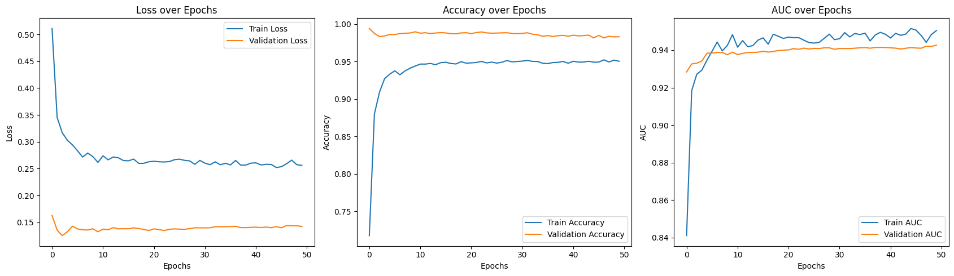
In the early epochs, both training and validation loss drop off quickly before levelling off at low values. The steady decline and stabilization of both losses indicate that the model is learning effectively and not overfitting. The validation loss remains consistently low and close to the training loss, suggesting good generalization to unseen data.
Accuracy for both training and validation sets quickly rises and stabilizes above 95%. High and stable accuracy on both sets indicates the model is consistently predicting the correct class for most samples. The close alignment between training and validation accuracy further suggests minimal overfitting.
AUC values for both training and validation sets increase rapidly and then stabilize above 0.94. High AUC values indicate the model is highly effective at distinguishing between failed and non-failed machines, even with class imbalance. The similarity between training and validation AUC curves confirms robust model performance and strong generalization.

7. Next Steps and Recommendations
Building on the strong results achieved by the neural network model, the following steps and recommendations are proposed to maximize the impact and sustainability of predictive maintenance in industrial operations:
- Address the class imbalance problem as outlined in the proposal's "Data Exploration" section (e.g., using SMOTE) by considering combining SMOTE with random undersampling of the majority and evaluating the models on the SMOTE pre-processed data.
- Explore One-Class SVM for Anomaly Detection by training One-Class SVM on Normal Data, detecting Anomalies as Potential Failures, and comparing its performance with supervised models trained on SMOTE-processed data.

8. Conclusion
Based on the comprehensive analysis and model development presented in this report, we demonstrated that machine learning, particularly neural networks, can effectively predict machine failures using operational and sensor data, even in the presence of significant class imbalance. The neural network model achieved the best balance of precision and recall for detecting rare failure events, making it highly suitable for real-world deployment. Moving forward, addressing class imbalance through advanced techniques like SMOTE and exploring unsupervised approaches such as One-Class SVM will further strengthen the predictive maintenance pipeline. Overall, this project highlights the substantial potential of data-driven approaches to reduce unplanned downtime, optimize maintenance schedules, and enhance the reliability and efficiency of industrial operations.

9. References
1. Kaggle Playground Series S3E17 Dataset
2. https://scikit-learn.org/stable/supervised_learning.html
3. https://keras.io/getting_started/
4. https://github.com/akashmailar/Tata-Steel-Machine-Failure-Prediction
5. https://learn.microsoft.com/en-us/fabric/data-science/predictive-maintenance
6. https://www.mercity.ai/blog-post/use-ai-for-predictive-maintenance
7. https://github.com/JMViJi/Binary-Classification-of-Machine-Failures

