**Project 2: Data Analysis with Visualization Software**

**Web Page to display insights of all the mentioned data sets.**

**Url :** <https://neehariko.github.io/Tableau/Project2.html>

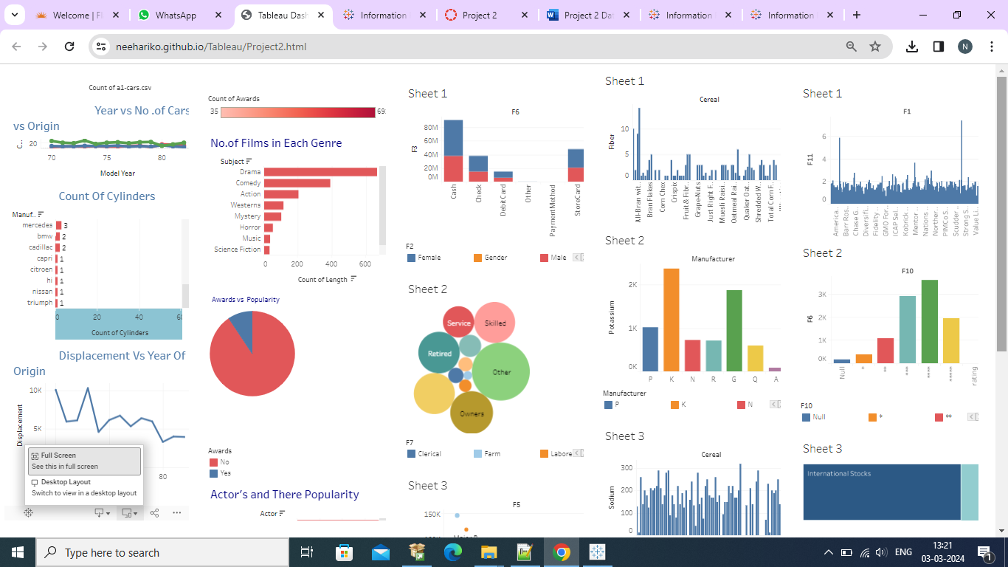

**Data Insight for the films data set is as follows: a1-films.csv**

* In the films data found the following insights which are difficult to identify normally, and tableau is useful to visualize the insights clearly.
* In this data set we can see that drama genre is bagging many no.of awards as compared to other genres
* Wayne Jhon, Eastwood Clint, Newman Paul are the top three actors with more popularity
* No.of Films produced each year increased drastically.

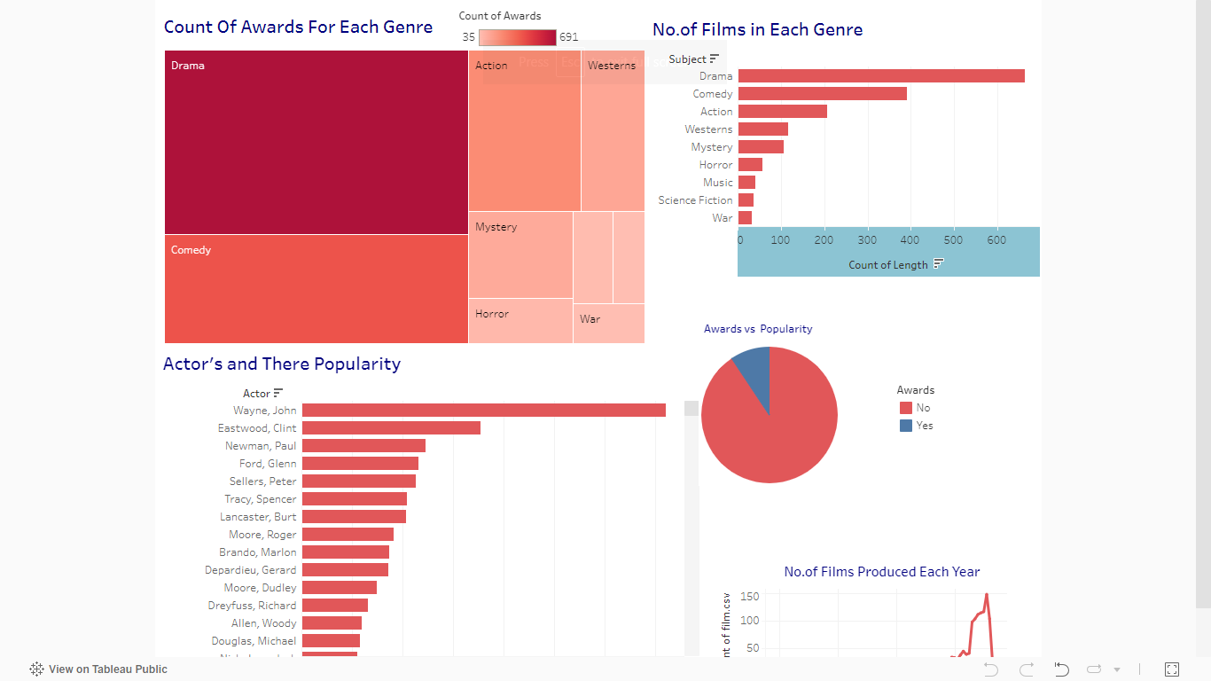

**Url :** <https://public.tableau.com/app/profile/neeharika.adella/viz/Films_17089082402840/Dashboard1>

**Data Insight for the films data set is as follows: a1-Cars.csv**

* Major share of car manufacturers is from America then next Europe and at last Japan
* Ford is the manufacturer who sold highest no.of cars over the years.
* Displacement or the distance these cars traveled reduced as the years passed.
* Car manufacturering was constant in European nations but it is reduced with us after the year 1974.

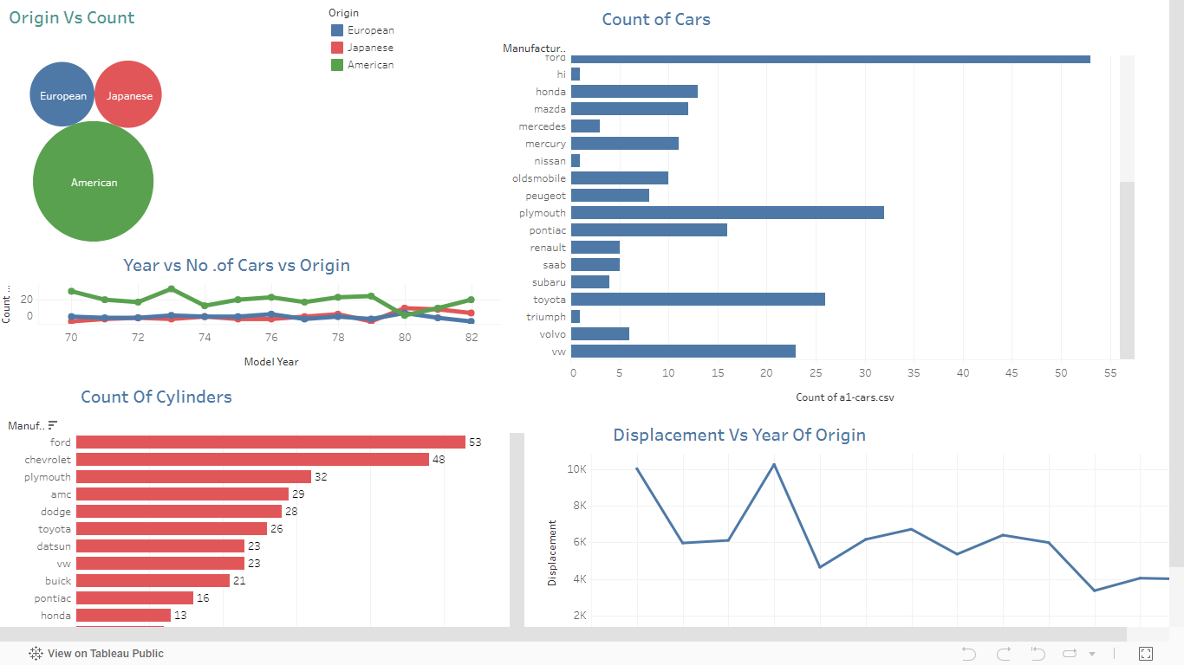

**Url:**

<https://public.tableau.com/views/InformationRelatedToCars/Dashboard1?:language=en-US&:sid=&:display_count=n&:origin=viz_share_link>