-TOEIC:
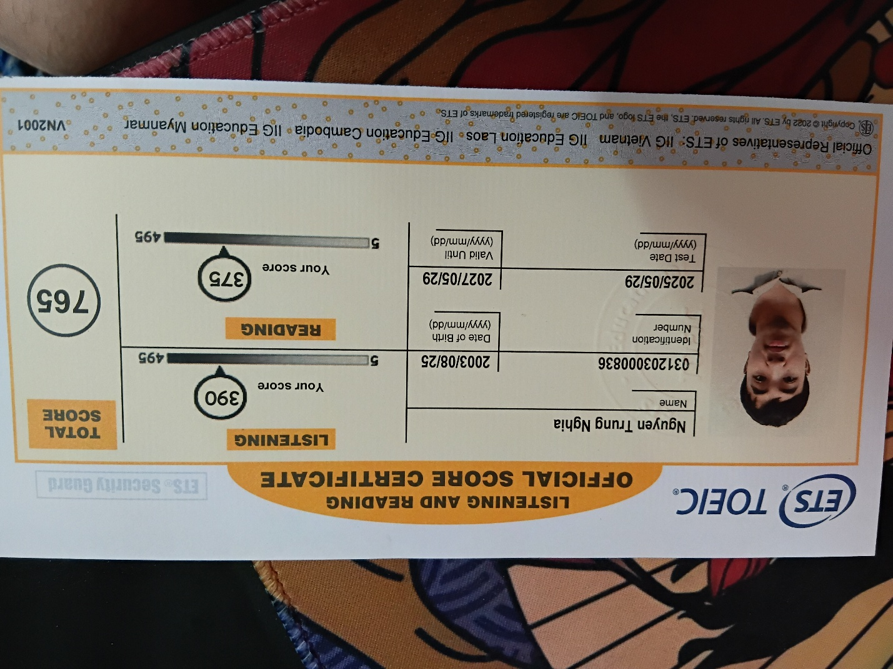
-OCP: https://catalog-education.oracle.com/ords/certview/sharebadge?id=FF09D9C66D42FFA03FE33B847A439A894895EE40E8BACFCF24891C23004D25C2
