# Chapter 1: An Introduction to Java

1.1 Java as a Programming Platform

-Java is whole **platform**, with a huge library, containing lots of reusable code, and an execution environment that provide services such as security, portability across operating systems, and automatic garbage collection

1.2 The Java “White Paper” Buzzwords

1.2.1 Simple

1.2.2 Object-Oriented

1.2.3 Distributed

1.2.4 Robust

1.2.5 Secure

1.2.6 Architecture-Neutral

1.2.7 Portable

1.2.8 Interpreted

1.2.9 High-Performance

1.2.10 Multithreaded

1.2.11 Dynamic

1.3 Java Applets and the Internet

-Java programs that work on web pages are called applets.

1.4 A Short History of Java

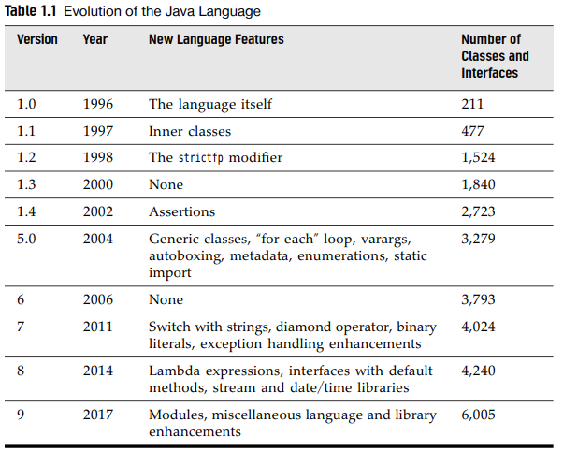

1.5 Common Misconception about Java

# Chapter 2: The Java Programming Environment

2.1 Installing the Java Development Kit

2.1.1 Downloading the JDK

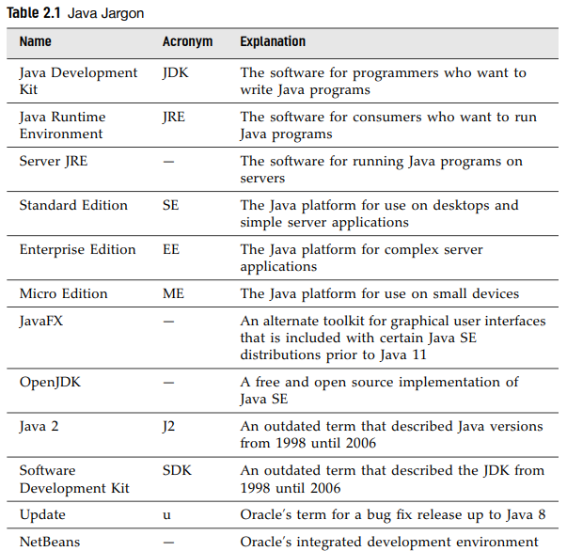

2.1.2 Setting up the JDK

2.1.3 Installing Source Files and Documentation

p22-23

2.2 Using the Command-Line Tools

Javac Welcome.java

java Welcome

2.3 Using an Integrated Development Environment

2.4 JShell

Get a list of all methods that you can invoke with the A class.