1. Introduction

1.1 A Brief History of Concurrency
-In ancient past, computers executed a single program from begin to end and that program direct access all resource of machine.
-OS: allow more one program to run at once, run individual programs in processes. (programs which OS allocates resources like memory, file handles…)
-In early time, each process was a virtual von Neumann computer: had a memory space storing instructions and data, execute instructions sequentially, interact with OS through set of I/O primitives.
-Threads: allow multiple streams of program control flow to coexist within a process. They share process-wide resources (memory, file handles…) but each thread has its own program counter, stack, local variables. Threads provide natural decomposition for exploiting hardware parallelism on multiprocessor systems , multiple threads within same program can be scheduled simultaneously on multiple CPUs
-Threads are called lightweight processes, most modern OS treat threads as the basic unit of scheduling.
-In the absence of explicit coordination, threads execute simultaneously and asynchronously with respect to one another.
-All threads within a process have access to same variables and allocate objects from same heap.
-Without explicit synchronization to coordinate access to shared data, thread may modify variables that another thread is in the middle of using.

1.2 Benefits of Threads
1.2.1 Exploiting Multiple Processors
-The basic unit of scheduling is thread, a program with only one thread can run at most one processor at a time. Programs with multiple active threads can execute simultaneously on multiple processors.
-Multiple threads also achieve better on single-processor systems. Another thread can still run while 1st thread is waiting for I/O to complete, allow app to make progress during blocking I/O
1.2.2 Simplicity of Modeling
-A complicated, asynchronous workflow can be decomposed into number of simpler, synchronous workflows each running in a separate thread, interact only with each other at specific synchronization points
-This benefit exploited by frameworks like servlet or RMI. Framework handles details of request management, thread creation, and load balancing, dispatching portions of request handling to appropriate application component at appropriate point in work-flow.
1.2.3 Simplified Handling of Asynchronous Events
-Server app that accepts socket connection from multiple remote clients may be easier to develop when each connection is allocated its own thread and allowed to use synchronous I/O
-If an app read from a socket when no data, read blocks until data available. If each request has is own thread, blocking doesn’t affect the processing of other requests.
-OS developed efficient facilities for multiplexed I/O: Unix select and poll system calls. Java libraries acquires packages (java.nio) for non-blocking I/O.
-OS support for larger numbers of threads has improved, making thread-per-client model practical.
1.2.4 More Responsive User Interfaces
-Modern GUI frameworks (AWT, Swing) use event dispatch thread. When a UI event occurs, event handlers are called in event thread. Most GUI frameworks are single-threaded subsystems, so main event loop is still present, but it runs in its own thread

1.3 Risks of Threads

1.3.1 Safety Hazards
-The ordering of operations in multiple threads is unpredictable.
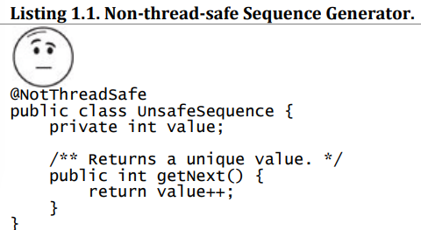
+This behaves correctly in single-threaded environment, but not in multithreaded.
+With some unlucky timing, 2 thread could call getNext() and receive the same value.
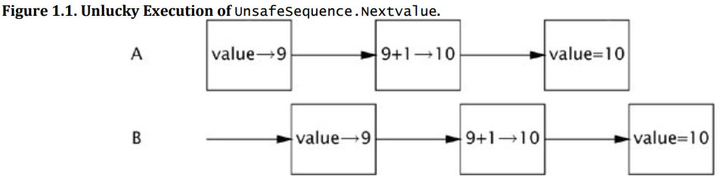
+This is a common currency hazard: race condition. nextvalue() called from multiple threads depends on how the runtime interleaves the operations.
-Threads share same memory address spaces and run concurrently->they can access or modify variables that other threads might be using, make them confused by having data change unexpectedly.
-Access to shared variables must be coordinated so that threads don’t interfere with one another -> Java provides synchronization mechanisms.
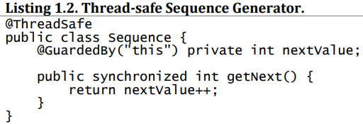

1.3.2 Liveness Hazards
-While safety means “nothing bad ever happens”, liveness concerns “something good eventually happends”
-Liveness failure occurs when an activity gets into a status such that it’s permanently unable to make forward progress (deadlock, livelock, starvation).
+Example: sequential programs in an infinite loop, where the code that follows the loop never gets executed.
+Example: thread A waiting resources that thread B holds, B never releases it, A waits forever.
-Like most concurrency bugs, bugs causing liveness failures can be elusive as they depend on relative timing of event in different threads, so don’t always manifest themselves in development or testing.

1.3.3 Performance Hazards
-Related to liveness, we often want good things to happen quickly.
-Context switches: scheduler suspends the active thread temporarily so another thread can run. They have significant costs: save and restore execution context, loss locality, CPU time spent scheduling threads instead of running them.
-When threads share data, must use synchronization mechanisms to inhibit compiler optimization, flush or invalidate memory caches, create synchronization traffic on shared memory bus.

1.4 Threads are Everywhere
-Frameworks may create threads on your behalf, and code called from these threads must be thread-safe.
-Every Java app uses threads. When JVM starts, it creates threads for JVM housekeeping tasks (garbage collection, finalization) and a main thread for running main(). AWT and Swing UI frameworks create threads for managing UI events. Timer creates threads for executing deferred tasks. Component frameworks (servlets, RMI) create pools of threads and invoke component methods in these threads.
-Servlets and JSPs: servlets framework is designed to handle all infrastructure of deploying web app and dispatching request from remote HTTP clients. A request arriving at server is dispatched, perhaps through a chain of filter, to appropriate servlet or JSP. Each servlet represents a component of app logic, and in high-volume web sites, multiple clients may require the services of same servlet at once. The servlets specification requires that a servlet be prepared to be called simultaneously from multiple threads. -> thread-safe.

