Part I: Fundamentals

Chapter 2: Thread Safety
-Writing thread-safe code is about managing access to state, and in particular to shared, mutable state.
-Shared: a variable could be accessed by multiple threads, Mutable: its value could change during its lifetime.
-When more than one thread accesses a given state variable, one of them might write to it, they all must coordinate their access to it using synchronization. The primary mechanism for it is synchronized keyword, which providing exclusive locking. But the term also includes: volatile variables, explicit lock, atomic variables.
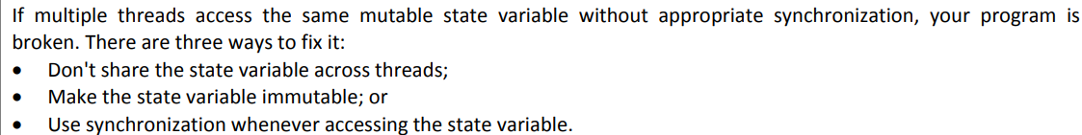
-Thread-safe class make sense only if class encapsulates its own state.

2.1 What is Thread Safety
-The heart of any reasonable definition of thread safety is concept of correctness.
-Correctness: a class conforms to its specification. A good specification defines invariants constraining an object’s state and post-conditions describing the effects of its operations. Let assume that single-threaded correctness is “we know it when we see it”
-Any single-threaded program is also a valid multithreaded, it can’t be thread-safe if it isn’t current in single-thread environment.
-If an object is correctly implemented, no sequence of operations-calls to public methods or reads or writes of public fields-should be able to violate any its invariants or post-conditions.
-Frameworks create threads and call components from those threads, leaving you to make components thread-safe. Very often, thread-safety requirements stem not from a decision to use thread directly but from a decision to use a facility like Servlets framework.
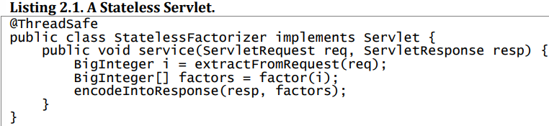
-Most servlets are stateless: It has no fields and references no fields from other classes. The transient state for a particular computation exists in local variables that are stored on thread’s stack and are accessible only to executing thread. Since actions of thread accessing stateless object can’t affect the correctness of operations in other threads, stateless objects are thread-safe.
-Issue: servlets want to remember things from one request to another.

2.2 Atomicity
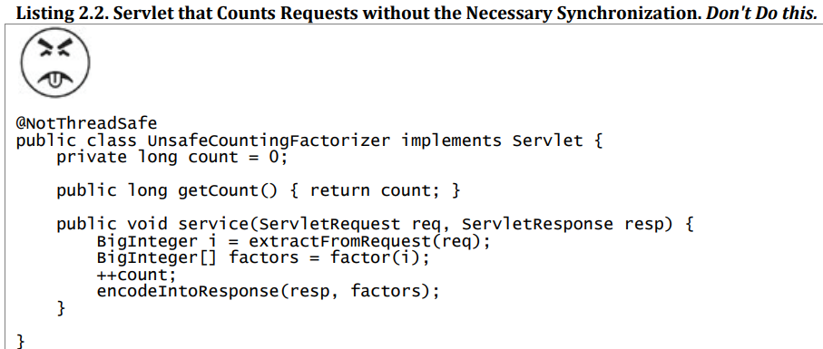
+ ++count isn’t atomic: execute as a single, indivisible operation. It’s shorthand for a sequence of 3 discrete operations: fetch current value, add one, write new value back.
->Race condition: the possibility of incorrect results in the presence of unlucky timing in concurrent programming.

2.2.1 Race Conditions
-Occurs when the correctness of a computation depends on relative timing or interleaving of multiple threads by runtime. In other words: getting the right answer relies on lucky timing.
-The most common type of race condition is check-then-act: a potentially stale observation is used to make a decision on what to do next.

2.2.2 Example: Race Conditions in Lazy Initialization
-A common idiom using check-then-act is lazy initialization: defer initializing an object until it’s actually needed and ensure it’s initialized once.
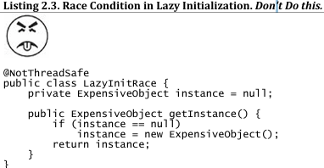
+getInstance() 1st checks if ExpensiveObject has already been initialized, otherwise it creates a new instance, so that future invocations can avoid more expensive code path.
-Race conditions example: threads A and B execute at the same time,
+A sees instance is null, and instantiates new object. +B also check instance depends on timing including the vagaries of scheduling and how long A takes to instantiate object and set instance field. If instance is null when B examines, the 2 callers to getInstance() may receive 2 different results.
-Race conditions don’t always result in failure, they can cause serious problems: lost registrations, multiple activities have inconsistent views. Generate entity identifiers: 2 objects could end up with same ID, violate identity integrity constraints.

2.2.3 Compound Actions
-To avoid race conditions, prevent other threads from using a variable while modifying it, ensure other threads can observe or modify state only before we start of after we finish, not in the middle.
-To ensure thread safety, check-then-act and read-modify-write operations must always be atomic.
->compound actions: sequences of operations must be executed atomically to remain thread-safe.
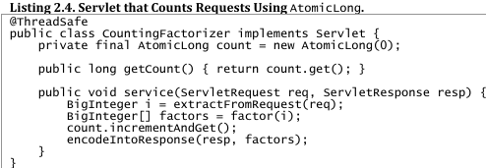
+atomic package contains atomic variable classes for atomic state transitions on numbers and object references.
+AtomicLong: ensure all actions accessing counter state are atomic.

2.3 Locking
-When we want to add more state to servlet, can we just add more thread-safe state variables?
+Example: caching the most recently computed result: the last number factored and its factors
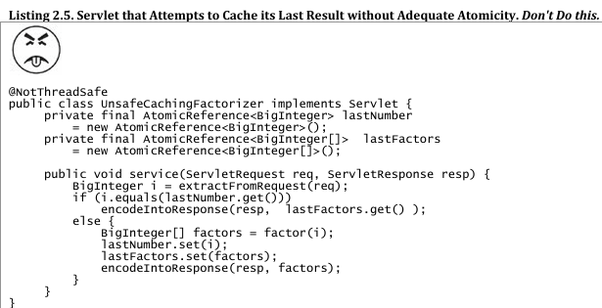
+Using atomic references, we can’t update lastNumber and lastFactors simultaneously even though each call to set is atomic, there is still a time when one has been modified and the other are not.

2.3.1 Intrinsic Locks
-Java provides a built-in locking mechanism for enforcing atomicity: synchronized block.
-Synchronized block has 2 parts: a reference to an object that will serve as the lock, a block of code to be guarded by that lock.
-Synchronized method is shorthand for a synchronized block that spans an entire method body, whose lock is object on which method is being invoked (static synchronized methods use Class object for the lock)
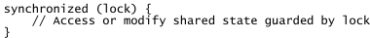
-Every Java object can implicitly act as a lock for purposes of synchronization, these built-in locks are called intrinsic locks/monitor locks. The lock is automatically acquired by executing thread before entering a synchronized block and automatically released when control exists synchronized block (whether by normal control path or throw exception). The only way to acquire intrinsic lock is to enter synchronized block or method.
-Intrinsic locks act as mutexes (mutual exclusion locks): at most one thread may own the lock.
-> Synchronized blocks guarded by the same lock execute atomically with respect to one another. No thread executing a synchronized block can observe another thread to be in middle of synchronized block guarded by the same lock.
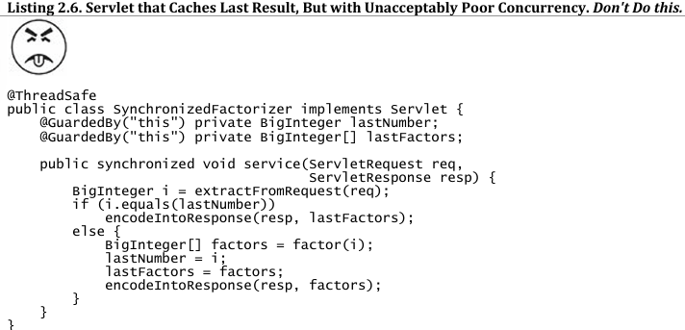
+This class is now thread-safe, but fairly extreme. Since it inhibits multiple clients from using servlet simultaneously ->performance problem.

2.3.2 Reentrancy
-When a thread requests a lock that is already held by another thread, the requesting thread blocks.
-Intrinsic locks are reentrant, so if a thread tries to acquire a lock that it already holds, the request succeeds. Reentrancy: locks are acquired on a per-thread rather than per-invocation basic.
-Each lock has an acquisition count and an owning thread. When count=0, the lock is unheld. When a thread acquire a previously unheld lock, JVM records the owner and sets count=1. If same thread acquires the lock again, count+1 then when owning thread exits synchronized block, coun-1. When count=0, lock is released.
-> Reentrancy facilities encapsulation of locking behavior, simplifies the development of object-oriented concurrent code.
+If without deadlock -> deadlock
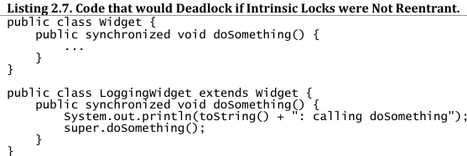

2.4 Guarding State with Locks
-Locks enable serialized access to code paths they guard, we can use them to construct protocols to guarantee exclusive access to shared state. Following these protocols consistently can ensure state consistency.
-Compound actions on shared state (read-modify-write or check-then-act) must be made atomic to avoid race conditions. Holding a lock for entire duration of compound action can make that compound action atomic.
-There is no inherent relationship between object’s intrinsic lock and its state. Acquiring the lock associated with an object doesn’t prevent other threads from accessing that object – The only way is acquiring that same lock.
-Every object has a built-in lock, you needn’t create lock objects. You need to construct locking protocols or synchronization policies that let you access shared state safely, and use them consistently throughout your program.
-A common locking convention is to encapsulate all mutable state within an object and protect it from concurrent access: synchronize any code that access mutable state using object’s intrinsic lock. This pattern used by many thread-safe classes (Vector, synchronized collection classes).
+In such cases, all variables in object’s state are guarded by object’s intrinsic lock. It’s also easy to subvert this locking protocol by adding new method or code path and forgetting to use synchronization.
-When a variable is guarded by a lock, you’ve ensured that only one thread at a time can access that variable. When a class has invariants that involve more than one state variable, there is additional requirement: each variable participating in the invariant must be guarded by the same lock. This allows to access or update them in single atomic operation, preserving invariant.
-Why not just declare every method synchronized: It isn’t enough to render compound actions on a Vector atomic:
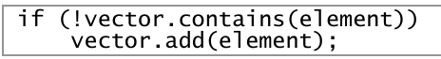
+Synchronized methods make individual operations atomic, locking is required-when multiple operations are combined into a compound action.
+Also, synchronizing every method can lead to liveness or performance problems.

2.5 Liveness and Performance
- In UnsafeCachingFactorizer example, synchronization makes it perform badly.
+service method is synchronized, only one thread execute it at once, this subverts the use of servlet framework: handle multiple requests simultaneously
-Example: multiple requests arrive for synchronized factoring servlet
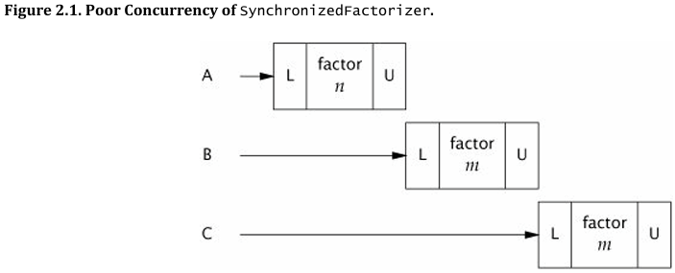
+Try to exclude from synchronized block long-running operations that don’t affect shared state, so that other thread aren’t prevented from accessing shared state while long-running operation is in progress.
+We restructure the servlet to use 2 separate synchronized blocks: One guards the check-then-act and other guards updating both factors. The portions of code outside operates on local (stack-based) variables which aren’t shared across threads.
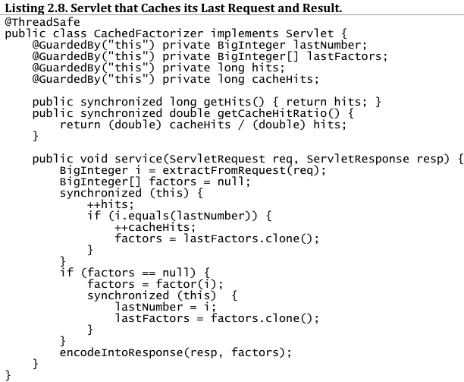
+We can use atomic, but using 2 different synchronization mechanisms would be confusing and would offer no performance or safety benefit.
-Deciding how big or small to make synchronized blocks may require tradeoffs among competing design forces: safety (not be compromised), simplicity and performance. Sometimes simplicity and performance are at odds with each other.
-Whenever using locking, should be aware of what the code in the blocking is doing and how likely it is to take a long time to execute. Holding a lock for a long time -> risk of liveness or performance problems.

Chapter 3: Sharing Objects
-Chap 2 about using synchronization to prevent multiple threads from accessing same data at same time. Chap 3 will examine techniques for sharing and publishing objects so they can be safely accessed by multiple threads
-> Together they lay the foundation for building thread-safe classes and safely structuring concurrent apps
-Synchronization: not only atomicity, demarcate “critical sections”, but also memory visibility: when a thread modifies the object state, other threads can see the changes that were made.

3.1 Visibility
-Visibility is subtle (not obvious) because the things that can go wrong are unexpected
+Single-threaded: write a value to variable, then read that variable with no intervening writes, you can expect to get the same value.
+Different threads: There is not guarantee that reading thread will see a value written by another thread on a timely basis, or even at all.
-> To ensure visibility of memory writes across threads, must use synchronization.
-Example: threads share data without synchronization
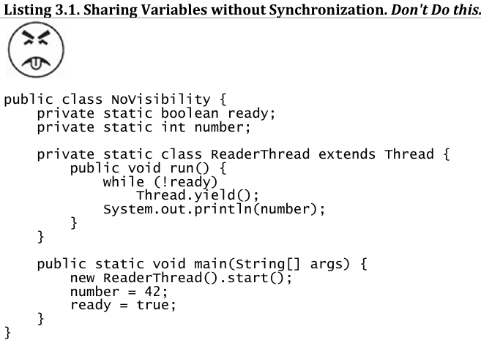
+Example could loop forever because the value of ready might never become visible to reader thread. Or It could print 0 because the write to ready might be made visible to reader thread before write to number.
-> Reordering: There is no guarantee that operations in one thread will be performed in the order given by program, as long as the reordering is not detectable from within that thread – even if the reordering is apparent to other threads.
-To avoid these complex issues: always use synchronization whenever data is shared across threads.

3.1.1 Stale Data
-Example above can cause stale data: When the reader thread examines unsynchronized variable, it may see an out-of-date value.
+Staleness is not all-or-nothing: a thread can see an up-to-date of one variable but a stale value of another variable that was written first.
-Stale values can cause safety or liveness failure. In object reference (link pointers in linked list implementation), stale data can cause failures like unexpected exceptions, corrupted data structures, inaccurate computations, infinite loops.
-Example: Non-thread-safe mutable integer:
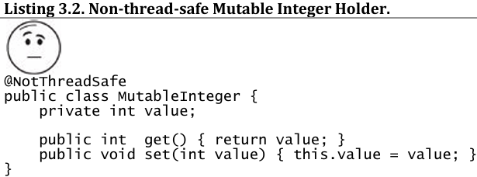

+Stale value: if one thread calls set(), other threads calling get() may or may not see that update.
+Synchronizing getter and setter:
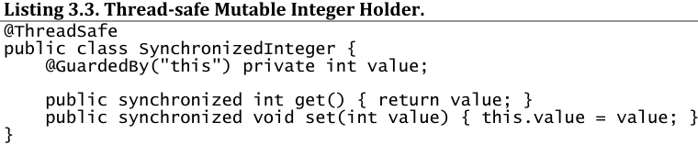
+Synchronizing only setter would not be sufficient: threads calling get would still be able to see stale values.

3.1.2 Non-atomic 64-bit Operations
-out-of-thin-air safety: thread reads a variable without synchronization, it may see a stale value, but at least it sees a value that was actually placed there by some thread rather than some random value.
-This safety applies to all variables but not 64-bit numeric variables (double, long) that aren’t volatile.
+Java Memory Model treats 64-bit read or write as 2 separate 32-bit operations. If reads and writes occur in different threads, it’s possible to read a nonvolatile long and get back the high 32 bits of one value and the low 32 bits of another.

3.1.3 Locking and Visibility
- Intrinsic locking guarantee that one thread sees the effects of another in a predictable manner.
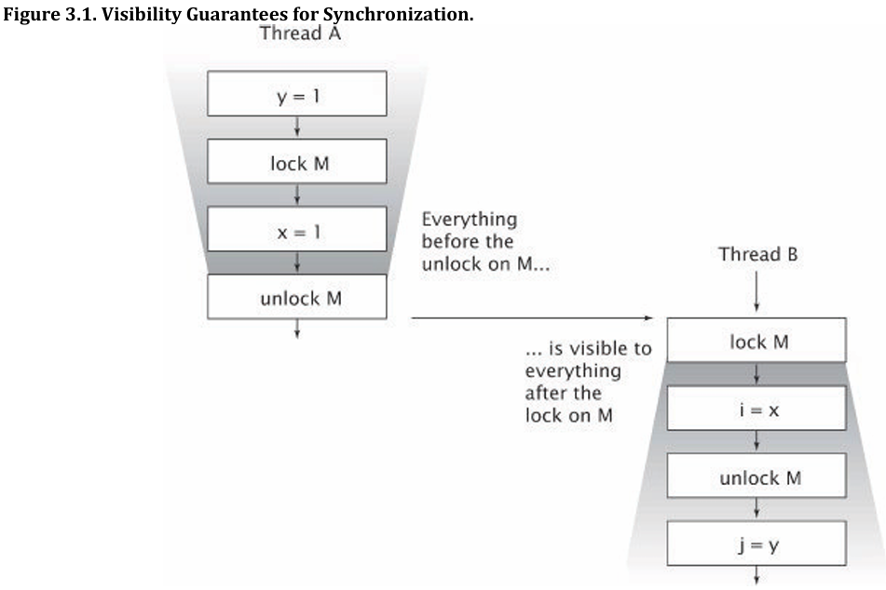
+Everything A did in or prior to a synchronized block is visible to B when it executes a synchronized block guarded by the same lock.

3.1.4 Volatile Variables
-volatile variable: ensure that updates to a variable are propagated predictably to other threads.

3.2 Publication and Escape

3.3 Thread Confinement

3.4 Immutability

3.5 Safe Publication

