New features in JDK 17

13.1 Sealed class
-Sealed classes and interfaces: restrict which other classes or interfaces may extend or implement them.
-Declare:
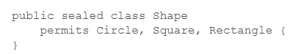
+The permitted subclasses are in the same module or in the same package.
+You can define permitted subclasses in the same file, then you can omit permits:
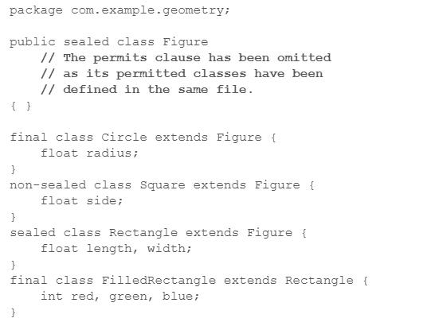
-Permitted subclasses:
+Must extend the sealed class.
+Must be one of:
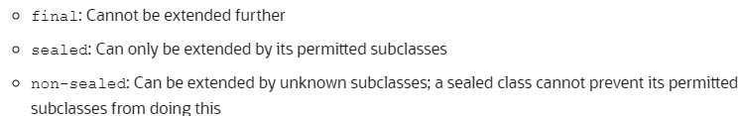
+Must be in the same module or same package.
-Sealed interface: specifies classes and interfaces that can extend and implement
-Record classes as permitted subclasses of a sealed interface: record is final
-java.lang.Class methods:
permittedSubClasses()
isSealed()

13.2 Record
https://www.baeldung.com/java-record-keyword
13.2.1 Purpose
-We write classes to hold data (database result, query result, information from a service), this data is immutable.
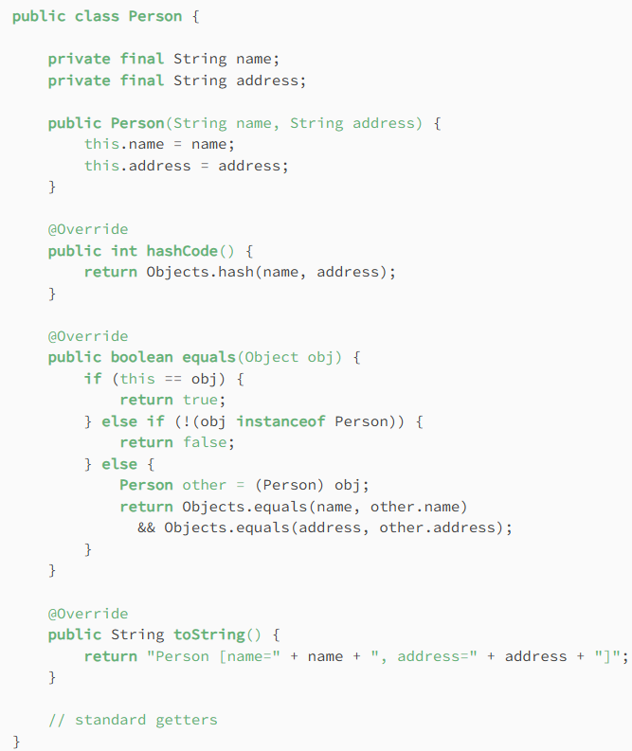
+There’s lots of boilerplate code.
+Obscure the purpose of the class
13.2.2 The basics
-JDK 14: Records are immutable data classes that requires only the type and name of fields. final equals(), final hashCode(), final toString(), private, final fields and constructor are generated by Java compiler.
-The equivalent constructor:
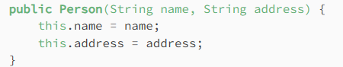
+Instantiate objects from record:
-The equivalent getters (Note: name of getter = name of instance fields, example: name()), equals (true if objects of same type and values match), hashCode (return same value for 2 objects if all field values match), toString(name of record+field names+field values)
-Record can’t be extended and can’t have extend clause.
-Record can implement Serializable interface
-Record may have at most 1 varagrs component.
    - Constructors
-Canonical constructor:
+We can customize constructor for validation: (compact form)
+Example: fields aren’t null
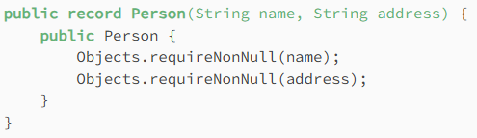
+Creating a constructor with same arguments as the generated public constructor is valid, but each field is manually initialized: regular form canonical constructor
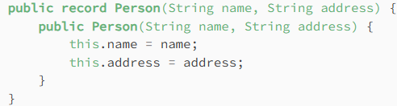

Or public Journal {id=id+1}
-Non-canonical constructor: Create new constructors with different arguments by supplying either a canonical constructor or another constructor:
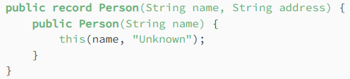
-Error when declare 2 canonical constructors:
+Example: compact form + regular form
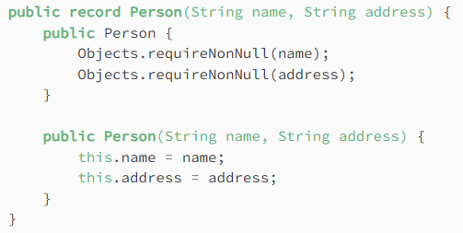
13.2.4 Static variables and methods
-We can use static variables and static (and instance, not setter) methods in record
