Chapter 3: Fundamental Programming Structures in Java

3.1 A Simple Java Program
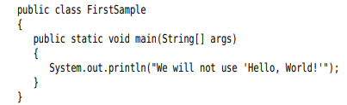
public: access modifier
class: a container for the program logic that defines the behavior of an application. Everything in a Java program must be inside a class.
You need to make the file name for the source code the same as the name of the public class.
System.out.println(): using the System.out object and calling println method
Object.method(parameters)
-Note:
docs.oracle.com/javase/specs: Java Language Specification
bugs.java.com/bugdatabase/index.jsp: find a bug

3.2 Comments
//
/* */
Generate documentation automatically:
/**
* This is…
* @version 1. 2023-…
* @author …
*/

3.3 Data Types
-Java is a strongly typed language. Every variable must have a declared type.
-Java has 8 primitive types.
3.3.1 Integer Types
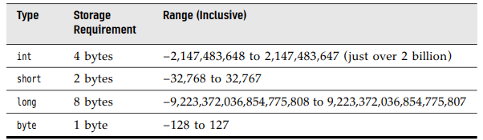
3.3.2 Floating-Point Types
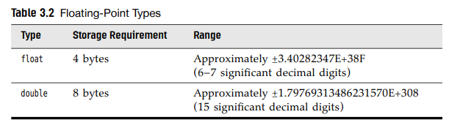
-There are 3 special floating-point values to denote overflows and errors: Positive infinity, Negative infinity, NaN (Not a Number)
-Floating-point numbers are not suitable for financial calculations.
3.3.3 The char Type
-it is used to describe individual characters.
- ‘A’ is different form “A”
-Values of type char can be expressed as hexadecimal values: \u0000 to \uFFFF
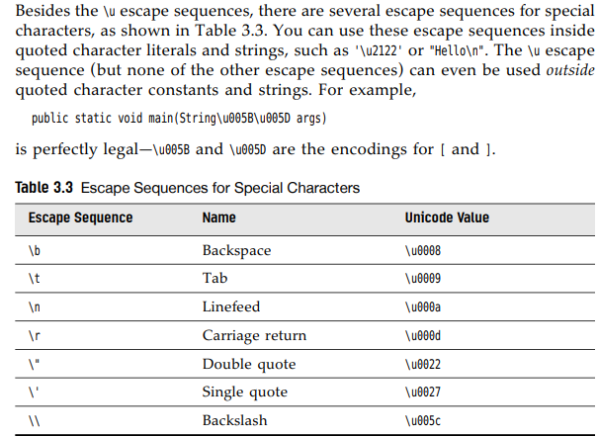
3.3.4 Unicode and the char Type
-Encoding schemes before Unicode (ASCII, ISO 8859…) had 2 problems: a particular code value corresponds to different letters in different encoding schemes, and the encoding for large character sets have variable length
-> Unicode was invented to overcome the limitations of traditional character encoding schemes.
-Unicode have 17 code planes: basic multilingual plane and supplementary characters.
-In Java, the char type describes a code unit in the UTF-16 encoding
-Our strong recommendation is not to use char type in programs unless you are actually manipulating UTF-16 code units.
3.3.5 The Boolean Type
-The Boolean type has two values: false and true.
-It is used for evaluating logical conditions.

3.4 Variables and Constants
3.4.1 Declaring Variables
int i ,j; //not recommend
3.4.2 Initializing Variables
int vacationDays;
vacationDays = 12;
-We can both declare and initialize a variable on the same line
-We can put declaration anywhere.
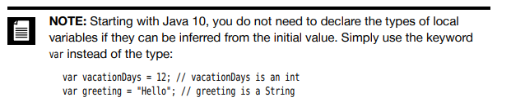
3.4.3 Constants
-You use the keyword final to denote a constant.
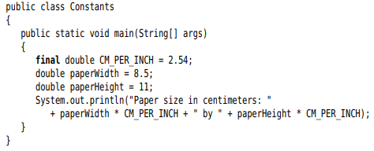
-To create a constant to multiple methods inside a single class.-> class constants, use static final. So the constant can be used in other methods of the same class.
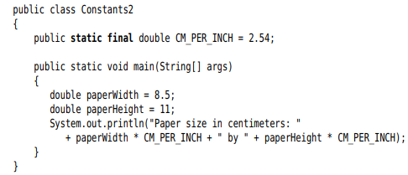

3.4.4 Enumerated Types
-Sometimes a variable should only hold a restricted set of values. -> use enumerated type
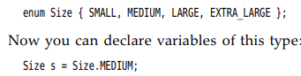

3.5 Operators
3.5.1 Arithmetic Operators
-Addition+, subtraction-, multiplication*, division/, integer remainder %
-Note: integer / 0 =exception, floating / 0 = NaN or infinite
3.5.2 Mathematical Functions and Constants
-The Math class contains an assortment of mathematical functions.
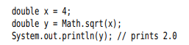
+Note: println method operates on System.out object. But sqrt in Math class does not operate on any object
->static method
-The power:
-The floorMod() with integer remainder
-The usual trigonometric functions:
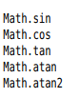
-The exponential, the natural logarithm, decimal logarithm: 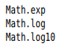
-2 constants : 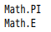
-You can avoid the Math prefix by import:
3.5.3 Conversions between Numeric Types
-The legal conversion:
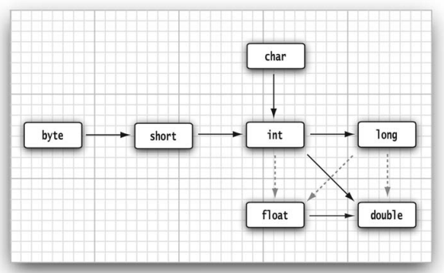
3.5.4 Casts
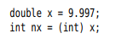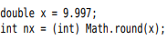
Note: boolean->number:
3.5.5 Combining Assignment with Operators
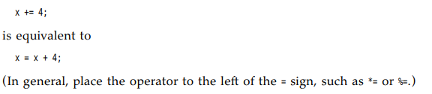
3.5.6 Increment and Decrement Operators
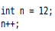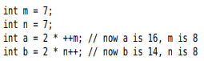
3.5.7 Relational and boolean Operators
- ==, !=, <, &&, ||..
-The ternary ?: 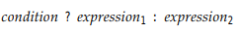

3.5.8 Bitwise Operators
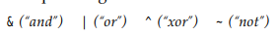

3.5.9 Parentheses and Operator Hierarchy
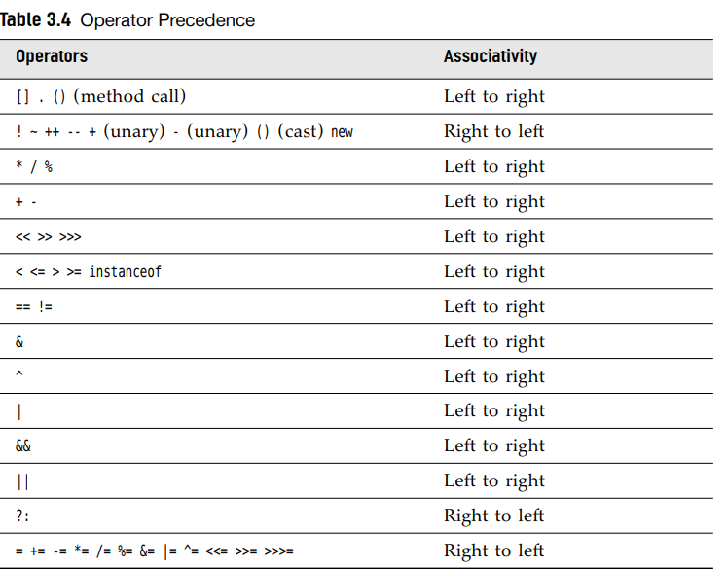

3.6 String
-Java strings are sequences of Unicode characters.
-Java does not have a built-in string type. It contains a predefined class String.
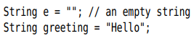
3.6.1 Substrings
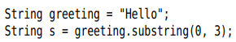
3.6.2 Concatenation
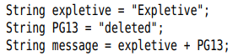
-string+ (value is not string) => convert to string
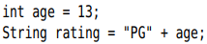
-join method:
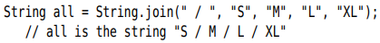
-repeat method:
3.6.3 Strings are Immutable
-Can not directly change a string. Modify by concatenating the substring:
3.6.4 Testing Strings for Equality
-equal method: 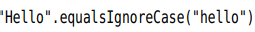
- == operator only determines whether the strings are stored in the same location
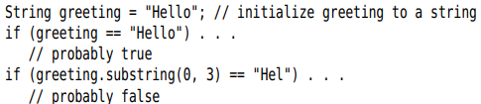
3.6.5 Empty and Null Strings
-The empty string “” is a string of length 0.
Test an empty: 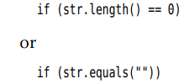
-Null indicates no object is associated with the variable.
-Test an empty and null:
3.6.6 Code Points and Code Units
-Java strings are sequences of char values.
-The char data type is a code unit for representing Unicode code points in UTF-16 encoding.
-Get the number of code points:
-charAt method:
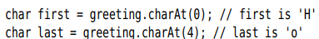
-Get the code point:
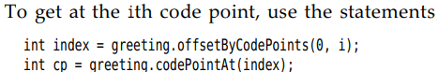
-Look at each code point:
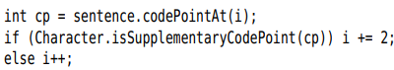
Or
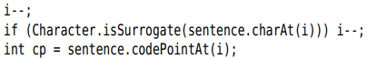
-Another way is use codePoints method
-Turn an array of code points to a string, use a constructor:
3.6.7 The String API
Pages 69,70
3.6.8 Reading the Online API Documentation
https://docs.oracle.com/en/java/javase/11/docs/api
-Local: jdk-11-docs/index.html
3.6.9 Building Strings
-Build a string from many small pieces:
+Construct an empty string builder:
+Add another part by append
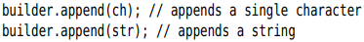
+toString method:
-API notes: p. 74,75

3.7 Input and Output
3.7.1 Reading Input
-Print output to “standard output stream”(console window) by System.out.println()
-Read from “standard input stream” System.in:
+Construct a Scanner that is attached to System.in
+Use methods of Scanner to read input:
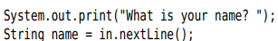
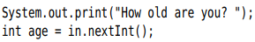
-The Scanner class is defined in java.util package
-Console class read a password:
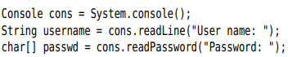
3.7.2 Formatting Output
-printf method:
-Format specifiers starts with %. Conversion character indicates the type of value to be formatted
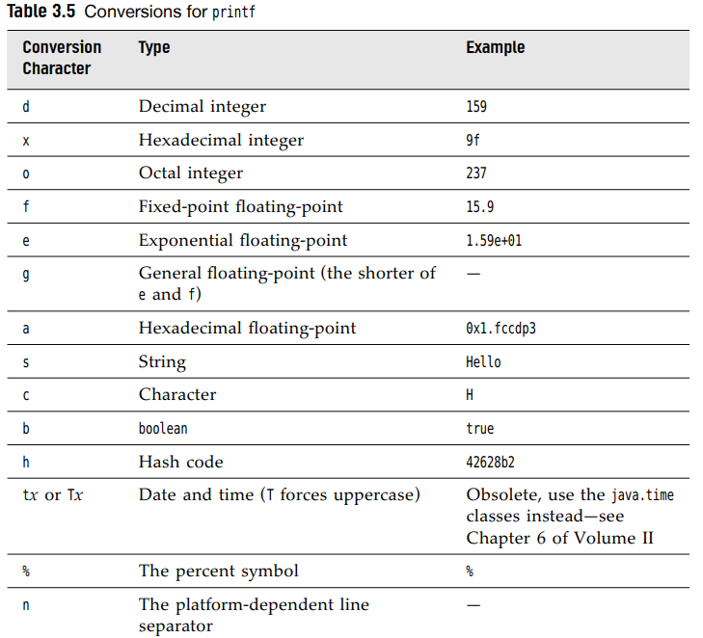
-Flags control the appearance of formatted output:
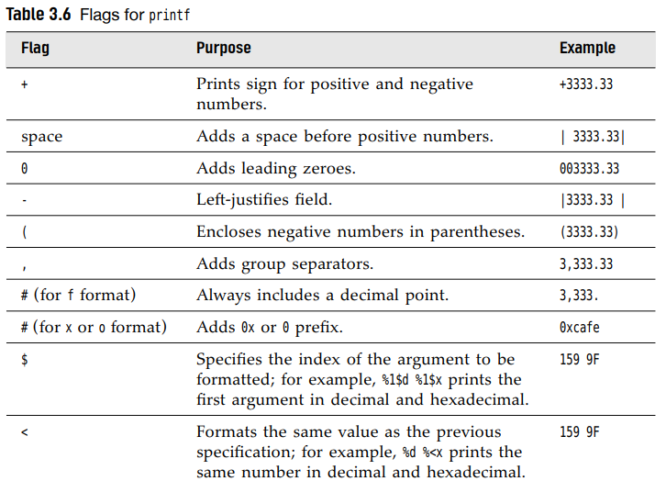
-You can use static String.format method:
-Date and time formatting:
+Format consists of 2 letters: t + (letter in table):
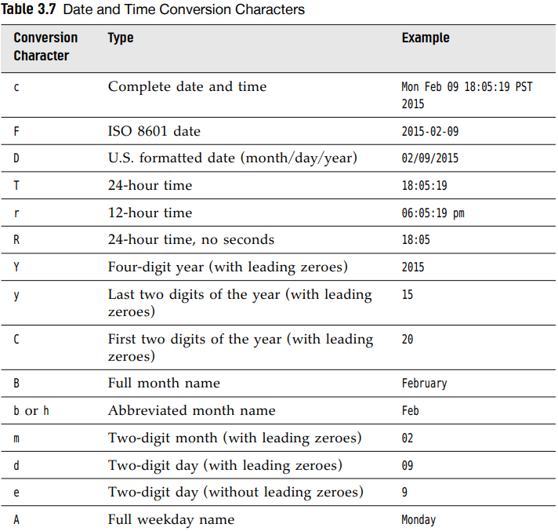
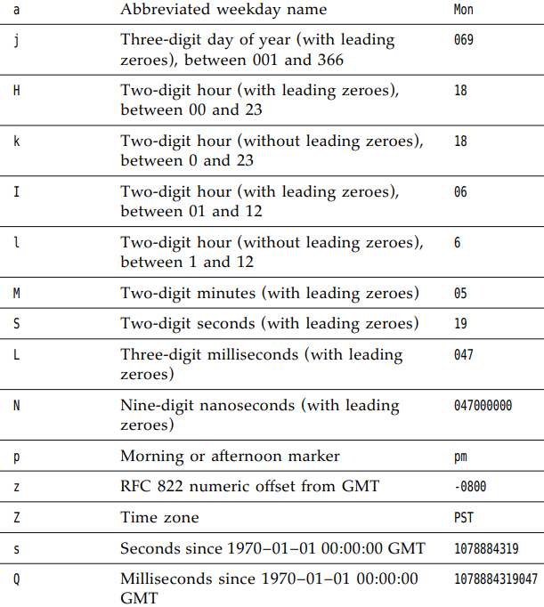
-Format string can indicate the index of argument: %+index+$
Or use < flag:
+Note: Argument index values start with 1.
-Syntax diagram for format specifiers:
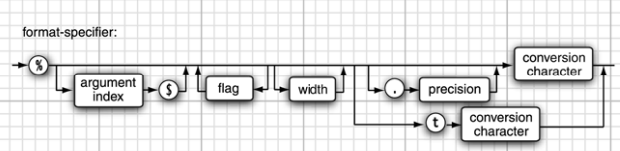
3.7.3 File Input and Output
-Read from a file:
-Write to a file, construct a PrintWriter object
+If file does not exit, it is created. You can use print, println, printf
-Note: Scanner interprets input as data, not a file name:
-Note: When specify a relative file name, the file is located relative to the directory in which the Java VM was started
+Find the directory location:
-API note: 85, 86

3.8 Control Flow

3.8.1 Block Scope
-Block: consists of Java statements, surrounded by a pair of braces.

3.8.2 Conditional Statements

3.8.3 Loops

3.8.4 Determinate Loops

3.8.5 Multiple Selections The switch Statement

3.8.6 Statements that break Control Flow

-break: exit a switch and break out of a loop.
-label and break: break out of all nested loops
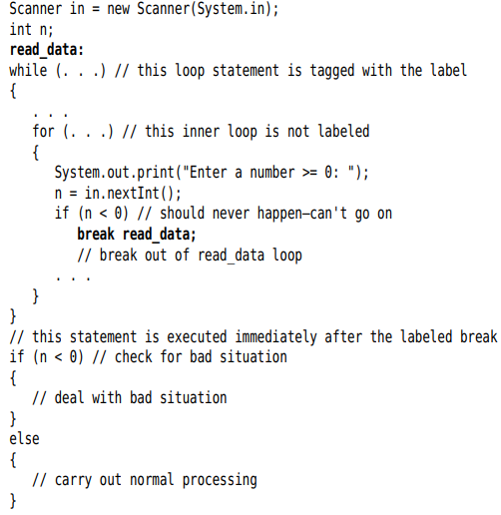
-continue: transfer control to the header of innermost enclosing loop

3.9 Big Numbers
-valueOf:
-For longer numbers, use constructor with a string:
-Constants: BigInteger.ZERO, ONE, TWO, TWEN…
-Cannot use operators. Use methods: add, multiply
-Note: Java has no programmable operator overloading
-API: p107

3.10 Arrays

3.10.1 Declaring Arrays
-Array is a data structure that stores a collection of values of the same type.
-Declare:
-Use new to declare and initialize
-Note: Define array variable:
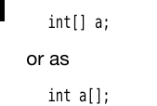
-Shortcut for creating and supplying initial values:
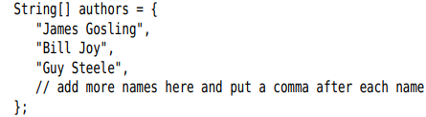
-Anonymous array:
+Use this syntax to reinitialize an array:
-Note: Have arrays of length 0 (not the same as null). Use for empty result array. Construct:
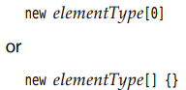

3.10.2 Accessing Array Elements
-The array elements are numbered from 0 to 99
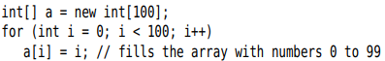
-When initialize: number element =0, boolean element = false, object element = null
-array.length
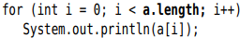

3.10.3 The “for each” loop
-for-each: the enhanced for
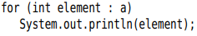
-Note: An easier way to print all values of an array, use toString method:

3.10.4 Array Copying
-Use = , both variables refer to the same array
-copyOf: copy all values of one array into a new array
+Use this method to increase the size of an array:

3.10.5 Command-Line Parameter
-Note: The name of program is not stored in args array
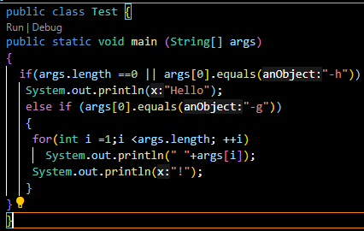

3.10.6 Array Sorting:
-sort:
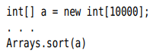
-API note: p116

3.10.7 Multidimensional Arrays
-Two-dimensional array:
-Shorthand notation for initializing:
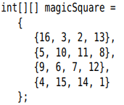
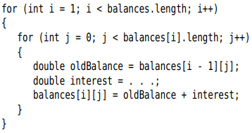
-Note:
+For each in two-dimensional array:
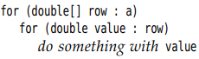
+Print quickly list of two-dimensional array:

3.10.8 Ragged Arrays
