Chapter 4: Objects and Classes

4.1. Introdu ction to Object-Oriented Programming
-An object-oriented is made of objects which will be taken from a library or custom-designed.
OOP order: put the data first, then look at algorithms to operate on data
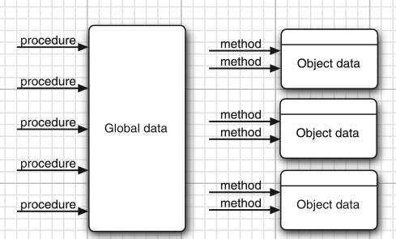

4.1.1 Classes
-A class specifies how objects are made. When you construct an object from a class, you have created an instance of the class.
-All code you write is inside a class.
-Standard Java library supplies thousand classes: UI design, dates and calendars, network
-Encapsulation(information hiding): combine data and behavior in one package and hide the implementation details from users of object. The bits of data in object are instance fields, procedures are methods. An object is an instance of class and have values of instance fields: called state. The key to making encapsulation is to have methods never directly access instance in class other than their own.
-Classes can be build by extending other classes. Java comes with superclass Object, all other classes extend this class. When extend a class, new class has all properties and methods of class. The concept of extending to make new class is inheritance

4.1.2 Objects
-3 key characteristics of objects: behavior, state, indentity
-Behavior: defined by methods
-State: what object looks like
-Identity: the objects that are instances of a class always differ in their identify.

4.1.3 Identifying Classes
-First work is to identify class and add methods to each class: look for nouns in problem analysis. Methods correspond to verbs.

4.1.4 Relationships between Classes
-Most common relationships classes: Dependence(uses-a), Aggregation(has-a), inheritance(is-a)
-UML: draw k describe relationships between classes.
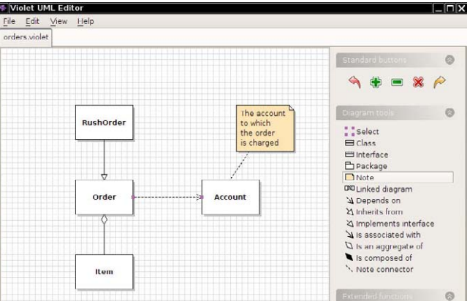
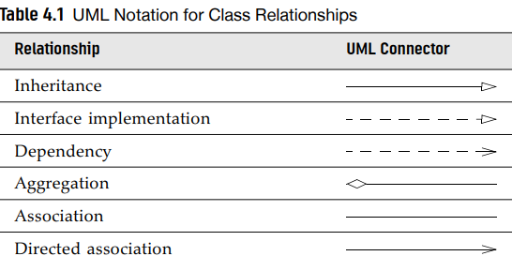

4.2 Using Predefined Classes

4.2.1 Objects and Object Variables
-First, construct object:

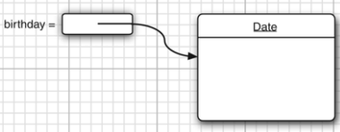
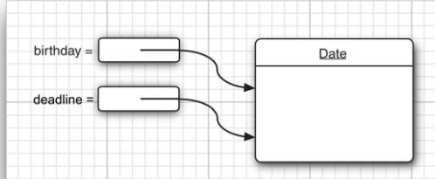
-Object variable only refers to an object. The value of any object variable is a reference to an object that is stored elsewhere.

4.2.2 The LocalDate Class of the Java Library
-Java library contains 2 classes: Date class (represent a point in time) and LocalDate (Expresses days in calendar)
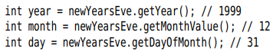
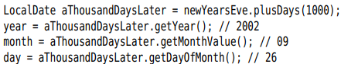
-Note: Date class also has methods to get day, month, year but these are deprecated.

4.2.3 Mutator and Accessor Methods
+pluDays method yields a new LocalDate object then assigned to aThousandDaysLater variable, the originally object remains unchanged => plusDays method does not mutate the object.
-The GregorianCalendar.add method is a mutator method:
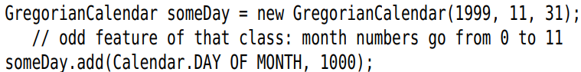
-Method that only access objects without modifying them are accessor methods: LocalDate.getYear, GregorianCalendar.get
-API note:p141

4.3 Defining your own Classes

4.3.1 An Employee Class
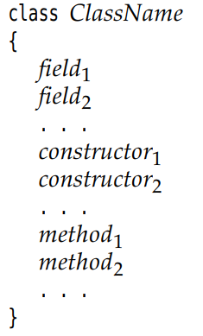

4.3.2 Use of Multiple Source Files
-Just compile the class including main method. Class inside will be automatically searched and compiled (or recompiled if having a new version)

4.3.3 Dissecting the Employee Class
-1 constructor and 4 methods
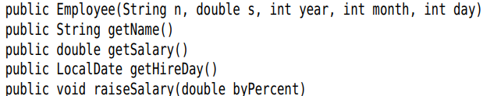
-3 instance fields
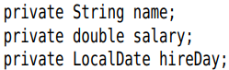

4.3.4 First Steps with Constructors
-A constructor can only be called in conjunction with new operator:

4.3.5 Declaring Local Variables with var

4.3.6 Working with null References
-null indicates the absence of an object in variable.
-If you apply a method to a null value => NullPointerException
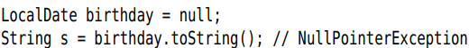
-Solution:
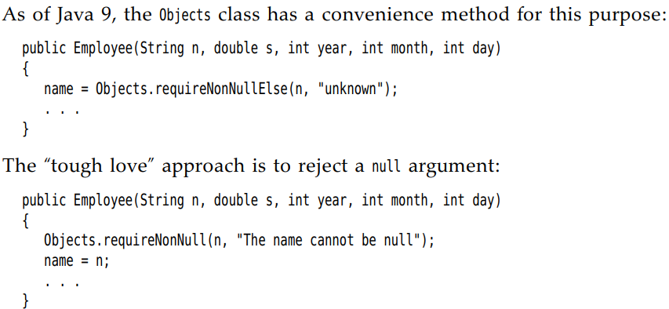

4.3.7 Implicit and Explicit Parameters
-Implicit parameter: the object of type, the keyword this
-Explicit parameter: other parameters

4.3.8 Benefits of Encapsulation
-field accessors: accessor methods, return the values of instance fields.
-Get and set the value of an instance field: private data field, public field accessor method and public field mutator method.
-Note: Not to write accessor methods return references to mutable objects:
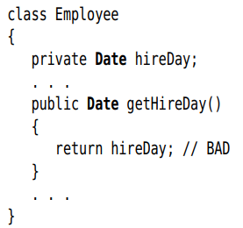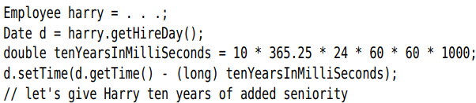
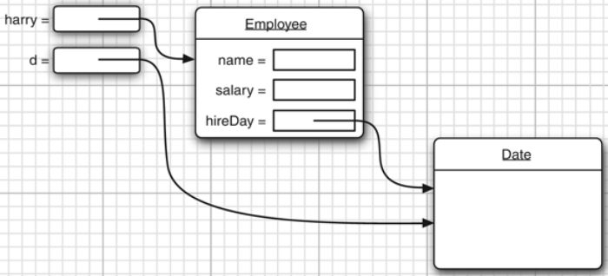
+You should clone it first:
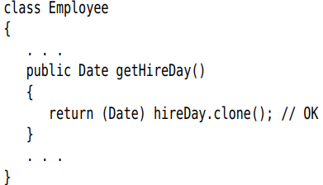

4.3.9 Class-Based Access Privileges
-A method can access all objects of its class:
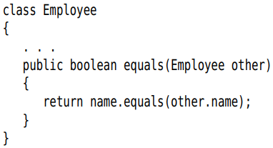

4.3.10 Private Methods
-We make all data fields private. Most methods are public. Sometimes methods are best implemented as private.

4.3.11 Final Instance Fields
-After setting value of constructor, final fields may not be modified again
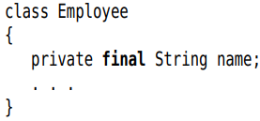

4.4 Static Fields and Methods

4.4.1 Static Fields
-Static field: there is only one field per class. It belongs to the class, not to any individual object.
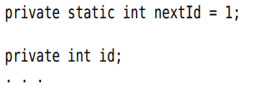

4.4.2 Static Constants
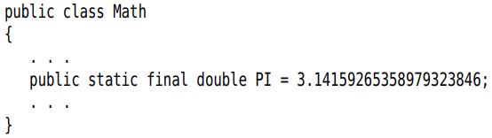

4.4.3 Static Methods
-Methods that do not operate on objects that don’t have a this parameter.
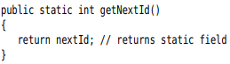

4.4.4 Factory Methods
-Factory methods that construct objects: LocalDate.now, LocalDate.of
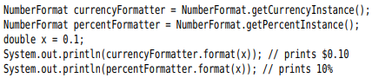

4.4.5 The main Method
-When a program starts, there aren’t any objects yet, the static main method executes and constructs the objects that program needs.
-Note: Every class can have a main method for unit testing of classes.

4.5 Method Parameters
-Call by value: the methods gets just the value
-Call by reference: the method gets the location of the variable.
-Java always uses call by value
-There are 2 kinds of method parameters: primitive types(number, boolean) and object references. Method can change object parameters.
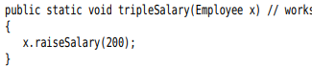
-Summary:
+Method cannot modify a parameter of a primitive type
+Method can change the state of an object parameter
+Method cannot make an object parameter refer to a new object

4.6 Object Construction
4.6.1 Overloading
-Overloading: several methods have the same name but different parameters and different return types.

4.6.2 Default Field Initialization
-If you don’t set a field explicitly in a constructor, it is automatically set to a default value: numbers to 0, boolean to false, object reference to null.

4.6.3 The Constructor with No Arguments
-Constructor with no arguments: creates an object whose state is set to an appropriate default.
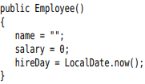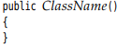
-If a class with no constructors: a no-argument constructor is provided with all default values fields.
-If a class supplies at least 1 constructor but does not supply no-argument constructor => cannot construct object with no-arguments
would be an error

4.6.4 Explicit Field Initialization
-You can simply assign a value to any field in class definition. This assignment is carried out before the constructor executes.
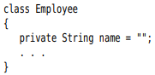
-The initialization value doesn’t have to be a constant value:
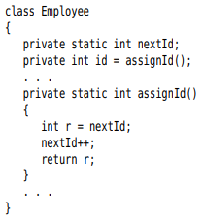

4.6.5 Parameter Names
-Prefix each parameter with “a”
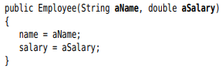
-this:
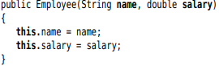

4.6.6 Calling Another Constructor
-If the first statement of a constructor has form this(…), the constructor calls another constructor.
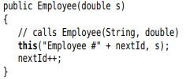

4.6.7 Initialization Blocks
-Initialization block:
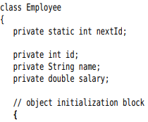
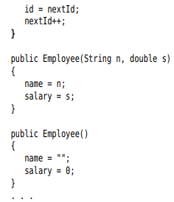
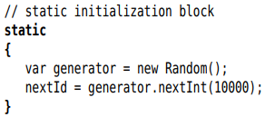
-Summary: Initialize a data field
+In constructor
+In declaration
+Initialization block
-Summary: Constructor flow
+First line calls a second constructor? Executes
+fields: default values + fields initializers and initialization block in the order in class declaration
+The body of constructor.
-Static initialization block: complex static field
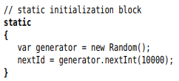
-API note: p180

4.6.8 Object Destruction and the finalize method
-Java does automatic garbage collection, manual memory reclamation is not needed.
-Some objects utilize a resource other than memory (file) =>reclaimed and recycled when no needed.
-You can use close method. If you can wait until the virtual machine exits, use Runtime.addShutdownHook. Java 9: you can use Cleaner class that carried out when object is no reachable.

4.7 Packages
-You can group classes in a collection called package. It helps you to organize and separate the work from code libraries by others.

4.7.1 Package Names
-Use packages to guarantee the uniqueness of class names. To guarantee a unique package name, use Internet domain name written in reverse, then use subpackages for different projects.
-Note: No relationship between nested packages from the point of view of the compiler

4.7.2 Class importation
-A class can use all classes from its own package and all public classes from other packages.
-2 ways to access public classes in another package:
+Use fully qualified name(package name+ class name):
+Use import statement:
package
or specific class:
-Use * notation to import a single package.

4.7.3 Static imports
-Use the static methods and fields of class:
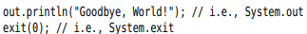
-Import a specific method or field:

4.7.4 Addition of a class into a Package
-To place classes inside a package, put the name of package at the top of source file, before the code.
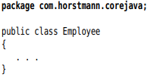
-If you don’t put a package statement, file belongs to unnamed package
-Place source files into a subdirectory that matches the full package name
-Note: the compiler: javac, the interpreter: java

4.7.5 Package Access
-If you don’t specify the feature (class, method, variable) either public or private, it can be accessed by all methods in the same package.

4.7.6 The Class Path
-Classes are stored in subdirectories of file system. The path to the class must match the package name.
-Class files can also be stored in JAR (Java archive) file. It contains class files and subdirectories in compressed format => saving space and improving performance.
-To share classes among programs:
+Place the class files inside a directory – base directory
+Place any JAR files inside a directory
+Set the class path: the collection of all location that contain class files.
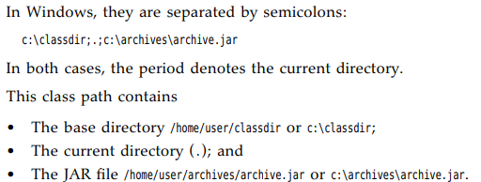
-You can specify a wildcard for JAR file directory:
-The class path lists all directories and archive files that are starting points for locating classes.

4.7.7 Setting the class path
-Specify the class path with the option -classpath
-CLASSPATH environment variable. The class path is set until the shell exits:

4.8 JAR Files
-When you package your application, you want to give uses a single file =>JAR file compressed by ZIP.
4.8.1 Creating JAR files
-JAR file contain class files and other file types, give users a single file.
-Use jar tool:
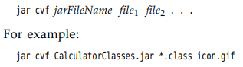
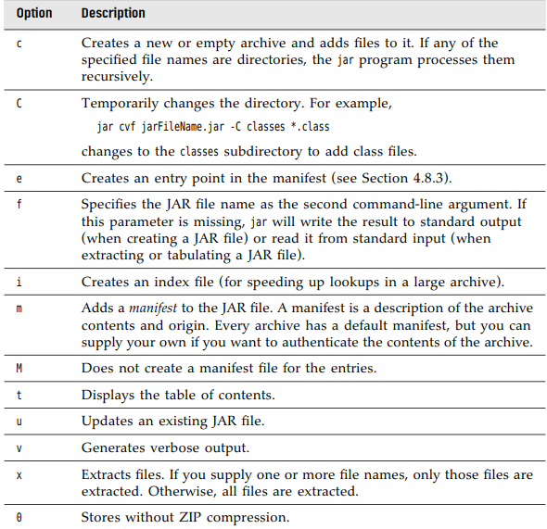
4.8.2 The Manifest
https://docs.oracle.com/javase/10/docs/specs/jar/jar.html
-manifest file describes special features of the archive, called MAINFEST.MF and located in META-INF bd
4.8.3 Executable JAR files
-Use the e option of jar command to specify the entry point of the program:
-Specify the main class in manifest:
-Either method, users can start the program:
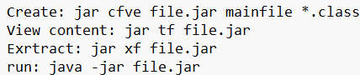
4.8.4 Multi-Release JAR files
-multi-release JARs contain class files for different Java releases.
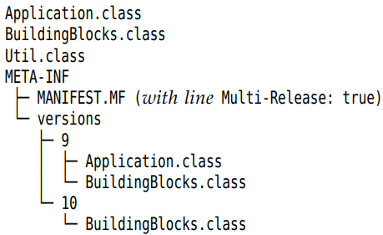
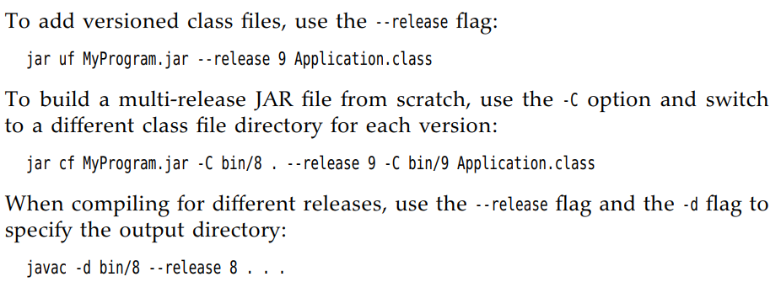
Or
-Remember to run javac and jar in Base directory.
4.8.5 A note about Command-Line options
-javadoc tool generates HTML documentation form source files.

4.9 Documentation Comments
Javadoc tool generates HTML documentation form source files.
4.9.1 Comment Insertion
-Each comment is placed above the feature, starts with /** and end with */. It contains first sentence (summary statement) and free-form text followed by tags @.
4.9.2 Class Comments
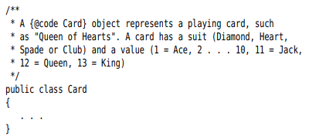
4.9.3 Method comments
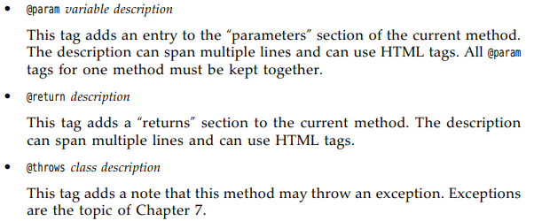
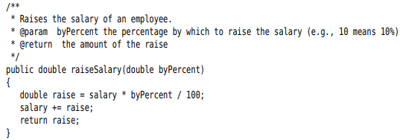
4.9.4 Field comments
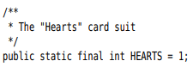
4.9.5 General comments
4.9.6 Package comments
4.9.7 Comment Extraction
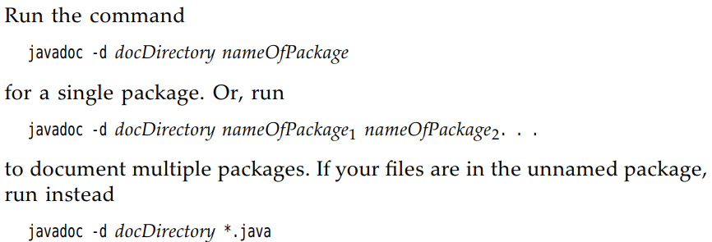
-Read later

4.10 Class Design Hints
-Always keep data private
-Always initialize data.
-Don’t use too many basic types in a class
-Not all fields need individual field accessors and mutators
-Break up classes that have too many responsibilities
-Make the names of your classes and methods reflect their responsibilities
-Prefer immutable classes.

