Chapter 5: Inheritance

5.1 Classes, Superclasses, and Subclasses

5.1.1 Defining Subclasses
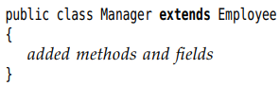
+ Employee is the superclass, base class, parent class. Manager class is the subclass, derived class, child class.
-Subclass has new fields, new methods:
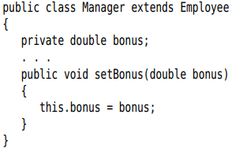
-When defining a subclass, you only need to indicate the differences between subclass and superclass.

5.1.2 Overriding methods
-super: call the method of superclass
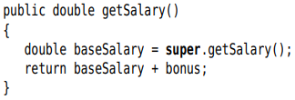

5.1.3 Subclass constructors
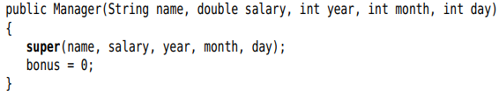
-Example:
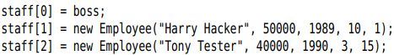
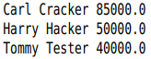
+The virtual machine knows about the actual type of the object to which e refers, and can invoke the correct method.
-The fact that an object variable can refer to multiple actual types is polymorphism. Automatically selecting the appropriate method at runtime is dynamic binding

5.1.4 Inheritance Hierarchies
-Inheritance hierarchies: The collection of all classes extending a superclass
-Inheritance chain: path from a class to its ancestors
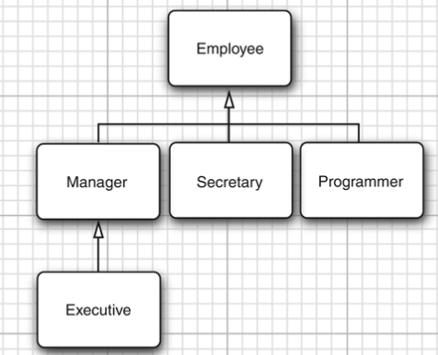

5.1.5 Polymorphism
-The “is-a”: every object of subclass is an object of the superclass. Substituation principle: you can use a subclass object whenever the program expects a superclass object
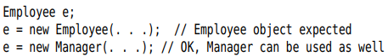
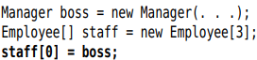
+staff[0] and boss refer to same object, but staff[0] is considered to be only an Employee object
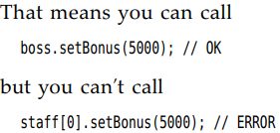
-Caution: Arrays of subclass can be converted to arrays of superclass. To make sure no corruption, all arrays remember the element type which they were created

5.1.6 Understanding method calls
-x.f(args) (X is an object of class C)
+The compiler looks at the declared type of object and method name. It enumerates all methods called f in the class C and accessible methods called f in superclasses
+The compiler determines the types of arguments in method call. Overloading resolution: find the method whose parameters types are best match for arguments
Method signature: name and parameter type for method
+static binding: knows exactly the method private, static, final, constructor.
+Dynamic binding. The virtual machine call the version of method for the actual type of object.
-It’s time-consuming to carry out this search. The virtual machine precomputes for each class a method table that lists all method signatures and the actual methods call.

5.1.7 Preventing inheritance: final classes and methods
-final classes: Classes that cannot be extended
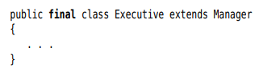
-You can also make a final method – no subclass can override that method.
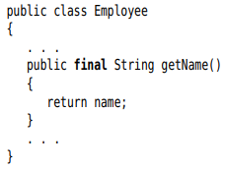
-Good reason to make a method or class final: its semantics cannot be changed in subclass.

5.1.8 Casting
-Casting: the process of forcing a conversion from one type to another
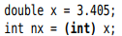
-Convert an object reference from one class to another:
-Good practice: find out whether a cast will succeed before attempting it by instanceof operator:
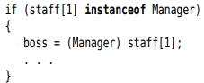
-The only reason to make the cast is to use a unique method.

5.1.9 Abstract classes
-Moving up the inheritance hierarch, classes become more general and abstract. There are some attributes that make sense for every class. Using the abstract, you don’t need to implement the method:
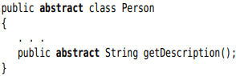
-Abstract methods act as placeholders for method that are implemented in subclasses. It can has instance fields and concrete methods, or no abstract method.
-Abstract cannot be instantiated, you can create object variable but refer a nonabstract class. The variable always refers to an object of subclass.
-Abstract methods are an important concept in Java => inside interfaces.

5.1.10 Protected access
-protected: allow subclass methods to access a superclass field. A protected field is accessible by any class in same package. Use protected fields with caution.
-Protected methods: subclasses can be trusted to use
-Summary:
+Accessible in the class only (private)
+Accessible by the world (public)
+Accessible in package and subclass (protected)
+Accessible in package – the default

5.2 Object: The Cosmic Superclass
Every class in Java extends Object

5.2.1 Variables of Type Object
-You can use Object variable to refer objects of any type
+It just a generic holder for any values. To do sth specific, you need to cast.
-Primitive types are not Objects

5.2.2 The equals method

-equal method in Object class test whether one object is considered equal to another. The default determines whether 2 object references are identical.
-We want to implement state-based equality testing:
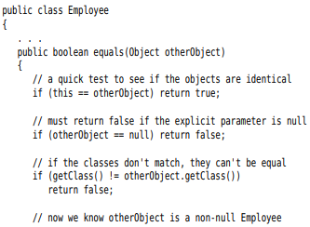
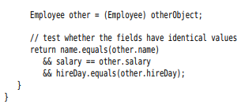
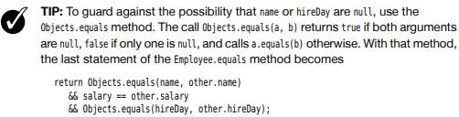

5.2.3 Equality Testing and Inheritance
-Writing the perfect equals method:
equals(Object otherobject)
+Test whether this happens to be identical to otherObject:
+Test whether otherObject is null:
+Compare the classes
+Cast otherObject to your class type:
+Compare the fields:
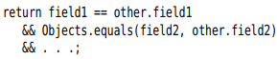
-Note: Use @Override. It invoked an error when you override a method with wrong parameters.

5.2.4 The hashCode method
-Hash code is an integer that is derived from an object.
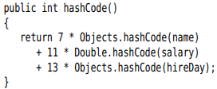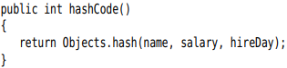

5.2.5 The toString method
-toString: return a string representing the value of this object
-Most toString follow this format: the name of class, the field values in []
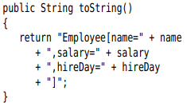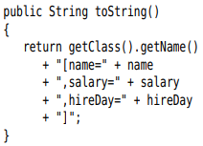
-Subclass:
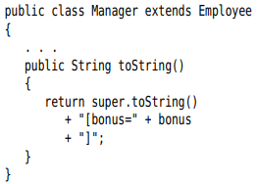
-ToString everywhere(system.out.x),string +x
-Caution: with Arrays, use Arrays.toString() or Arrays.deepToString()
-toString method is a great tool for logging.
-We strongly recommend adding a toString method to each class.

5.3 Generic Array Lists
-ArrayList class is similar to an array, but it automatically adjust its capacity as you add or remove elements. It is a generic class with a type parameter.

5.3.1 Declaring Array Lists
-Declare and construct an array list:
Or “diamond” syntax:
-Add method to add new elements:
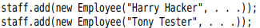
+Array list manages an internal array of object references. If you call add method and the internal array is full, the array list creates a bigger array and copies all objects to this array.
-ensureCapacity if you know how many elements:
-Pass an initial capacity to the constructor:
-Note: allocating an array list is not the same as allocating a new array: p250
-size method return the current number of elements
-If you are sure that the array list is at its permanent size, call trimToSize method. The garbage collector will reclaim any excess memory.
-API note: p251

5.3.2 Accessing Array List elements
-Set the ith element:
-Get an element:
-flexible growth and convenient element access:
+Made an array list and add all the elements
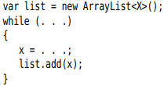
+Use toArray to copy elements into array: 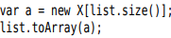
-Add elements in the middle of an array list:
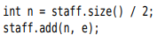
-Remove the element:
-Traverse the content of array list:
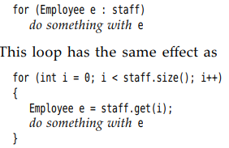

5.3.3 Compatibility between Typed and Raw Array Lists
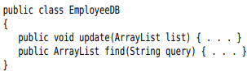
-You can pass a typed array list to update method without any cast:
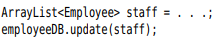
-You get a warning when you assign a raw ArrayList to a typed one:
-you can tag the variable that receives the cast with the @SuppressWarnings("unchecked") annotation.

5.4 Object Wrappers and Autoboxing
-All primitive types have own wrappers: Integer, Long, Float, Double, Short, Byte, Character, and Boolean. (The first six inherit from the common superclass Number.)
-The wrappers are immutable and final.
-Autoboxing: =
-Unboxed:
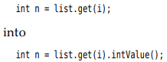
-Autoboxing and unboxed work with arithmetic expression
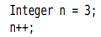
-Wrapper class references can throw NullPointerException
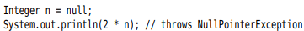
-Mix Integer and Double types:
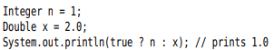
-Number wrappers put basic method: convert string to number:
-Note: If you want to change the value of wrapper, use holder types org.omg.CORBA:
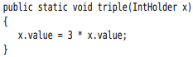
-API notes: p259

5.5 Methods with a Variable number of parameters
-It’s possible to provide methods that can be called with a variable number of parameters. (“varagrs” methods)

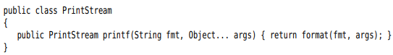
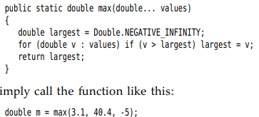

5.6 Enumeration Classes
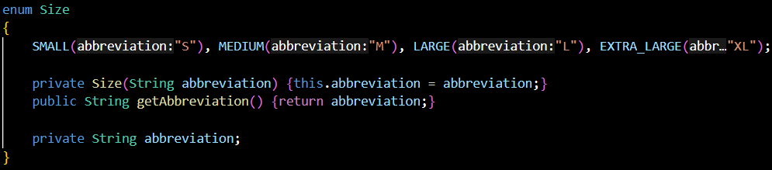
-Enum type is a data type that enables for a variable to be a set of predefined constants.-> enum is final + Can’t override clone(). The enum values can be the same (MS1(“Ms.”), MS2(“Ms.”))
-enums implicitly extend java.lang.Enum -> cant extend anything else
-enum defines a class (enum type). The enum body can include methods and other fields. The compiler automatically adds special methods: static values() and valueOf(), ordinal() name().
-The constants are defined 1st, then fields + methods.
-The enum constructor must be package or private access.
-Can’t access non-final static field in constructor.
-Enums implement Comparable in the natural order which they are defined

5.7 Reflection
-reflection library: toolset to write programs that manipulates code dynamically. It supports UI builders, object-relational mappers and development tools that dynamically inquire about capabilities of classes.
-A reflective program can analyze the capabilities of classes.

5.7.1 The Class Class
-runtime type identification: used by JVM to keep track of the class which each object belongs. Runtime type info used by VM to select correct method to execute.
-We can also access this info by Class class.
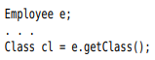
-Obtain a Class object corresponding to a class name:
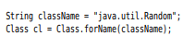
+Tip: static loading and dynamic loading (Compiler vs Runtime)
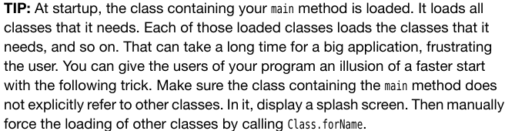
-If T is any Java type, T.class is the matching class object
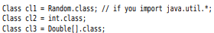
+Tip: Class is a generic class
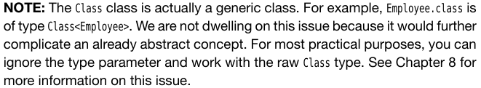
+Caution:
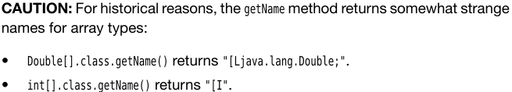
-The JVM manages a unique Class object for each type. You can use == to compare class objects:
-You can use a class object to construct instances of the class:
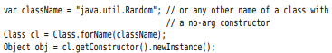
-API note: p267

5.7.2 A Primer on declaring exceptions
-When an error occurs at runtime, a program can throw an exception. You can provide a handler that catches the exception and deals with it.
-There are 2 types of exceptions:
+checked exceptions: the compiler checks that the programmer are aware of exception
+unchecked: the compiler does not expect that a class exists: access a null reference.
-throw: used when a method contains a statement that might throw a checked exception
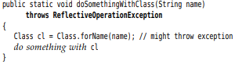
+Any method calling this method needs a throws.

5.7.3 Resources
-Classes often have associated data files: image and sound file, text files with message. It’s resource
-The Class class provides a useful service for locating resource files. p269
+Class: getResource(), getResourceAsStream

5.7.4 Using Reflection to analyze the capabilities of classes
-java.lang.reflect: Field, Method, Constructor class
+All 3 classes have getName()
+getModifier(): return int with various bits turned on and off that describe the modifiers used. You can use Modifier static methods: isPublic(), isPrivate(), isFinal(), toString()
-Class: getField(), getMethod(), getConstructor()
-Class: getFields(), getMethods(), getConstructors() return arrays of public fields, methods and constructors.
-Class: getDeclaredFields(), getDeclaredMethods(), getDeclaredConstructors() return arrays all fields, methods and constructors declared in class. This includes private, package, protected members (not superclasses members)
-API: p275
+Class: getFields(), getDeclaredFields(), getMethods(), getDeclaredMethods(), getConstructors(), getDeclaredConstructors(), getPackageName()
+Field, Method, Constructor: getDeclaringClass(), getExceptionTypes() (in Constructor and Method), getModifiers(), getName(), getParameterTypes() (Constructor and Method), getReturnType() (Method)
+Modifier: toString(), isAbstract/Final/Interface/Native/Private/Protected/Public/Static/Strict/Synchronized/Volatile

5.7.5 Using reflection to analyze objects at Runtime
-Reflection lets you look at fields of objects that weren’t known at compile time.
-The key method is get() in Field: f.get(obj)
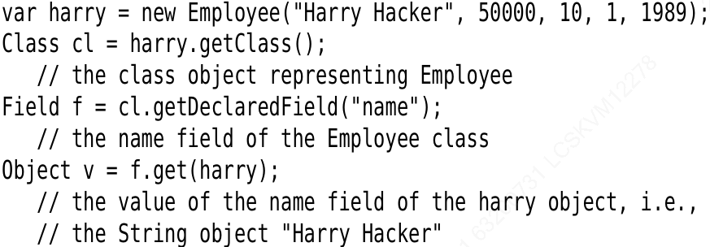
-f.set(obj, value): set the field
-Problem: If field is private -> set() and get() throws IllegalAccessException. The security mechanism of Java lets you find out what fields an object has, but need permission to read and write.
+The default reflection mechanism is to respect Java access control. But you can override access control:
f.setAccessible(true);
+setAccessible() is from AccessibleObject, common superclass of Field, Method, Constructor. This feature is provided for debuggers, persistent storage…
+setAccessible() throws exception if access is not granted. It because module system or security manager. As Java 9, every programs contains modules since Java API is modularized.
+Java 9 and 10: Only give a warning when you use reflection to access nonpublic feature inside module
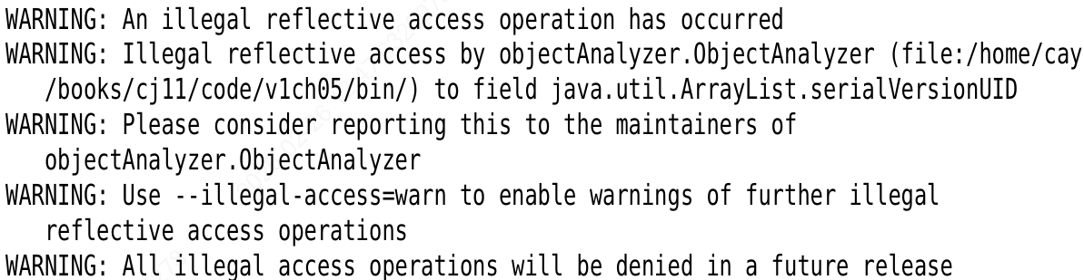
+To use reflection in future version, you need to open packages in java.base module to “unnamed module”
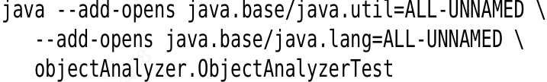
+Future version: use
to throw IllegalAccessException.
-Note: Variable handles vs Reflection
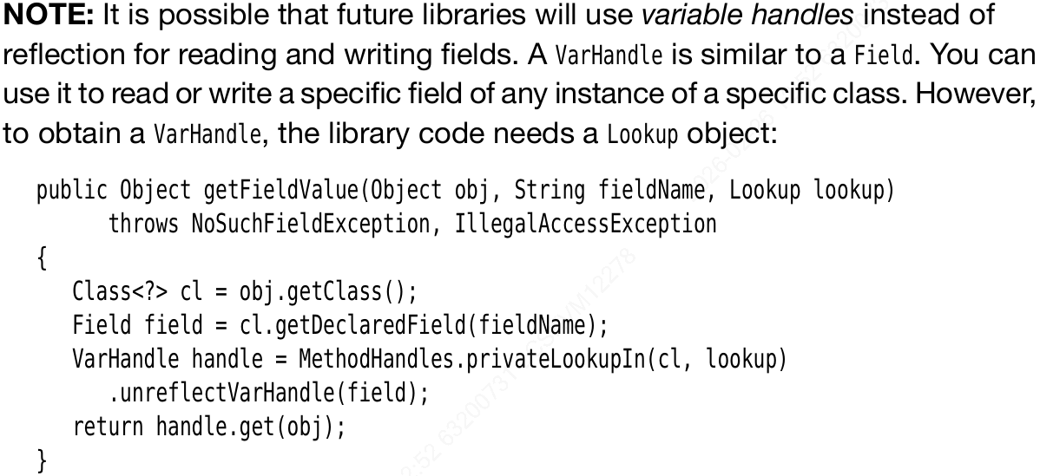
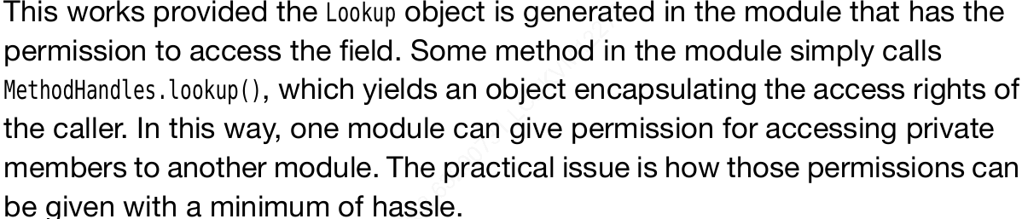

5.7.6 Using reflection to write generic array code

5.7.7 Invoking arbitrary methods and constructors

-Study later

5.8 Design Hints for Inheritance

