Chapter 8: Generic Programming

8.1 Why Generic Programming?
-Generic Programming: writing code that can be reused for objects of many different types. Example: ArrayList

8.1.1 The advantage of Type Parameter
-ArrayList class has a type parameter that indicates the element type:
->Make programs easier to read and safer.

8.1.2 Who wants to be a Generic Programmer?
-Wildcard type: abstract but allow a library builder to make methods as flexible as possible.
-Generic programming has 3 skill levels: use generic classes without thinking how and why they work – Learn enough about Java generics to solve problems-implement your own generic classes and methods.
-App programmer won’t write lots of generic code. Only code that traditionally involved lots of casts from very general types will benefit from using type parameters.

8.2 Defining a simple generic class
-Generic class have one or more type variables.
-Generic Pair class:
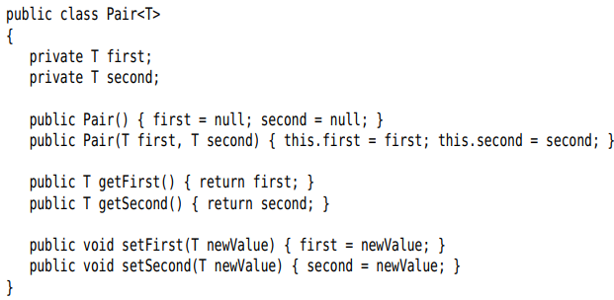
+A generic class can have more than 1 type variable:
+The type variables are used throughout the class definition to specify method return types and the types of fields and local variables.
+Instantiate the generic type by substituting types for the type variables:
-Note: Use uppercase letters for type variables: E for element type of collection, K and V for key and value types of a table, T for any type at all.

8.3 Generic Methods
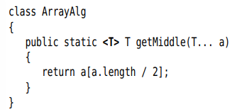
+Type variable <T> is between modifier and return type
-You can define generic methods both inside ordinary classes and generic classes.
-You can omit the <T> type parameter from method call

8.4 Bounds for Type Variables
-Restrict T to a class that implements the interface->give a bound for the type variable T:
+T should be a subtype of the bounding type. Both T and the bounding type can be a class or an interface.
-A type variable or wildcard can have multiple bounds:
+The bounding types are separated by &.
-You can have as many interfaces supertypes as you like.

8.5 Generic Code and the Virtual Machine
-The VM doesn’t have objects of generic types – all objects belong to ordinary classes.

8.5.1 Type Erasure
-When you define a generic type, a corresponding raw type is automatically provided. The name of the raw type is the name of generic type. The type variables are erased and replaced by their bounding types
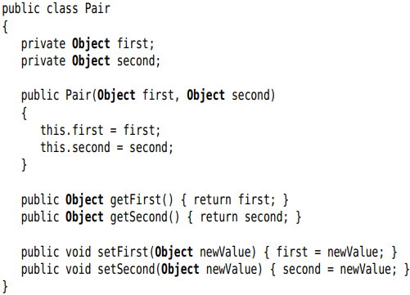
+T is an unbounded type variable, it’s replaced by Object. The result is an ordinary class.
-Note: class Interval<T extends Serializable & Comparable>: raw type replaces T with Serializable, and the compiler inserts casts to Comparable when necessary. You should put tagging interface (interface without method) at the end of the bounds list.

8.5.2 Translating Generic Expressions
-When program call a generic method, the compiler inserts casts automatically when the return type has been erased: a call to the raw method + A cast of the returned Object to the type T.
-Casts are also inserted when accessing a generic field.

8.5.3 Translating Generic Methods
-Summary:
+There are no generics in the virtual machine, only ordinary classes and methods.
+All type parameters are replaced by their bounds.
+Bridge methods are synthesized to preserve polymorphism.
+Casts are inserted as necessary to preserve type safety.

8.5.4 Calling Legacy Code

8.6 Restrictions and Limitations

8.6.1 Type Parameters cannot be instantiated with Primitive Types
-Because of type erasure.

8.6.2 Runtime Type Inquiry only works with raw Types
-Objects in VM always have a specific nongeneric type. So all type inquiries yield only the raw type:
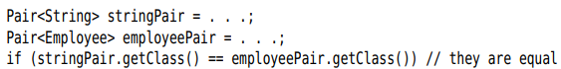

8.6.3 You cannot create Arrays of Parameterized Types
-Note: You can declare arrays of wildcard types and cast them:
-If you need to collect parameterized type objects, use ArrayList<Pair<String>>

8.6.4 Varargs Warnings
-Passing instances of a generic type to a method with a variable number of arguments:
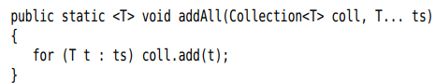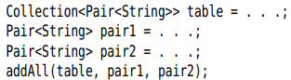
+VM must make an array of Pair<String>->get a warning. So add @SuppressWarnings(“unchecked”) to the method containing adAll() or add addAll() with @SafeVarargs (static, final or private).
-Note: Use @SafeVarargs to defeat the restriction against generic array creation:
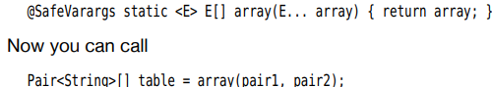

8.6.5 You cannot instantiate Type Variables
-Cannot use type variable in new T(…)
-Make the caller provide a constructor expression:
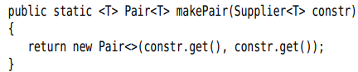
-A traditional workaround is to construct generic objects through reflection. You must design an API
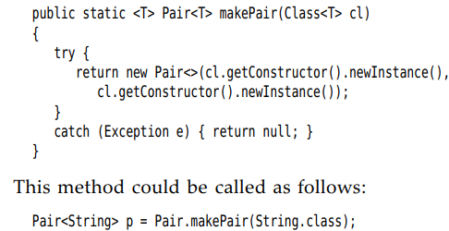
+Class class is generic. String.class is an instance of Class<String>

8.6.6 You cannot Construct a Generic Array
-If the array is only used as a private instance field of a class, you can declare the element type of the array to be the erased type and use casts:
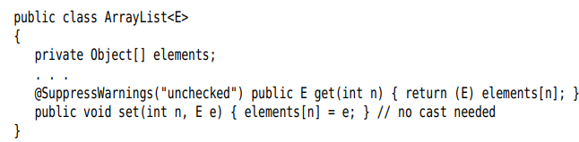

8.6.7 Type Variables are not valid in static contexts of Generic Classes
-Can’t reference type variables in static fields or methods.
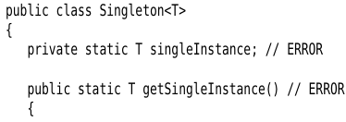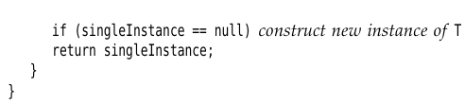

8.6.8 You cannot throw or catch instances of a Generic Class
-You cant throw or catch objects of a generic class:
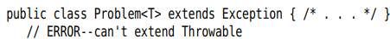
-Can’t use type variable in catch:
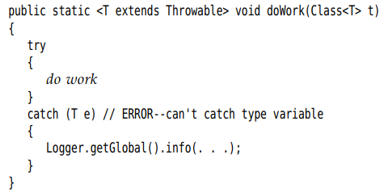
-You can use type variables in exception specifications
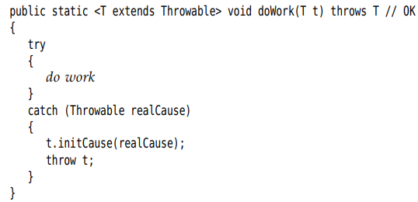

8.6.9 You can defeat Checked Exception Checking

8.6.10 Beware of Clashes after Erasure

8.7 Inheritance Rules for Generic Types
-There is no relationship between Pair<S> and Pair<T>, no matter how S and T are related.
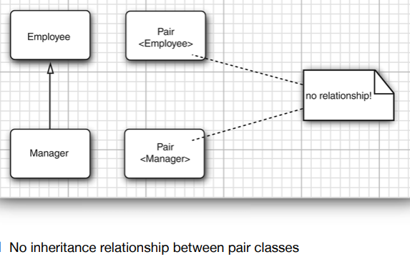
+Note: This is an important difference between generic types and Java arrays.
 but when you store a Employee into emoloyeeBuddies[0]-> throws ArrayStoreException
-You can convert a parameterized type to a raw type. Example: Pair<Employee> is a subtype of the raw type Pair -> Interfacing with legacy code.
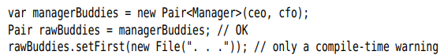
-Generic classes can extend or implemented other generic classes.
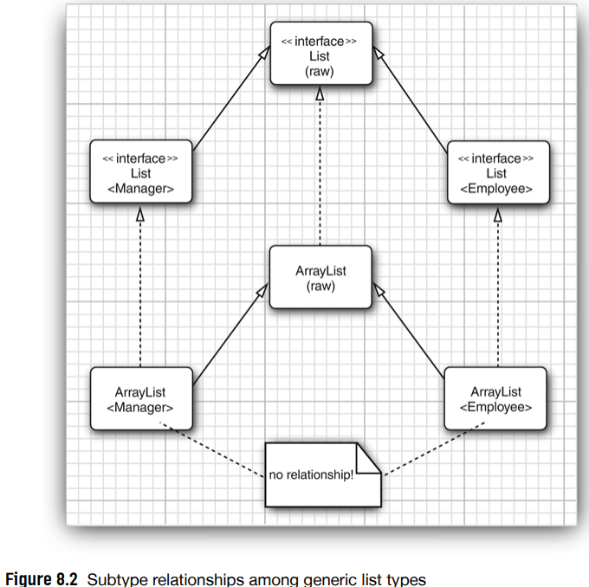
+ArrayList<T> implement List<T> -> ArrayList<Manager> can be converted to List<Manager>, but ArrayList<Manager> isn’t an ArrayList<Employee> or List<Employee>

8.8 Wildcard Types

8.8.1 The Wildcard Concept
-In a wildcard type, a type parameter is allowed to vary:
denotes any generic Pair type whose type parameter is a subclass of Employee.
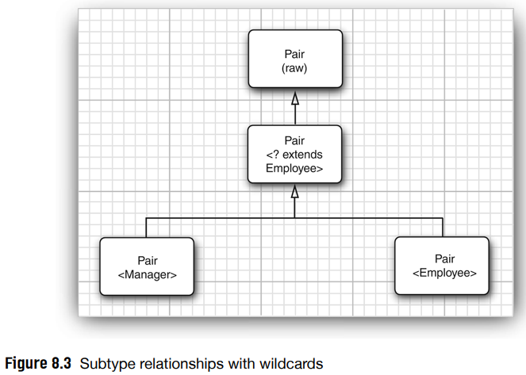

8.8.2 Supertype Bounds for Wildcards
-Supertype bound: . This wildcard is restricted to all supertype of Manager.
-Example:
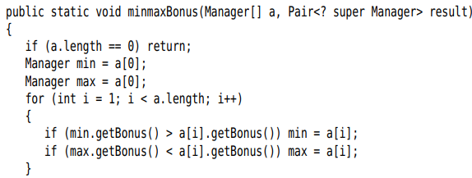
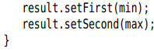
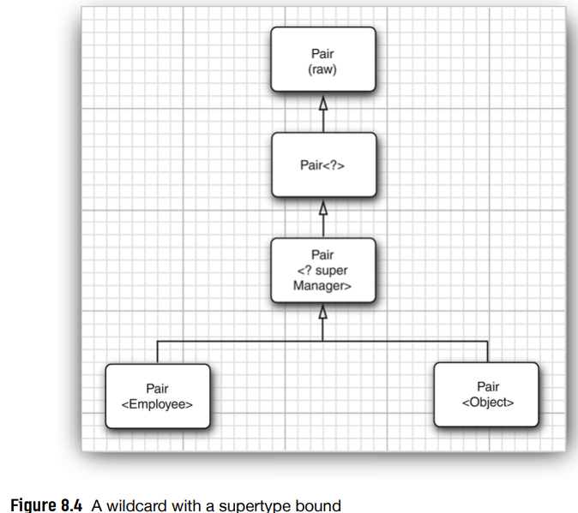
-Note:Wildcard with suptertype bounds let you write to a generic object, while wildcard with subtype bounds let you read from a generic object.
-Use Comparable with generic:
-Note: Supertype bounds can be an argument type of a functional interface:
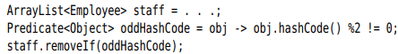

8.8.3 Unbounded Wildcards
-Pair<?> no bounds:
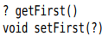
+getFirst return only Object. setFirst can never be called
Note: You can call setFirst(null)
-It’s useful for very simple operation: test whether a pair contains null:
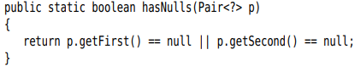

8.8.4 Wildcard Capture
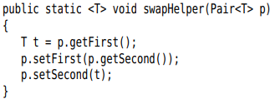
+swapHelper is a generic method, swap is not-it has a fixed parameter of type Pair<?>
+The parameter T of swapHelper method captures the wildcard.

8.9 Reflection and Generics

8.9.1 The Generic Class Class
-Class class is generic. String.class is the sole object of class Class<String>
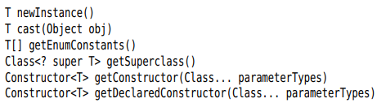
-API: p468

8.9.2 Using Class<T> Parameters for Type Matching
-Match the type variable of a Class<T> parameter in a generic method:
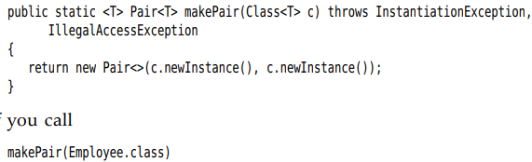
+Employee.class is an object of type Class<Employee>. The type parameter T of the makePair method matches Employee.

8.9.3 Generic Type Information in the Virtual Machine
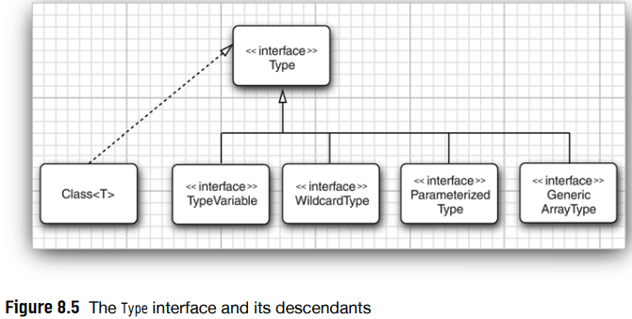
+TypeVariable = T extends Comparable<? Super T>
+WildcardType = ? super T
+ParameterizedType = Comparable<? Super T>
+GenericArrayType = T[]

8.9.4 Type Literals
-Make difference actions for ArrayList<Integer> and ArrayList<String>
-See 8.9 later

