Chapter 10: Security
-Security mechanisms are an integral part of Java tech.
-3 mechanisms help ensure safety:
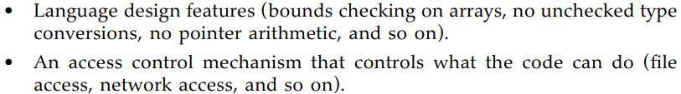
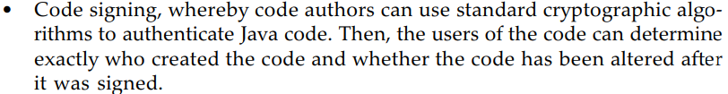
-For an in-depth view, refer “Inside Java™ 2 Platform Security: Architecture, API Design, and Implementation, Second Edition”

10.1 Class Loaders
-Java compiler converts source instructions into code for JVM. The VM code is stored in .class file. See how VM loads these class files.

10.1.1 The Class-Loading Process
-Example: Program execution starts with MyProgram.class
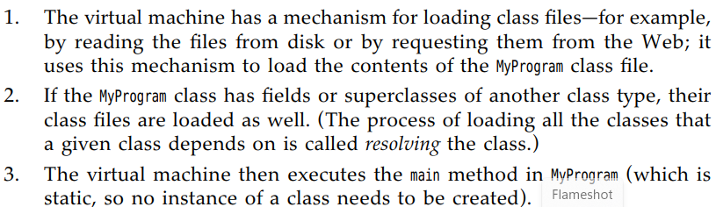
-Every Java program has at least 3 class loaders:
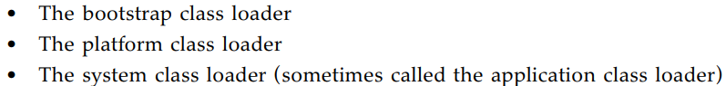
-Bootstrap class loader loads the platform classes contained in the modules:
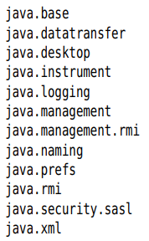 and JDK-internal modules.
+There is no ClassLoader object corresponding to bootstrap class loader: return null.
-Java platform is modular, each platform module is contained in a JMOD file. The platform class loader loads all classes of Java platform that are not loaded by bootstrap class loader.
-System class loader loads application classes from module path and class path.

10.1.2 The Class Loader Hierarchy
-Class loaders have a parent/child relationship. A class loader will give its parent a chance to load any given class and will only load it if the parent has failed.
-Some programs have a plugin architecture in which certain part of the code are packaged as optional plugins. If the plugins are packaged as JAR files, load the plugin classes with an instance of URLClassLoader:
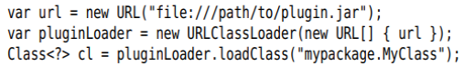
+The parent of pluginLoader is system class loader.
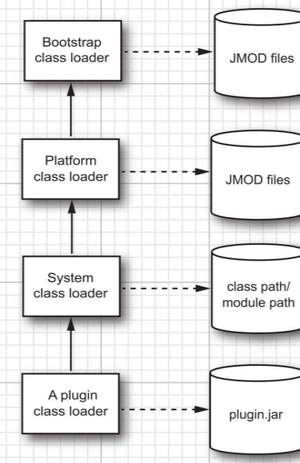
-Classloader inversion: to overcome this problem, the helper method needs to use correct class loader. It’s can be set as the context class loader of the current thread. This strategy is used by many frameworks (JAXP, JNDI)
+Set any class loader:
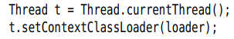
+Then retrieve the context class loader:
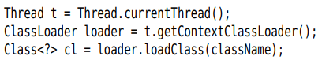

10.1.3 Using Class Loaders as Namespaces
-You can have 2 classes in the same VM that have the same class and package name. A class is determined by its full name and the class loader.
-This technique is useful for loading code from multiple sources (An app server uses separate class loaders for each app, this allows the VM to separate classes from different apps)
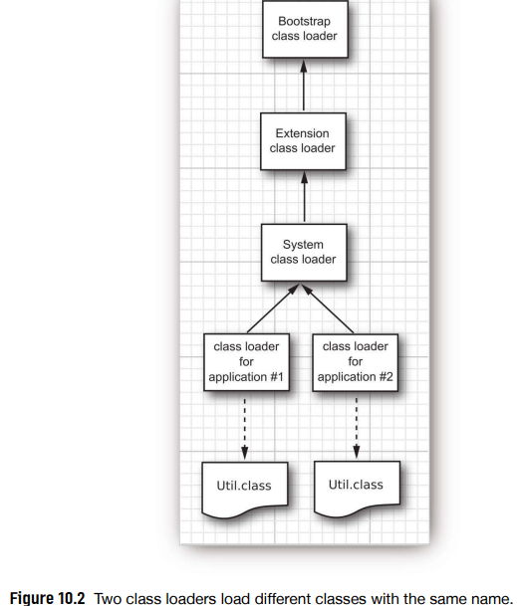

10.1.4 Writing your own Class Loader
-Write your own class loader for specialized purposes. It lets you carry out custom checks before you pass the bytecode to VM.
-Extend ClassLoader and override: . loadClass() takes care of delegation to the parent and call findClass() only if the class hasn’t already been loaded.
+The implementation of findClass():
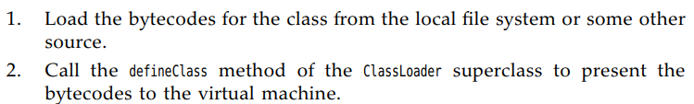
-API: p540

10.1.5 Bytecode Verification
-When a class loader presents the bytecodes, they are 1st inspected by a verifier: check that the instructions cannot perform actions that are damaging. All classes except system classes are verified.
-Some checks the verifier carries out:
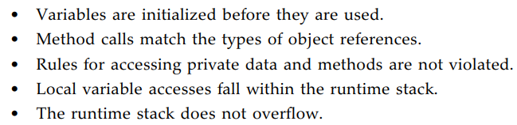
-This strict verification is an important security consideration.
-A class file generated by a compiler always passes verification. But sb can produce class file containing valid but unsafe instructions for JVM. The verifier is guarding against maliciously altered class files.

10.2 Security Managers and Permissions
-Note:SecurityManager removed from JDK 17
-One a class has been loaded into VM and checked by the verifier, the 2nd security mechanism of Java platform springs into action: the security manager.

10.2.1 Permission Checking
-Security manager controls whether a specific operation is permitted
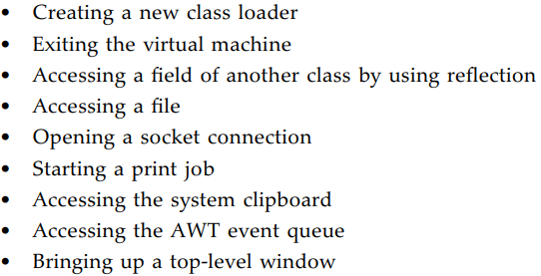
-The default behavior when running Java apps is to install no security manager, so these operations are permitted. In contrast, applets relied on a very restrictive security policy.
+Example: You run Tomcat instance and allow students to install servlets. You don’t want any of them to call System.exit since this terminates Tomcat instance:
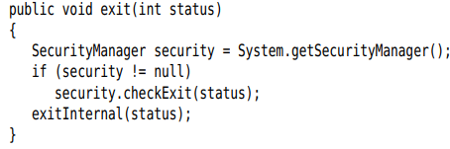

10.2.2 Java Platform Security
-JDK 1.0: local classes had full permission, remote classes were confined to the sandbox.
-JDK 1.1: remote code that was signed by a trusted entity was granted the same permission as local classes.
-Start with Java 1.2: A security policy maps code sources to permission sets:
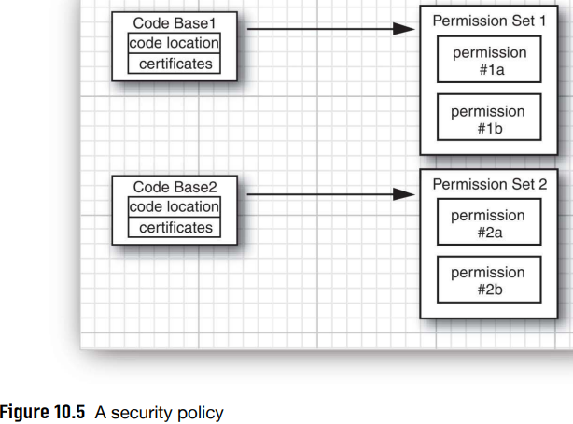
-A code source is specified by a code base and a set of certificates. Code base specifies the origin of the code. A certificate is an assurance by some party that the code hasn’t been tampered with.
-A permission is any property that is checked by a security manager. Java platform supports permission classes. Example: FilePermission class states it’s OK to read and write file in /tmp:
+The default implementation of Policy class reads permissions from a permission file. Inside this file expresses the same read permission
+The hierarchy of the permission classes:
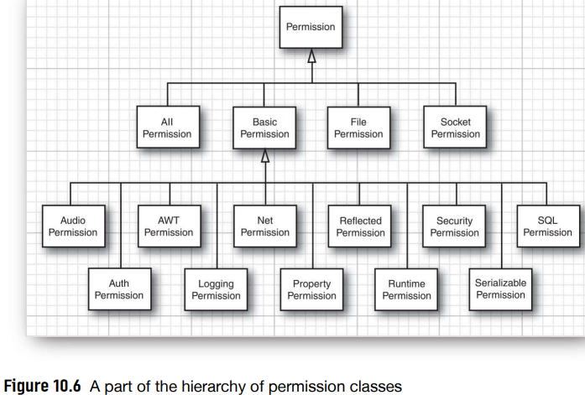
+SecurityManager class has security check methods, they all map to permission checks:
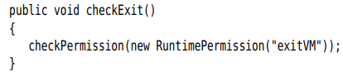
-Each class has a protection domain-an object encapsulating the code source and the collection of permissions of class.
+When SecurityManager checks a permission, it looks at the classes, get protection domains and ask if its permission collection allows the operation. If all domains agree, the check passes or throw SecurityException
+Example: init() of servlet wants to open a file
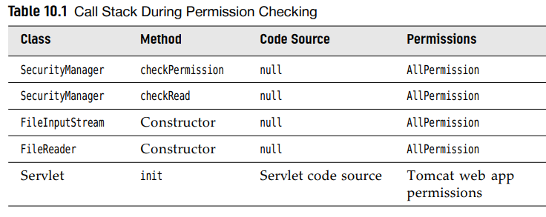
-Note: For more critical view, see “Securing Java: Getting Down to Business with Mobile Code, Second Edition”, http://www.securingjava.com/
-Java API: p550
10.2.3 Security Policy Files
-Policy manager reads policy files that contains instructions for mapping code sources to permissions.
-A typical policy file:
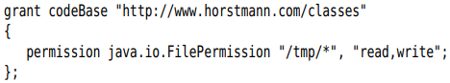
+This file grants permission to read and write files in /tmp directory to all code that was downloaded from www.horstmann.com/classes
-Install policy files in standard locations. By default, there are 2 locations:
+Note: Change the locations of these files in java.security configuration file in jdk/conf/security
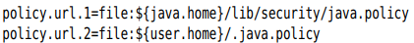
-Name the policy file for each app. Place the permissions into a separate file. To apply the policy:
+Or start the VM as:
MyApp.policy is added to other policies in effect.
+ the app will use only the specified policy file, the standard policy file is ignored.
-By default, Java apps don’t install a security manager. Install:
or
*Policy file format except for code certificates
-A policy file contains a sequence of grant entries:
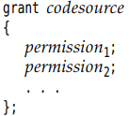
+code source contains a code base (omit if entry applies to code from all sources) and the names of trusted principals and certificate signers (omit if signatures aren’t required for this entry)
-The code base:
+If url ends in /, it refers to a directory. Otherwise, it refers to JAR file:
+The code base is a URL and should always contains /, even for file URLs in Windows
+Policy file reader accepts 2 forms of file URLs: file://localFile and file:localFile. A slash before a Window drive letter is optional.
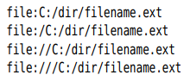
-The permissions:
+className is fully qualified class name of permission class. targetName is a permission-specific value (a file or directory, a host and port). actionList is also permission-specific (read, write…)
+Some permission classes don’t need target names and action lists.
+Table 10.2 lists the commonly used permission classes and their actions.
-Most permissions simply permit a particular operation. Think of the operation as the target with an action “permit”. These permission classes extend BasicPermission class.
-File permission targets:
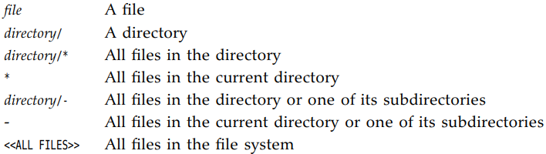
+ give access to all files in /myapp and any of its subdirectories.
+Use \\ in Windows:
-Socket permission targets consists of a host and a port range. Host specifications: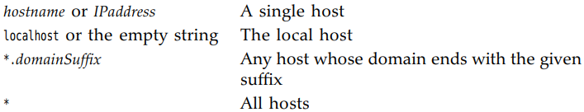
+Port ranges are optional:
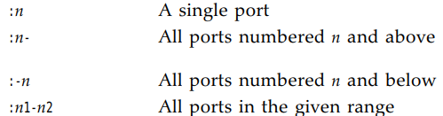
+Example:
-Property permission targets:
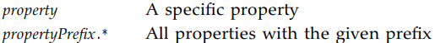
+Examples are “java.home” and “java.vm.*”
+ entry allows to read all properties that start with java.vm
+You can use system properties in policy files. ${property} is replaced by property value.
+${/} is a shortcut for ${file.separator}:
read and write in user’s home directory and its subdirectories

10.2.4 Custom Permissions
-Extend Permission class and supply methods:
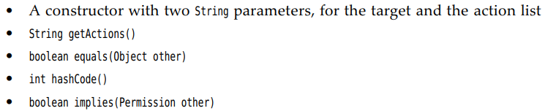
-The last method is the most important. Permissions have an ordering, in which more general permissions imply more specific ones.
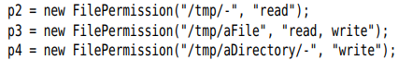
+File permission p1 implies p2 if:
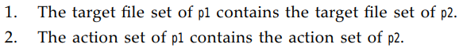
+Example: FileInputStream to open a file for reading, it checks if it has permission to do. A specific file permission objects is passed to checkPermission():
+The security manager asks all applicable permissions if they imply this permission, the check passes.
+AllPermission implies all other permissions.

10.2.5 Implementation of a Permission Class
-Ask the security manager if it’s OK to add new text:
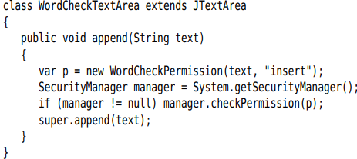
-Word check permissions have 2 actions: insert and avoid
-Policy file:
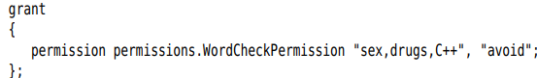
-When design the WordCheckPermission class, pay attention to implies()
-To retrieve permission target, use getName() of Permission class. Use the method to transform comma-separated list of avoid permission into a Set:
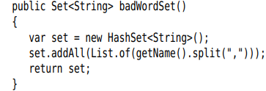
-API:p566

10.3 User Authentication
-Java API provides a framework: JAAS that integrates platform-provided authentication with permission management

10.3.1 The JAAS Framework
-JAAS frameworks has 2 components: authentication part is ascertaining the identity of a program user. Authorization part maps users to permissions.
-Authentication: it supports Windows logins, UNIX logins, Kerberos authentication and certificate-based authentication.
-Once user has been authenticated, you can attach a set of permissions.
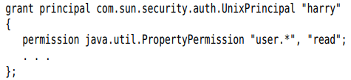
+com.sun.security.auth.UnixPrincipal class checks the name of UNIX user who running program. getName() return login name and check if that name equals “harry”
-Use LoginContext to allow the security manager to check such a grant statement. The login code:
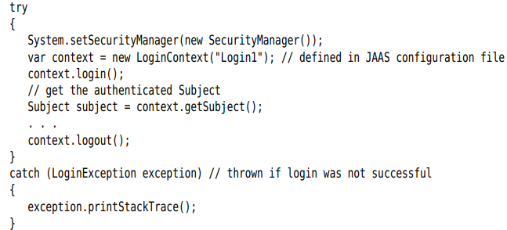
+subjects denotes the individuals who has been authenticated.
+Login1 refers to an entry with the same name in JAAS configuration file:
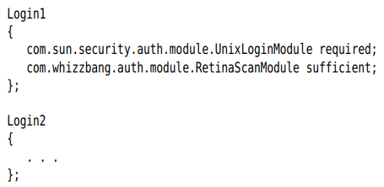
+JDK contains no biometric login module. The modules are supplied in com.sun.security.auth.module package
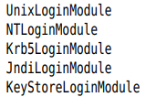
+A login policy consist of a sequence of login modules, each labeled required, sufficient, requisite, optional.
-A login authenticates a subject, which can have multiple principals. A principal describes some property of subject: user name, groupID, role
-A grant clause can test for a principal:
+Example:
-When a user has logged in, you then run, in a separate access control context, the code that require checking of principals. Use static doAs() or doAsPrivileged() to start a new PrivilegedAction whose run() executes code using the permissions of subject’s principals.
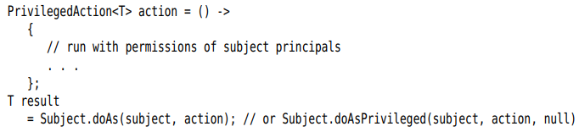
+If the actions throw checked exceptions, implement PrivilegedExceptionAction
-The difference between doAs() and doAsPrivileged():
+doAs() starts out with the current access control context
+doAsPrivileged() starts out with a new context. It allows to separate the permission for login code and business code.
-Example: restrict permissions to certain users. It authenticates a user and runs an action that retrieves a system property.
+The login code has permissions:
+The authenticated user has a permission
-Run the program:
+Package the code for the login and the action into JAR
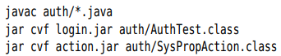
+Run in UNIX:
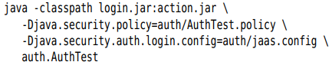
On Windows: change UnixPrincipal to NTUserPrincipal in .policy, UnixLoginModule to NTLoginModule in jaas.config. Use ; instead of :

10.3.2 JAAS Login Modules
-This JAAS example shows: implement your own login module +Implement role-based authentication.
+Supply your own login module is useful if you store login information in a database. It helps you understand JAAS configuration file options.
+Role-based authentication is essential if you manage a large number of users. The login module maps users to roles such as “admin” or “HR”, the permissions should be based on these roles.
-One job of login module is to populate the principal set of the subject that is being authenticated. If a login module supports roles, it adds Principal objects that describe roles:
+The class stores a description/value pair, getName() return that pair, we can add role-based permissions into a policy file
-The login module looks up users, passwords and roles in a text file:
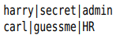
+In a realistic login module, you store this information in a database or directory.
-SimpleLoginModule class:
+checkLogin() checks if the user name and password match a record in the password file. If so, add 2 SimplePrincipal objects to subject’s principal set:
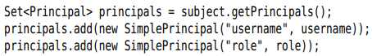
+initialize()
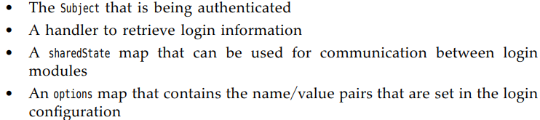
-Example: configure the module
+The login module retrieves pwfile settings from options map.
-A separate handle gather user name and password. It’s specified when constructing LoginContext:
+DialogCallbackHandler pops up a GUI dialog box to retrieve user name and password. class gets the information from console.
-In our app, use GUI for collecting the user name and password:
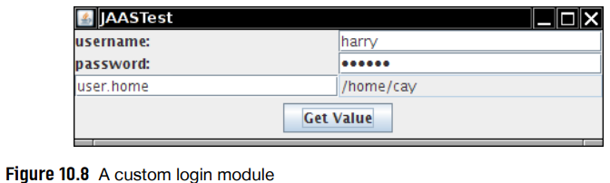
+The handler has handle(): process an array of Callback objects. It analyzes the types of callback objects:
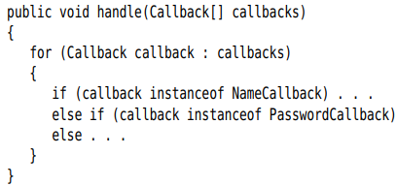
+The login module prepares an array of callbacks that it needs for authentication:
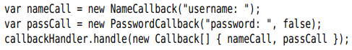
Then it retrieves the info from callbacks.
-The program displays a form to enter login info and the name of a system property. If the user is authenticated, the property value is retrieved in a PrivilegedAction. In policy file, only users with admin role have permission to read properties.
-Run the program:
+Separate the login and action code:
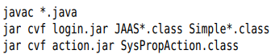
+Run the program:
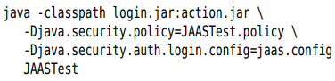

10.4 Digital Signatures
-Message digests can detect changes in data files and digital signatures can prove the identity of the signer

10.4.1 Message Digests
-A message digest is a digital fingerprint of a block of data. Example: SHA-1 condenses any data block into a sequence of 160 bits (20 bytes)
-A message digest has 2 essential properties:
+If one bit or several bits of data are changed, the message digest also changes
+A forger can’t construct a fake message that has the same message digest as the original.
-Algorithms to compute message digests: SHA-1, MD5. See “Cryptography and Network Security, Seventh Edition”. Java supports SHA-2 and SHA-3 sets
-MessageDigest class serves 2 duty:
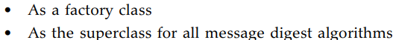
-getInstance(): obtain the object that computes fingerprints
-Feed all the bytes in MessageDigest object: update()
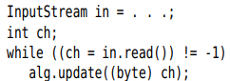
+Or if you have the bytes in an array:
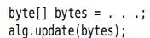
-digest():
-You can specify the file and algorithm on command line:
-API: p586

10.4.2 Message Signing
-A message digest is a fingerprint for the original message. If the message is altered, the fingerprint of altered message won’t match the fingerprint of original.
-But if both the message and the fingerprint were intercepted, it’s easy to modify the message and then recompute the fingerprint. Digital signatures solve this problem.
-public key cryptography: based on a public key and private key.
+You tell everyone your public key. But only you hold the private key, safeguard it and don’t release it to anyone.
+The keys are matched by mathematical relationships (see “The Handbook of Applied Cryptography” http://www.cacr.math.uwaterloo.ca/hac)
+The keys are long and complex. It’s impossible to compute one key from the other.
+Most cryptographers believe that keys with >=2000 bits are completely safe from any attack. DSA (Digital Signature Algorithm) is believed to be similarly secure.
-Process work with DSA:
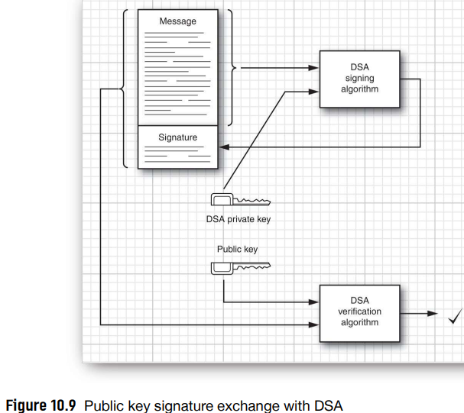
+A wants to send B a message, B wants to know this message came from A and not an impostor. A writes the message and signs the message digest with her private key. B gets a copy of her public key. B then apply the public key to verify the signature. If the verification passes, B can know that:
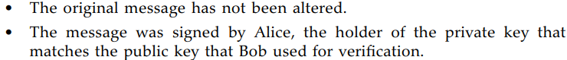

10.4.3 Verifying a Signature
-keytool: a command-line tool to generate and manage a set of certificates
-keytool program manages keystores-databases of certificates and private/public key pairs. Each entry in keystore has an alias
-Create a keystore, alice.certs and generate a key pair with alias alice, set the password secret:
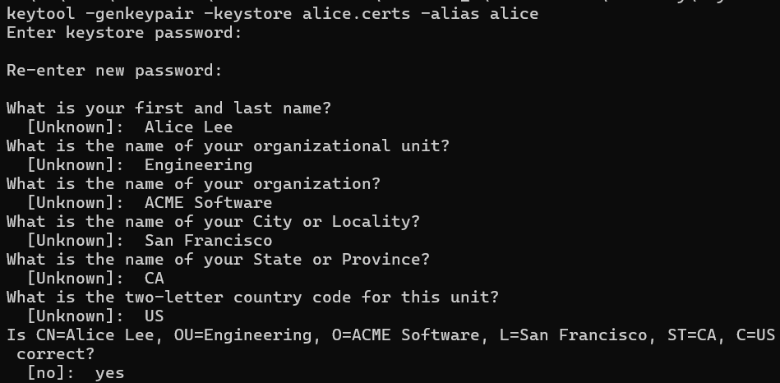
-A wants to give her public key to B, export a certificate file:
-Now A can send certificate to B. When B receives the certificate, he can print it:
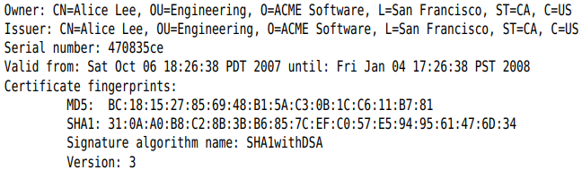
-Once B trusts the certificate, he can import it into his keystore
-Now A can start sending signed documents to B. jarsigner tool signs and verifies JAR files.
+A adds the documents to be signed into a JAR file
+Add signature to the file:
-When B receives the file, use –verify:
+If JAR file is not corrupted and the signature matches, it prints or displays an error message.

10.4.4 The Authentication Problem
-Authentication problem: the problem of determining the identity of the sender.
-The usual way to solve the authentication problem is simple. The stranger and you have an acquaintance you both trust. The stranger meets your acquaintance and hand over a disk with public key. The acquaintance meet you and assures that he met the stranger.
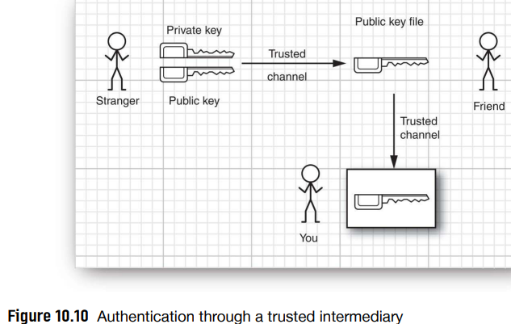
+In fact, your acquaintance doesn’t need to meet you. He can use his private key to sign the stranger’s public key file:
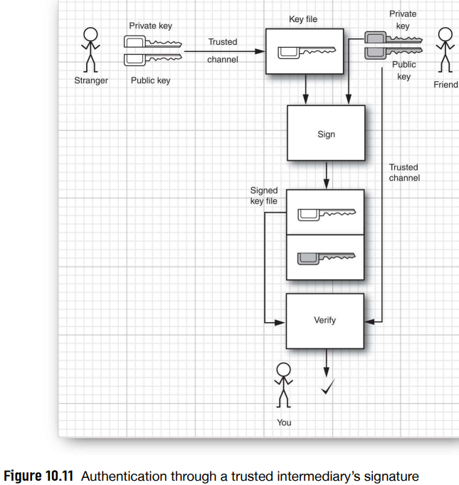
-Trust models assume that there is a big brother-a company in which we all trust: DigiCert, GlobalSign, Entrust provide verification services.

10.4.5 Certificate Signing
-You sawn how A used a self-signed certificate to distribute a public key to B. But B need to ensure that the certificate was valid by verifying the fingerprint with A.
-Suppose A wants to send C a signed message, C trusts the Information Resources Department at ACME Software. That department operates a certificate authority (CA). Everyone at ACME has CA’s public key in their keystore, installed by a system administrator
-Create a keystore acmesoft.certs. Generate a key pair and export the public key:
-Add certificate to every employee’s keystore:
-When A send messages to C and everyone else at ACME, she needs to bring her certificate to IRD and have it signed. CertificateSigner class supplied in this book will do this work. An staff member at ACME verifies A’s identity and generate a signed certificates:
-A gives the file alice_singedby_acmeroot.cer to C and anyone else in ACME.
-Alternatively, ACME can store the file in a company directory. This file contains A’s public key and an assertion by ACME that this key belongs to A.
-C imports the signed certificate into her keystore:
+The keystore verifies that the key was signed by a trusted root key that is present in the keystore.

10.4.6 Certificate Requests
-Most CAs run software to manage certificates, they use different formats for certificates.

10.4.7 Code Signing
-A common use of authentication technology is signing executable programs.
+If you download a program, concern about the damage it can do (virus…)
-Sign the JAR files that contain the program code on web server:
+Generate a root certificate:
+Create a 2nd keystore for public certificates and add public certificate into it:
+Run jarsigner to sign any app that they wish to sign:
-In client machine, to reference a keystore, a policy file starts with:
+URL can be absolute or relative. The type is JSK
+The grant can have signedBy “alias”
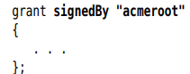

10.5 Encryption
-We have discussed one important cryptographic technique in Java security API: authentication through digital signatures. A 2nd aspect of security is encryption. When information is encrypted, it’s not visible. It can only be decrypted with a matching key.
-Authentication is sufficient for code signing. Encryption is necessary when apps transfer information like credit card numbers or personal data.

10.5.1 Symmetric Ciphers
-Cipher class is superclass of all encryption algorithms.
-getInstance() get a cipher object
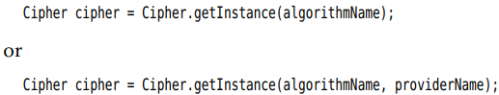
+”SunJCE” is default provider. Use another provider if Oracle doesn’t support algorithms
-Algorithm name is “AES” or
+DES (Data Encrption Standard) is obsolete. The alternative is AES (Advanced Encryption Standard)
-Initialize the cipher object by mode and key:
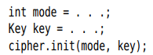
+The mode is one of:
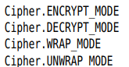
-Repeatedly call update() to encrypt blocks of data:
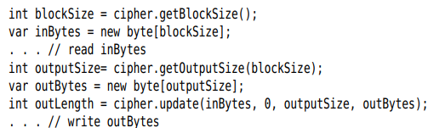
-When you are done, doFinal() once.
+If a final block of input data is available (with fewer than blockSize bytes)
+If all input data have been encrypted:

10.5.2 Key Generation
-To encrypt, generate a key:
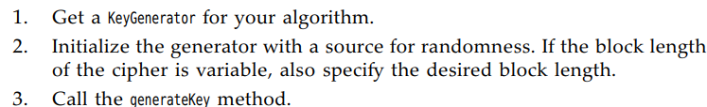
+Example: generate an AES key:
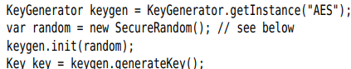
+Alternatively, produce a key from a fixed set of raw data. Construct a SecretKeySpec:
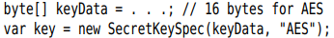
+SecureRandom class generates random numbers that are far more secure than Random class. You can provide a seed to start the number sequence at a random spot:
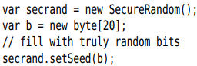
-Only use in the program,
+1st generate a secret key:
+Encrypt:
+Decrypt:
-API: p606

10.5.3 Cipher Streams
-JCE library provides a convenient set of stream classes that automatically encrypt or decrypt stream data.
-Encrypt data to a file:
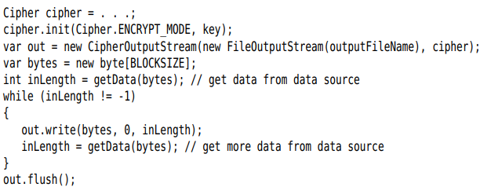
-Read and decrypt data from a file:
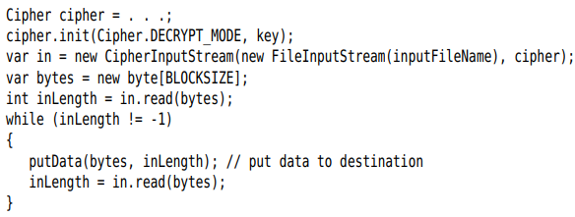
-API: p608

10.5.4 Public Key Ciphers
-AES cipher is a symmetric cipher:
+The same key is used for both encryption and decryption.
+The disadvantage is key distribution. If A sends B an encrypted method, B needs the same key that A used. If A changes the key, she needs to send B both the message and the new key.
-Public key cryptography: B has a key pair consisting of a public key and a matching private key. B can publish the public key anywhere, but he must guard the private key. A uses public key to encrypt her message to B.
+All public key algorithms are much slower than symmetric key algorithms like DES or AES. That problem can be overcome by combining a public key cipher with a fast symmetric cipher:
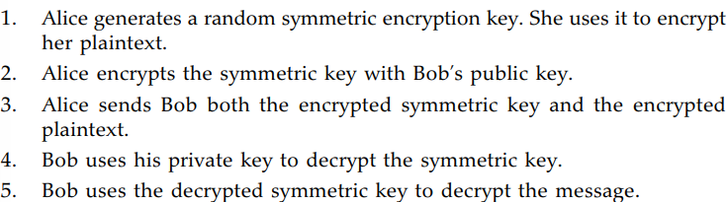
-The most commonly used public key algorithms is RSA algorithm.
+You need a public/private key pair. Use KeyPairGenerator:
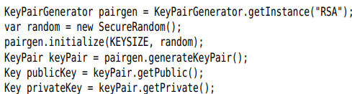
-The program has 3 options:
+-genkey produces a key pair
+-encrypt generates an AES key and wraps it with public key.
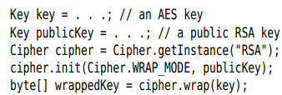
It then produces a file that contains:
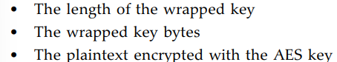

+-decrypt decrypt a file
-Try the program:
+Generate the RSA keys:
+Encrypt a file:
+Decrypt it and verify that the decrypted file matches the plaintext:

