Chapter 4: Networking

4.1 Connecting to a Server
-Connect to a server with Telnet and Java program

4.1.1 Using Telnet
-Telnet is a debugging tool for network programming
-Use telnet to connect to a remote computer or communicate with services provided by Internet hosts.
-Example: connect to the “time of day” service most UNIX machines run. This service is attached to port number 13.b
+Note: Port is an abstraction facilitating communication between a server and a client.
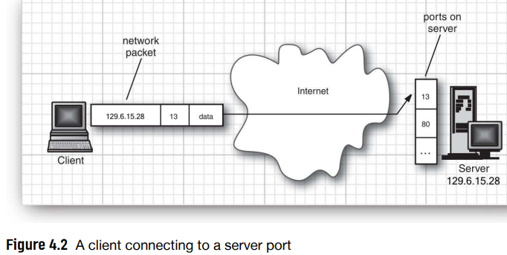
+The server software is continuously running on the remote machine, waiting for any network traffic that wants to chat with port 13.
+When the OS on the remote computer receives a network package containing a request to connect to port 13, it wakes up the listening server process and establishes the connection. The connection stays up until it’s terminated by one of the parties.
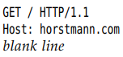

4.1.2 Connecting to a Server with Java
-Example: Connect to a port and print out what it finds. The key statements of this program are:
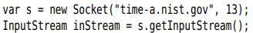
-Socket class is easy to use because Java library hides the complexities of establishing networking connection and sending data. Java.net package give the same programming interface with a file.
-API: Socket: Socket() and getInpuStream(), getOutputStream p232

4.1.3 Socket Timeouts
-Reading from a socket blocks until data are available.
-setSoTimeout(): set a timeout value
+You can catch the SocketTimeoutException and react the timeout:
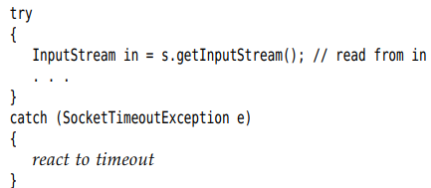
-There is no timeout for write operations.
-block indefinitely until a connection to the host is established. Overcome this problem:
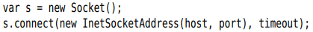
-API: p233

4.1.4 Internet Addresses
-InetAddress class: convert between host names and IP.
-java.net supports IPv6
+InetAddress.getByName():
+getAddress():
-Some host names correspond to multiple I addresses. One of them is picked at random when this host is accessed. Get all hosts with getAllByName():
-Localhost:
-API: p235

4.2 Implementing Servers

4.2.1 Server Sockets
-Starting, a server program waits for a client to attach to its port.
-ServerSocket class establishes a socket:
tell the program to wait indefinitely until a client connects to that port. Once sb connects to this port, the method returns Socket object representing the connection. You can use this to get input and output streams:
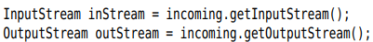
+Things server sends to server output becomes the input of client program, all the output from client program ends up in server input stream.
+Turn the streams into scanners and writers:
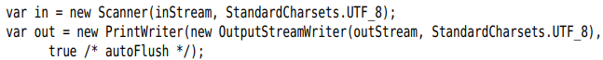
+Send the client:
+Read the client’s input:
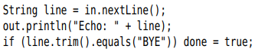
+Close the socket:
-Every server program (HTTP web server), perform loop:
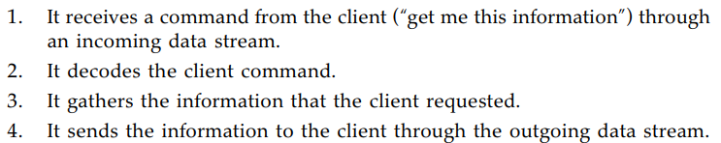
-API: p239

4.2.2 Serving Multiple Clients
-Suppose we want to allow multiple clients to connect to our server at the same time. A server run on a server computer, and clients use it at the same time. Use thread
+When the program establishes a new socket connection, launch a new thread to take care of the connection between the server and that client.
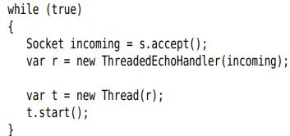
+ThreadedEchoHandler class implements Runnable and contains communication loop with client in run():
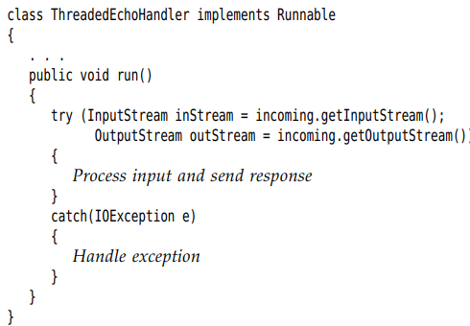

4.2.3 Half-Close
-The half-close allows one end of a socket connection to terminate its output while still receiving data from the other end.
-Example: client side
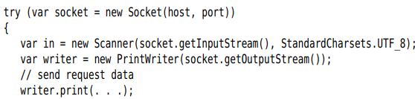
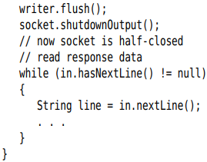
+The server side reads input until the end of input stream is reached. Then it sends the response.
-This protocol is useful for one-shot services like HTTP
-API: p244

4.2.4 Interruptible Sockets
-In interactive apps, give users an option to cancel a socket connection. Use SocketChannel of java.nio:
+A channel has read() and write() use Buffer objects.
+If you don’t want to deal with buffers, use Scanner:
+Turn a channel into an output stream:
-API: p251

4.3 Getting Web Data

4.3.1 URLs and URIs
-URL and URLConnection classes retrieve information from a remote site.
+Construct a URL object from a string:
+Fetch the contents of resource:
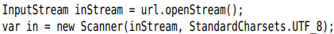
-java.net make a distinction between URLs (uniform resource locators) and URIs (uniform resource identifiers)
+URI is a purely syntactical construct containing various parts of the string specifying a web resource.
+URL is a special kind of URI, one with sufficient information to locate a resource.
+URN (uniform resource name): other URI is no data
-URI class has no methods for accessing the resource, URL class can open a stream to the resource. So URL class only works with schemes: http:, https:, files:, jar:
-URI class parse an identifies and break it up into its components:
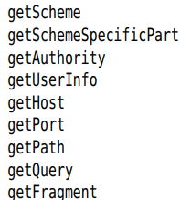

4.3.2 Using a URLConnection to Retrieve Information
-URLConnection class give more control than basic URL.
-Carefully schedule the steps:
+openConnection() of URL class to obtain URLConnection
+Set any request properties:
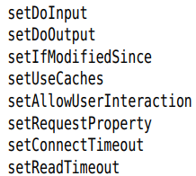
+connect(): connect to server and query the server for header information
+getHeaderFieldKey() and getHeaderField() enumerates all fields of the header. For convenience, use:
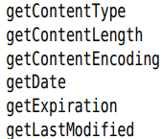
+Access the resource data: getInpuStream(), getContent()
-Look at methods of URLConnection:
+setDoInput() and setDoOutput(): By default, the connection yields an input stream but no output stream. Call:
+Set some request headers: setIfModifiedSince(), setRequestProperty()
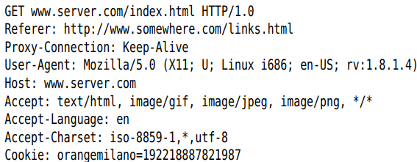
+Some parameters are not documented and are passed from one programmer. Example: access a password-protected web page:
+Query the response header information:
get the nth key
return nth value
return a Map of response header fields
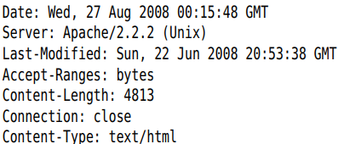
Tip: obtain the response status line as
As convenience, 6 methods query the values of most common header types and convert them to numeric type
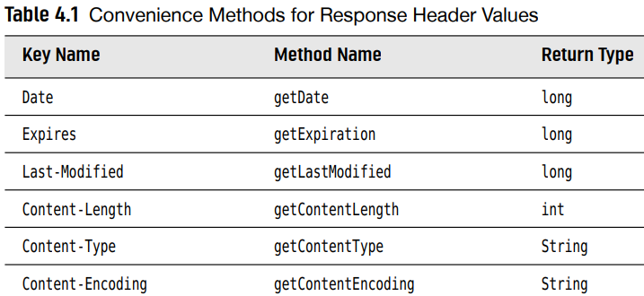
-API: p259

4.3.3 Posting Form Data
-To send information from a web browser to web server, a user fills out a form.
+When user click Submit button, information in form is sent back to web server. The web server invokes a program that processes the user input.
+Many technologies enable web servers to invoke programs: Java servlets, JavaServer Faces, Microsft ASP, CGI scripts.
-The server-side program processes the form data and produces another HTML pages that the web server sends back to the browser
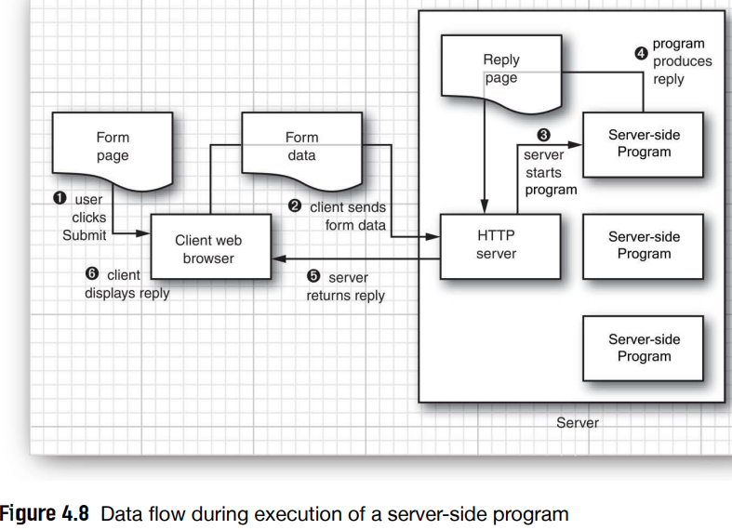
-When form data are sent to web server, it doesn’t matter whether the data are interpreted by which server-side technology. The clients sends the data in a standard format, and web server take care of passing it on to the program generating the response.
-GET and POST commands are used to send information.
-GET: attach query parameters to the end of URL
+URL form:
+Parameter form: separated by &.
+Parameter values are encoded using URL encoding scheme, following these rules:
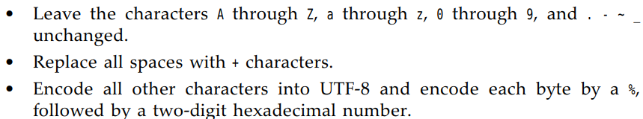
+Example:
+Very long query strings can look unattractive, older browsers and proxies have a limit on the number of characters including in GET request.
-POST: used for forms with a lot of data
+Get an output stream from URLConnection and write name/value pairs to the output stream. You still have to URL-encode the values and separate them with &.
+The process:
Establish a URLConnection:
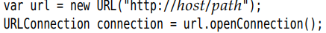
setDoOutPut()
getOutputStream() and wrap the stream into PrinWriter
Send data to server:
Close output stream:
getInputStream() and read server response.

4.4 The HTTP Client

4.5 Sending E-Mail
<CONTINUE LATER>

