Chapter 5: Database Programming
-1996, Sun released the 1st version of JDBC API: let programmer connect to a database to query or update it using SQL.

5.1 The Design of JDBC
-Provide a pure Java API for SQL access along with a driver manager to allow 3rd party driver to connect to specific databases.
-Programs written according to the API talk to the driver manager, which uses a driver to talk to actual database.

5.1.1 JDBC Driver Types
-JDBC specification classifies drivers into 4 types:
+type 1 driver: translate JDBC to ODBC and relies on ODBC driver to communicate with database.
+type 2 driver: written partly in Java and partly in native code. It communicates with the client API of a database.
+type 3 driver: a pure java client library using a database-independent protocol to communicate database request to a server component, which then translates requests into a database-specific protocol.
+type 4 driver: pure Java library translate JDBC requests directly to a database-specific protocol.
-Most database vendors supply type 3 or 4 driver.
-Summary, JDBC:
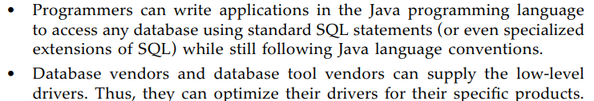

5.1.2 Typical Uses of JDBC
-The traditional client/server model has a rich GUI on the client and a database on the server:
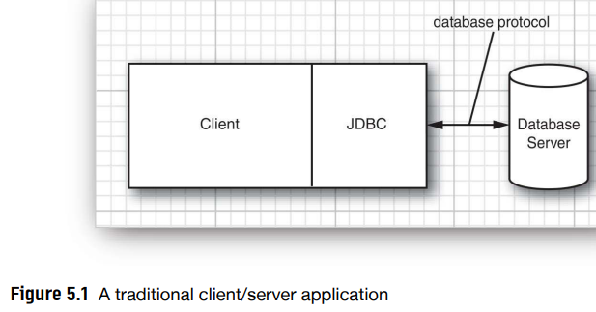
+In this model, a JDBC driver is deployed on the client.
-Nowadays, it has a three-tier model where the client app doesn’t make database calls. It calls on a middleware layer on the server that in turn makes the database queries.
+Communication between client and middle tier occurs through HTTP. JDBC manages the communication between the middle tier and back-end database.
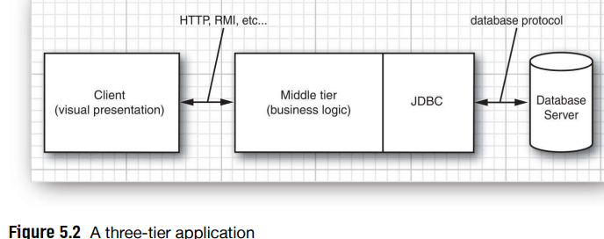

5.2 The SQL
-SQL: the command language for essentially all modern relational database. Server-based database are accessed purely through SQL.
-JDBC package is an API for communicating SQL statements to database.
-We use a set of database tables that describe a collection of classic computer science books:
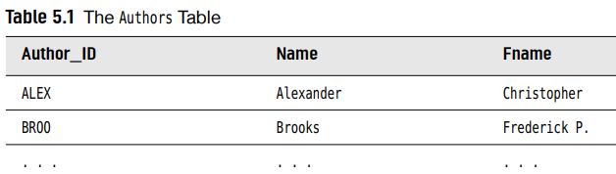
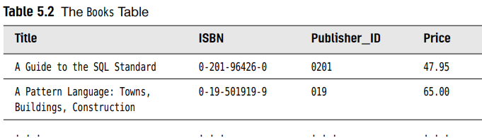
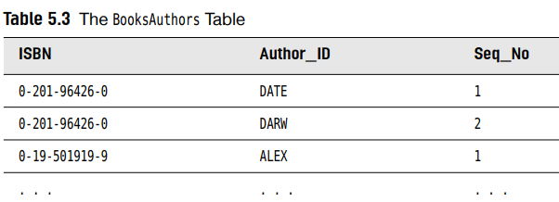
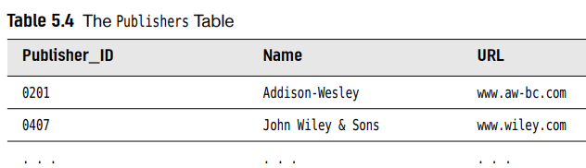

5.3 JDBC Configuration
-You need a database program for which a JDBC driver is available: IBM DB2, Microsoft SQL Server, MySQL, Oracle, PostgreSQL.
-You must also create a database named COREJAVA.

5.3.1 Database URLs
-Connect to a database: host names, port numbers and database names.
-JDBC uses a syntax similar to URLs:
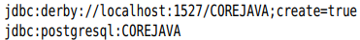
-The general syntax:
+subprotocol: selects the specific driver to connect to the database.
+otherstuff: depends on subprotocol. Look up the vendor’s documentation for specific format.

5.3.2 Driver JAR Files
-Obtain the JAR file in which the driver for your database is located. Include the driver JAR file on the class path when running a program that accesses the database.

-When launch programs from cmd, use:
-On Windows, use a semicolon to separate the current directory (instead of : ) from the driver JAR location

5.3.3 Starting the Database
-The database server needs to be stared before you can connect to it. The details depends on your database.

5.3.4 Registering the Driver Class
-Many JDBC JAR files automatically register the driver class if they contain a file Unzip the driver’s JAR file to check.
+If the driver’s JAR file doesn’t support automatic registration, find out the name of JDBC driver classes used by your vendors:
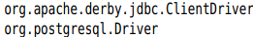
-2 ways to register the driver with DriverManager:
+Load the driver class in Java program:
+Set the jdbc.drivers property with cmd arugment:
Or set the system property:
+You can also supply multiple drivers:

5.3.5 Connecting to the Database
-In java program, open a database connection:
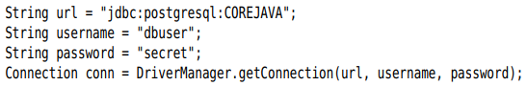
-See the example.

5.4 Working with JDBC Statement
-Use JDBC Statement to execute SQL statements, obtain results, deal with errors, populate a database.

5.4.1 Executing SQL Statements
-Execute a SQL statement, 1st create Statement object by Connection from DriverManager.getConnection()
-Place the statement into a string:
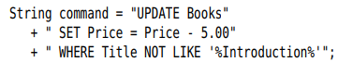
-executeUpdate() of Statement interface:
+executeUpdate() return a count of rows affected by SQL statement or zero.
+executeUpdate() can execute actions INSERT, UPDATE, DELETE, CREATE TABLE, DROP TABLE…
-executeQuery(): SELECT
+This method returns ResultSet object to walk through the result one row at a time:
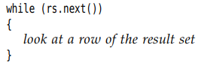
+The order of rows is arbitrary. You can specify with ORDER BY
+Take the contents of the fields:
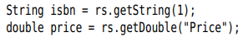
There are accessors for various type, such as getString() and getDouble(). Each accessor has 2 forms: string (name column) and numeric (number column) argument.
Each get method make type conversions. Example: getString() convert any type to string.
-execute(): catch-all statement to execute arbitrary SQL statements. It’s commonly used only for queries that a user supplies interactively. Return boolean
-API: p301

5.4.2 Managing Connections, Statements, and Result Sets
-Every Connection object can create one or more Statement objects. You can use the same Statement object for multiple unrelated commands and queries.
-A statement has at most one open result set. If you want multiple queries concurrently, use multiple Statement.
-There is a limit to the number of statements per connection. Use getMaxStatements() of DatabaseMetaData interface.
-close() when you done using ResultSet, Statement or Connection. closeOnCompletion() on Statement close automatically as soon as all its result sets have closed.
-Use try-with-resource with short-lived connection:
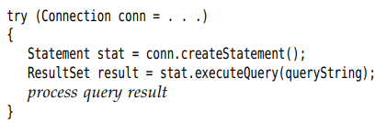

5.4.3 Analyzing SQL Exceptions
-Each SQLException has a chain of SQLException objects that are retrieved with getNextException(). This exception chain is in addition to the chain of Throwable objects. Use for():
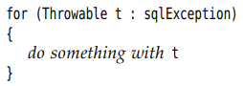
-getSQLState() and getErrorCode() on SQLException to analyze it further.
-SQL exceptions are organized into an inheritance tree:
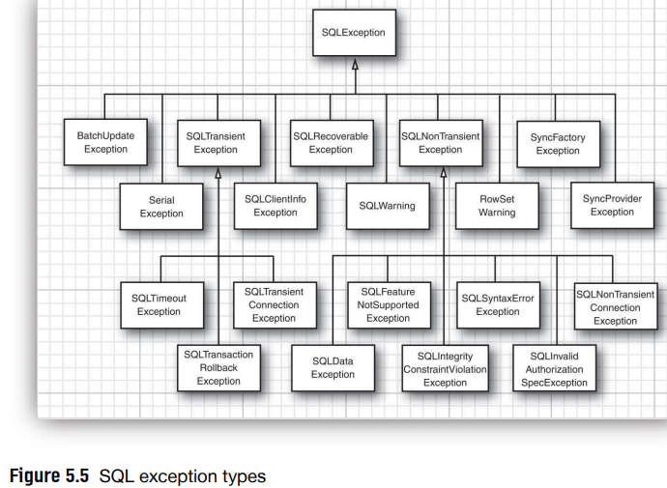
-The database driver can report warnings. SQLWarning is a subclass of SQLException.
+getSQLState() and getErrorCode() to get further information about the warning.
+Warnings are chained. Retrieve all warnings:
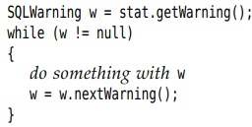
-DataTruncation is subclass of SQLWarning when data read from database are truncated. If data truncation happens in an update statement, a DataTruncation is thrown as exception.
-API: p305

5.4.4 Populating a Database
-Populate a database: insert data into it.
-We will use JDBC in a simple program that reads a file with SQL instructions
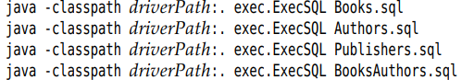
-Note: your database has a utility to read SQL files directly:

5.5 Query Execution

5.5.1 Prepared Statements
-Prepared statements:
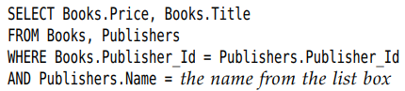
+We prepare a query with a host variable and use it many times, each time filling in a different string for the variable. -> improve performance
+Each host variable in a prepared query is indicated with a ?. If there is more than one variable, keep track of the positions of ? when setting the values
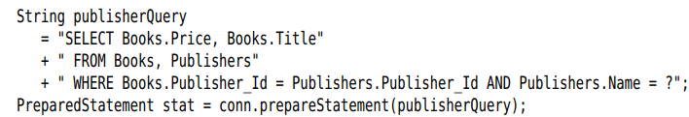
-You must bind the host variables to actual values with set(). There are different set() for various types
+ 1st argument is the position number of the host variable. 2nd argument is the value.
+If you reuse a prepared query that already executed, all host variables stay bound unless you change them with set() or clearParameters().
-Once all variables have been bound to values, execute the prepared statement:
-Tip: Building a query manually, by concatenating strings, is tedious and dangerous and injection attack. So use prepared statements.
-executeUpdate() return the count of changed rows.
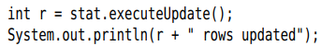
-Note: PreparedStatement object becomes invalid after Connection object is closed. But many databases automatically cache prepared statements.

5.5.2 Reading and Writing LOBs
-In addition to numbers, strings, dates, many databases can store large objects (LOBs) like images or other data.
-In SQL, binary large objects are BLOBs, character large objects are CLOBs.
-Read a LOB: execute a SELECT statement and call getBlob() or getClob() to return Blob or Clob object
+getBlob(): getBytes() or getBinaryStream()
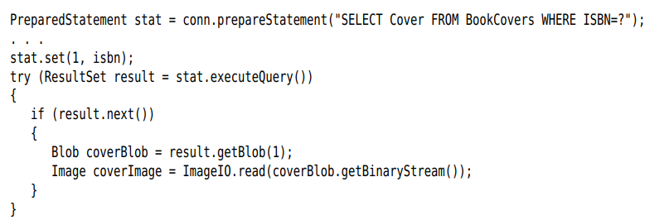
+getClob(): getSubString or getCharacterStream()
-Place a LOB into a database: createBlob() or createClob() on Connection object. Get an output stream or writer to LOB, write the data, store the object in database
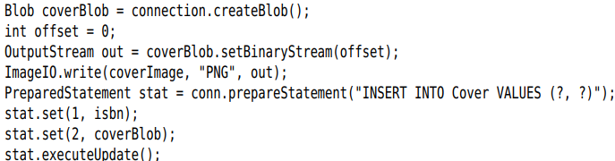
-API: p318

5.5.3 SQL Escapes
-“escape” syntax features are supported by databases but use database-specific syntax variations. JDBC driver translates the escape syntax to syntax of database.
-Date and time literals: Use d, t, ts for DATE, TIME or TIMESTAMP values:
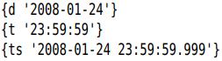
-Scalar function: function returns a single value.
+Embed the standard function name and arguments:
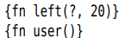
-Stored procedure: procedure that executes in the database. Use call escape. Use = to capture return value:
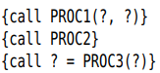
-Outer join
-_ and % in LIKE:
+No standard way to use them literally.
+Example: match all strings containing a _


5.5.4 Multiple Results
-Return multiple results when executing a stored procedure, database that allow submission of multiple SELECT statements in single query.
-Retrieve all results sets:
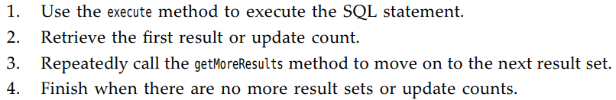
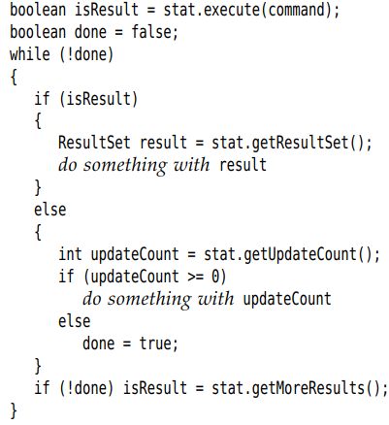

5.5.5 Retrieving Autogenerated Keys
-Most databases support mechanisms for autonumbering rows in database. They differ among vendors. The automatic numbers are often used as primary key.
-Retrieving them:
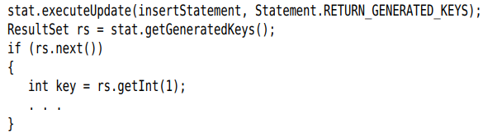

5.6 Scrollable and Updatable Results Sets
-In a scrollable result, you can move forward and backward through a result set and jump to any position.
-In an updatable result set, you can update entries so that the database is automatically updated.

5.6.1 Scrollable Result Sets
-By default, result sets are not scrollable or updatable.
-Must obtain a different Statement object with:
-For a prepared statement:
-type and concurrency:
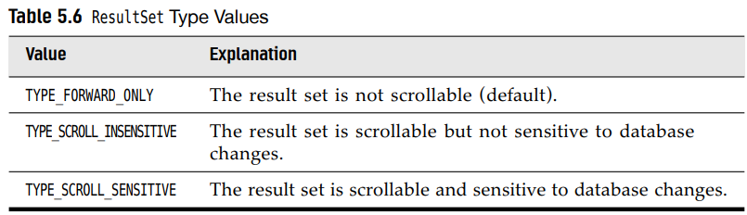
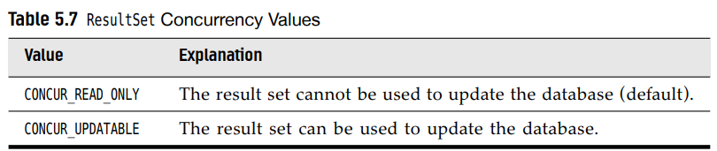
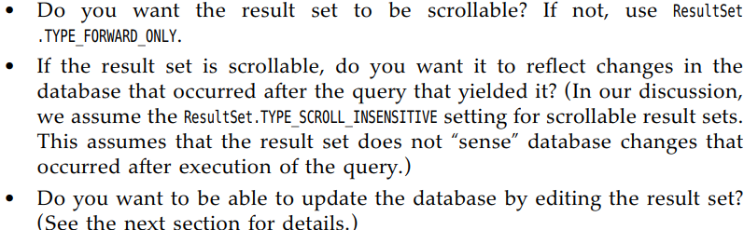
-Example: scroll through a result set but don’t edit data:
+Return the result sets:
are now scrollable. A scrollable result set has a cursor that indicates the current position.
-Note: Not all database drivers support scrollable or updatable result sets
+supportsResultSetType() and supportsResultSetConcurrency() of DatabaseMetadata interface tell which types and concurrency modes are supported by a database using a driver.
+getType() and getConcurrency() of ResultSet interface to find out what mode a result set actually has.
-Scrolling:
+ return true or false
+ move the cursor by any number of rows
+ set the cursor to a row number
+ get the current row number
+first(), last(), beforeFirst(), afterLast()
+isFirst(), isLast(), isBeforeFirst(), isAfterLast()

5.6.2 Updatable Result Sets
-Obtain updatable result sets:
-Note: Not all queries return updatable result sts
+The query is a join involves multiple tables not updatable
+The query involves only a single table or join multiple tables by their primary key: you should expect the result set to be updatable.
+getConcurrency() to find out.
-Update:
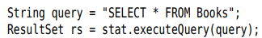
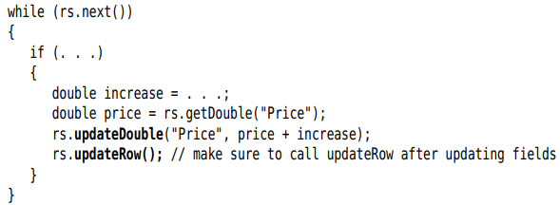
+There are updateXXX methods for all data types that correspond to SQL types: updateDouble(), updateString()
+Note: If you use updateXXX whose 1st parameter is the column number, be aware that this is the column number in the result set.
+updateXXX changes only the row values, not the database. Use updateRow(). You can also call cancelRowUpdates() cancel the updates to current row
-Add a new row to database:
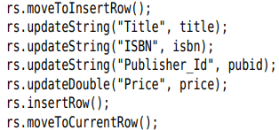
+You can’t influence where the new data is added in the result set or database.
+If you don’t specify a column value in insert row, it’s set to SQL NULL. If the column has a NOT NULL constraint, an exception is thrown and the row is not inserted.
-Delete the row under the cursor:
-To sum up, java programmers might find it more natural to manipulate the database contents through result sets than by constructing SQL statements.
-For the advanced features of JDBC, see: JDBC™ API Tutorial and Reference, Third Edition and JDBC specification
-API: p328

5.7 Row Sets
-For scrollable results sets, you need to keep database connection open during the UI.
-RowSet interface extends the ResultSet, but row sets don’t have to be tied to a database connection.
-Row sets are also suitable if you need to move a query result to a different tie of a complex app, or to another device such as a cell phone.

5.7.1 Constructing Row Sets
-javax.sql.rowset package provides:
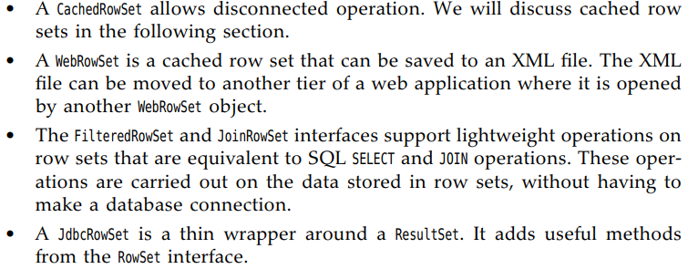
-As of Java 7, there is a standard way to obtain a row set:
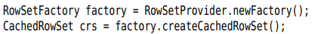

5.7.2 Cached Row Sets
-A cached row set contains all data from a result set. Since CachedRowSet is a subinterface of ResulSet, you can use a cached row set exactly as a result set.
-You can close the connection and still use row set.
-It’s possible to modify data in cached row set. The modifications are not immediately reflected in database, make an explicit request to accept the changes. The CachedRowSet then reconnect the database and issues SQL statements to write changes.
-Populate a CachedRowSet from a result set:
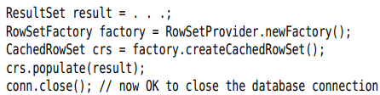
-Or you let CachedRowSet object establish a connection automatically:
+Set up database parameters:
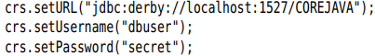
+Set query statement and any parameters:
+Populate the row set with query result:
-If the query results is very large, users will only look at a few rows. Specify a page size:
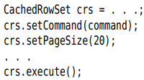
+Get the next batch of rows:
-You can inspect and modify the row set with same methods you use for result sets. If you modified the row set contents, write it back to database:
or
-If the data in database have changed after you populated the row set. The reference implementation checks for synchronization.
-API: p332

5.8 Metadata
-JDBC can give you additional information about the structure of a database and tables.
-In SQL, data that describe the database are metadata (to distinguish them from actual data). You get 3 kinds of metadata: database, result set, parameters of prepared statements.
-Database: request a DatabaseMetaData object:
+Get some metadata:
+Each row in result set contains information about a table in database. 3rd column is table name
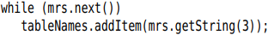
-ResultSetMetaData reports information about result set
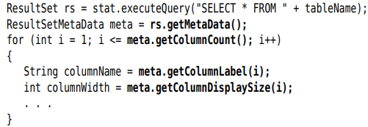
-Note: Many databases have more sophisticated tools for viewing and editing tables: DBeaver, Squirrel. These programs can view tables in any JDBC database.
-API: p343

5.9 Transactions
-You can group a set of statements to form a transaction. It can be committed when all has gone well-or an error has occurred in one of them, it can be rolled back as if none of the statements had been issued.
-The major reason for grouping statements into transactions is database integrity.

5.9.1 Programming Transactions with JDBC
-By default, database connection is in autocommit mode –each SQL statement is committed to database as soon as it is executed. Once a statement is committed, you can’t roll it back.
-Turn off the default:
-Create a statement object in normal way:
-executeUpdate() any number of times:
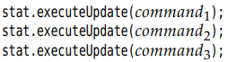
-If all statements have been executed without error:
-If an error occurred:
+All statements since the last commit are automatically reserved. You issue a rollback when the transaction was interrupted by a SQLException

5.9.2 Save Points
-Create a save point marks a point to which you can later return without having to abandon entire transaction.
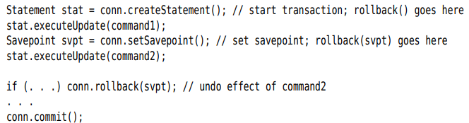
-If you no longer need a save point:

5.9.3 Batch Updates
-In a batch updates, a sequence of statements is collected and submitted as a batch.
-Note: use supportsBatchUpdates() of DatabaseMetaData to find out if the databse supports this feature.
-Execute a batch:
+Create a Statement object:
+addBatch() instead of executeUpdate():
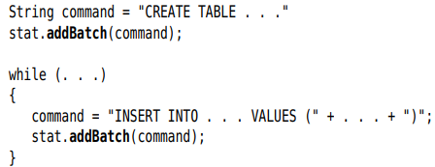
+Submit the entire batch:
returns an array of row counts for all submitted statements.
-Treat the batch execution as a single transaction. If a batch fails in the middle, roll back to the state before the beginning of the batch.
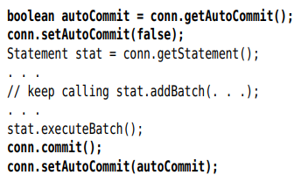
-API: p347

5.9.4 Advanced SQL Types
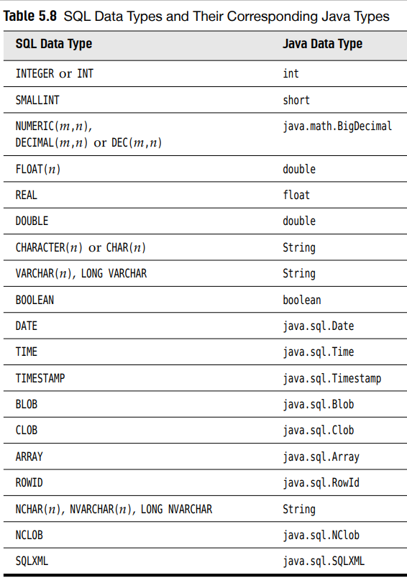
-See more in “JDBC API Tutorial and Reference” and JDBC specification

5.10 Connection Management in Web and Enterprise Applications
-The simplistic database connection setup with a database.properties is suitable for small test programs but won’t scale for larger app.
-When a JDBC app is deployed in a web or enterprise environment, the management of database connections is integrated with the JNDI. The properties of data source across the enterprise can be stored in a directory.
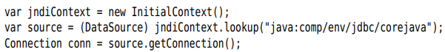
+JNDI service locates a data source: an interface that allows for JDBC connections and more advanced features: distributed transactions involving multiple database. DataSource interface in javax.sql.
-Note: In a Java EE container, simply use Resource annotation on DataSource field:
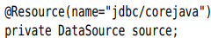
-The data source needs to be configured somewhere. If your write database programs that executes in a servlet container (Apache Tomcat) or in an app server (GlassFish), place the database configuration in a configuration file, or set it in an admin GUI.
-Another issue is the cost of establishing database connections. The solution is to pool connection: Database connections are not physically closed but are kept in a queue and reused.
+Vendors of web container and app servers supply connection pool implementation.
+getConnection() from a source of pooled connections. close() when done using the connection.
-For advanced JDBC capabilities, refer to JDBC API Tutorial and Reference or the JDBC specification

