Chapter 6: The Date and Time API

6.1 The Time Line
-Java Date and Time API specification requires that Java use a time scale that:
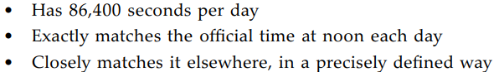
-Instant represents a point on the time line.
+An origin (epoch) is set at midnight of 1/1/1970 at the prime meridian passing through Greenwich Royal Observatory in London. Time is measured in 86400 seconds per day, to nanosecond precision. Instant values go back as far as a 1 billion years.
+Instant.MAX is 31/12/1000000000
+Instant.now() give the current instant.
+Instant.truncatedTo(ChronoUnit): make a copy
+You can compare 2 instants with equals() and compareTo().
+Duration.between() find out the difference between 2 instants. Example: measure the running time algorithm:
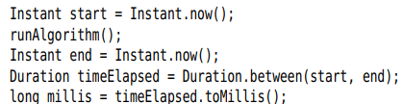
-Duration is the amount of time between 2 instants. You can get the length of Duration by toNanos(), toMillis(), getSeconds(), toMinutes(), toHours(), toDays()
+toString() format: PT…H…M…S
+Duration API has methods to carry out arithmetic.
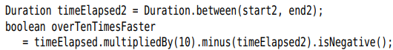
-Note: Instant and Duration classes are immutable, all methods return a new instance.
-API: p357

6.2 Local Dates
-There are 2 kinds of human time in Java API: local date/time and zoned time.
-Local date/time has a date and/or time of day, no associated time zone information.
+Example: local date is June 14, 1903. Zoned date/time is July 16, 1969, 09:32:00 EDT
+TemporalAccessor interface (get)-> Temporal interface (plus, minus, until, with) -> LocalDate,Time… + TemporalAdjuster interface

-LocalDate is a date with a year/month/day of month
-Construct LocalDate with now() or static of():
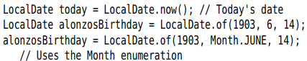
-Compute the day of the year:
-Period express numbers of elapsed years, months, days. toString() Period format: P…D
+ or
+until() yields the different between 2 local dates:
+Find the number of days:
-Caution: some methods in LocalDate could create non-existen dates:
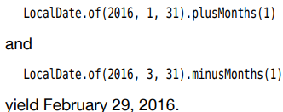
-getDayOfWeek() yields the weekday as a value of DayOfWeek enumeration:
+DayOfWeek enumeration have plus() and minus():
+Note: java.util.Calendar: Sunday has value 1.
-2 methods datesUntil() yield streams of LocalDate:
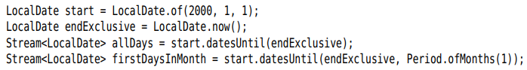
-There are also classes MonthDay, YearMonth, Year to describe partial dates.
-API: p362

6.3 Date Adjusters
-TemporalAdjusters class provides a number of static methods for common adjustments. Pass the result of an adjustment method to with(TemporalAdjuster) or TemporalAdjuster.adjustInto()
-You can make your own adjuster by implementing TemproalAdjuster interface:
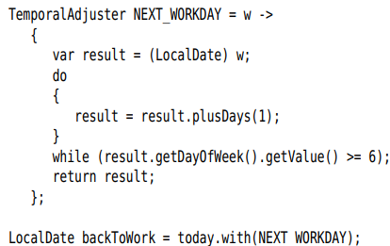
+The parameter of lambda expression has type Temporal, it must be cast to LocalDate. You can avoid this cast with ofDateAdjuster() that expects a lambda of type UnaryOperator<LocalDate>:
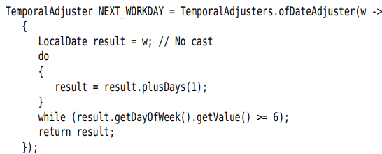
-API: p365

6.4 Local Time
-LocalTime represents a time of day: 15:30:00. You can create an instance with now() or of():
-plus() and minus() wrap around a 24-hour day.
-Note: LocalTime doesn’t concern itself with AM/PM
-LocalDateTime class represent a date and time. This class is suitable for storing points in time in a fixed time zone (schedule of classes or events)
-API: p366

6.5 Zoned Time
-IANA keeps a database of all known time zones around the world (http://www.iana.org/time-zones). Java use the IANA database.
-Each time zone has an ID (America/New_York, Europe/Berlin). ZoneId.getAvailableZoneIds() to find out all available time zones.
-ZoneId.of(id) yields a ZoneId object. You can use it to turn LocalDateTime into ZonedDateTime by local.atZone(zoneId)
-Construct a ZonedDateTime:
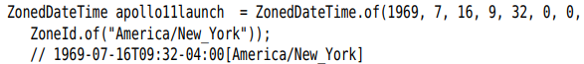
+apollolaunch.toInstant() to get the Instant.
+ get ZonedDateTime from Instant, use ZoneId.
-Many methods of ZonedDateTime are the same as those of LocalDateTime
-Daylight savings time: clocks advance by an hour.
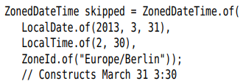
+When daylight time ends, clocks are set back by 1 hour, there are 2 instants with same local time.
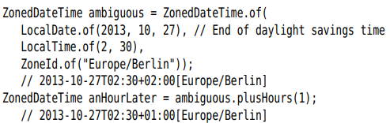
The time has the same hours and minutes, but the zone offset has changed.
+Pay attention when adjusting a date across daylight savings time boundaries. Example: set a meeting for next week, don’t add 7 days:

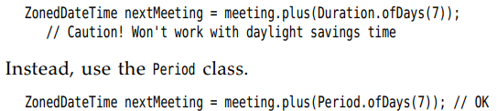
+between ZonedLocalDate in DST and not in DST: need to +1 hour to between time.
-Caution: OffsetDateTime represents times with an offset from UTCm without time zone rules.
-API: p370

6.6 Formatting and Parsing
-DateTimeFormatter class provides 3 kinds of formatters to print date/time value:
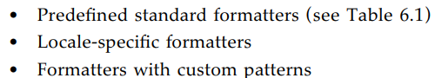
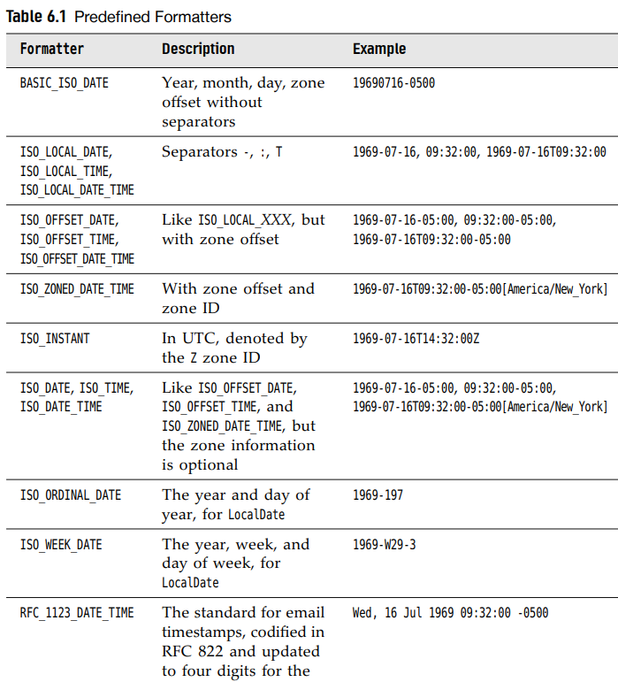
-Use one of the standard formatters:
-To present dates and times to human readers, use locale-specific formatter. There are 4 styles: SHORT, MEDIUM, LONG, FULL
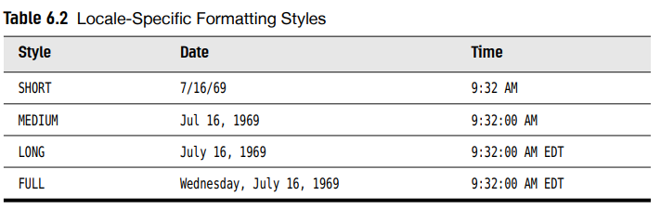
-Static ofLocalizedDate(), ofLocalizedTime(), ofLocalizedDateTime() create a formatter:
+These methods use default locale. Change withLocale()
-DayOfWeek and Month enumerations have getDisplayName() for giving info in different locales and formats:
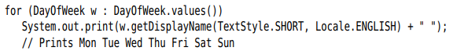
-Note: java.time.format.DateTimeFormatter class is intended as a replacement for java.util.DateFormat. Call formatter.toFormat()
-You can roll your own date format by specifying a pattern:
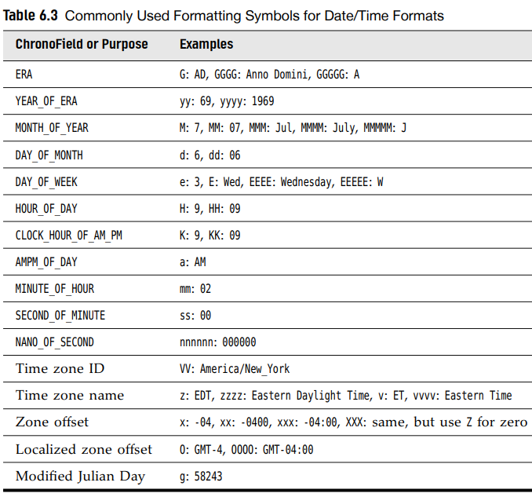
-Parse a date/time value from a string: parse()
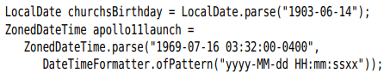
+1st call use standard ISO_LOCAL_DATE formatter. 2nd one use a custom formatter.

6.7 Interoperating with Legacy Code

