Chapter 7: Internationalization

7.1 Locales

7.1.1 Why Locales?
-Simply translating UI text is not sufficient. There are many more subtle differences:
+numbers: (English and German)
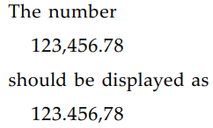
+Date: USA: month/day/year, Germany: day/month/year, China: year.month.day
+German: . and , are reserved.
+If the month names are written out explicitly:
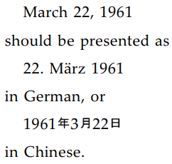
-A locale captures local preferences such as these above.

7.1.2 Specifying Locales
-A locale has 5 components:
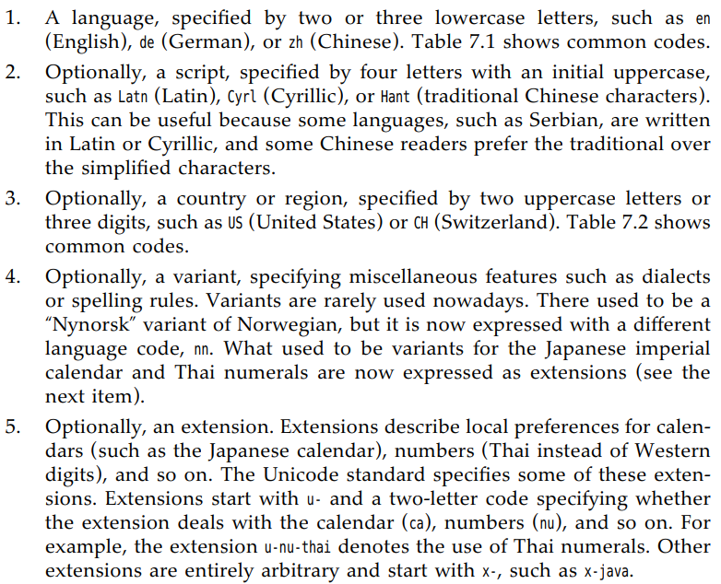
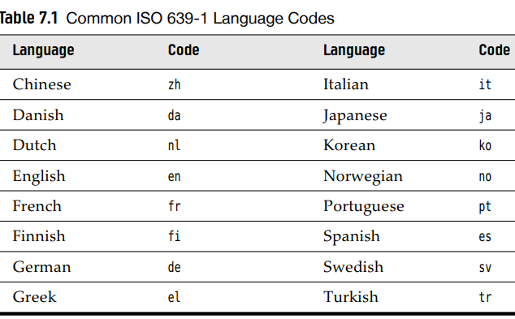
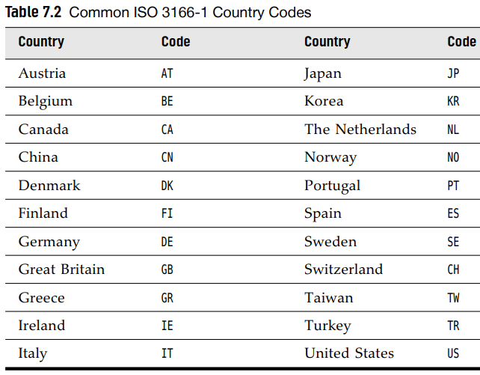
-Rules for locales are formulated in: http://tools.ietf.org/html/bcp47. You can find a more accessible summary at http://www.w3.org/International/articles/language-tags
-Locales are described by tags: hyphenated strings of locale elements: en-US
-Construct a Locale from a tag string:
-toLanguageTag() yields language tag for given locale:
+Predefined locale object for various countries:
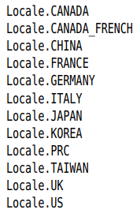
+Predefined locales specify just language without location
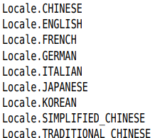
-statc getAvailableLocales() return arrays all locales, Locale.getISOLanguage() get all language code, Locale.getISOCountries() get all country codes.

7.1.3 The Default Locale
-static Locale.getDefault() get default locale stored by local OS. You can change by setDefault()
-Some OSs allow user to specify different locales for displayed messages and for formatting.
+Example: French menu but dollar currency
-Tip: Test language and country locale in command line

7.1.4 Display Names
-The only useful methods in Locale class are those for identifying:
+getDisplayName(): describe the locale that can be presented to a user.
+You can set the preferred language to present string:
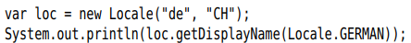
+You feed Locale objects to locale-aware methods that produce text that is presented to users in different locations.
-Note: Explicitly set the locale for input and output operations:
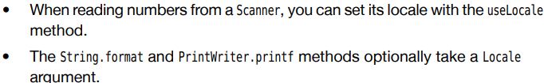
-API: p386

7.2 Number Formats
-Java library supplies a collection of formatter objects that can format and parse numeric values in java.text.

7.2.1 Formatting Numeric Values
-Steps to format a number for a particular locale:
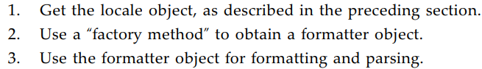
+Factory method are static methods of NumberFormat class taking a Locale argument. There are 3 factory methods: getNumberInstance(), getCurrencyInstance(), getPercentInstance().
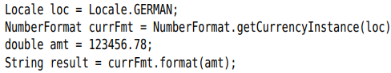
-parse() to read in a number with the convention of a certain locale
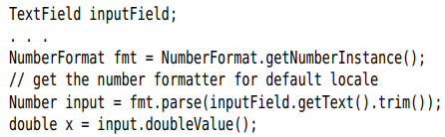
+parse() return abstract type Number. The returned object is Double or Long. Use doubleValue() or intValue()
+If the text isn’t in the correct form, method throws ParseException Whitespace is not allowed (use trim()), characters follow the number in string are ignored.
-getAvailableLocales(): list of currently supported locales
-Note: Use Scanner to read localized integers and floating-point numbers. useLocale() to set locale.

7.2.2 Currencies
-NumberFormat.getCurrencyInstance(): format currency. But it returns a formatter for a single currency.
-Use Currency class to control currency by formatters. Currency.getInstance(currency identifier) and setCurrency() for each formatter:
-The currency identifiers are defined by ISO 4217: https://www.iso.org/iso-4217-currency-codes.html

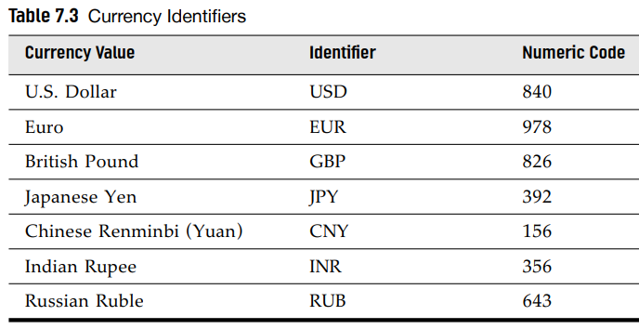
-API: p394

7.3 Date and Time
-Formatting date and time in 4 locale-dependent issues:
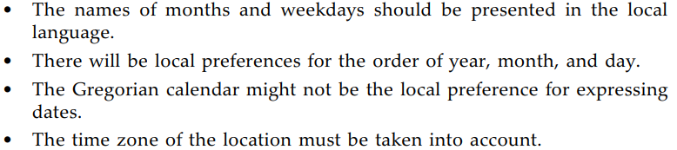
-DateTimeFormatter class from java.time: Pick one formatting style and get a formatter:
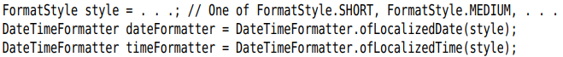
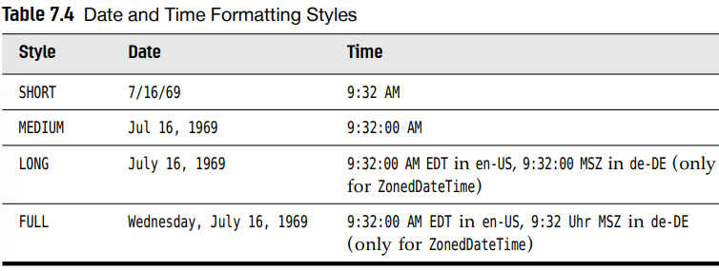
+These formatters use current locale. wittLocale() to use different locale:
+format LocalDate, LocalDateTime, LocalTime, ZonedDateTime:
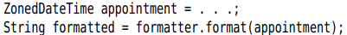
+Use parse() to parse a date or time in a string:
+getDisplayName() of DayOfWeek and Month enumerations to display just names of weekdays and months:
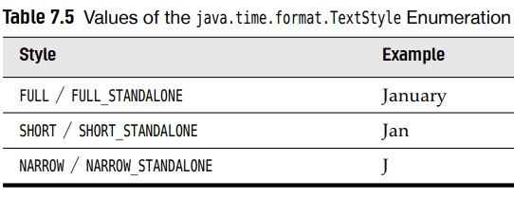
-Note: Obtain the 1st day of the week (maybe Saturday, Sunday, Monday, depending on the locale)
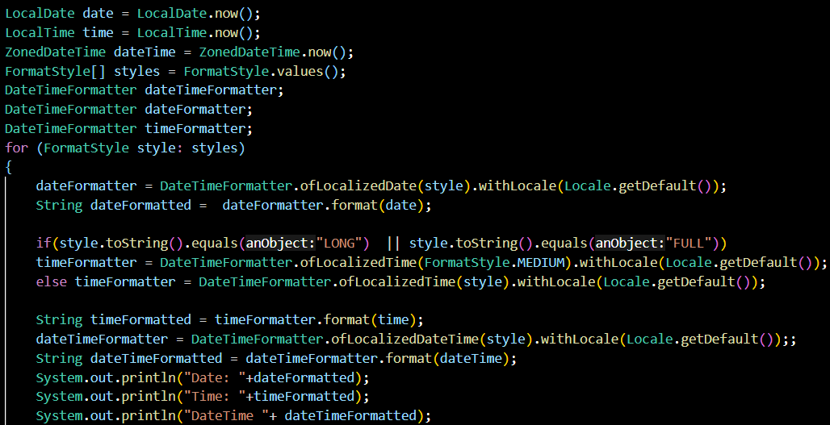

7.4 Collation and Normalization
-Most programmers knows how to compare strings with compareTo(), but when interact with human users, this method is not useful
+compareTo() use UTF-16 encoding value, there are different ordering.
-Collator.genInstace(): a locale-sensitive comparator
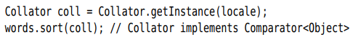
+Collator class implements Coparator interface, you can pass a Collator to List.sort(Comparator)
-Set collator’s strength: Collator.PRIMARY(A-Z), Collator.SECONDARY (A-Ă), Collator.TERTIARY (A-a)
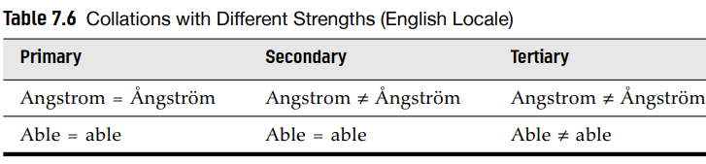
-Collator.IDENTICAL: no differences are allowed. It’s useful in conjunction with decomposition mode
-A character or sequence of characters can be described in more the one way in Unicode. Surprisingly, the letter sequence can be described with a single character.
-Unicode standard defines 4 normalization forms: (D, KD, C, KC) http://www.unicode.org/unicode/reports/tr15/tr15-23.html
+form C: accented characters are composed.
+form D: accented characters are decomposed.
+KC, KD: decompose characters such as ligatures or trademark symbol.
+Choose the degree of normalization. Collator.NO_DECOMPOSITION doesn’t normalize strings. Collator.CANONICAL_DECOMPOSITION use form D. Full decomposition use form KD
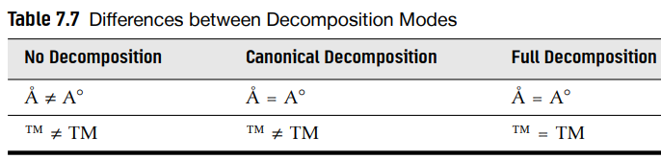
-Save the decomposition in a collation key object
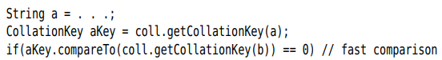
-Convert strings into normalized forms if you don’t do collcation: to store strings in database or communicate with another program. Use java.text.Normalizer:
-W3C recommended mode for transferring data over I: Normalization form C first applies decomposition and then combine the accent back in standardized order.

7.5 Message Formatting
-MessageFormat class formats text with variable parts. It’s similar to formatting with prtinf() but support locales and formats for numbers and dates.

7.5.1 Formatting Numbers and Dates
-MessageFormat.format()
+Supply an optional format for placeholders:
-The placeholder index has a type and a style. Separate the index, type, style by ,.
+The type:
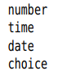
+If the type is number, the style:
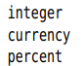or number format pattern $, ##0… See the documentation of DecimalFormat class.
+If the type is time or date, the style:
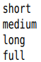or date format pattern: yyyy-MM-dd. See the documentation of SimpleDateFormat class.
-Caution: MessageFormat.format() use current locale. To format with an arbitrary locale:
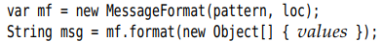
-API: p410

7.5.2 Choice Formats
-The placeholder would replace with the grammatically correct combination.
-choice formatting:
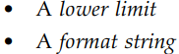
+The lower limit and format string are separated by #, the pairs are separated by |
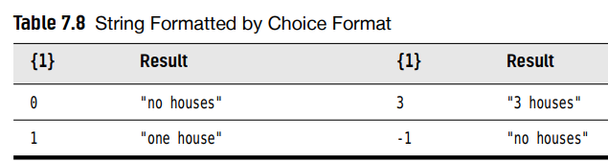
-<, <=,-∞:
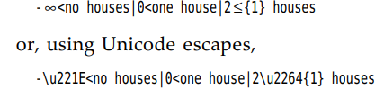
-Put the choice string inside original message string

7.6 Text Input and Output
-Java programming language is fully Unicode-based. Windows and Mac OS X still support legacy character encodings. Communicating with user through text is not simple as it should be.

7.6.1 Text Files
-It’s best to use UTF-8 for saving and loading text files. But you may need to work with legacy files.
-If you know the expected character encoding, specify it
-For a guess of best encoding to use, get platform encoding:

7.6.2 Line Endings
-This is an issue of platforms.
+On Windows, text files use r\n at the end of each line.
+UNIX-based systems use only \n
+Most Windows programs deal with just a \n. The notable exception is Notepad.
-Any line written with println() will be terminated. The only problem is if you print strings containing \n
-Use printf() and %n to produce platform-dependent line endings:
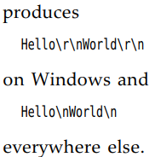

7.6.3 The Console
-Programs that communicates with users through System.in/System.out/System.console() have the possibility that the console may use character encoding different from platform encoding by Charset.defaultCharset().
-Switch the character encoding of console: chcp
-Idealy, users should switch console of UTF-8. Windows:
+It’s also necessary to set the platform encoding with unofficial file.encoding system property:

7.6.4 Log Files
-When log messages from java.util.logging are sent to console, they are written in console encoding. Log message use FileHandle using platform encoding by default.
-Change encoding to UTF-8 in logging configuration file

7.6.5 The UTF-8 Byte Order Mark
-Add a “byte order mark” character U+FEFF as the first character of a file.

7.6.6 Character Encoding of Source Files
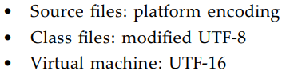
-See UTF-8 and UTF-16 in Chap 1.
-Tip: Specify the character encoding of source files

7.7 Resource Bundles
-Define the message strings in an external location: resource. The person carrying out the translation can edit resource files without touching the source code.

7.7.1 Locating Resource Bundles
-To localize an app, produce a set of resource bundles. +Each bundle is a property file or class that describes locale-specific items (messages, labels…)
+You provide versions for all locales for each bundle
-Specify naming convention for bundles:
+ For all country-specific resources::
+For all language-specific resources
-Load a bundle:
+method tries to load bundles:
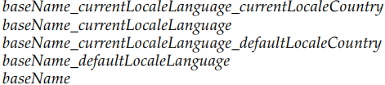
-Tip: Don’t place all resources for app into a single bundle. You could have one bundle for button labels, one for error messages…

7.7.2 Property Files
-Internationalizing: place all strings into a property file.
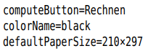
+Name the property files:
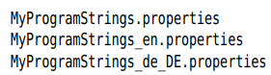
-Load the bundle:
-Look up a specific string:

7.7.3 Bundle Classes
-To define resources that are not strings, define classes extending ResourceBundle class.
-Use the standard naming convention to name classes:
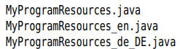
-Load class with getBundle():
-Each resource bundle class implements a lookup table. Provide a key string for each setting you want to localize, use that key string to retrieve setting:
-Extend ListResourceBundle. This class places all resources into an object array and lookup:
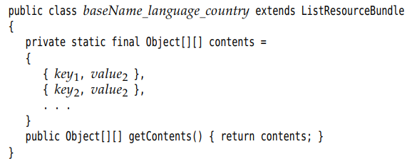
+Example:
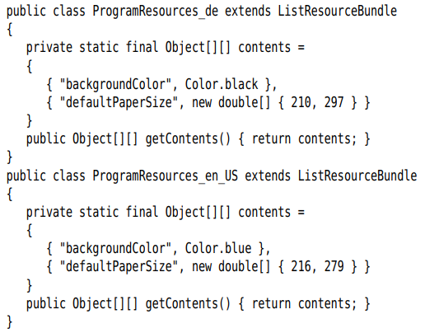
+Note: paper sizes are given in millimeters. Everyone on planet (except US, Canada) use ISO 216. See http://www.cl.cam.ac.uk/~mgk25/iso-paper.html
-Alternatively, the resource bundle can extend ResourceBundle. You need implement 2 methods to enumerate keys and look up value for given key:
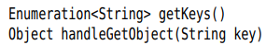
-API: p421

7.8 A Complete Example

