Chapter 8: Scripting, Compiling, and Annotation Processing

8.1 Scripting for the Java Platform
-Scripting language: avoid the usual edit/complie/link/run cycle by interpreting the program text at runtime.
-Advantages:
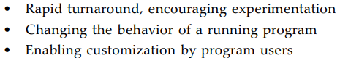
-Disadvantage: lack features of programming complex apps: strong typing, encapsulation, modularity…
-The scripting API: invoke scripts (JavaScript, Groovy, Ruby, Scheme, Haskell,…) from Java program.
+Example: http://www.renjin.org/ provide a Java implementation of R

8.1.1 Getting a Scripting Engine
-Scripting engine: a library executing scripts in a particular language.
+Enumerate them: Construct a ScriptEngineManager and invoke getEngineFactories()
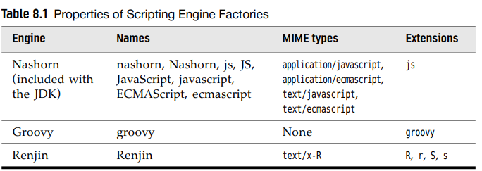
-Request engine:
-API: p441

8.1.2 Script Evaluation and Bindings
-When having an engine, call a script:
-If the script is stored in a file, open Reader:
-You can invoke multiple scripts. Engines retain the definitions for later use:
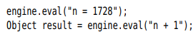
-Note: Find out whether it’s safe to concurrently execute scripts in multiple threads:
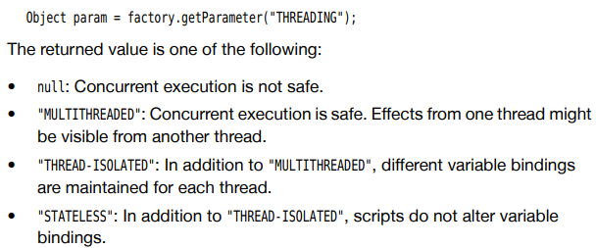
-Add variable binding to engine. A binding consist of a name + an associated Java object:
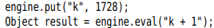
-Most scripting languages can access Java objects
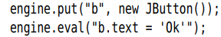
-Retrieve variables that were bound by scripting:
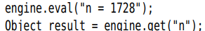
-Engine scope and global scope. Any binding adding to ScriptEngineManager are visible to all engines.
-Collect bindings in Bindings object and pass to eval()
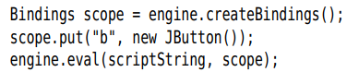
-API: p443

8.1.3 Redirecting Input and Output
-setReader() and setWriter() of script context:
+Any output written with JavaScript print(), println() is sent to writer()
-setReader() and setWriter() only affect the scripting engine’s standard input and output sources:
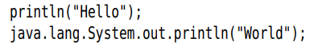
+Only 1st output is redirected.
-Nashorn engine doesn’t have the notion of standard input source. setReader() has no effect.
-API: p 444

8.1.4 Calling Scripting Functions and Methods
-You can invoke a function in scripting language without having to evaluate the actual script code.
-Nashorn engine implements Invocable interface
-To call a function: invokeFunction()
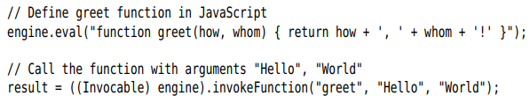
-If the scripting language is object-oriented, invokeMethod():
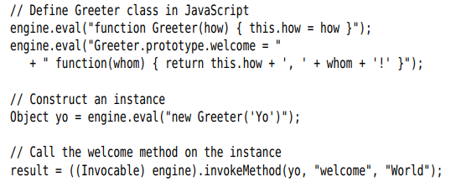
-Note: book JavaScript—The Good Parts
-Note: If the script engine doesn’t implement Invocable, call method in a language-independent way: getMethodCallSyntax() of ScriptEngineFactory interface produces a string that you can pass to eval().
-You can ask scripting engine to implement a Java interface. Then you can call scripting functions and methods with Java method call syntax
+Typically, supply a function for each method of interface.
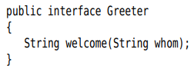
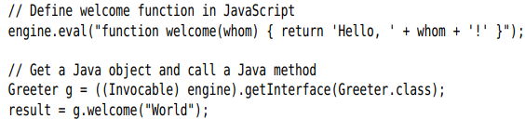
-API: p446

8.1.5 Compiling a Script
-Use Compilable interface to compile scripting code.
-Example: Compile and evaluate code in script file
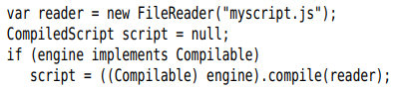
+Once the script is compiled, you can execute it
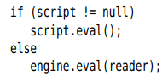
-It’s only makes sense to compile a script if you need to execute it repeatedly.
-API: p447

8.1.6 An Example: Scripting GUI Events
-Note: Nashorn has been removed from Java 15.
Use GraalVM.

8.2 The Compiler API
-Tools that need to compile Java code: development environments, programs, testing and build automation tools.
-JavaServer Pages: web pages with embedded Java statements.

8.2.1 Invoking the Compiler
-Invoke the compiler:
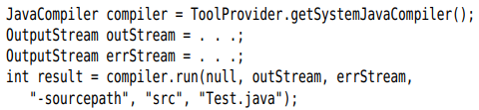
+1st parameter is input stream, always null. The other parameters are arguments you pass to javac on cmd.

8.2.2 Launching a Compilation Task
-More control over the compilation process with CompilationTask object. It’s useful if you supply source from string, capture class files in memory, process the error and warning messages.
-Obtain a CompilationTask, compiler()
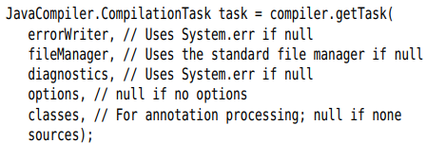
+The last 3 arguments are Iterable instaces. For example, a sequence of options might be:
+sources parameter is an Iterable of JavaFileObject instances. If you want to compile disk files, get StandardJavaFileManager and call getJavaFileObjects():
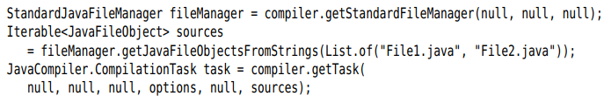
+CompilationTask extends Callable<Boolean>. Pass it to ExecutorService or
+Note: classes parameter is only used for annotation processing. Call task.processors() with a list of Processor objects. See 8.6

8.2.3 Capturing Diagnostics
-Listen to error messages: install a DiagnosticListener interface. The listener receives a Diagnostic object whenever the compiler reports warning/error message.
-DiagnosticCollector collects all diagnostics:
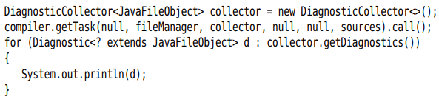
+A Diagnostic object contain info about problem (file name, line number, column number)
-Also install a DiagnosticListener to standard file manager to trap messages about missing files:
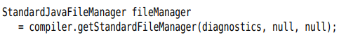

8.2.4 Reading Source Files from Memory
-Hold the code compiled from memory without having to save files to disk:
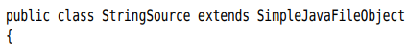
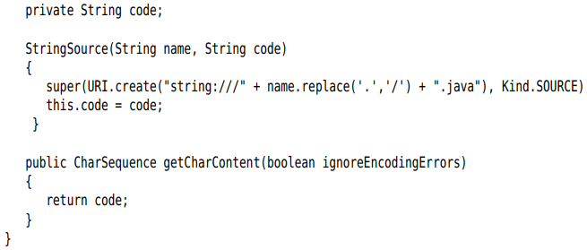
-Then generate the code for the classes and give compiler a list of StringSource objects:
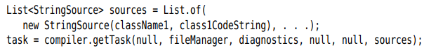

8.2.5 Writing Byte Codes to Memory
-Save class files to memory and load them right away:
-The class for holding the bytes:
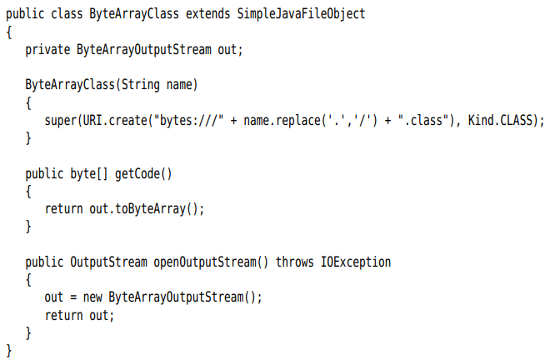
-Configure the file manager to use these classes for output:
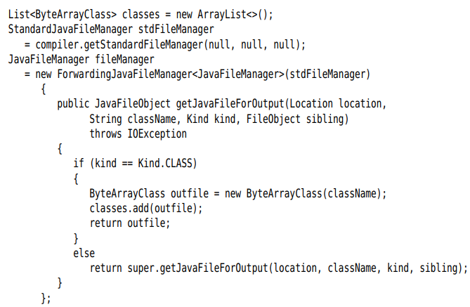
-To load the classes, you need a class loader (Chap 10)
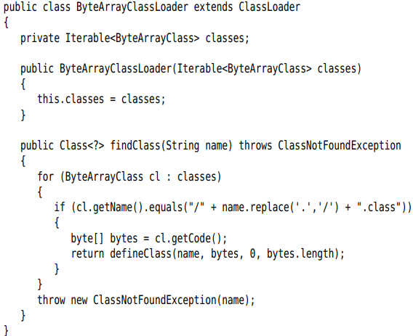
-After compilation has finished, call Class.forName() with that class loader:
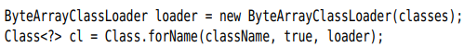

8.2.6 An Example: Dynamic Java Code Generation

8.3 Using Annotations
-Annotation are tags that you insert into the source code so that some tool can process them. The tool can operate on the source level, or process class files into which the compiler has placed annotation.
-Annotations don’t change the way in which the programs are compiled.
-Select a processing tool: Use annotations the processing tool understands, apply the processing tool to the code.
-Some uses of annotations:
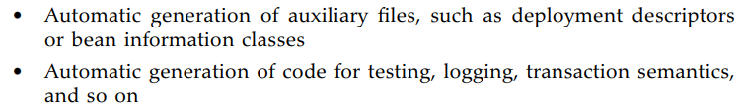

8.3.1 An Introduction into Annotations
-Example:
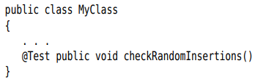
+In Java, annotation is used like a modifier and is placed before the annotated item without a semicolon. Name of annotation is preceded by @.
+By itself, @Test doesn’t do anything. It needs a tool to be useful. Example: JUnit testing tool calls all methods that are labeled @Test when testing a class.
-Annotations can be defined to have elements:
+Elements can be processed by tools.
-Beside methods, you can annotate classes, fields, local variables, packages, parameter variables, type parameters, type users
-Each annotation must be defined by an annotation interface. The method of interface correspond to elements of annotation. Example: JUnit Test annotation
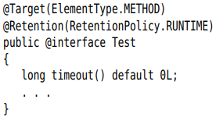
+@interface create an actual Java interface. Tool that process annotations receives objects that implements annotation interface. A tool calls timeout() to retrieve timeout element of Test annotation.
+Target and Retention annotations are meta-annotations. See 8.5.3
-Note: For a compelling use of annotations, check out JCommander (http://jcommander.org/) and picolcli (http://picocli.info/)

8.3.2 An Example: Annotating Event Handles
-Annotation: The programmer no longer has to make calls
Each method is tagged with an annotation
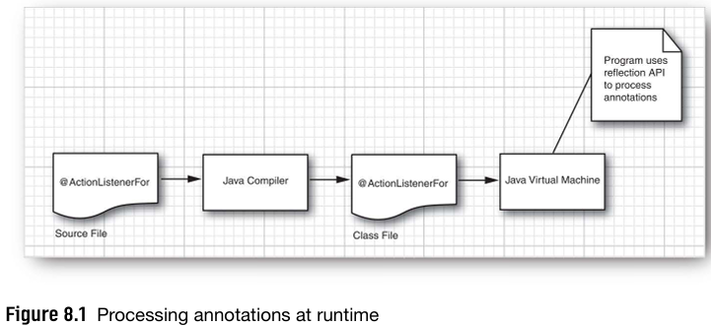

8.4 Annotation Syntax

8.4.1 Annotation Interface
-An annotation is defined by an annotation interface
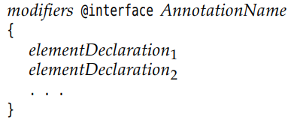
-Each element declaration has the form:
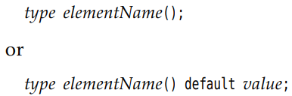
+Example:
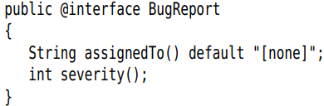
-All annotation interfaces implicitly extend java.lang.annotation.Annotation interface.
-The method of an annotation interface have no parameters and no throws. They can’t be default or static methods and type parameters.
-The type of an annotation element:
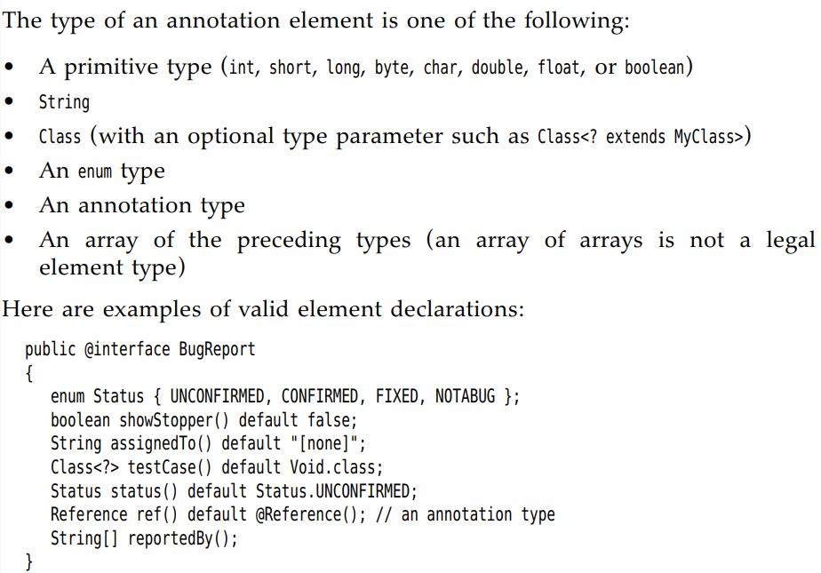
-API: p472
Java.lang.annotation.Annotation

8.4.2 Annotations
-Format of each annotation:
+Example:
+The order of elements doesn’t matter:
-The default value is used if an element value isn’t specified.
-2 special shortcuts annotations:
+Marker annotation: no element are specified because the annotation doesn’t have any or all of them use the default value.
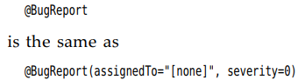
+Single-value annotation:
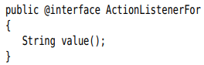
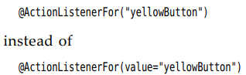
-An item can have multiple annotations
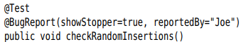
-If the author declared its annotation to be repeatable, you can repeat the same annotation:
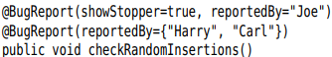
-Note: Annotations are evaluated by compiler, all element values must be compile-time constants
-Caution: Annotation element can never set to null, even default of null. Find other defaults: “” or Void.class
-Element value is an array:
+Omit the braces if element has a single value
-An annotation element can be another annotation
+Note: BugReport has an element of annotation type Reference, so Reference can’t have an element of type BugReport.

8.4.3 Annotating Declaration
-Annotations fall into 2 categories: declarations and type uses.
-Declaration annotations appear at declaration of:
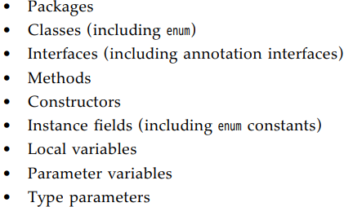
-Class and interface: put annotations before class or interface:
-Variables: Before the type
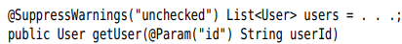
-Type parameter in generic class:
-Package:
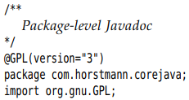
-Note: Annotations for local variables only processed at the source level. Class files don’t describe local variables. So all local variable annotations are discarded when a class is compiled. The same with packages.
-Declaration annotation provides information about the item being declared:
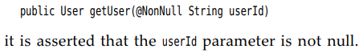
+Note: @NonNull is a part of Checker Framework (https://checkerframework.org/): include assertions in program (non-null, string having regular expression). A static analysis tool checks if the assertions are valid in a given body of source code.

8.4.4 Annotating Type Uses
-Place the annotation before the type argument
-Type use annotations appear in:
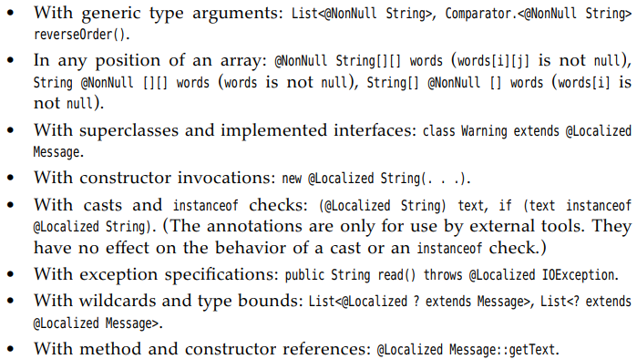
-A few type positions cannot be annotated:
-It’s customary to put type use annotations after modifiers and declaration annotations before modifiers
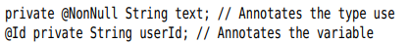

8.4.5 Annotating this
-Receiver parameter: only for methods, not constructors
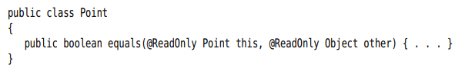
-Inner class: EnclosingClass.this
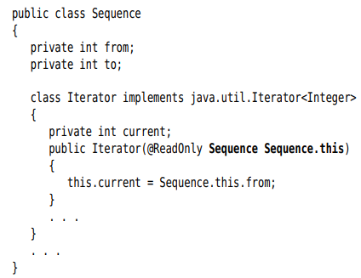

8.5 Standard Annotations
-Annotation interfaces are defined in java.lang, java.lang.annotation, javax.annotation. 4 of them are meta-annotation (describe behavior of annotation interfaces) and regular annotations using to annotate items in source code.
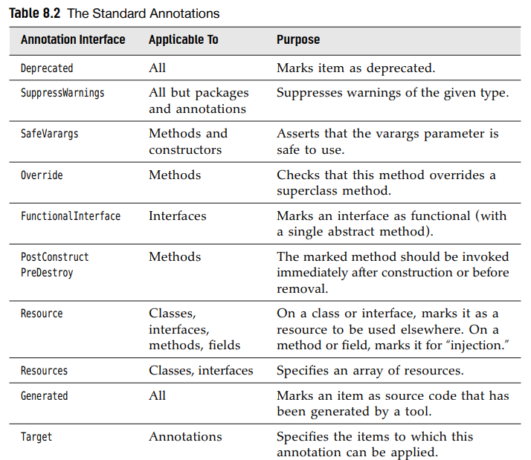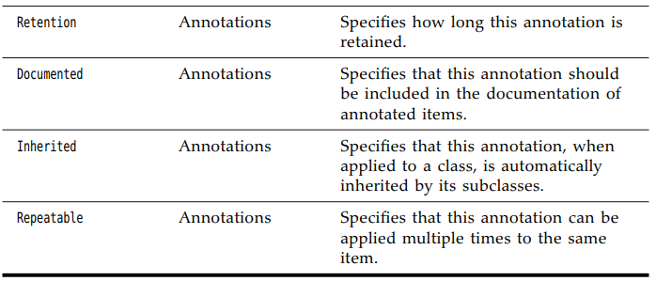

8.5.1 Annotations for Compilation
-@Deprecated annotation: items whose use is no longer encouraged. The compiler will warn when you use this item. It persists until runtimes
+Note: jdeprscan is part of JDK can scan JAR files for deprecated elements
-@SuppressWarnings tells the compiler to suppress warnings of a particular type
-@Override applies on to methods. The compiler checks that a method really overrides a method from superclass.
+Example:
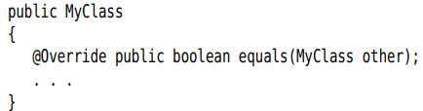
The compiler will report an error.
-@Generated used by code generator tools. Any generated source code can be annotated to differentiate it from programmer created code.

8.5.2 Annotations for Managing Resources
-@PostConstruct and @PreDestroy are used in environment that control the lifecycle of objects (web container, application servers). Tagged methods should be invoked immediately after an object has been constructed or before it’s being removed.
-@Resource for resource injection.
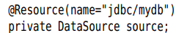
+When an object containing this field is constructed, the container injects a reference to data source.

8.5.3 Meta-Annotations
-@Target is applied to an annotation, restricting the items to which the annotation applies.
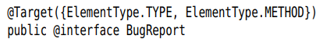
-Values belong to enumerated type ElementType.
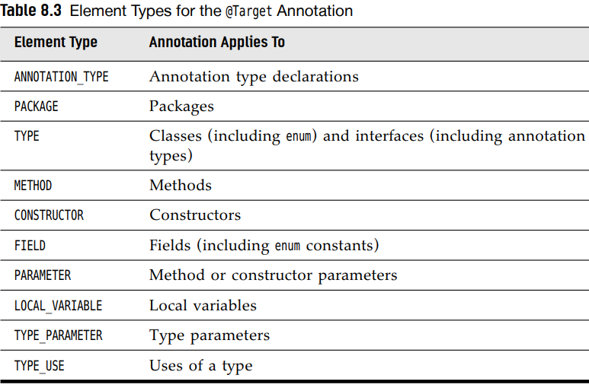
-@Retention specifies how long an annotation is retained. The default is RetentionPolicy.CLASS
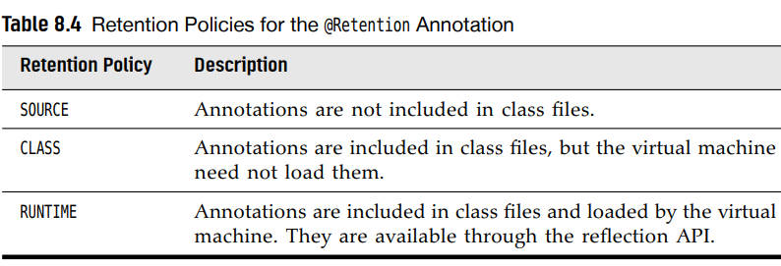
-@Inherited applies only for classes. When a class has this annotation, all of its subclasses automatically have the same annotation.
-@Serializable would be more appropriate than Serializable marker interface with no methods.
-@Persisten: indicate that objects of a class can be saved in database. The subclasses of persistent class are automatically annotated as persistent
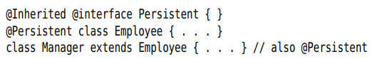
-It’s legal to apply same annotation type multiple times to an item. The implementor of repeatable annotation needs to provide a container annotation that holds the repeated annotations in an array.
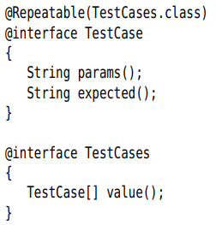

8.6 Source-Level Annotation Processing
-Another use for annotation is the automatic processing of source files to produce more source code, configuration files, scripts to generate.

8.6.1 Annotations Processors
-Annotation processing is integrated into Java compiler. During compilation, you can invoke annotation processors:
-An annotation processor implements Processor interface, extend AbstractProcessor class. You need to specify which annotations the processor support
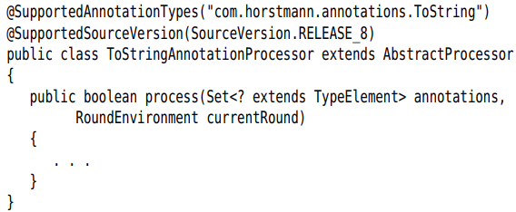

8.6.2 The Language Model API
Continue

8.6.3 Using Annotation to Generate Source Code

8.7 Bytecode Engineering

8.7.1 Modifying Class Files

8.7.2 Modifying Bytecodes at Load Time

