Chapter 9: The Java Platform Module System
-An important characteristic of OOP is encapsulation.
-Java 9 introduced Java Platform Module System supported by Java compiler and VM: modularize the large code base of Java platform

9.1 The Module Concept
-A Java platform module consists of :
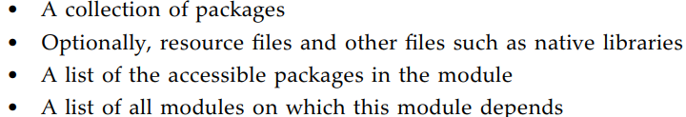
-2 advantages of using JPMS:
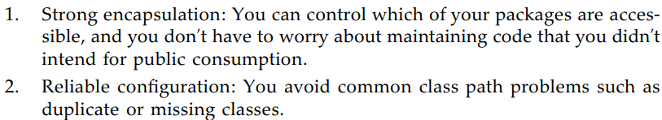
-Some issues that JPMS doesn’t address: versioning.

9.2 Naming Modules
-Module name ‘s the same as package name.
-Like a path name, module name is made up of letters, digits, underscores and periods.
-There’s no hierarchical relationship between modules.
-Most module names follow “reverse domain name” convention like package names.
-The easiest approach is to name a module after the top-level package that the module provides.
-Any given package can only be placed in one module.
-Note: Module names are only used in module declaration. In the source files for Java classes, never refer to module names.

9.3 The Modular “Hello, World!” Program
-1st, put the class into a package-the “unnamed package” cannot be contained in a module.
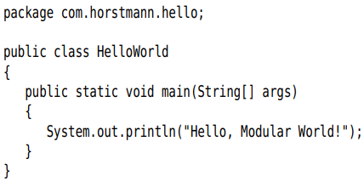
-Add a module declaration: Place it in a file named module-info.java, located in base directory. By convention, the name of base directory is the same as the module name.
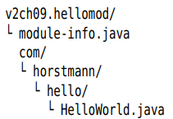
-module-info.java contains module declaration:
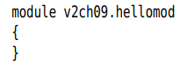
+-module, requires, exports… are “restricted keywords” that have a special meaning only in module declaration.
-Compile:
+The file is complied into module-info.class file that contains module definition in binary form.
-Run this program as a modular app: specify the module path. Also specify main class in format modulename/classname:
+Instead of --module-path and --module, use single-letter options –p and –m:
-> Successfully modularized the 1st app.
-Note: When compile, you get a warning:
+This warning is intended to discourage programmer to add version numbers to module names. You can ignore the warning or suppress it with:
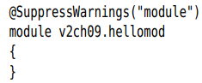

9.4 Requiring Modules
-Module v2ch09.requiremod
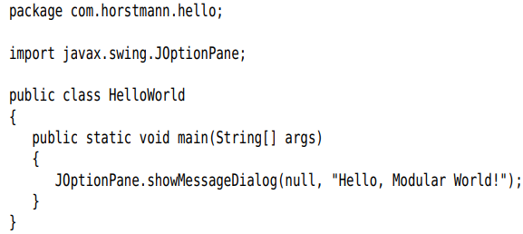
-Compilation fails:
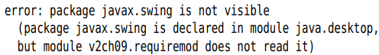
+JDK has been modularized, javax.swing package is contained in java.desktop module. Our module needs to declare that it relies on that module:
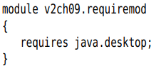
-Modules are explicit about their requirements. java.lang and java.io packages are included in java.base module which is required by default.
+java.desktop module declares that it’s requires 3 modules: java.datatransfer, java.prefs, java.xml
-Module graph: whose nodes are modules. The edge of graph-the arrow-are declared requirements or the implied requirement on java.base when none is declared.
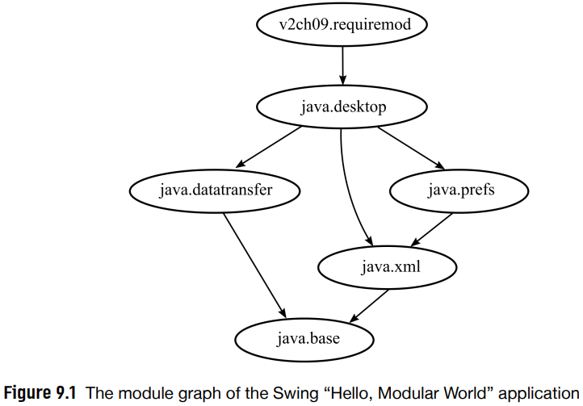
-A module cannot require itself.
-A module doesn’t automatically pass on access rights to other modules.
-Note: module M reads module N in cases:
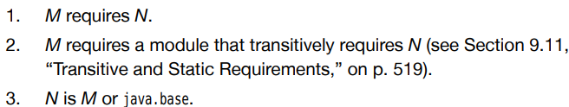

9.5 Exporting Packages
-A module uses exports to state packages which are accessible:
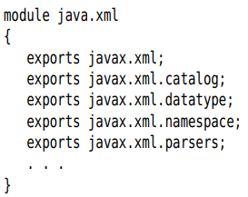
-When a package is exported, its public and protected classes and interface are accessible outside the module.
-Note: exports followed by package name, requires followed by module name
-Example: prepare com.horstmann.greet package
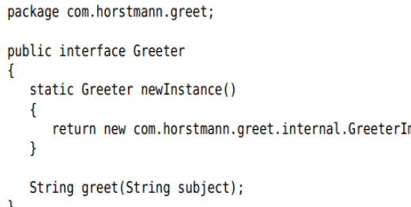
+2nd com.horstmann.greet.internal package:
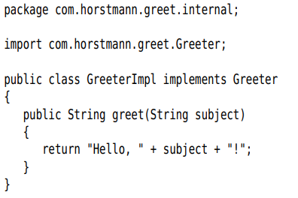
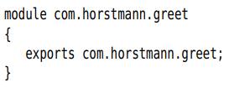
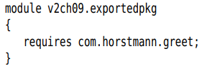
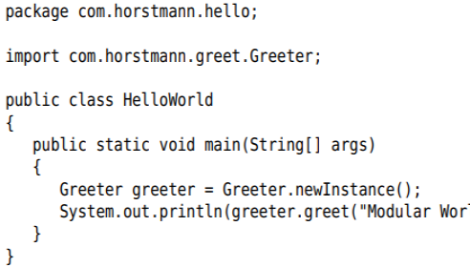
+Source file structure
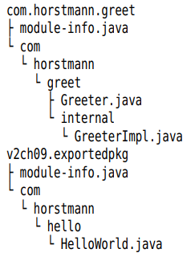
+Build this app:
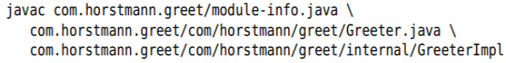
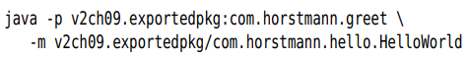

9.6 Modular JARs
-A module can be deployed by placing all its classes in JAR file, with a module-info.class in the root. This JAR file is a modular JAR.
+Use jar tool:
+Use build tool (Maven, Ant, Gradle).
-Specify main class in modular JAR:
-When you launch the program, specify the module containing the main class:
-Also optionally specify version number:

9.7 Modules and Reflective Access

Continue later

9.8 Automatic Modules
-Almost project rely on third-party libraries
-Automatic module: A JAR without a module-info.class on the module path
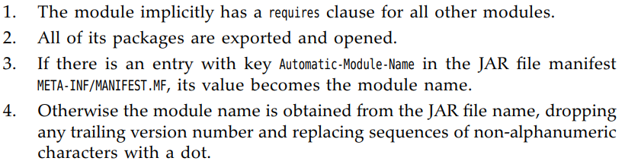
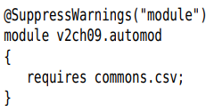
-Compile and run:
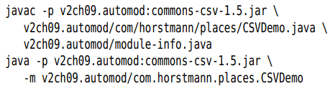

9.9 The Unnamed Module
-Any class that is not on module path is part of an unnamed module.
-No explicit module (a module with a module-info.class on module path) can access the unnamed module.

9.10 Command-Line Flags for Migration

9.11 Transitive and Static Requirements

9.12 Qualified Exporting and Opening

9.13 Server Loading
s

9.14 Tools for Working with Modules
-jdeps: analyzes the dependencies of a given set of JAR files
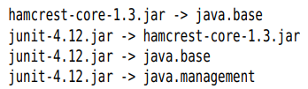
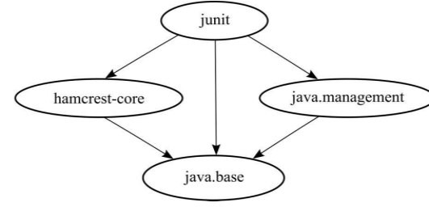
+-v: map classes to required packages and modules
+--generate-module-info:
+Note: dot tool:
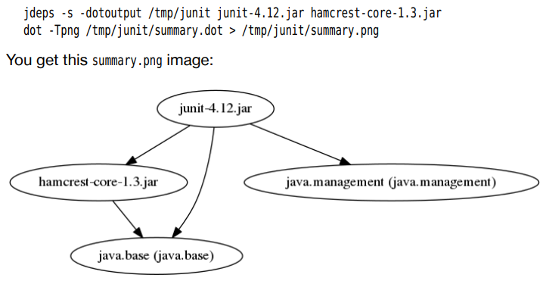
-jlink: produce an app that executes without a separate Java runtime.
-jmod: builds and inspects the module files that are included with JDK.

