Part 1: The big picture stuff

1. Container from 30000 feet

1.1 The bad old days
-In the past, we could only run one app per server. The open-systems world of Windows and Linux didn’t have technologies to safely and securely run multiple apps on same server. So when the business needed a new app, IT department would buy a new server. Nobody knew the performance requirements of new app, so IT department makes guesses to choose model and size of server.
-Underpowered servers unable to execute transactions and losing customers and revenue. Over-power servers operate 5-10% of capacity.
=> A tragic waste of company capital and environmental resources!

1.2 Hello VMware
-VM: run multiple business apps safely on a single server.

1.3 VMwarts
-VM requires its own dedicated OS. Every OS consumes CPU, RAM and other resource. Every OS needs patching and monitoring, and a license in some cases. Wast time and resources.
-Other challenges: slow to boot, not portable – migrate and move VM workloads between hypervisors and cloud platforms is harder.

1.4 Hello Containers!
-All containers shares the host’s OS: save on the time, resources, fast to start and ultra-portable.

1.5 Linux containers
-Modern containers started in Linux world.
-Google LLC has contributed container-related technologies to Linux kernel: kernel namespaces, control groups, capabilities, Docker.

1.6 Hello Docker
-Docker Inc make containers simple.

1.7 Docker and Windows
-Windows desktop and server platforms support both: Windows containers and Linux containers.
-Windows containers run Windows apps that require a host system with a Windows kernel. Windows 10/11/Server have native support Windows containers.
-The vast majority of containers are Linux containers. Linux containers are smaller, faster, and majority of tooling exists for Linux.
-Windows containers vs Linux containers
+Containers share the kernel of the host they’re running on.
+You can run Linux containers on Windows systems that has WSL 2 backend.
+Containerized app: an application running as a container.
-What about Mac containers?
+There is no such thing as Mac containers. But Mac are great platforms for working with containers. The most popular ways of working with containers on Mac is Docker Desktop. It works by running Docker inside a lightweight Linux VM on Mac.

1.8 What about Wasm
-Wasm (WebAssembly): modern binary instruction set that builds applications that are smaller, faster, more secure and more portable than containers. You write your app in favorite language and compile it as a Wasm binary that will run anywhere you have a Wasm runtime.
-Wasm apps have many limitations, container remains the dominant model for cloud-native apps.
-Container ecosystem is much richer and more mature than Wasm ecosystem.
-Docker and container ecosystem are adapting to work with Wasm apps.

1.9 Docker and AI
-Exposing GPUs and other AI acceleration hardware to apps running inside containers is very hard. Because they all have their own drivers and SDKs, and it’s too much work for industry to make them all work with containers.
-Docker has released Docker Model Runner to run local LLMs outside of containers so they have direct access to host’s hardware.

1.10 What about Kubernetes
-Kubernetes: an open-source project out of Google as the defector orchestrator of containerized apps: the most popular tool to deploy and manage containerized apps.
-Kubernetes uses Docker as default container runtime. But modern Kubernetes clusters have a pluggable container runtime interface (CRI) to swap-out different container runtimes. Most new Kubernetes clusters use containerd: small part of Docker that does low-level tasks of starting and stopping containers.
-Quick Start Kubernetes and The Kubernetes Book.

2. Docker and container-related standards and projects
2.1 Docker
-Docker is at the heart of container ecosystem. It can mean 2 things: Docker platform or Docker, Inc.
-Docker, Inc
+A technology company started at PaaS provider called dotCloud. dotCloud delivered its services on top of containers and had an in-house tool to help them deploy and manage those container called Docker.
+2013, dotCloud dropped PaaS, rebranded as Docker, Inc and focused on bringing Docker and containers to world.
-Docker technology
+At high level, there are 2 major parts to Docker platform: CLI (client) and engine (server).
+CLI is familiar docker command-line tool to deploy and manage containers. It converts commands into API requests and sends them to engine.
+Engine comprises all server-side components that run and manage containers. The client and engine can be on the same host or connected over the network.
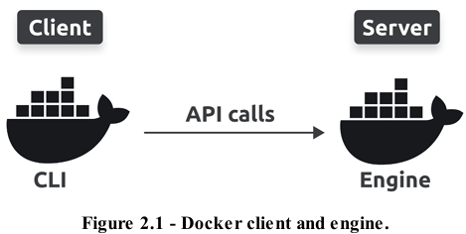
+Client and engine are complex and comprise lots of small specialized parts. Example: you type docker commands into CLI, CLI converts them to API requests and sends them to daemon, and daemon takes care of everything else.
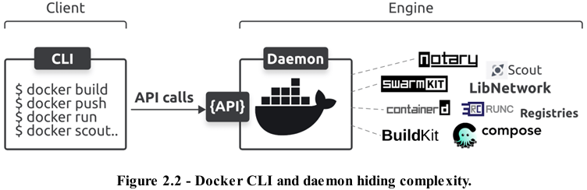
2.2 Container-related standards and projects
-Several important standards and governance bodies influence container development and container ecosystem. Some of these include: OCI, CNCF, Moby Project.
-Open Container Initiative (OCI)
+OCI: a governance council responsible for low-level container-related standards. It operates under the umbrella of Linux Foundation and was founded in early days of container ecosystem when some people at company called CoreOS didn’t like the way Docker was dominating the ecosystem. CoreOS created an open standard appc that defines specifications for things such as image format and container runtime. They also created a reference implementation rkt.
+appc standard did things differently from Docker and put ecosystem in an awkward position with 2 competing standards. The main players in ecosystem came together and formed OCI as vendor-neutral lightweight council to govern container standards. This allowed us to archive appc project and place all low-level container-related specifications under OCI’s governance.
+OCI maintains 3 standards specs: image-spec, runtime-spec and distribution-spec.
+We often use rail track analogy to explain OCI standards: when size and properties of rail tracks were standardizes, it gave entrepreneurs in the rail industry confidence the trains, carriages, signaling systems, platforms, and other products they build would work with standardized tracks – nobody wanted competing standards for track sizes.
+OCI specifications did the same thing for container ecosystem and it’s flourished ever since. All modern versions of Docker implement all 3 specs.
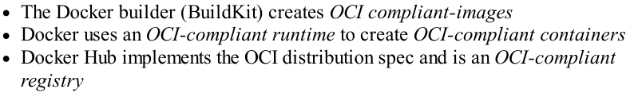
-The Cloud Native Computing Foundation (CNCF)
+CNCF is another Linux Foundation project that is influential in container ecosystem. Instead of creating and maintaining container-related specifications, CNCF hosts important projects such as Kubernetes, containerd, Notary, Prometheus, Cilium…
+CNCF hosts these projects means it provides a space, structure, and support for projects to grow and mature. All CNCF projects pass through 3 phases: Sandbox, incubating, graduated. Each phase increases a project’s maturity level by requiring higher standards of governance, documentation, auditing, contribution tracking, marketing, community engagement…
+Graduated projects are considered ready for production and are guaranteed to have strong governance and implement good practices.
-The Moby projects
+Docker created Moby project as a community-led place for developers to build specialized tools to build container platforms.
+Platform builders can pick specific Moby tools to build their container platform. They can comprise their platforms using a mix of Moby tools, in-house tools, and tools from other projects.
+Docker, Inc. created Moby project, but it now has members including Microsoft, Mirantis, and Nvidia.
+Docker platform is built using tools from various projects, including Moby project, CNCF, OCI.

3.Getting Docker
3.1 Docker Desktop
-Docker Desktop is a desktop app from Docker, Inc – the best way to work with containers. You get Docker Engine, a slick UI, all latest plugins and features, extension system with a marketplace, Docker Compose and a Kubernetes cluster.
-It’s free for personal use and education, but you have to pay a license fee if you use it for work and your company has over 250 employees or does > $10M in annual revenue.
-Docker Desktop on Windows 10/11 Professional and Enterprise editions supports Windows containers and Linux containers. Docker Desktop on Mac, Linux, and Home editions of Windows only support Linux containers.
-Windows prereqs
+64-bit version of Windows 10/11.
+Hardware virtualization support must be enabled in your system’s BIOS
+WSL 2.
3.2 Install Docker with Multipass
-Multipass is a free tool to create cloud-style Linux VMs on Linux, Mac or Windows machine and easy to install and use. It’s easy way to create multi-node production like Docker clusters. It doesn’t ship with out-of-the box support: docker scout, docker debug, docker init.
-Once installed, you only need 3 commands: multipass launch + ls + shell
-multipass launch docker --name node1: create a new VM node1 based on docker image. The docker image has Docker pre-installed and ready to go.
-multipass ls: list VMs to make sure yours launched properly.
-multipass shell node1: connect to VM
-docker --version + docker info: check Docker version and list CLI plugins
-exit: log out VM.
-multipass delete node1 then multipass purge: delete
3.3 Install Docker on Linux
-If you can’t use Docker Desktop, as it doesn’t give you access to docker scout, docker debug, docker init.
-sudo snap install docker
-sudo docker --version
-sudo docker info
-sudo groupadd docker + sudo usermod -aG docker $(whoami): create docker group and add your user account to it.
-sudo service docker start

4. The big picture

4.1 The Ops Perspective
-A typical Docker installation installs the client and engine on the same machine and configures them to talk to each other.
-docker version: ensure both are installed and running
-Download image:
+Images: objects that contains everything an app needs to run. This includes an OS filesystem, the application, and all dependencies.
+docker pull <image>:<version>: copy new images onto your Docker host.
+docker images: see all images
-Start a container from the image
+docker run --name <container_name> -d -p <port_out>:<port_in> <image>:<version>: start a new container
+docker ps: see running container
-Execute a command inside the container
+docker exec -it <container_name> bash: attach your shell to a new Bash process inside container.
+Most containers only ship with essential apps and tools to keep them small and reduce attack vectors.
+exit: terminate your bash process and connect your shell back to your local terminal.
-Delete the container
+docker stop <container_name>: stop the container
+docker rm <container>: kill container
+docker ps -a: list all containers
4.2 The Dev Perspective
-git clone <link>: make a local clone of repo. You need the git CLI.
-Inspect the app’s Dockerfile
+Dockerfile: a plain-text document that tells Docker how to build the app and dependencies into an image.
+Contents of Dockerfile:
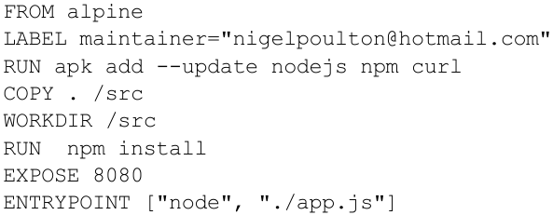
-Containerize the app
+docker build -t <image>:<version> . : create a new image based on instructions in Dockerfile.
-Run the app as a container
+docker run -d –name <container> --publish <port_out>:<port_in> <image>:<version>
-Clean up
+docker rm <container> -f: terminate the container and delete image
Part 2: The technical stuff

5. The Docker Engine
5.1 Docker Engine-The TLDR
-Docker Engine: server-side components of Docker that run and manage containers. It’s modular and built from many small specialized components pulled from projects like OCI, CNCF, Moby project.
-The components of Docker Engine that create and run containers
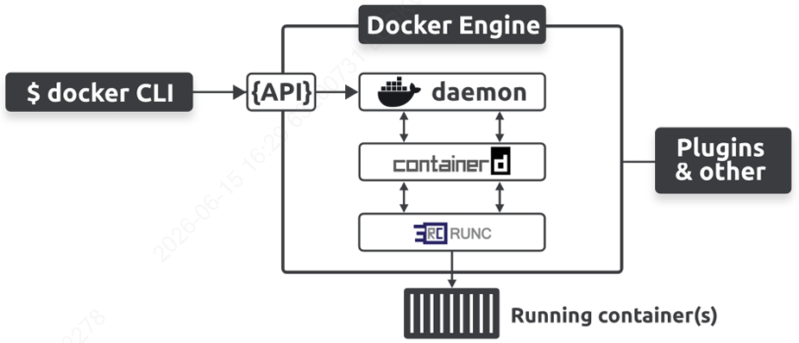
5.2 The Docker Engine
-When Docker was 1st released, Docker Engine has 2 major components: Docker daemon + LXC.
+Daemon was a monolithic binary containing all code for API, image builders, container execution, volumes, networking…
+LXC did the hard work of interfacing with Linux kernel and constructing the required namespaces and cgroups to build and start containers.
-Replacing LXC
+LXC is Linux-specific, and Docker had aspirations of being multi-platform. Docker was evolving fast, and there is no way of ensuring LXC evolved in the way Docker needed.
+Docker replaced LXC with libcontainer. The goal of libcontainer was to be a platform-agnostic tool that gave Docker access to fundamental container building blocks in host kernel.
-Breaking up he monolithic Docker daemon
+Docker Engine was originally a monolithic with almost all functionality coded into daemon. But this became more problematic: it got slower, it wasn’t wat the ecosystem wanted, it’s hard to innovate on monolithic software.
+The project began a long-running program to break apart and refactor the Engine so that every feature became its own small specialized tool.
+Notable examples: remove high-level and low level runtime functionality and re-implement them in separate tools called containerd and runc, both of which are used by different projects (Docker, Kubernetes, Firecracker, Fargate). Starting with Docker Desktop 4.27.0, Docker has removed image management from daemon and now uses containerd’s image management.
+Docker Engine components: run containers and lists primary responsibilities of each component
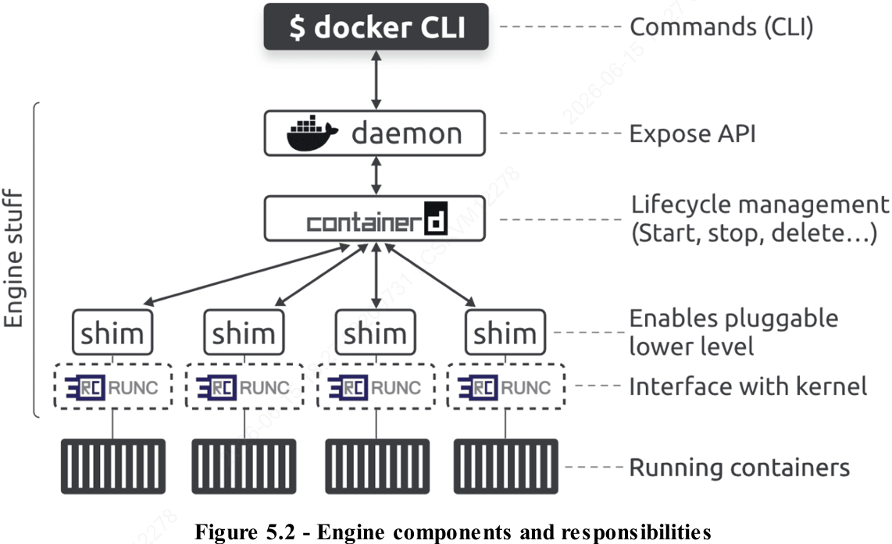
5.3 The influence of Open Container Initiative (OCI) runc
-The same time Docker, Inc. was refactoring the Engine, OCI was in the process of defining 2 container-related standards: image + runtime spec (2017). They’ve been added a 3rd distribution spec governing how images are distributed via registries.
-Docker, Inc. was a founding member of OCI and was heavily involved in defining the original specifications.
-All versions of Docker since 2016 have implemented OCI specifications. Docker uses runc, the reference implementation of OCI runtime-spec, to create OCI-compliant contaiers (runtime-spec). It also uses BuildKit to build OCI-compliant images (image-spec), and Docker Hub is an OCI-compliant registry (registry-spec).
5.4 runc
-runc: the reference implementation of OCI runtime-spec. Docker, Inc. was heavily involved in defining the spec and contributed the initial code for runc.
-runc is a lightweight CLI wrapper for libcontainer that you can download and use to manage OCI-compliant containers. It’s a very low-level tool and lacks almost all of features and add-ons you get with Docker Engine. Fortunately, Docker uses runc as its low-level runtime, this means you get OCI-compliant containers and the feature-rich Docker user experience.
-runc operates at OCI layer, we often refer to it as a low-level runtime.
-Docker and Kubernetes use runc as their default low-level runtime, and both pair it with containerd high-level runtime: containerd operates as high-level runtime managing lifecycle events. Runc operates as low-level runtime executing lifecycle events by interfacing with kernel to do the work of actually building containers and deleting them.
5.5 containerd
-containerd: another tool that Docker created as a high-level runtime as it manages lifecycle events (start, stop, delete containers). It needs a low-level runtime to perform actual work. Most of the time, containerd is paired with runc as its low-level runtime. It uses shims that make it possible to replace runc with other low-level runtime.
-The original plan was for containerd to be a small specialized tool for managing container lifecycle events. But it has since grown to include the ability to manage images, networks, volumes.
-One reason to add more functionality is for projects such as Kubernetes that want containerd to be able to push and pull images. This extra functionality is modular.
-containerd was originally developed by Docker, Inc. and donated the Cloud Native Computing Foundation (CNCF).
5.6 Start a new container (example)
-The most common way of starting containers is using Docker CLI:
docker run
-When you run commands like this, Docker client converts them into API requests and sends them to API exposed by daemon.
-Daemon can expose API on a local socket or over network. On Linux, the local socket is /var/run/docker.sock and on Windows it’s \pipe\docker_engine
-The daemon receives the request, interprets it as a request to create a new container, and passes it to containerd. Remember that daemon no longer contains any code to create containers.
-daemon communicates with containerd via a CRUD-style API over gRPC
-Even containerd can’t create containers. It converts the required Docker image into OCI bundle and tells runc use this to create a new container. runc interfaces with OS kernel to pull all constructs necessary to create a container (namespaces, cgroups…). The container starts as a child process of runc, as soon as container starts, runc exits.
-Summarize the process:
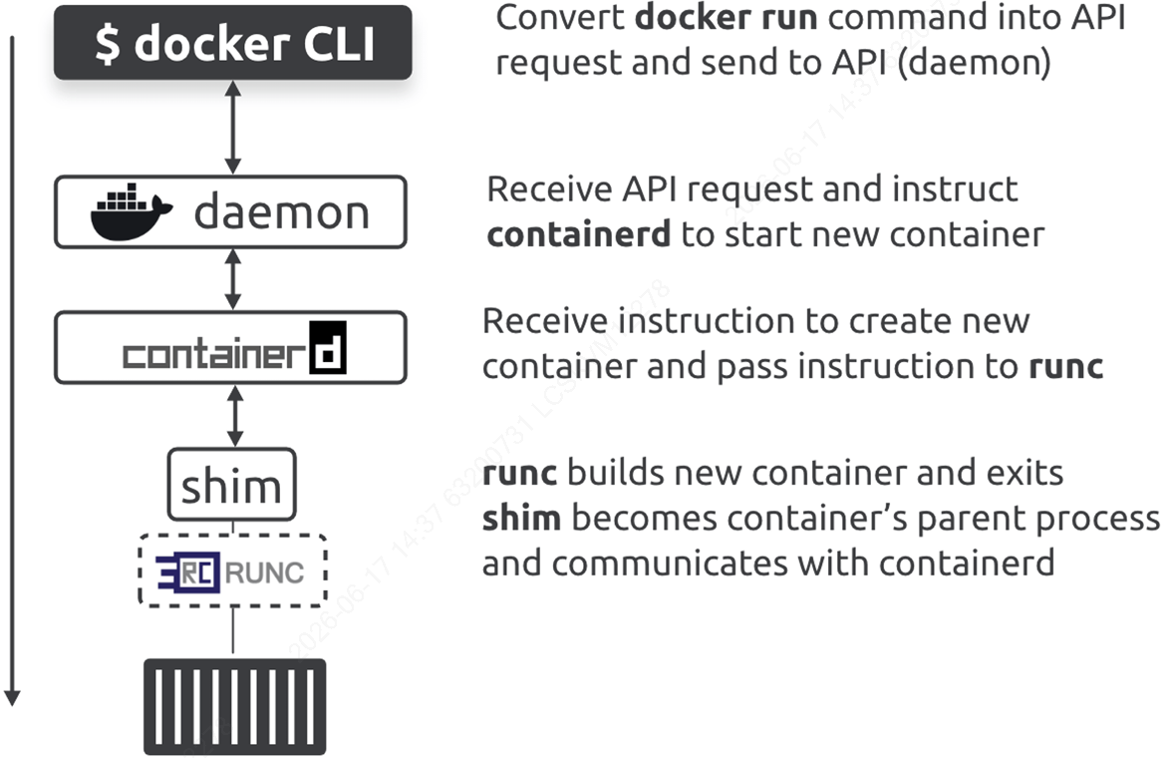
-daemonless containers: decoupling the container creation and management from Docker daemon and implementing it in containerd and runc makes it possible to stop, restart, and even update the daemon without impacting running containers.
5.7 What’s the shim all about?
-Shims are popular software engineering pattern, Docker Engine uses them between containerd and OCI layer, bring benefits: daemonless containers, improved efficiency, pluggable OCI layer.
-Daemonless containers is the ability to stop, restart, and update Docker daemon without impacting running containers.
-Containerd forks a shim and a runc process for every new container. But each runc process exits as soon as container starts running, leaving shim process as container’s parent process. The shim is lightweight and sits between containerd and container. It reports on container’s status and performs low-level tasks (keep container’s STDIN and STDOUT streams open)
-Shims also make it possible to replace runc with other low-level runtimes.
5.8 How it’s implemented on Linux
-On Linux system, Docker implements components we’ve discussed as separate binaries: /usr/bin/dockerd (daemon), /usr/bin/containerd, /usr/bin/containerd-shim-runc-v2, /usr/bin/runc
-Do we still need the daemon
+Docker has stripped most of functionality out of daemon. However, it still serves Docker API.

6. Work with Images
6.1 Docker images-The TLDR
-image: read-only package containing everything you need to run an app. They include application code, dependencies, minimal set of OS constructs, metadata.
-With VMware, images are a bit like VM templates – a VM template is like a stopped VM, an image is like a stopped container. As developer, images are similar to classes.
-The easiest way to get image is to pull one from a registry.
-Docker creates images by stacking independent layers and representing them as a single unified object. One layer might have OS components, another layer might have application dependencies, and another layer might have application. Docker stacks these layers and makes them look like aa unified system.
-Images are small, but Windows images can be huge.
6.2 Intro to images
-Images are build-time constructs, container are run-time constructs.
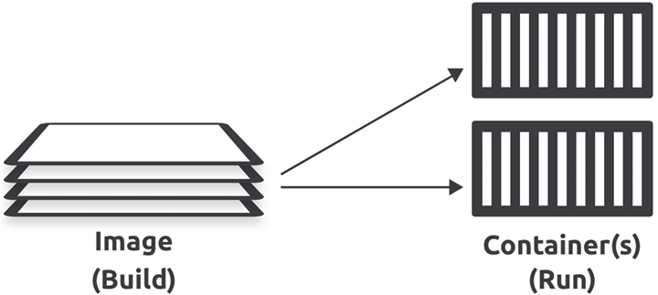
-docker run: most common way to start a container from an image. Once the container is running, image and container are bound, and you can’t delete image until you stop and delete container.
-Containers are designed to run a single app or microservice. They should only contain application code and dependencies. You should not include non-essentials (build tools, troubleshooting tools).
-Another thing that keeps images small is the lack of an OS kernel. This is because containers use the kernel of the host they’re running on. The only OS-related components in most images are filesystem objects, people say images contain just enough OS.
6.3 Pull images
-A clean Docker installation has an empty local repository.
-Local repository: an area on your local machine where Docker stores images for more convenient access. We sometimes call it the image cache, on Linux it’s usually located in /var/lib/docker/<storage-driver>. If you are using Docker Desktop, it will be inside Docker VM.
-docker images: inspect the contents (images) of local repository.
-pulling: the process of getting images.
-Docker is opinionated and made 2 assumptions when pulling image:
+It assumed you wanted to pull image tagged as latest.
+It assumed you wanted to pull image from Docker Hub.
6.4 Image registries
-We store images in centralized places called registries. The job of registry is to securely store images and make them easy to access from different environments.
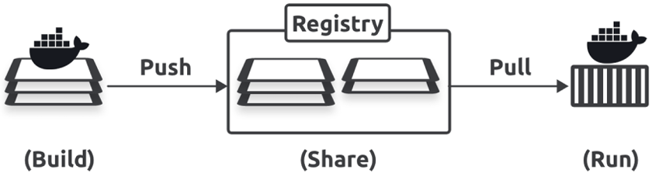
-Most modern registries implement OCI distribution-spec or OCI registries. Most registries also implement Docker Registry v2 API, so you can use Docker CLI and other API tools to query them and work with them in standard ways. Some offer advanced features: image scanning, integration with build pipelines.
-The most common registry is Docker Hub, but others exist, including 3rd-party internet-based registries and secure on-premises registries.
-Image registries contain ore or more image repositories, and image repositories contain one ore more images.
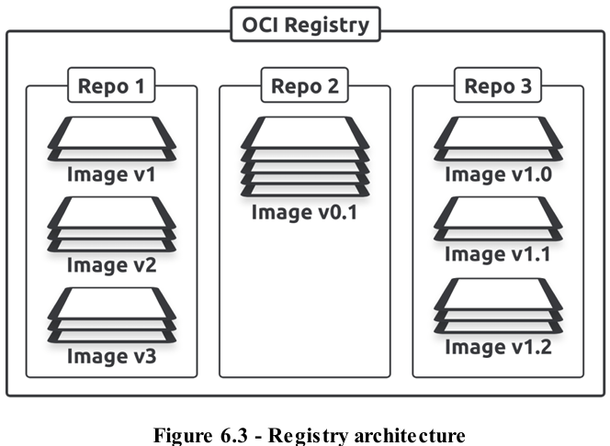
-Official repositories
+Docker has the concept of official repositories: home to images vetted and curated by Docker and application vendor. They should contain up-to-date high-quality code that is secure, well-documented, and follows good practices.
+Most of population applications and operating systems have official repositories on Docker hub, they live at the top level of Docker Hub namespaces and have a green Docker Official Image badge.
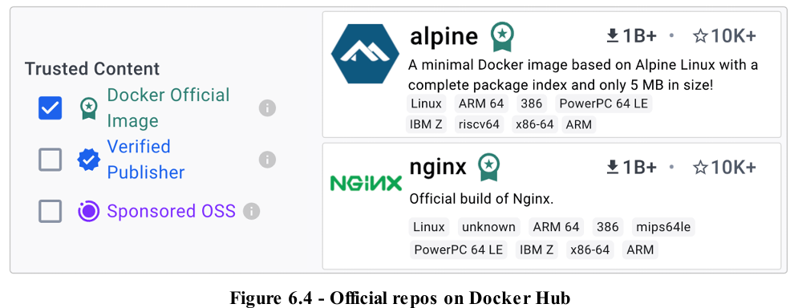
-Unofficial repositories
+You should always start with the assumption that anything from an unofficial repository is unsafe. This is based on the good practice of never trusting software from internet. You should also exercise caution when downloading and using Docker Official Images.
6.5 Image naming and tagging
-Full qualified image name. Docker automatically populates registry and tag values if you don’t specify them
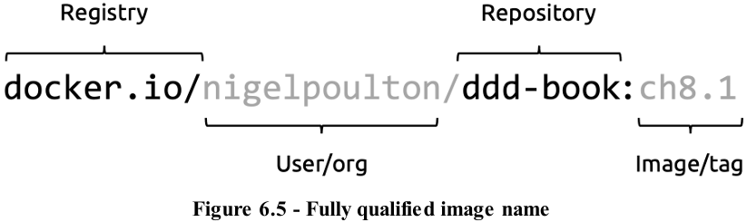
-docker pull <repository>:<tag>: pull image from official repository
-docker pull <usernamne/organization name>/<repository>:<tag>: pull images from unofficial repositories
-To pull image from different registry, just add registry’s DNS name before repository name.
-Images with multiple tags
+You can give a single image as many tags as you want.
+latest doesn’t need to be relating to newest image in repo.
6.6 Images and layers
-Images are collection of loosely connected read-only layers where each layer comprises one or more files.
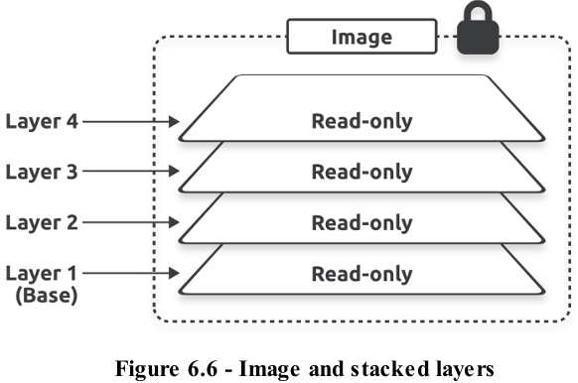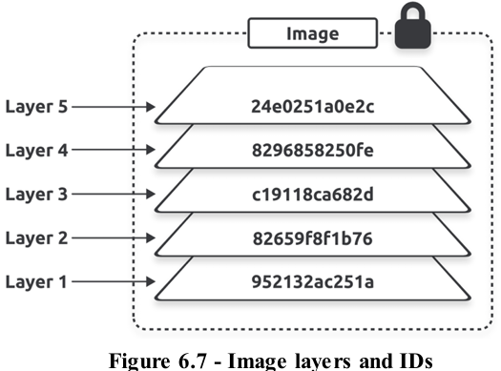
-docker pull: observe it pulling the individual layers. Each line ending with Pull complete represents a layer that Docker pulled.
-Another way to see image layer: docker inspect <image>:<tag>. It shows their SHA256 hashes, which are different from short IDs.
-docker history: inspect an image and see its layer data. But this command shows build story of an image and not a strict list of layers in final images (example: ENV, EXPOSE, CMD, ENTRYPOINT only add metadata and don’t create layers)
-Base layers
+All Docker images start with a base layer, every time you add new content, Docker adds a new layer.
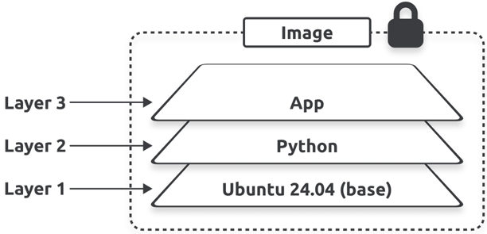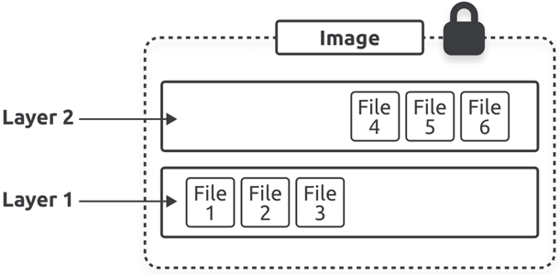
+Image is the combination of all layers stacked in the order they were built. Layers are stored as independent objects, and image is just metadata identifying the required layers and explaining how to stack them.
+You update files and make other changes to images by adding new layers containing the changes.
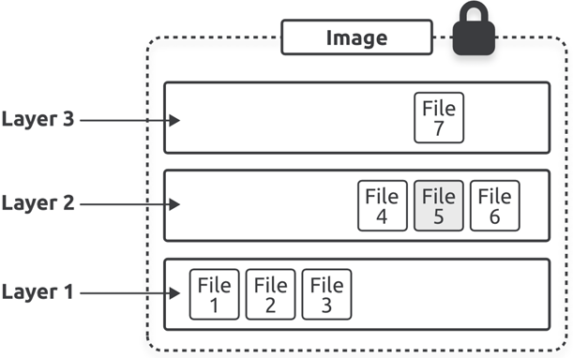
+Docker uses storage drivers to stack layers and present them as a unified filesystem and image. Almost Docker setups use overlay2 driver, alternative options are zfs, btrfs, vfs.
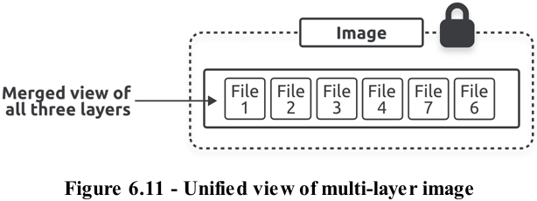
-Sharing image layers
+images can share layers, leading to efficiencies in space and performance.
+docker pull commands generates Already exists message because one of Docker Desktop extensions had pulled an image that used the exact same layer. So Docker skipped that layer as it already had a local copy.
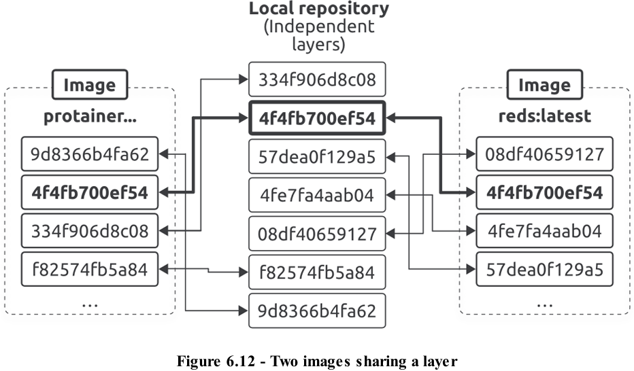
+Layers are also shared on registry side. You can store lots of similar images in a registry, and registry will save space by never storing more than a single copy of any layer.
6.7 Pulling images by digest
-Docker uses a content addressable storage model where every image gets content hash that we usually call digest. It’s impossible for 2 different images to have the same digest. It’s also impossible to change an image without creating a new digest.
-docker images --digest <image>: see image’s digest.
-docker buildx imagetools inspect <image>:<tag> : find image’s digest before pulling it.
-It’s possible to directly query the registry API for image data, including digest. Use curl.
-Image hashes and layer hashes
+An image is just a manifest file with some metadata and a list of layers. The actual application and all its dependencies live in layers that are fully independent and have no concept of being part of an image.
+Images and layers have their own digests: Image digests are a crypto hash of image’s manifest file. Layer digests are a crypto hash of layer’s contents.
-Content hashes vs distribution hashes
+Docker compares hashes before and after every push and pull to ensure no tampering occurs while data is crossing network. It also compresses images during push and pull to save network bandwidth and storage space on registry. As a result, before and after hashes won’t match.
+Each layer get 2 hashes: content hash (uncompressed) + distribution hash (compressed)
+Every time Docker pushes or pulls a layer from a registry, it includes layer’s distribution hash and uses this to verify no tampering occurred. This is one reason why the hashes in different CLI and registry output don’t always match.
6.8 Multi-architecture images
-Registry API supports 2 constructs: Manifest lists: a list of architectures supported by an image tag. Each supported architecture then has its own manifest that lists the layers used to build it.
-docker buildx imagetools inspect <image><tag> : see different architectures behind.
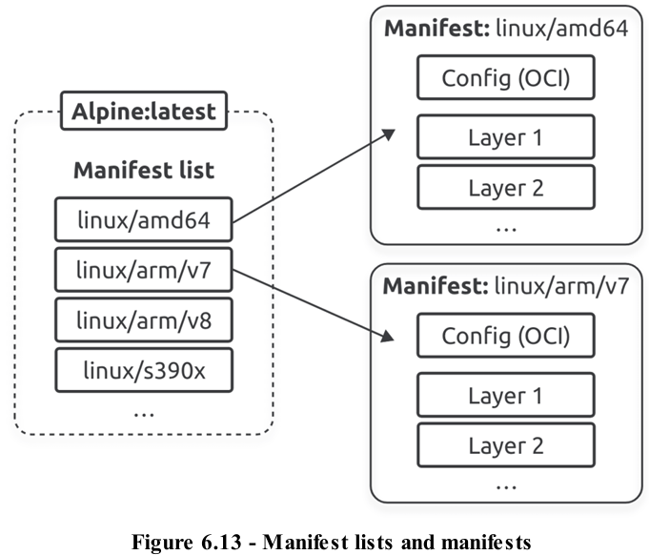
-docker manifest inspect <image>:<tag> | grep ‘architecture\|os’ : inspect manifest list for image.
-docker buildx offers 2 ways to create multi-architecture images: Emulation + Build Cloud
6.9 Vulnerability scanning with Docker Scout
-Docker Scout: built into almost every level of Docker: CLI, Docker Desktop, Docker Hub. It’s a slick service, but it requires a paid subscription.
-docker scout quickview <image>:<tag> : get a quick vulnerability overview of image.
-docker scout cves <image>:<tag> : get more detailed information + remediation advice.
6.10 Delete images
-docker rmi <image>:<tag> : delete images.
-Deleting images removes them from local repository. The operation also deletes all directories on local filesystem containing layer data. But Docker won’t delete layers shared by multiple images until you delete all images that reference them.
-You can delete images by name, short ID, or SHA.
-Docker will prevent the delete operation if image is being used by a container or referenced by more than one tag. But you can force operation with -f .
-docker rmi $(docker images -q) -f : delete all images. docker image -q returns a list of local image IDs.
6.11 Images-The commands
docker pull <image>:<version> | Download images from remote registries
docker images | see all images
docker inspect <image>:<tag> | shows image layer in SHA256 hashes
docker manifest inspect <image>:<tag> | grep ‘architecture\|os’ | inspect manifest list for image
docker buildx imagetools inspect <image>:<tag> | find image’s digest before pulling it
docker rmi <image>:<tag> | delete images

7. Work with containers

7.1 Containers – The TLDR
-Containers are run-time instances of images, you can start one or more containers from a single image.
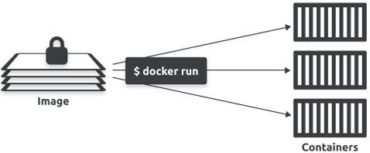
-Containers are smaller, faster, more portable than VMs. They’re designed to be stateless and ephemeral, whereas VMs are designed to be long-running and can be migrated with their state and data.
-Containers are designed to be immutable. You shouldn’t change them after you’ve deployed them. If a container fails, you replace it with a new one instead of connecting to it and making a live fix.
-Containers should only run a single process and we use them to build microservices apps. Example: an application with 4 features (web server, auth, catalog, store) will have 4 containers.
7.2 Containers vs VMs
-Containers and VMs are both virtualization technologies to run apps. The ways they virtualize are different: VMs virtualize hardware, containers virtualize OS.
+In VM model, you power on a server and a hypervisor boots. When hypervisor boots, it claims all hardware resources (CPU, RAM, storage, network adapters). To deploy an app, you ask hypervisor to create a VM. It does this by carving up the hardware resources into virtual versions (virtual CPUs, virtual RAM) and packing them into a VM that looks exactly like a physical server. Once you have VM, install OS and then an app.
+In container model, you power on the same server and an OS boots and claims all hardware resources. You then install a container runtime (Docker). To deploy an app, ask Docker to create a container. It does this by carving up OS resources (process trees, filesystems) into virtual versions and then packing them as a container that looks exactly like a regular OS. Then tell Docker to run app inside container.
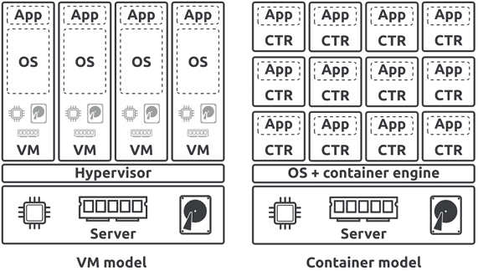
-Summary: hypervisors perform hardware virtualization where they divide hardware resources into virtual versions and package them as VMs. Container runtimes perform OS virtualization where they divide OS resources into virtual versions and package them as containers. VMs look exactly like physical servers. Containers look exactly like regular OS.
-Biggest problems with VM model is you need to install an OS on every VM – every OS consumes CPU, RAM, storage and take long time to boot
-Containers share a single OS on the host they’re running on. This gives containers all benefits over VMs:
+Containers are smaller and more portable.
+Can run more containers on your infrastructure.
+Containers start faster.
+Containers reduce number of OSs you need to manage.
+Containers present a smaller attack surface.
7.3 Images and Containers
-You can start multiple containers from a single image. In this relationship, the image is read-only, each container is read-write. Docker accomplishes this by creating a read-write layer for each container and placing it on top of shared image.
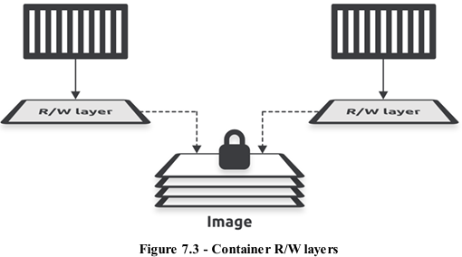
+Each container has its own thin R/W layer but share the same image. Containers can see and access files and apps in image through their R/W layer, if they make any changes, these get written to their R/W layer. When you stop container, Docker keeps R/W layer and restores it when you restart container. But when you delete container, Docker delete its R/W layer.
7.4 Check Docker is running
-docker version: check Docker is running
-In Linux:
+Not use Systemd: service docker status
+Use Systemd: systemctl is-active docker
7.5 Starting a container
-docker run –d --name <container> -p <port_out>:<port_in> <image>:<tag> : tell Docker to run a new container
7.6 How containers start apps
-There are 3 ways to start an app in a container: Entrypoint instruction im image, Cmd instruction in image, CLI argument.
-Entrypoint and Cmd instructions are optional image metadata where you can store the command you want Docker to run to start the default app. Whenever you start a container from image, Docker checks Entrypoint or Cmd instruction and executes command.
-Entrypoint instructions can’t overridden on CLI, anything you pass in via CLI will be appended to Entrypoint instruction as argument.
-Cmd instructions are overridden by CLI arguments.
-If image doesn’t have Entrypoint or Cmd, you need to pass argument on CLI.
-Format: docker run <arguments> <image> <command>
+<command> is optional, you don’t need it if image has Cmd/Entrypoint. If you specify <command>, it will override Cmd but will be appended to Entrypoint.
7.7 Connect to a running container
-docker exec: execute commands in running containers, it has 2 modes: Interactive + Remote execution
-Interactive exec sessions connect your terminal to a shell process in container and behave like remote SSH sessions. Remote execution mode lets you send commands to a running container and prints output to your local terminal.
-docke exec -it <container> sh : start an interactive session by creating a new shell process (sh) inside running container. -it makes it an interactive exec session, sh argument starts a new sh process inside container.
7.8 Inspect container processes
- ps: see processes running
-If you kill container’s main process, you also kill container. Because containers only run while their main process is executing.
-exit: quit exec session and return local terminal.
-docker exec without -it: This will remotely execute command without creating interactive session. The format is: docker exec <container> <command>, it will only work if container has the command you’re trying to execute.
7.9 The docker inspect command
-docker inspect <container>: detailed info about images + containers
7.10 Write data to a container
-docker exec -it <container> sh: open a new interactive exec session
-vi <file>: vi editor
7.11 Stop, restart, and delete a container
-docker ps: check running container
-docker stop <container>: stop running container
-docker ps -a: show all containers
-docker restart <container>: restart container
-docker rm <container> -f: delete container
7.12 Kill a container’s main process
-Containers only run while their main process executes.
-Crtl+PQ: exit a container without killing process you’re attached to
7.13 Debug slim images and containers with Docker Debug
-Require Pro/Team/Business subscription.
7.14 Self-healing containers with restart policies
-Container restart policies are a simple form of self-healing that allows local Docker Engine to automatically restart failed containers.
-You apply restart policies per container, Docker supports 4 policies: no (default), on-failure, always, unless-stopped.
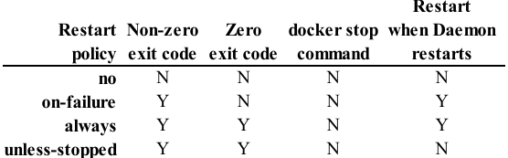
-docker run --name <container> -it --restart <restart_policy> <image> sh
-docker inspect <container> | grep RestartCount:
-Work with Docker Compose:
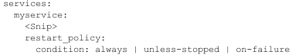
-Clean up
docker rm <container> -f
docker rmi <image>
7.15 Containers-The commands
docker run –d --name <container> -p <port_out>:<port_in> <image>:<tag> | Start new container
Ctrl PQ | Detach from a container without killing process
docker ps | List running containers
docker ps –a | List all containers
docker exec -it <container_name> bash | Start a new Bash shell inside running container and connect your terminal to it
docker exec -it <container> ps | Run a ps command inside running container without opening an interactive shell session
docker stop <container> | Stop running container
docker restart <container> | Restart stopped container
docker rm <container> | Delete stopped container
docker rm <container> -f | Delete container without having to stop it
docker inspect <container> | Show detailed configuration and run-time information about container

8. Containerizing an app

8.1 Containerizing an app – The TLDR
-Docker aims to make it easy to build, share, and run apps. We call this containerization and the process looks like this:
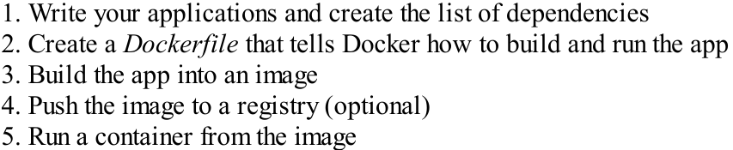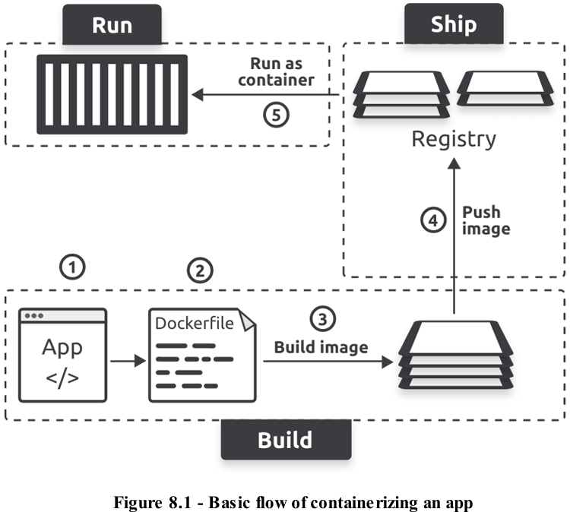
8.2 Containerize a single-container app
-Get the application code
-Create the Dockerfile:
+docker init: read build context, analyze app, automatically creates DOckerfile
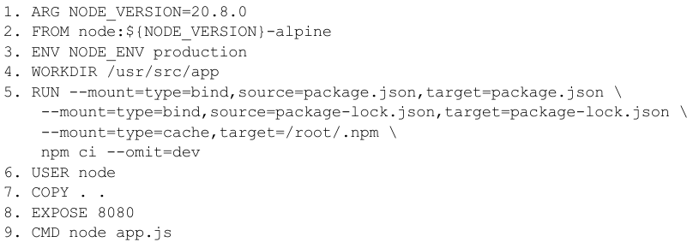
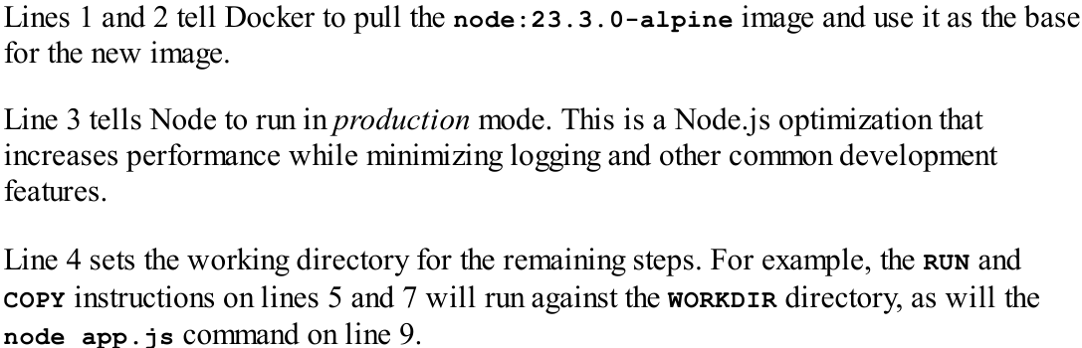
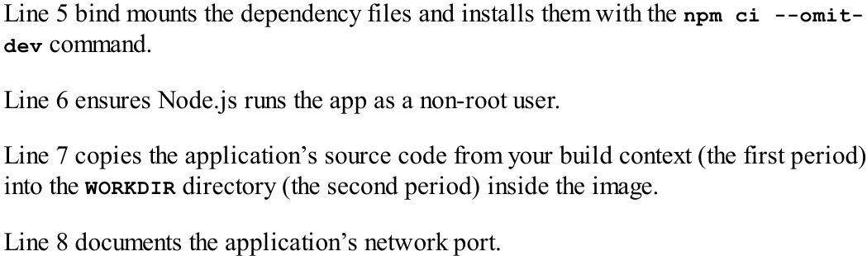
-Containerize the app: docker build -t <image>:<tag> .
-Push image to Docker Hub
-Run the app
-Test the app
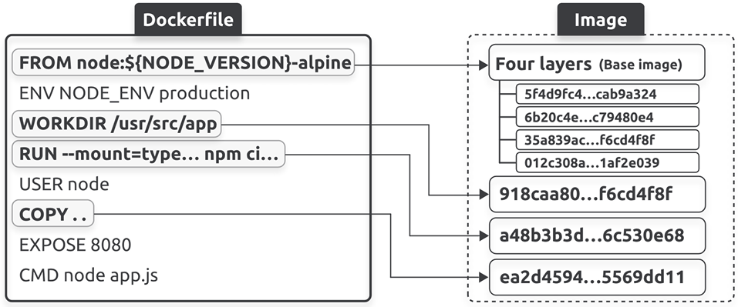
8.3 Move to production with multi-stage builds
-Container images should only contain the stuff needed to run your applications in production.
-multy-stage builds use a single Dockerfile with multiple FROM – each FROM represents a new build stage. This allows to have a stage where you do heavy lifting of building app inside a large image with compiler and other build tools, but then have another stage where you copy compiled app into a slim image for production.
-Slim image: very small image for production that only contains files and apps that are absolutely necessary to run application. They don’t include shells, package managers, troubleshooting tools.
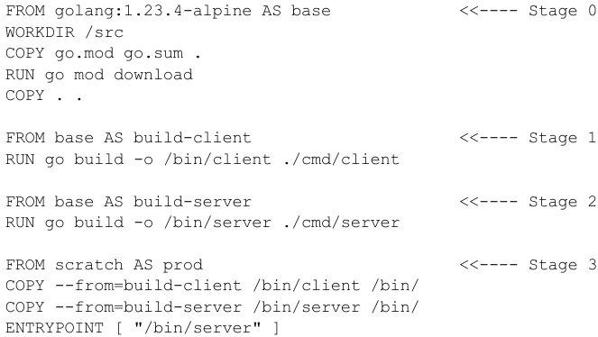
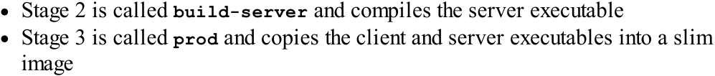
-Each stage outputs an intermediate image that later stages can use. But Docker deletes them when final stage completes.
-Multi-stage builds and build targets
+You can also build multiple images from a single Dockerfile.
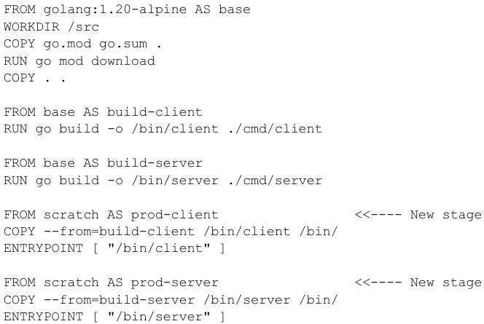
8.4 Buildx, BuildKit, drivers, and Build Cloud
-Docker’s build system: Client (Buildx) + Server (BuildKit)
-Buildx is Docker’s latest and greatest build client. It’s implemented as a CLI plugin an supports all latest features of BuildKit (multi-stage builds, multi-architecture images, advanced caching…). It’s been the default build client: when you run docker build, you use Buildx builder.
-You can configure Buildx to talk to multiple BuildKit instances (BuildKit builder). Builders can run on local machine, cloud or datacenter.
-If you point buildx at a local builder, image builds will be done on local machine. If you point it at a remote builder (Docker Build Cloud), builds will be done on remote infrastructure.
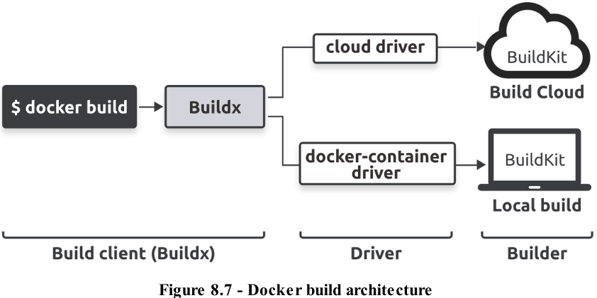
8.5 Multi-architecture builds
8.6 A few good practices
-Leverage the build cache
-Only install essential packages
-Clean up
8.7 Containerizing an app – The commands

9. Multi-container apps with Compose
9.1 Docker Compose – The TLDR
-Microservices applications: create modern cloud-native application combining lots of small services that work together.
-Compose lets you describe the application in a Compose file YAML. Then use Compose file with docker compose to deploy and manage entire app.
9.2 Compose background
9.3 Install Compose
-All modern versions of Docker come with Docker Compose pre-installed.
-docker compose version: test
9.4 The sample app
-Sample app: 2 services, a network, a volume
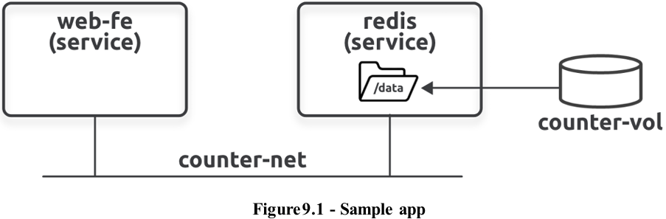
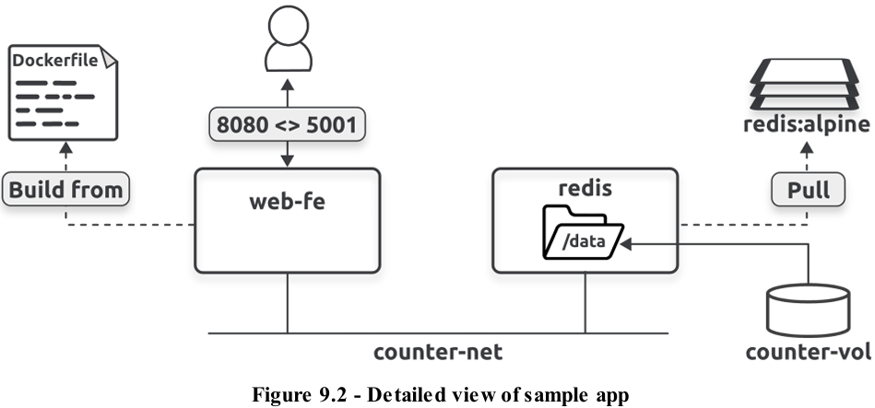
9.5 Compose files
-Compose uses YAML files to define microservices applications. We call them Compose files, and Compose expects to name them compose.yaml or compose.yml.
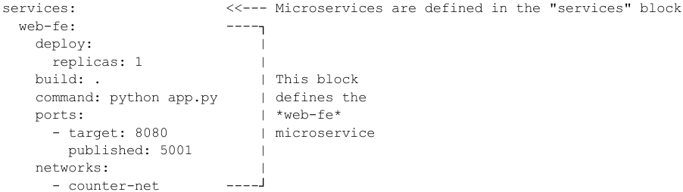
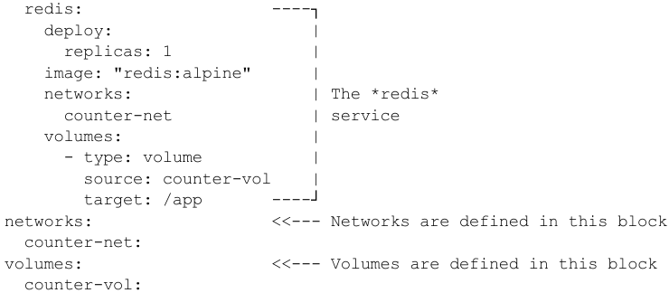
-The file has 3 top-level keys: services, networks, volumes.
-The services key is mandatory and is where you define application microservices. web-fe runs application’s web server and redis runs database backend.
-Look at web-fe service:
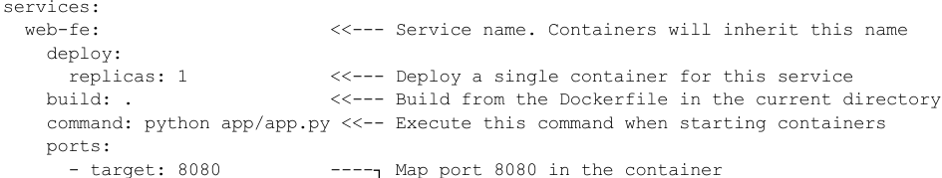
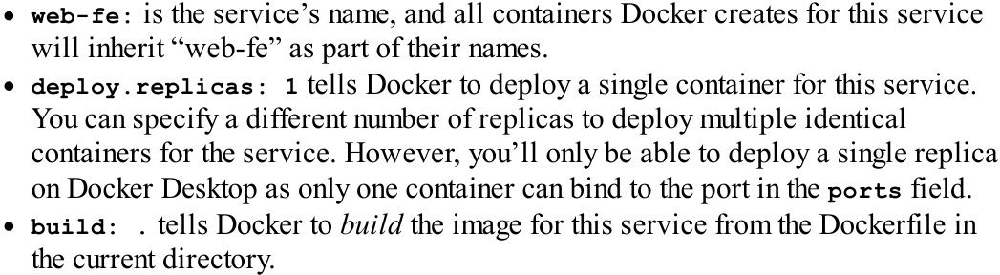
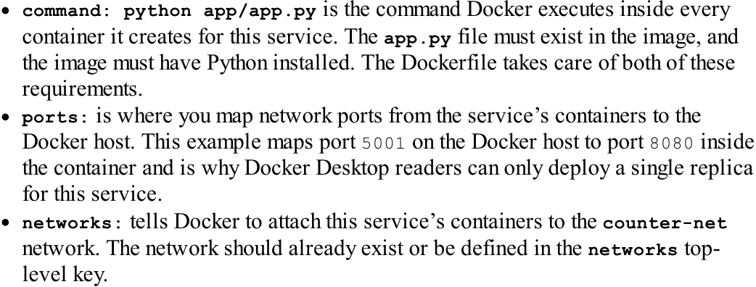
-Look at redis service:
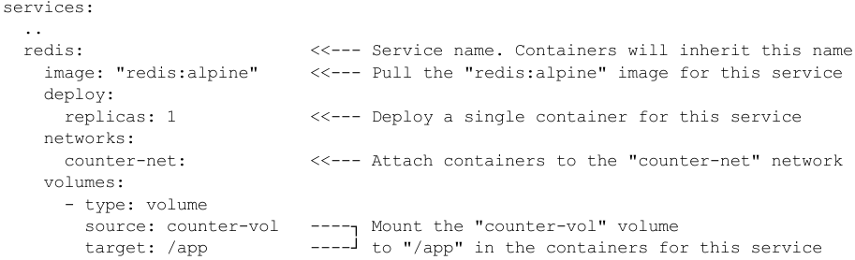
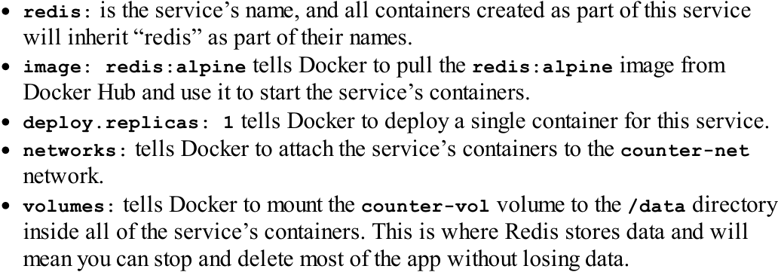
-network and volumes blocks define a network and a volume
9.6 Deploy apps with Compose
-docker compose up -d: deploy the app
-docker compose -f <location> up -d
-docker ps: list running containers
-docker network ls: see network
9.7 Manage apps with Compose
-docker compose down: shut down the app
-docker volume ls: see volumes
-docker compose ps: check the current state of app
-docker compose ps -a
-docker compose top: list the processes inside each container
-docker compose stop: stop the app
-docker compose restart: restart the app
-docker compose ls: check the status of app
-Clean up: docker-compose down --volumes --rmi all
9.8 Deploy apps with Compose – The commands
docker compose up | Deploy Compose app
docker compose stop | Stop containers in Compose app
docker compose restart | Restart stopped Compose app
docker compose ps | List each container in Compose app
docker compose down | stop and delete running Compose app. Be default, it deletes containers and networks, not volumes and images

10. Docker and AI

10.1 Docker Model Runner background

10.2 Docker Model Runner Architecture

10.3 Install Docker Model Runner

10.4 Explore Docker Model Runner

10.5 Use Docker Model Runner with Compose

10.6 Use Docker Model Runner with Open WebUI

10.7 Run models in containers

10.8 Docker Model Runner – The commands

11. Docker and Wasm

11.1 Pre-reqs

11.2 Intro to Wasm and Wasm containers

11.3 Write a Wasm app

11.4 Containerize a Wasm app

11.5 Run a Wasm container

11.6 Clean up

12. Docker Swarm

12.1 Swarm primer

12.2 Build a swarm

12.3 Deploy Swarm app

12.4 Docker Swarm – The commands

13. Docker Networking

13.1 Docker Networking – The TLDR
-Docker runs microservices applications comprised of many containers that work together to form the overall app. These containers need to be able to communicate, and some will have to connect with external services, virtual machines…
-Docker networking is based on libnetwork – the reference implementation of an open-source architecture Container Network Model (CNM)
-Docker ships everything for the most common networking requirements. The model is pluggable, and the ecosystem can extend Docker’s networking capabilities via drives that plug into libnetwork.
-libnetwork also provides native service discovery and basic load balancing.
13.2 Docker networking theory
-Docker networking is based on 3 components: Container Network Model (CNM), libnetwork, drivers.
-CNM is design specification and outlines the fundamental building blocks of a Docker network.
-libnetwork is a real-world implementation of CNM.
-Drivers extend the model by implementing specific network topologies such as VXLAN overlay networks.
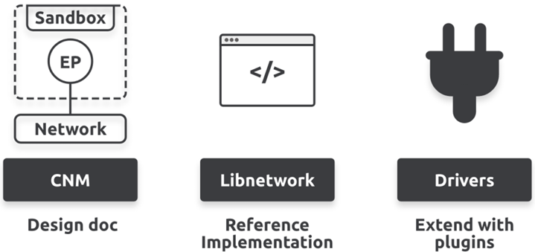
-Container Network Model (CNM)
+The design guide for Docker networking is CNM that outlines the fundamental building blocks of a Docker network.
+It defines 3 building blocks: sandboxes, endpoints, networks.
+A sandbox is an isolated network stack inside a container. It includes Ethernet interfaces, ports, routing tables, DNS configuration, everything else from a network stack.
+Endpoints: virtual network interfaces that look regular network interface. The connect sandboxes to networks.
+Networks: virtual switches (usually software implementation of an 802.1d bridge). They group together and isolate one or more endpoints that need to communicate.
+Using CNM terminology, endpoints connect sandboxes to network. Every container you create will have a sandbox with at least one endpoint connecting it to a network.
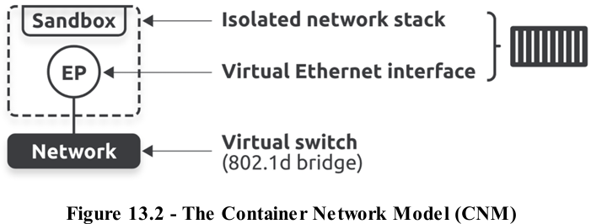
+CNM is all about providing networking for containers. Each container gets its own sandbox which hosts container’s entire network stack, including one or more endpoints that act as Ethernet interfaces and can be connected to networks.
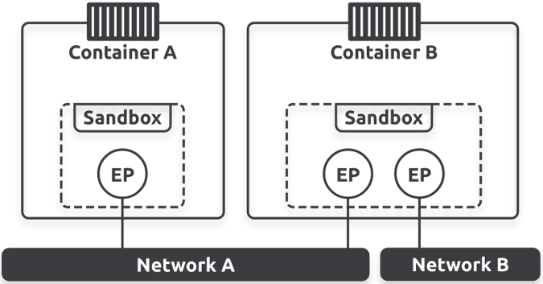
+Endpoints behave exactly like regular network adapters, you can only connect them to a single network.
+Extend it by adding Docker host. Although both containers are running on the same host this time, their network stacks are isolated and can only communicate via a network.
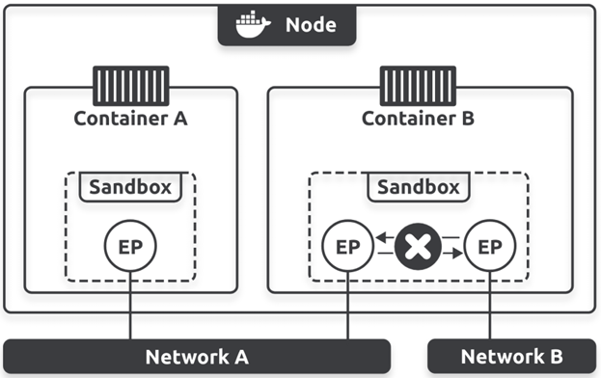
-Libnetwork
+The reference implementation of CNM. It’s open-source, cross-platform, maintained by Moby project, used by Docker.
+Today, Docker implements all core networking in libnetwork. It also implements network control plane (management APIs, service discovery, ingress-based container load balancing).
-Drivers
+Libnetwork implements control plane, but it relies on drivers to implement the data plane. Example, drivers are responsible for creating networks and ensuring isolation and connectivity.
+Docker ships with several built-in drivers called native drivers or local drivers. These include bridge, overlay, macvlan, and they build the most common network topologies.
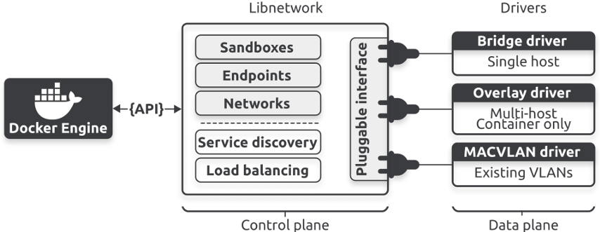
+Every network you create is owned by a driver, and driver creates and manages everything about network.
13.3 Single-host bridge networks
-single-host bridge network: the simplest type of Docker network.
-single-host: the network only spans a single Docker host. Bridge: implementation of an 802.1d bridge (layer 2 switch).
-2 Docker hosts with identical local bridge networks. Although networks are identical, they are independent and isolated, containers can’t communicate.
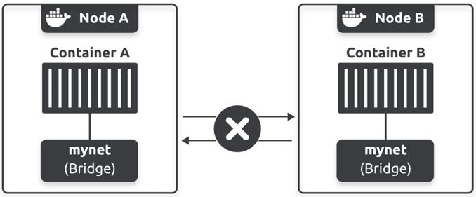
-Every new Docker host gets a default single-host bridge network called bridge that Docker connects new containers to.
-docker network ls
-docker network inspect <type>: get more information
-All bridge networks are based on Linux bridge technology. The default network on Linux-based Docker hosts called bridge and maps to an Linux bridge ins host’s kernel called docker0.
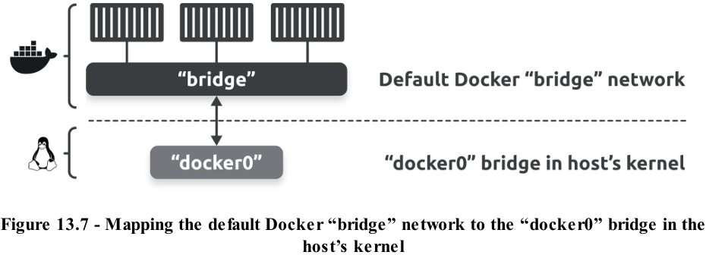
-docker network inspect bridge | grep bridge.name : confirm bridge network is based on docker0 bridge.
-brctl show: list all bridges on Docker host
-ip link show docker0: configuration and state of docker0 bridge
-Complete stack with containers connecting to bridge network, which, in turn, maps to docker0 Linux bridge in host’s kernel.
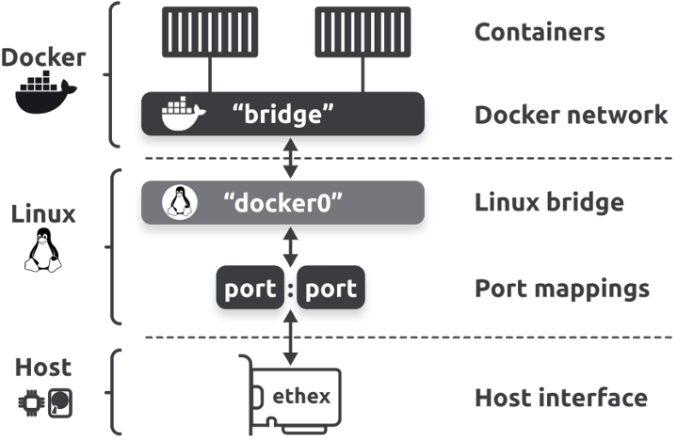
-docker network create -d bridge <name>
-docker run -d --name <container> --network <network> <image>
13.4 External access via port mappings
-We’ve said that containers on bridge networks can only communicate with other containers on the same network. But you can get around this by mapping containers to ports on Docker host. It’s clunky and has a lot of limitations, but it’s useful for testing and development work.
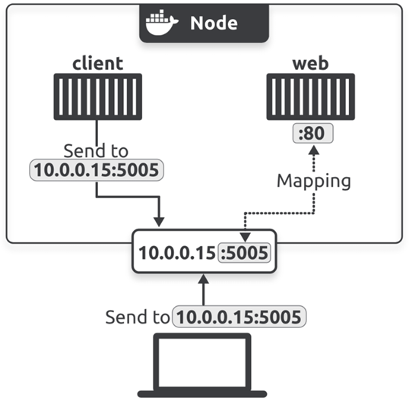
-docker run -d --name web --network <network> --publish 5005:80 nginx
-docker port web: verify port mapping
+You can test external access by pointing a web browser to Docker host on port 5005. You need to know IP or DNS name of Docker host.
-docker run -it --name --network bridge alpine sh
-apk add curl
13.5 Docker Networking – The Commands

14. Docker overlay networking

14.1 Docker overlay networking – The TLDR

14.2 Docker overlay networking history

14.3 Build and test Docker overlay networks

14.4 Overlay networking explained

14.5 Docker overlay networking – The commands

15. Volumes and persistent data

15.1 Volumes and persistent data – The TLDR

15.2 Containers without volumes

15.3 Containers with volumes

15.4 Volumes and persistent data – The commands

16. Docker security

16.1 Docker security – The TLDR

16.2 Kernel Namespaces

16.3 Control Groups

16.4 Capabilities

16.5 Mandatory Access Control systems

16.6 seccomp

16.7 Docker security technologies

16.8 Swarm security

16.9 Docker Scout and vulnerability scanning

16.10 Signing and verifying images with Docker Content Trust

16.11 Docker Secret

