4. Working with Docker Images
-Docker or Open Container Initiative (OCI) images provide basis for everything you deploy and run with Docker. To launch container, you must download a public image or create your own. You can think image as a single asset that represents the filesystem for container. Every image consists of one or more linked filesystem layers that have a direct one-to-one mapping to each build step used to create that image.
-Images built up from individual layers, they put special demands on Linux kernel, which must provide the drivers that Docker needs to run storage backend. The storage backend communicates with Linux filesystem to build and manage layers combine into image. The primary storage backend supported: Overlay21, B-Tree File System (Btrfs), Device Mapper. Each storage backend provide a fast copy-on-write (CoW) system for image management.

4.1 Anatomy of a Dockerfile
-To create custom image, you use Dockerfile: a file describes all the steps that are required to create an image and contained within the root directory of source code repository for your app.
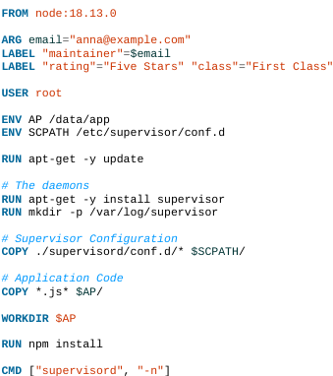
-Each line create a new image layer which contains all of changes that are a result of that command being issued. So when you build new images, Docker will need to build layers that deviate from previous builds, you can reuse all layers that haven’t changed.
-: Although you can build a Node instance from a base linux image, you can explore Docker Hub for official images (https://registry.hub.docker.com/). It maintains a series of images and tags to determine what versions are available. This code provide with an Ubuntu Linux image running Node 11.11.x
-: set variables and their default values, which are only available during image build process.
-
+Applying labels allows you to add metadata via key/value pairs that can later used to search for identify Docker images and containers
+You can see labels applied to any images using: docker image inspect
-: By default, Dockers run all process as root within container, you can USER instruction to change this.
: set shell variables used by your running application for configuration, to being available during build process.
-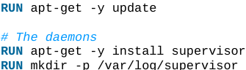: start and create required file structure you need, and install some required software dependencies.
-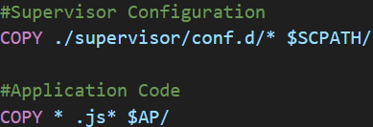: copy files from local filesystem into your image. Most often this will include your app code and any required support files. So you no longer need access to local filesystem to access them once the image is built.
-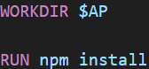: Change the working directory in the image for the remaining build instruction and the default process that launches with any resulting containers.
-: defines the command that launches the process that you want to run within the container.
-Note: It’s considered a best practice to try to run only a single process within a container. In example, you use supervisor as a process manager to help improve the resiliency of node app within container and ensure that it stays running. This can useful for troubleshooting during dev so you can restart your service without restarting the whole container.

4.2 Building an Image
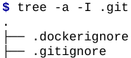

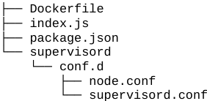
-.dockerignore: define files and directories don’t want to upload to Docker host when building image.
-supervisord directory contains configuration files for supervisord that you will use to start and monitor the application.
-Each step identified in output maps to a line in Dockerfile, each step creates a new image layer based on previous step. The 1st build will take a few minute as you download base node image. At the end of build command, you see “.”: refer to build context, which tells Docker what files it should upload to server so that it can build our image. “.” Represents the current directory. This build context is what .dockerignore file is filtering.
+-f: point directly to Dockerfile
-Run the build:
+Tip:
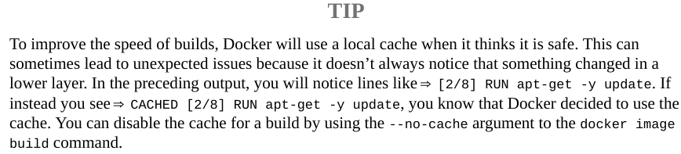
+Tip: docker image build = docker build

4.3 Running your Image
-Run image on your Docker host:
+This command tells Docker to create a running container in background from image with example/docker-node-hello:latest tag, then map port 8080 in container to port 8080 on Docker host.
+: verify running containers
+: determine Docker host IP address by examming the entry. Check the value of DOCKER_HOST env variable. If DOCKER ENDPOINT is set to a Unix socket, IP address is likely 127.0.0.1

4.3.1 Build Arguments
-Inspect the image:
-Change maintainer label: rerun the build and provide a new value:
+Then reinspect: dokcer image inspect…

4.3.2 Environment Variables as Configuration
-In index.js: refers to variable $WHO, which the app uses to determine who the app is going to say:
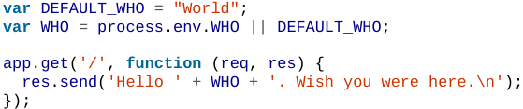
-Configure this app by passing in environment variables when you start it:
+Stop the existing container:
: see containers ID, image, status
: stop container
+Restart after adding --evn:
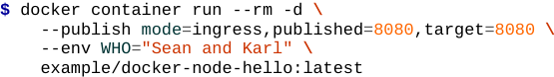
You can shorten the command:
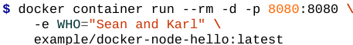

4.4 Custom Base Images
-Basic Images: the lowest-level images that other Docker images will build upon. These are based on minimal installs on Linux distributions (Ubuntu, Fedora, Alpine Linux).
-Build base image on various Linux distributions:
(https://dockr.ly/2N1FZcU)

4.5 Storing Images
-You’ve created image, you want to store it somewhere that can accessed by Docker host that you want to deploy it. You don’t normally build images on a production server and run them. Deployment is process of pulling image from repository and run it on Linux servers. There are ways to store images into central repository

4.5.1 Public Registries
-Docker provides an image registry for public images that community wants to share. (https://registry.hub.docker.com/)
-You can use some public registries: Docker Hub, Quay.io, Google Cloud, Github.

4.5.2 Private Registries
-Host some type of image registry internally, which can interact with Docker client support pushing, pulling and searching images. This open source project (https://github.com/distribution/distribution) provides the basic functionality that most other registries build upon
-Other private registry space: Harbor, Read Hat Quay.

4.5.3 Authenticating to a Registry
-Docker tries to make it easy to automate authentication things, it can store your login information and use it on your behalf when you request things like pulling down a private image. By default, Docker assumes the registry will be Docker Hub, the public repository hosted by Docker, Inc.
-Creating a Docker Hub account
-Logging into a registry
+Docker has written a dotfile in your home directory to cache your information. The permission are set to 0600 as security precaution against users reading your credentials. ${HOME}/.docker/config.json contain docker.io credentials for user in JSON. This configuration file supports storing credentials for multiple registries.
+docker logout:
-Pushing images into a repository
+Ensure you logged into Docker repository.
+Earlier, you used docker image build. In reality, Docker client interpret example/… as docker.io/example/… docker.io signifies the image registry hostname, and example/… is repository inside registry that contains images.
+When building image locally, registry and repository name can be anything. But uploading image to registry, you need to match the login. You can edit tags on image:
+If you need to rebuild image, run:
+Check: docker image ls or
+At this point you can upload image to Docker repository:
+Anyone in world can now download it:
-Exploring images in Docker Hub
+To use Docker Hub to explore what images are available, use: docker search to find images in name or description

4.5.4 Running a Private Registry
-In some cases, it makes sense to host an internal private registry. Setting up a basic registry is not difficult: https://docs.docker.com/registry.
-We will create a secure registry using SSL and HTTP auth.
-Testing the private registry

4.6. Optimizing Images

4.6.1 Keeping Images Small
-Multistage builds
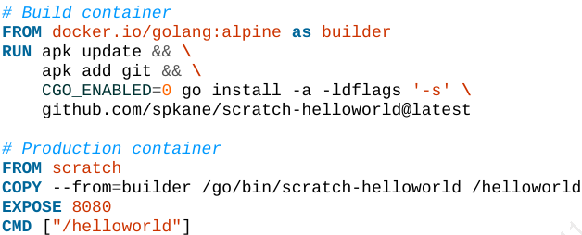
+COPY –from=builder … allow you to copy the binary that you built in builder image into the current image.

4.6.2 Layers are additive

4.6.3 Utilizing the Layer Cache

4.6.4 Directory Caching
-This line tells BuildKit to mount a caching layer into the container at /root/.cache. It will remove the contents of that directory from the resulting image, and be remounted and available to pip in consecutive build.

4.7. Troubleshooting Broken Builds

4.7.1 Debugging Pre-BuildKit Images

4.7.2 Debugging BuildKit Images

5. Working with Containers

5.1 What are Containers?
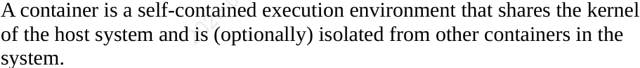

5.1.1 History of Containers

5.2 Creating a Container
-docker container run=docker container create + docker container start.

5.2.1 Basic Configuration
-Container name
+By default, Docker randomly names the container. To give a specific name, use --name:
-Labels
-Hostname
-Domain Name Service
-MAC address

5.2.2 Storage Volumes

5.2.3 Resource Quotas

-CPU shares

-CPU pinning

-Simplifying CPU quotas

-Memory

-Block I/O

-ulimits

5.3 Starting a Container
-Create a container: docker container create
-List all containers: docker container ls -a
-Start the container: docker container start

5.4 Auto-Restarting a Container
-Manage restart: --restart: no, always, on-failure:<number> (when the container exists with a nonzero exit code), unless-stopped (restart unless intentionally stop)

5.5 Stopping a Container
-docker container stop, docker container start

5.6 Killing a Container
-docker container kill

5.7 Pausing and Unpausing a Container
-docker container pause >< start

5.8 Cleaning up Containers and Images
Docker container/image rm (-f)

5.9 Windows Containers

6. Exploring Docker

6.1 Printing the Docker Version
-docker version

6.2 Server Information
-docker system info

6.3 Download Image Updates
-docker image pull <name>:latest

6.4 Inspect a Container
-docker container inspect <id>

6.5 Explore the Shell
-docker container run --rm -it <image> /bin/bash

6.6 Return a Result

6.7 Get inside a Running Container

6.7.1 docker container exec
docker container exec -it <id> /bin/bash

6.7.2 docker volume
-docker volume ls
-docker volume create <data>
-docker volume inspect <data>
-Start a container with data volume:
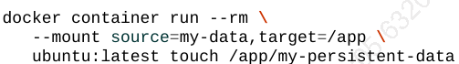
-docker volume rm <data>

6.8 Logging

6.8.1 docker container logs
-docker container logs <name>

6.8.2 More advanced Logging

6.9 Monitoring Docker

6.9.1 Container Statistics

-Command-line statistics
+docker container stats <name>
-stats API endpoint

6.9.2 Container Health Checks

6.9.3 docker system events

6.9.4 cAdvisor

6.10 Prometheus Monitoring

6.11 Exploration

8. Explore Docker Compose

8.1 Configure Docker Compose
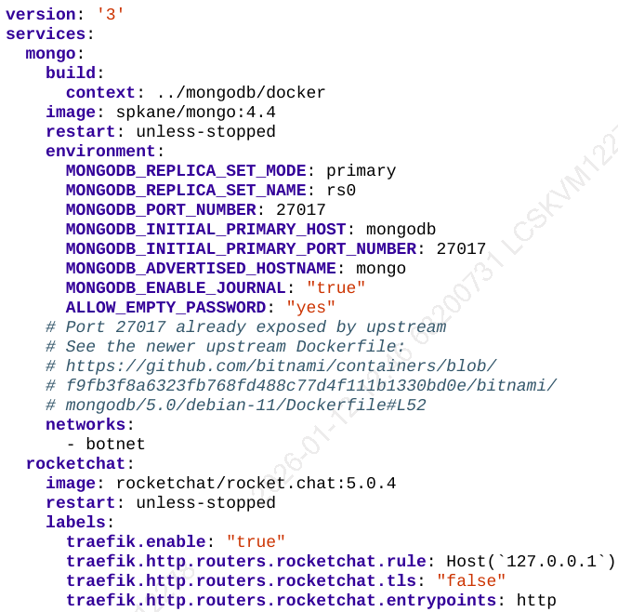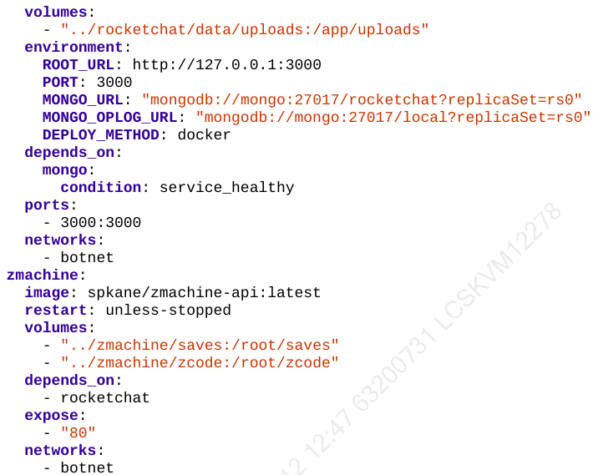
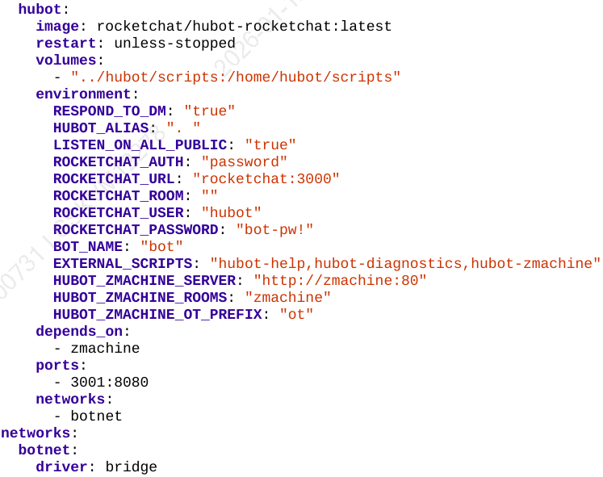
-version: the version of Compose configuration language this file was designed for.
-Docker network: (default) bridge network will bridge the Docker network with host’s networking stack.
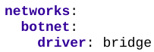
-volumes: mount local directories into containers.
-depends_on: you can leverage the HEALTHCHECK
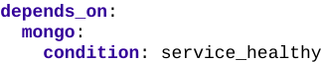

8.2 Launch Services
-docker compose config: confirm the configuration is correct.
-docker compose build (-d)
-docker compose logs
-docker compose stop/start/pause/unpause <name>
-docker compose down

8.3 Explore Rocket.Chat

8.4 Exercise Docker Compose
-docker compose top: see an overview.
-docker compose exec <name> bash

8.5 Manage Configuration

8.5.1 Default Values

8.5.2 Mandatory Values

8.5.3 The dotenv File

