1. Getting Started

1.1 About Version Control
-Version control: a system that records changes to a file or set of files over time so that you can recall specific versions later
-Version Control System (VCS): allow to revert selected files back to previous state, revert he entire project back to previous state, compare changes over time, see who last modified sth that might be causing problem, who introduced an issue and when…
-Local Version Control Systems: Have a simple database that kept all changes to files under revision control.
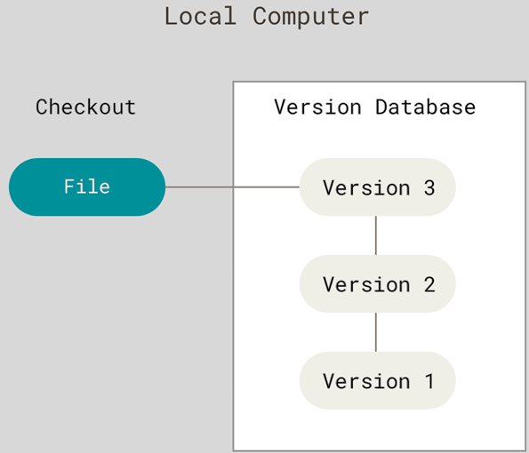
+One of most popular VCS tools: RCS. It works by keeping patch sets (the different between files) in a special format on disk; it can then re-create what any file looked like at any point I time by adding up all the patches.
-Centralized Version Control Systems (CVCS)
+The next major issue that people encounter is that they need to collaborate with developers on other system.
+CVCSs (like CVS, Subversion, Perforce) have a single server that contains all versioned files, and a number of clients that check out files from that central place.
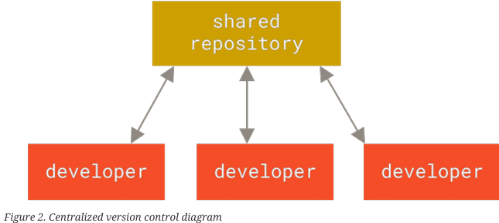
+Downsides: servers goes down for 1 hour ->nobody can work during that hour, hark disk corrupted and no backups -> lose everything.
-Distributed Version Control Systems (DVCS)
+DVCS (Git, Mercurial, Rarcs): clients don’t just check out the latest snapshot of files, they fully mirror the repository, including its full history. So if server dies, and these systems were collaborating via that server, any of client repositories can copied back up to server to restore it. Every clone is a full backup of all data.
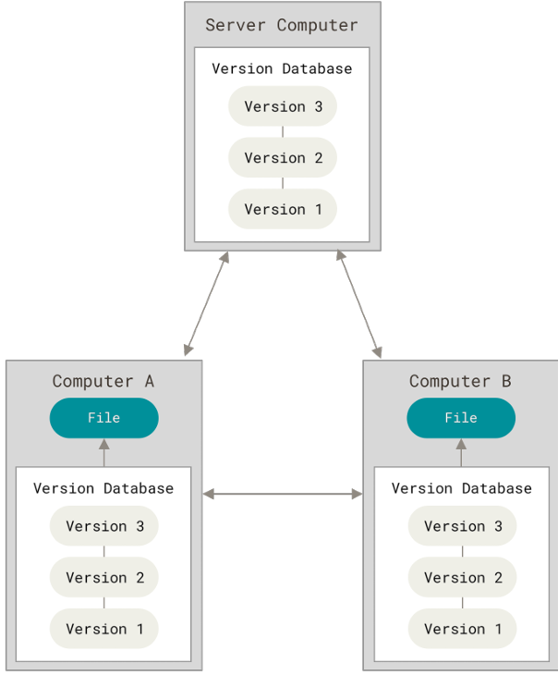
+Many systems deal with having several remote repositories they can work with, you can collaborate with different groups of people in different ways within the same project.

1.2 A Short History of Git
-Births: 2005
-Linus Torvalds, the creator of Linux, based on the lessons learned while using BitKeeper

1.3 What is Git
-Snapshots, not Differences
+Other systems (CVS, Subversion, Perforce) think of information they store as a set of files and changes made to each file over time (delta-based version control)
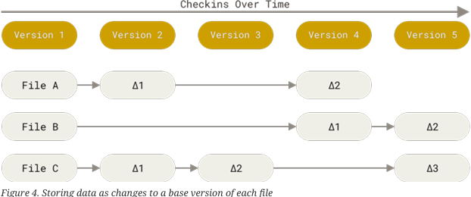
+Git thinks of its data more like a series of snapshots of a miniature filesystem. Every time you commit, or save the state of your project, Git takes a picture of what all your files look like at that moment and stores a reference to that snapshot. Git thinks about its data more like a stream of snapshots.
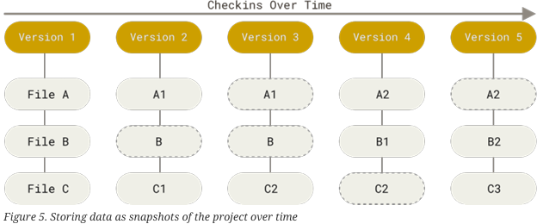
-Nearly Every Operation is Local
+Most operation in Git need only local files and resources to operate->no information needed from another computer on your network.
+There is a very little you can’t do if you’re offline or off VPN. You can work locally until get network connection to upload.
-Git has Integrity
+Everything in Git is checksummed before it stored and then referred to by that checksum.->You can’t lose information in transit or get file corruption without Git being able to detect it.
+The mechanism: SHA-1 (40-character string composed of hexadecimal characters) calculated based on contents of a file or directory structure in Git.
+Git stores everything in its database not by file name but by the hash value of its content.
-Git generally only Adds Data
+When you do actions in Git, nearly all of them only add data to Git database. It makes using Git a joy because we can experiment without danger of screwing things up
-The 3 States files can reside in: modified, stated, commited.
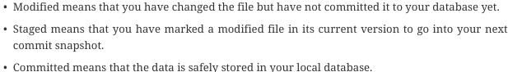
+This leads us to 3 main sections of Git project: working tree, staging area, Git directory
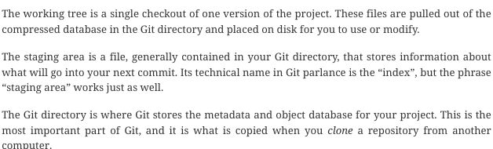
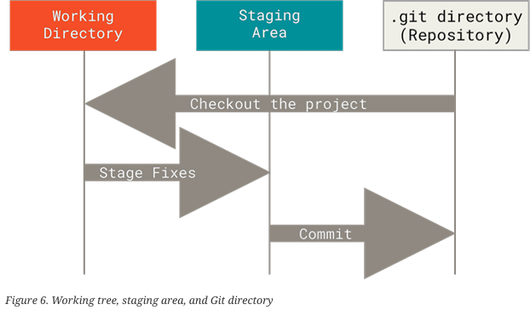
-The basic Git workflow:
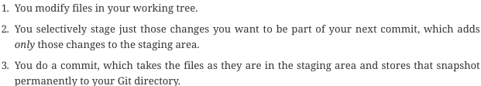

1.4 The Command Line
-There are lots of different ways to use Git: command-line tools, GUI.
-Command line is the only place you can run all Git commands-most of GUIs implement only a partial subset of Git functionality for simplicity.

1.5 Installing Git

1.6 First-Time Git Setup
-git config: a tool that lets you get and set configuration variables that control all aspects of how Git looks and operates.
+View all settings and where they are coming:
-Your identity:
+The 1st thing you should do when install Git to set user name and email address. Git commit uses this information, and it’s immutably baked into commits you start creating:
-Your Editor:
+Configure the default text editor used when Git needs you to type in a message.
-Your default branch name:
+By default Git will create a branch master when git init. To set main as default branch:
-Checking your setting:
+Check specific key’s value:
-Query Git as to the origin for that value:
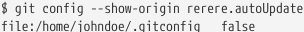

1.7 Getting Help
-If you ever need help, there are 3 equivalent ways to get the comprehensive manual page (manpage) help for any of Git commands
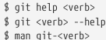
-Need a quick refresher on available options for Git command, use –h:

2. Git Basics
-If you can read only one chapter to get going with Git: should read it. This chapter covers every basic commands you need to do with Git.

2.1 Getting a Git Repository
-You obtain a Git repo in one of 2 ways:
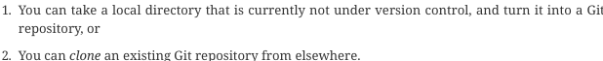
-Initializing a Repository in an Existing Directory:
+: create a new subdirectory .git containing necessary repository files.
+If you want to start verion-controlling existing files: tracking those file and do an initial commit.
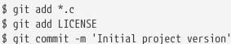
-Cloning an Existing Repository
+Specify the new directory name:

2.2 Recording Changes to Repository
-Each file in working directory is: tracked or untracked
+Tracked files: files were in last snapshot, newly staged files. They can be unmodified, modified, staged. They are files Git knows about.
+Untracked file: everything else: not in last snapshot and staging area.
+When 1st clone a repo, all files are tracked+unmodified
-As edit files->modified. As you work, you stage these modified files and then commit all those staged changes, and the cycle repeats:
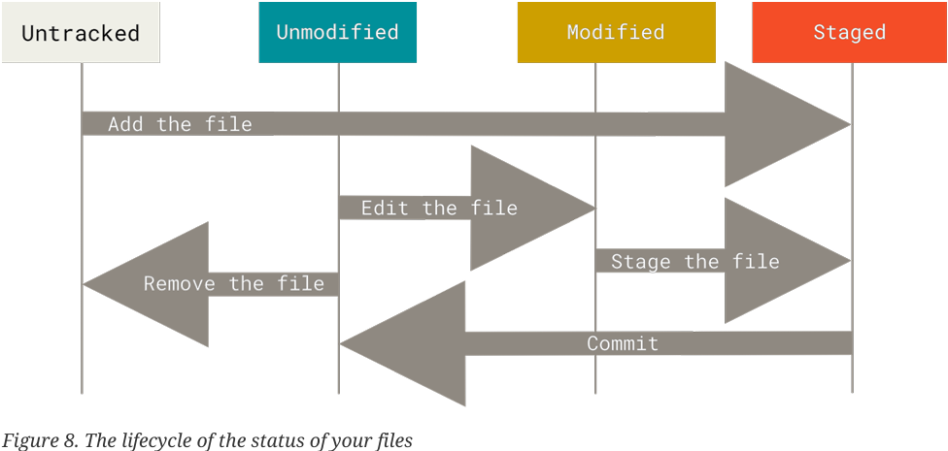
-Checking the status of your files: git status
-Tracking new Files: git add <file>
-Staging Modified Files: git add <file>
+git add is a multipurpose command: track new files, stage files, do other things like marking merge-conflicted files as resolved.
+If you modify file after running git add, you have to run git add again to stage the latest version of file.
-Short status: git status -s or git status --short get a far more simplified output from command:
-Ignoring Files:
+Create a file listing patterns to match untracked files (automatically generated files like log files, produced by build system): .gitignore
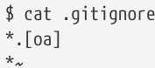
+The rules can put in:
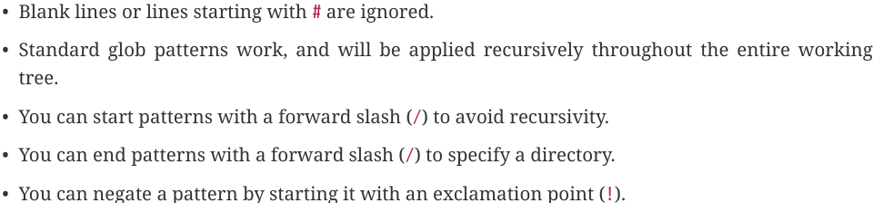
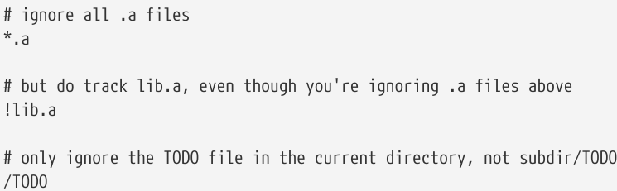
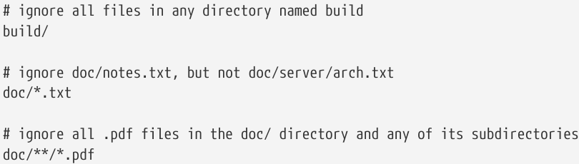
-View your Staged and Unstaged Changes
+git diff: what you’ve changed but not yet staged
+git diff --staged (or --cached): see what you’ve staged that will go into your next commit. This command compares your staged changes to your last commit.
-Committing your Changes
+git commit: simplest way to commit your changes, then type your message
+git commit -m “<message>”: Type commit message inline with commit command
-Skipping the staging area:
+git commit -a -m “<message>”: automatically stage every file that is already tracked before doing the commit, letting skip git add part.
+This is convenient, but be careful sometimes this flag will cause to include unwanted changes.
-Removing Files
+git rm <file>: Remove a file from Git: remove it from tracked files (staging area) and then commit.
+-f: safety feature to prevent accidental removal of data that hasn’t been recorded in a snapshot and that can’t be recovered from Git.
+--cached: Keep the file in working tree but remove it from staging area.
+Pass files, directories and file-glob patterns: Note: \*
-Moving Files:
is equivalent to:
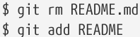

2.3 Viewing the Commit History
-git log: look back to see what has happened. By default, it lists the commits made in that repository in reverse chronological order: SHA-1 checksum, author’s name and email, data written and commit message.
+git log -p (--patch) <number>: shows the difference introduced in each commit. Number is the limit number of log entries displayed.
+git log --stat: See some abbreviated stats for each commit
+git log --pertty=<value>: change the log ouput to formats other than default.
online: print each commit on a single line -> look at a lot of commits
short, full, fuller: same format but less or more information.
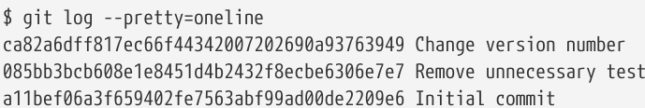
format: specify your own log output format
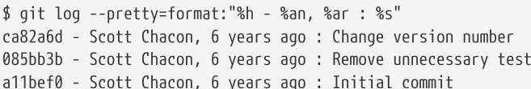
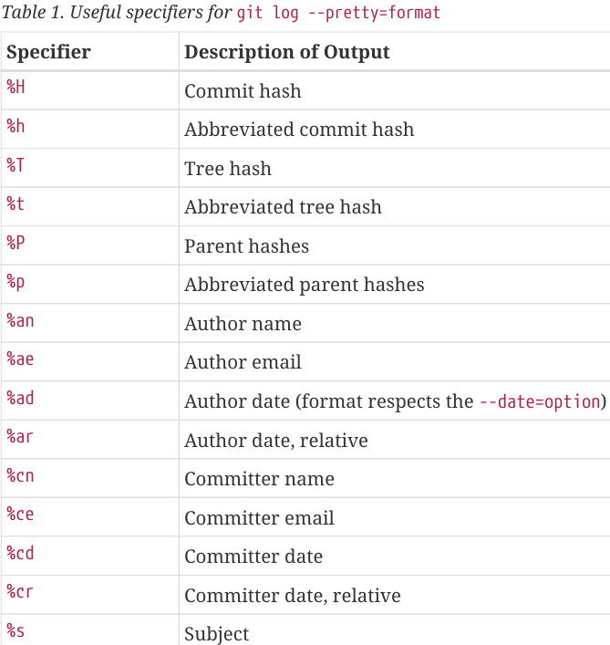
online and format are useful with --graph: nice little ASCII graph showing your branch and merge history
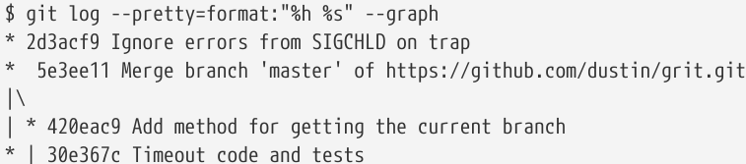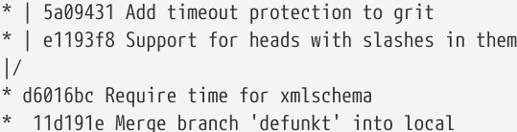
+--no-merges: prevent display of merge commits
+Common options to git log:
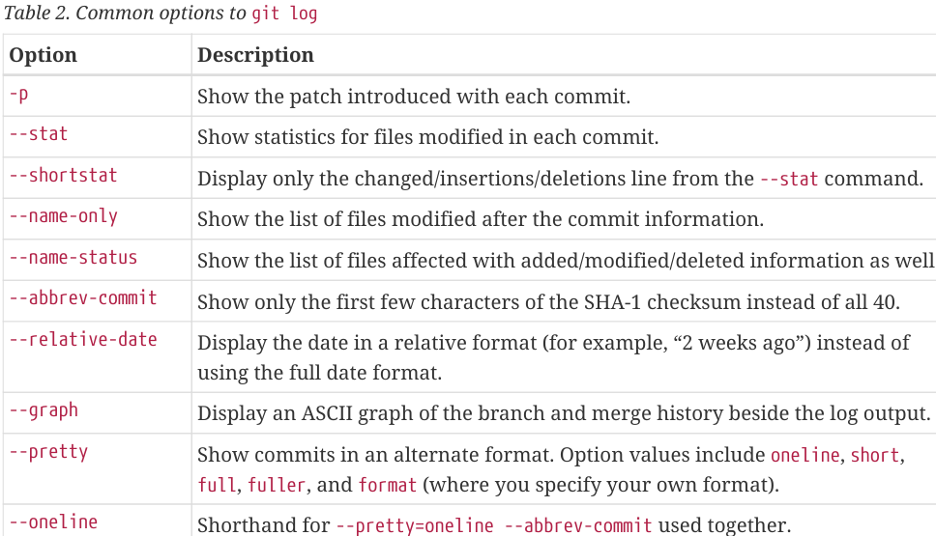
-Limiting Log Output
+git log taks some limiting options: show only a subset of commits.
+git log -<n>: show the last n commits
+git log --since=<value> and git log --until=<value>
+git log --author=<value>
+git log --grep=<value>: search for keywords in messages
--author and --grep limit commit output that match any of them -> use --all-match to get commits matching all
+-S: take a string and show only those commits that changed the number of occurrences of that string.
+git log -- path/to/file: pass a filter is a path, limit the output to commits that introduced a change to those files. This is always the last options.
+Options to limit the output:

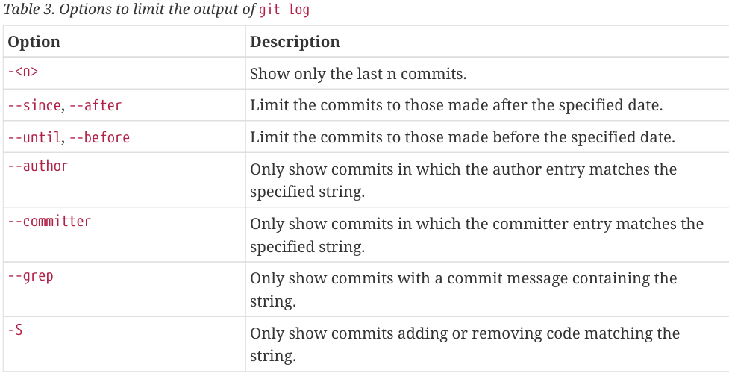
+Example:

2.4 Undoing Things
-To redo a commit, make the additional changes you forgot, stage them and git commit --amend:
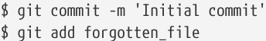
-Unstaging a Staged File: git reset <file>
-Unmodifying a Modified File
+git checkout -- <file>: Revert the file back to what it looked like when you last committed (or initially cloned, or however you got it into working directory)
+It’s important to understand that this command is dangerous. Any local changes you made to that file are gone-Git just replaced that file with the last staged or committed version.
-Undoing things with git restore
+git restore is an alternative to git reset.
+Unstaging a Staged File with git restore:
git restore --staged <file>
+Unmodifying a Modified File with git restore:
git restore <file>

2.5 Working with Remotes
-Remote repository: versions of your project that are hosted on Internet or network somewhere. You can have several of them, each of which is read-only or read/write for you. Collaborating with others involves managing these remote repositories and pushing and pulling data to and from them when you need to share work.
-Showing your Remotes:
+git remote: lists the shortnames of each remote handle you’ve specified. If you’ve cloned your repository, you should at least see origin-the default name Git gives to server you cloned from.
+git remote -v: show the URLs that Git has stored for shortname to be used when read + write to remote
-Adding Remote Repositories
+git remote add <shortname> <url>: add a new remote
-Fetching and Pulling from your Remotes
+git fetch <remote>: get data from remote projects that you don’t have yet. Then you should have references to all branches from that remote, which you can merge in or inspect at any time.
+If you clone a repository, it adds that remote repository under the name ‘origin’. git fetch origin fetches any new work that has been pushed to that server since you cloned (or last fetched from it).
+It’s important that git fetch only downloads data to local repository-it doesn’t automatically merge it with any of your work or modify what you’re currently one. You have to merge it manually into your work when you’re ready.
+If your current branch is set up to track a remote branch, you can use git pull: automatically fetch and then merge that remote branch into your current branch.
+By default, git clone automatically sets up your local master branch to track the remote master branch (or the default branch) on the server you cloned from. Running git pull fetches data from server you cloned from and automatically tries to merge it into the code you’re currently working on.
-Pushing to your Remotes: git push <remote> <branch>
-Inspect a Remote
+git remote show <remote>:see more information about a particular remote.
-Renaming and Removing Remotes
+git remote rename <old> <new>: change remote’s shortname
+git remote remove/rm <value>: remove a remote. All remote-tracking branches and configuration settings associated with that remote are also deleted.

2.6 Tagging
-Git has ability to tag specific points in a repository’s history as being important. Typically, people use this functionality to mark release points (v1.0, v2.0)
-Listing your Tags
+git tag: list the existing tags
+git tag -l/--list <string>: search for tags that match a particular pattern
-Creating Tags:
+Git supports 2 types of tags: lightweight+annotated
+Lightweight tag is like a branch that doesn’t change-it’s just a pointer to specific commit.
+Annotated flags are stored as full object in Git database. They’re checksummed, contain the tagger name, email and date; have a tagging message; can be signed and verified with GNU Privacy Guard (GPG)
+It’s recommended that you create annotated tags so you can have all this information; if you want a temporary tag or for some reason don’t want to keep other information, use lightweight.
-Annotated Tags:
+Create annotated tage: git tag -a <name> -m “<vs>”
+See the tag data: git show <name>
-Lightweight Tags
+Create: git tag <name>
-Tagging Later
+Tag commits after you’ve moved past them: Use git log to see the commit checksum (or part of it) and use:
git tag -a <name> <checksum>
-Sharing Tags
+By default, git push doesn’t transfer tags to remote servers. You will have to push tags to a shared server after creating them: git push <remote> <tagname>
+If you have lots of tags, use: git push <remote> –tags: push both lightweight and annotated tags.
+git push <remote> --follow-tags: push annotated tags
-Deleting Tags
+Delete a tag on local repository: git tag -d <name>
+Delete tag from remote server:
git push <remote> :refs/tags/<name> or
git push <remote> --delete <name>
-Checking out Tags
+View the versions of files a tag is pointing to:
git checkout <name>
+If you need to make changes (fixing a bug on an older version), you will want to create a branch:
git checkout -b <branch> <tag>

2.7 Git Aliases
-If you don’t want to type entire text of each Git commands, you can set up alias for each command using git config:
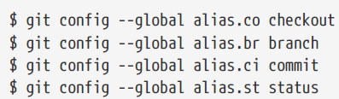
Instead of git commit, just type git ci.

3. Git Branching
-Branching: you diverge from main line of development and continue to do work without messing with that main line.

3.1 Branches in a Nutshell
-When you make a commit, Git stores a commit object that contains a pointer to the snapshot of the content you staged. This object contains author’s name and email address, the message, pointers to the commit or commits that directly came before this commit (its parent or parents): zero parents for initial commit, one parent for a normal commit, and multiple parents for commit that results from a merge of 2 or more branches
-Staging the file files computes a checksum for each one, stores that version of file in Git repo (blobs), and adds that checksum to staging area.
-When you create the commit, Git checksums each subdirectory and stores them as a tree object in Git repo. Git then creates a commit object that has metadata and pointer to root project tree
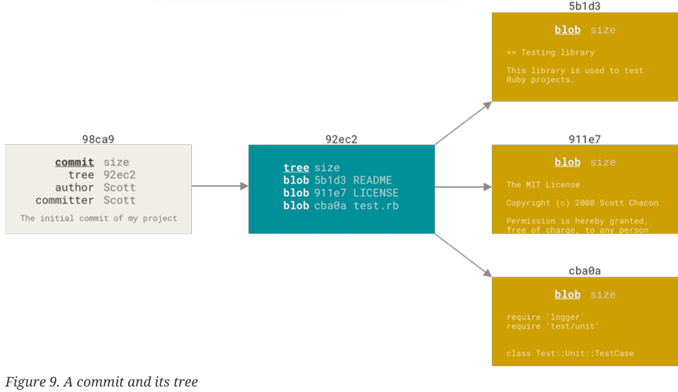
-If you make changes and commit again, the next commit stores a pointer to the commit that before it:
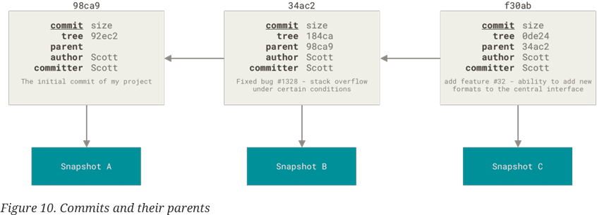
-A branch is a lightweight movable pointer to one of these commits. The default branch name is master. As you start making commits, you’ve given a master branch that points to the last commit you made. Every time you commit, master branch pointer moves forward.
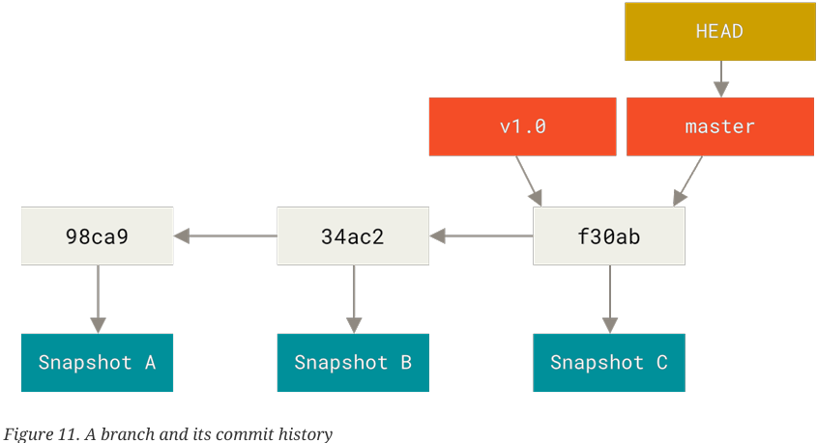
-Create a new branch: git branch <name>: create a new pointer to the same commit you’re currently on
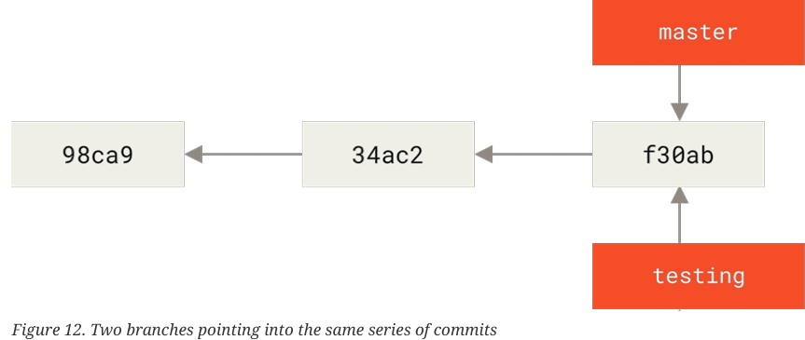
+Git keeps a special pointer HEAD to know what branch you’re currently on. git branch created a new branch, it didn’t switch to that branch.
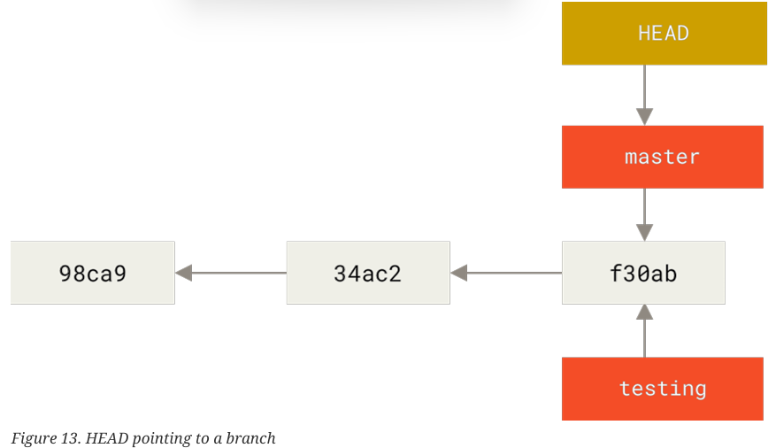
+git log --oneline --decorate: show where the branch pointers are pointing
-Switching Branches: git checkout <name>
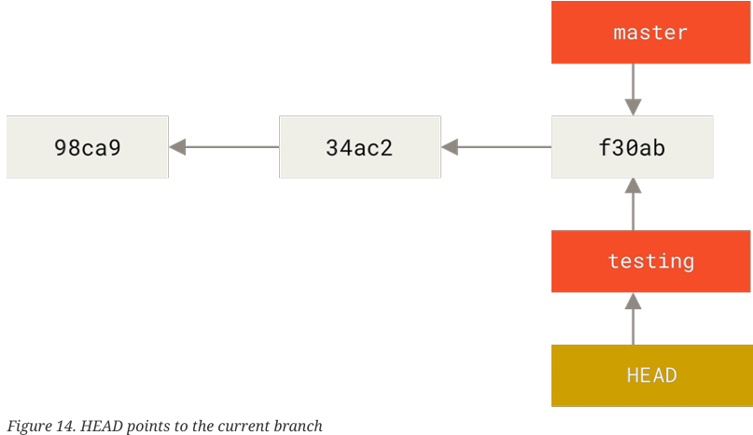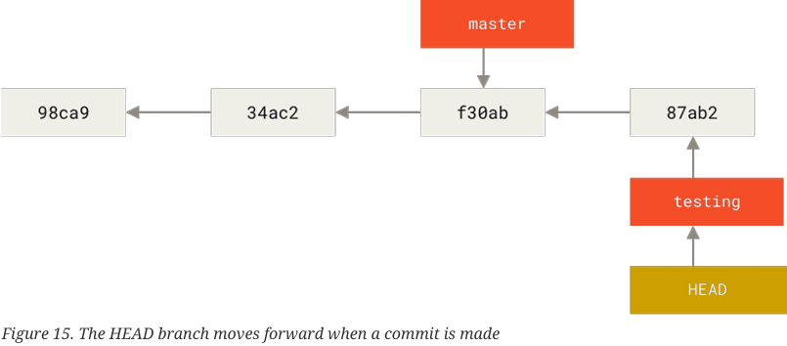
+git log doesn’t show all branches all the time. It only show commit history below the branch checked out.
+git log <name>: show commit history for a branch
+git log --all: show all of branches
+git log --oneline --decorate --graph --all: print out the history of commits, showing where your branch pointers are and how your history has diverged.
+Branch is a simple file containing SHA-1 checksum, it’s cheap to create and destroy.

3.2 Basic Branching and Merging
-Example of branching and merging with a workflow:
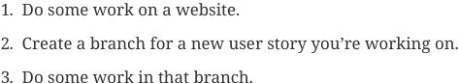
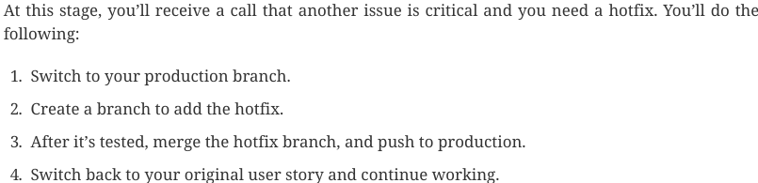
-Basic Branching
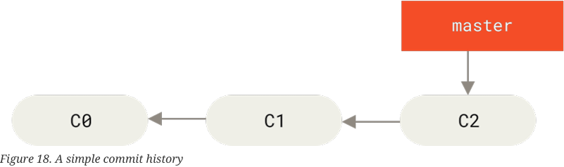
+git checkout -b <name>: create a new branch and switch to it.
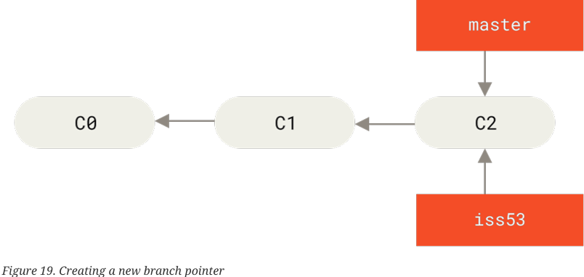
+Do some commits on iss53 branch:
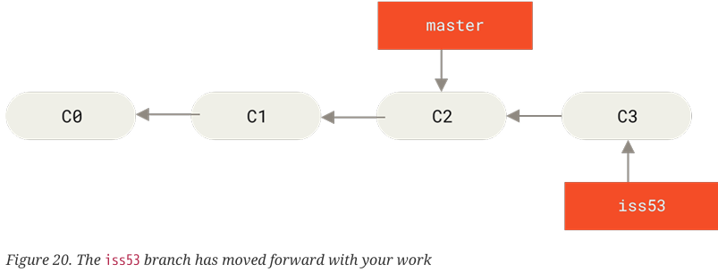
+You get the call that there is an issue: switch back to master. Note that before you do that, if working directory or staging area has uncommitted changes that conflict with the branch you’re checking out, Git won’t let you switch branches.
+git merge <name>:
+fast-forward: Move the pointer forward because there is no divergent work to merge together.
+git branch -d <name>: delete branch
-Basic Merging
+Git does a simple 3-way merge, using 2 snapshots pointed to by branch tips and common ancestor
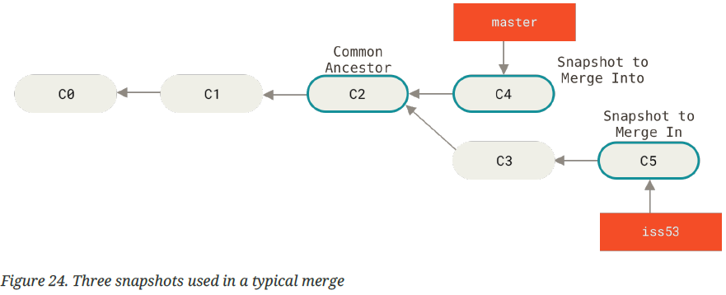
Instead of just moving branch pointer forward, Git creates a new snapshot that results from this 3-way merge and automatically create a new commit that points to it. This is referred to as a merge commit, and is special in that it has more than one parent.
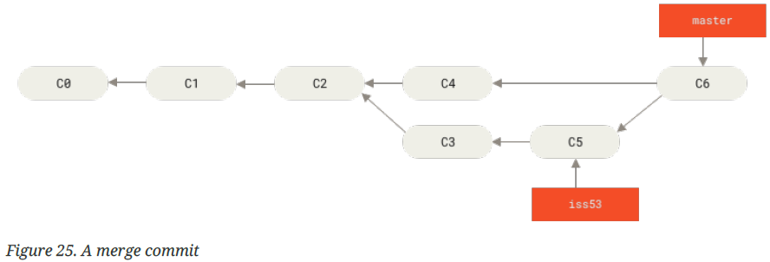
-Basic Merge Conflicts
+If you changed the same part of the same file differently in 2 branches you’re merging->Merge conflicts.
+Git hasn’t automatically created a new merge commit. It has paused the process while you resolve the conflict. To see which files are unmerged at any point after a merge conflict, use git status
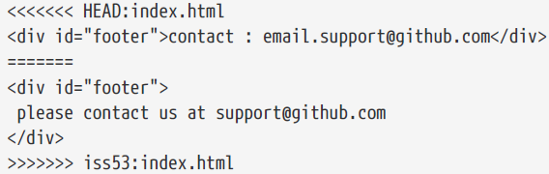
+If you want to use graphical tool: git mergetool

3.3 Branch Management
-git branch: list current branches
-git branch -v: see the last commit on each branch.
-git branch --merged/--no-merged: filter this list to branches that you have or have not yet merged into the branch you’re currently on.
-git branch -d <name>: may not work if it contains work that isn’t merged in. If you really want to delete the branch: git branch -D <name>
-Changing a branch name:
+Rename the branch locally:
git branch --move <old> <new>
and then push it:
git push --set-upstream origin <new>
and delete the old branch:
git push origin --delete <old>
-Changing the master branch name
+Changing the name of branch like master, main, mainline, default will break the integrations, services, helper utilities and build/release scripts that repo uses
+Rename local master branch:
git branch --move master <name>
git push branch --move master <name>
git push origin --delete master

3.4 Branching Workflows
-Long-Running Branches
+Git uses a simple three-way merge, merging from one branch into another multiple times over a long period is easy to do. This means you can have several branches that are always open and that you use for different stages of development cycle; you can merge regularly from some of them into others.
+Developers have this workflow: having only code that is entirely stable in master branch-possibly only code that has been or will be released. They have another parallel branch develop or next to work or test. Whenever it gets to stable state, it can be merged into master. It’s used to pull in topic branches when they’re ready.
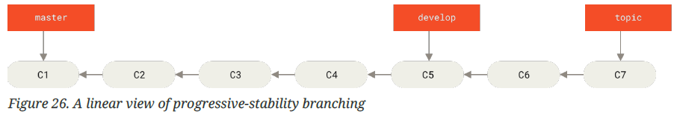
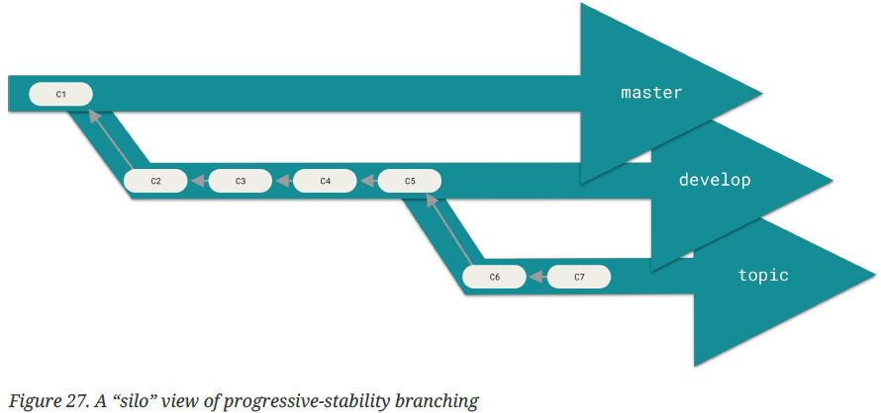
+Some larger projects also have a proposed or pu (proposed updates) branch that has integrated branches that may bot be ready to go into next or master.
+The idea is that your branches are at various levels of stability; when they reach a more stable level, they’re merged into branch above them.
+Having multiple long-running branches isn’t necessary, but it’s often helpful, especially when you’re dealing with very large or complex projects.
-Topic Brances
+Useful in projects of any size.
+A topic branch: a short-lived branch that you create and use for a single particular feature or related work. It’s common to create, work on, merge, and delete branches several times a day.

3.5 Remote Branches
-Remote references: references (pointers) in remote repositories: branches, tags… Get full list:
-Remote-tracking branches: references to the state of remote branches. It takes the form remote/branch.
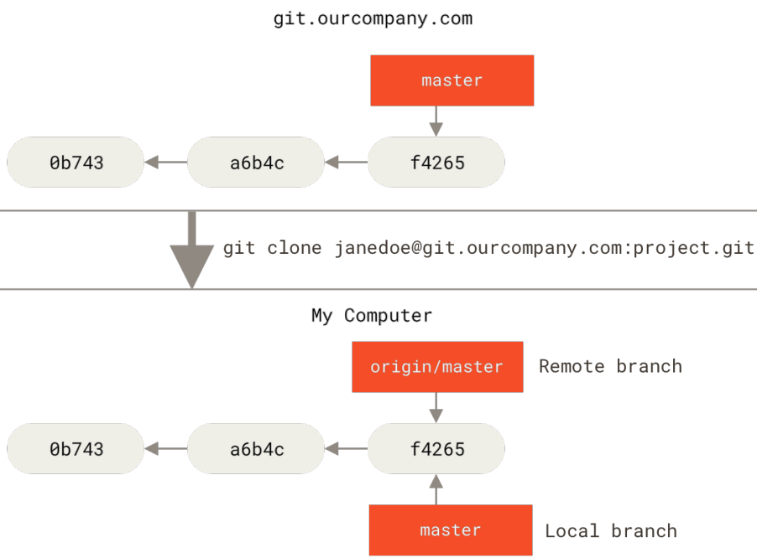
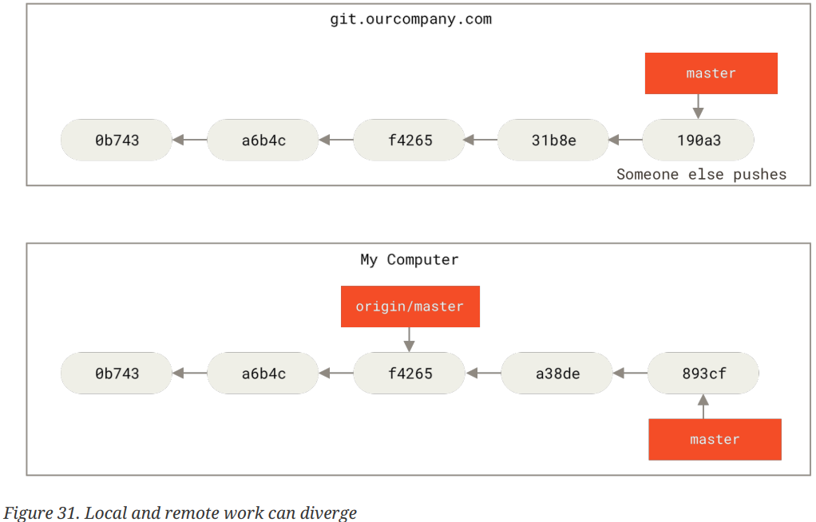
+To synchronize your work with remote: git fetch <remote>
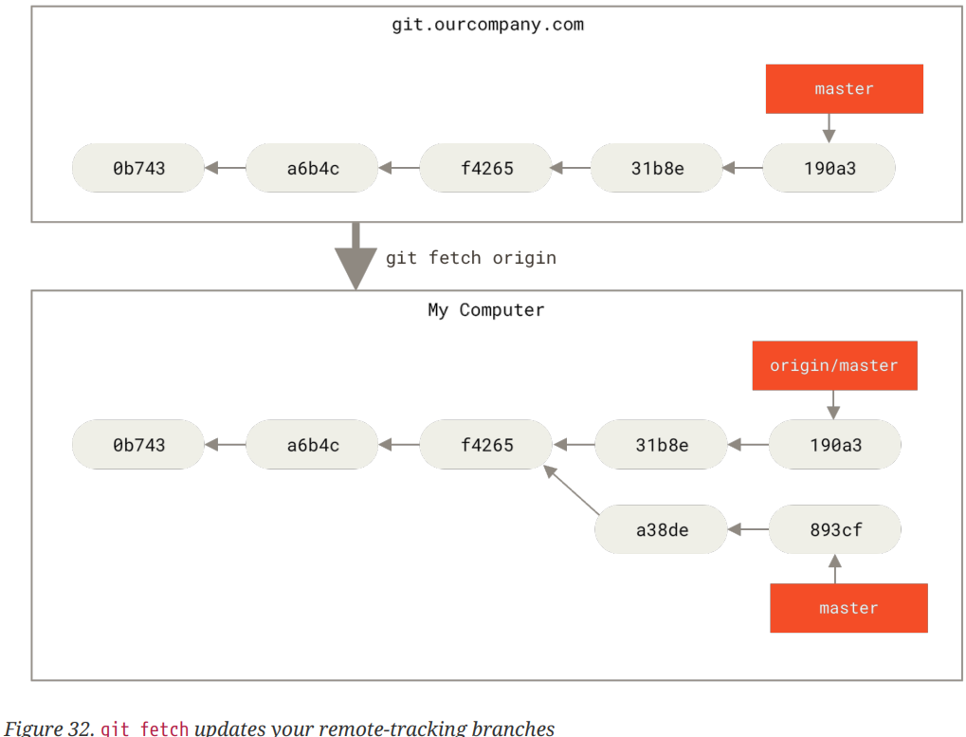
-Pushing: git push <remote>/<branch>
+Merge the new remote branches: git merge remote/branch
+Create your own branch based on remote branch:
git checkout -b <branch> <remote>/<branch>
-Tracking Branches
+Checking out local branch from a remote-tracking branch automatically create tracking branch ( the branch it tracks is up is upstream branch). Tracking branches: local branches that have a direct relationship to a remote branch.
+git pull: automatically knows which server to fetch and which branch to merge in.
+When you clone a repo, it automatically creates a master branch that tracks origin/master. You can set up other tracking branches: git checkout -b <branch> <remote>/<branch>
+See what tracking branches you set up: git branch -vv
-Pulling
+git fetch: fetch all changes on server you don’t have yet, it doesn’t change your code in working directory, it only get data and let you merge it yourself.
+git pull: git fetch + get merge. If you have a tracking branch set up by clone or checkout.
-Deleting Remote Branches
git push <remote> --delete <branch>

3.6 Rebasing
-There are 2 main ways to integrate changes from one branch into another: merge and rebase
-The Basic Rebase
+Basic Merging: it performs a three-way merge between 2 latest branch snapshots and the most recent common ancestor of the two, creating a new snapshot (and commit)
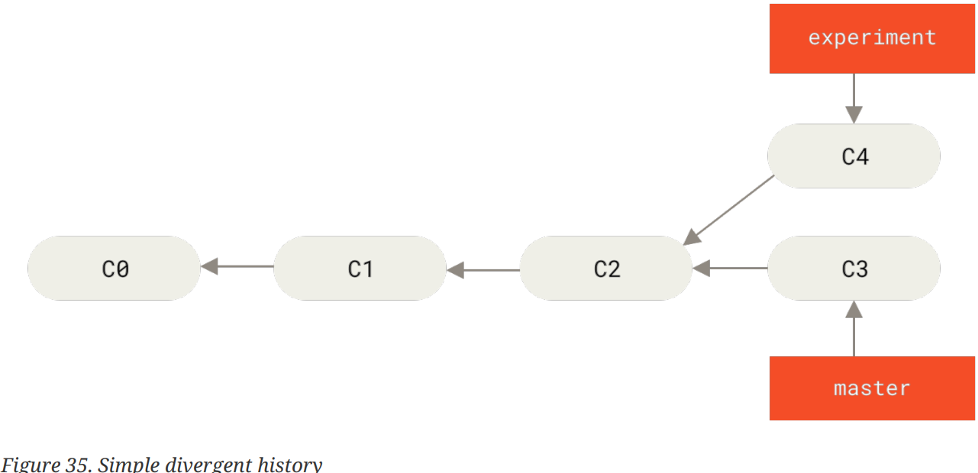
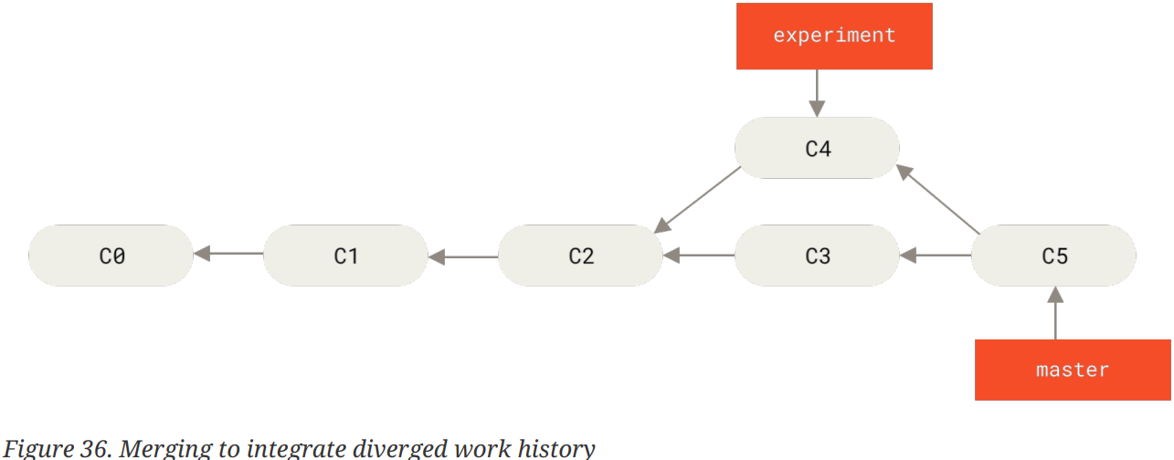
+Rebasing: take all changes committed on one branch and replay them on a different branch
+Example: check out experiment branch, then rebase it onto master branch:
git checkout experiment
git rebase master: go to common ancestor of 2 branches, get the diff introduced by each commit of branch you’re on, save those diffs to temporary files, reset current branch to same commit as the branch you are rebasing onto, and apply each change in turn.
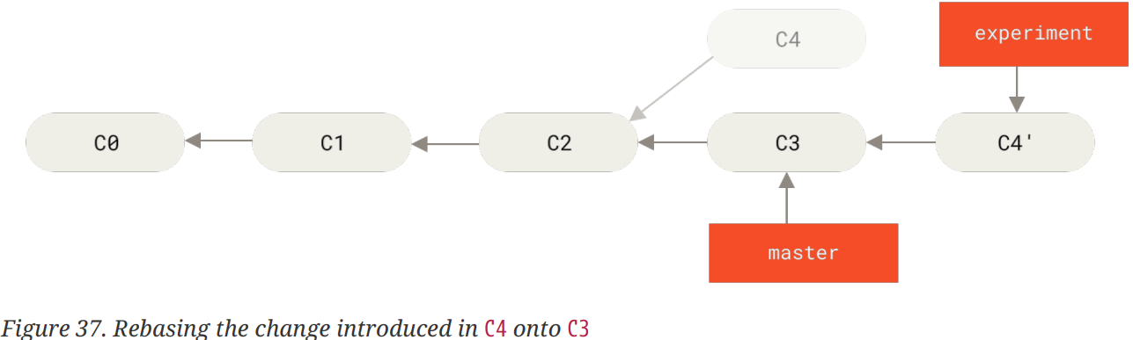
+Go back to master branch and do a fast-forward merge: git checkout master + git merge experiment
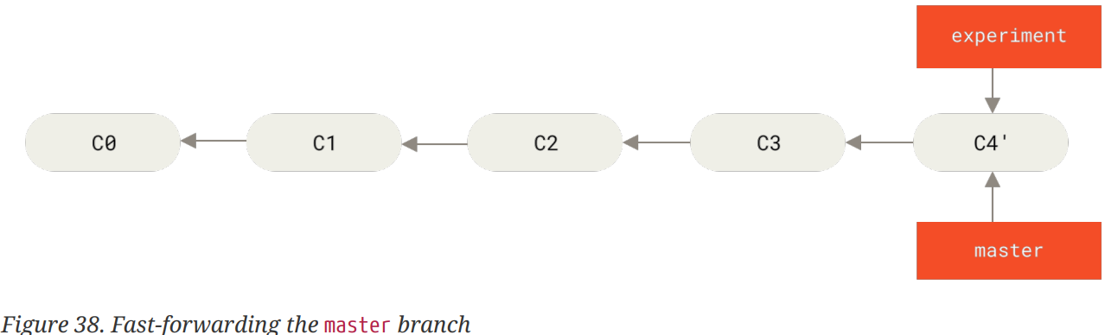
+The diff between merge and rebase is history. Rebasing replays changes from one line of work onto another in the order, merging takes the endpoints and merges them together.
-More Interesting Rebases
git rebase --onto <basebranch> <topicbranch>
-The Perils of Rebasing
+Don’t rebase commits that exist outside your repository and that people may have based work on.
+git push --force: overwrite the history on server.
-Rebase when you Rebase
+Rebase on top of force-pushed rebase work:
git pull --rebase = git fetch + git rebase <remote>/branch
-Rebase vs. Merge
+Commit history = a record of what actually happened.
+When you’re working on project, you need to record of all missteps and dead-end paths, but when it’s time to show your work to the world, you want to tell a coherent story of how to get from A to B. We use rebase and filter-branch to rewrite commits before merged into mainline branch.
+Rebase local changes before pushing to clean up your work, but never rebase anything that you’ve pushed somewhere.

4.Git on the Server

4.1 The Protocols

4.2 Getting Git on a Server

4.3 Generating Your SSH Public Key

4.4 Setting Up the Server

4.5 Get Daemon

4.6 Smart HTTP

4.6 GitWeb

4.7 GitLab

4.8 Third Party Hosted Options

5. Distributed Git

5.1 Distributed Workflows

5.2 Contributing to a Project

5.3 Maintaining a Project

6. Github

6.1 Account Setup and Configuration

6.2 Contributing to a Project

6.3 Maintaining a Project

6.4 Managing an organization

6.5 Scripting GitHub

