1. Fundamental of React

# 1.1 Hello React

-**SPA** (Single-page application) made it easier to build web app that advanced beyond vanilla JS and JQueryy. **React** was released by Facebook in **2013**.

-In the past, websites were **rendered** from **server**: user visits URL in browser and requests one HTML file and associated files. After network delay, users see the rendered HTML in browser (client).

-Modern JS shifted the focus from **server** to **client**. A user visits URL and request one small HTML file and one larger JS file. After network delay, user see the by JS rendered HTML in browser. Additional page transition wouldn’t request more files from web server, but would use initially requested JS to render new page. Every additional interaction by user is handled on client. In this modern version, the server delivers mainly JavaScript across the wire with one minimal HTML file. HTML file then executes all linked JS from files on client-side to render entire app.

-SPA is one bulk of JS, which is organized in folders and files, to create app whereas SPA framework (React) gives all tools to architect it. React takes over for rendering everything in browser as HTML and for dealing with user interactions with JS.

-How we moved from websites to web app: https://www.robinwieruch.de/web-applications/

# 1.2 Requirements

-**Editor** and **Terminal**: Visual Studio Code

-**VCS**: Github

<https://www.robinwieruch.de/git-essential-commands/>

-**Node** and **NPM**

+Both are used to manage libraries (node packages) you will need. These node packages can be libraries or whole frameworks. We install external node packages via npm

+node –version and npm –version.

<https://www.robinwieruch.de/npm-crash-course/>

-**Yarn** and **pnpm**: <https://yarnpkg.com/> https://pnpm.io/

# 1.3 Setting up a React Project

-We use **Vite** to **set up React application**: vite.dev

+Vite is a modern build tool for status quo web frameworks which comes with sensible defaults while staying highly extensible for specific use cases (SVG support, Lint support, TypeScript)

+The essential core of Vite is development server ( start React app on local machine) and a bundler (outputs optimized files for production ready deployment)

-There are 2 ways to create project with Vite: online template (vite.dev/guide/#trying-vite-online) and creating a React project with Viton on local machine for working on it in IDE/editor.

-Crash course for navigating on command line:

**-Create React project** hacker-stories



-**Install** all 3rd party **dependencies** of project and run it locally:

# 1.4 Project Structure

-code .: see project structure

-src/App.jsx used to implement React components. Later you want to split up React components into multiple files, each file maintains one or more components on its own.

-src/main.jsx is entry point to React world.

-src/index.css and src/App.css style overall app and components.

# 1.5 npm Scripts

-All project-specific commands can be found in package.json under scripts:

+these script are executed with **npm run <script>:**

-preview: run production-ready build on local machine for testing purposes

+npm run build -> npm run preview

# 1.6 Meet the React Project

-Every React app is built on the foundation of React components. The 1st React component which is located in src/App.jsx.

-This file will be our focus throughout this book.

-Reduce the component to a more lightweight version

-Optionally you can make src/index.css and src/App.css file bank for starting from a clean state style-wise.

-App component is just a JS function, it’s defined in PascalCase. Component has to start with a capital letter. App component is a function component: the modern way of using component in React.

-A function component can have implementation details between function signature and return statement:

-Variable defined in function’s body will re-defined each time this function runs.

-The function of a component runs every time a component is displayed in browser. This happens for the initial rendering of component, but also whenever the component updates because it has to display sth in different due to changes (re-rendering)

-Since we don’t want to re-define a variable within a function every time the function runs, we could define this variable outside of components as well.

# 1.7 React JSX

-JSX (JavaScript XML): combine HTML and JS

-The bridge between React and development server is React Fast Refresh (prior to that it was React Hot Loader) on React’s side and Hot Module Replacement on development server’s side.

-HTML input field and HTML label:

+htmlFor reflects the for attribute in HTML. JPX replaces a handful of internal HTML attributes caused by internal implementation details of React.

-Find all supported HTML attributes in React documentation: [DOM Elements – React](https://legacy.reactjs.org/docs/dom-elements.html#all-supported-html-attributes)

-React use camelCase naming convention: [Camel case - Wikipedia](https://en.wikipedia.org/wiki/Camel_case)

-When using HTML in JSX, React translate all HTML attributes to JS where certain words such as class or for are reserved during rendering process. Therefore React came up with replacement like className and htmlFor. Once the actual HTML is rendered for browser, the attributes get translated back to their native variant.

-Access properties within JSX:

-While HTML can be used almost (except for the attributes) in its native way in JSX, everything in curly braces can be used to interpolate JS in it.

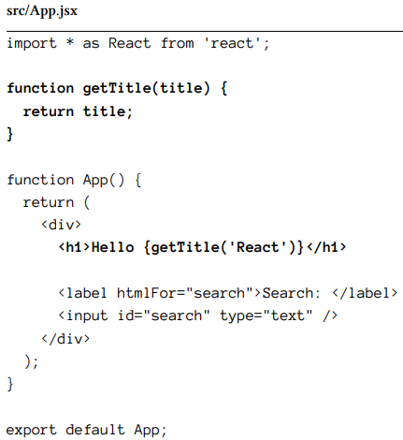

-The underlying build tools can be configured to acknowledge JSX in .js file. If they are configured this way, they will transpile JSX to JS. Tools like Vite embrace the .jsx extension though.

-JSX is the favorite things when being asked about React. Without any extra templating syntax (except curly brace), we can use JS in HTML. Every JS data structure can be used within HTML with JSX.

# 1.8 Linting with ESlint (Optional)

-Linting: process in programming where code is analyzed for potential errors, bugs, and style issues.

-ESLint is popular linting tool for JS.

-Install the respective plugin:

-vite.config.js: allow us to customize the development and build process of a Vite-based project. It gives us options such as setting public path, configure plugins, and modify the build ouput.

-Install the ESlint dependency: 

-Install one of ESLint’s many standardized linting configurations for React project:

-If you start project on cmd again, you will see error:



-Therefore we will create ESLint configuration file to define our linting rules: 

-When starting app on cmd, you will see warning:

-In VSCode, you can install ESLint Extension.

# 1.9. Lists in React

-When working with JS, most often data is array of objects. **map()**: iterate over each item of a list in order to return a new version of each item

-Render each object with its title property in React by map() in JSX:

-Without any made up templating syntax, it’s possible to use JS to map from a list of items to a list of HTML elements. That’s what JSX is for developer in the end: just JS mixed with HTML

-key is an HTML attribute and should be a stable identifier:

+The **key attribute** used for one specific reason: whenever React has to re-render a list, it checks whether an item has changed. When using keys, React can exchange the changed item.

+Using index should be avoided though, because it comes with the same rendering performance issues, it can cause actual bugs in UI when order of items got changed.

# 1.10 Meet another React Component

-Instead of making one component larger and more complex, we’ll split one component into multiple components. We will start with a new List component which extracts functionalities from App component:

-List component can be used in App:

-Create Search component:

-React app consists of many hierarchical components

# 1.11 React Component Instantiation

-A class is most often used in OOP languages. JS as a multi-paradigm programming language allows functional programming and OOP to co-exist side-by-side.

-The concept of JS class with declaration and instantiation is similar to React component, which also has only one component declaration, but can have multiple component instances:

-One we defined component, we can use it as an element in JSX. The element produces an instance of component. You can create as many instances of a component as you want as long as you have a component declaration. It’s not much different from JS class declare + instantiate. But technically JS class and React component are not the same.

# 1.12 React DOM

-src/main.jsx: see App components instantiation with <App /> element

+React DOM is usually once in React app to hook React into native HTML world.

+Open index.html and spot HTML element where id=”root”: this is the element where React inserts itself into HTML to bootstrap React app-starting with App component

+createRoot(): instantiate React

+render(): represent the entry point component (root component). Normally the entry point component is the instance of App component, but it can be any other JSX too:

-React DOM is everything that’s needed to integrate React into any website which uses HTML. If you start a React app from scratch, there’s only one ReactDom.createRoo(). In a legacy app that used sth else than React before, see multiple ReactDOM.createRoot() calls, because only certain areas of app are powered by React.

# 1.13 React Component Declaration

-We have used the standard function declaration, though arrow function can be used more concisely and therefore can establish a new standard for declaring function components

-Not only function components can be reactored, other functions like callback function:

-Block body (curly braces), concise body: implicit return statement:

-Often block bodies will be necessary to introduce more business logic between function signature and return statement:

# 1.14 Handler Function in JSX

-In native HTML, we can add event handlers by addEventListener() on DOM node.

-In React, refactor component function to block body and define a function for the change event of input field (event handler). Then the function can passed to onChange() (JSX named attribute) on HTML input field

-Synthetic event: logging occur as JS object and input field’s internal value

+ React synthetic event is a wrapper around browser’s native event.

-React as library for SPA, there was need for enhanced functionalities on the event to prevent native browser behavior.

+Example: native HTML submit a form triggered a page fresh. In React this page refresh should be prevented.

-Always pass function to handlers, not the return value of function, except when the return value is a function

# 1.15 React Props

-**Global scope**: it isn’t maintainable with multiple variables across multiple components.

-**props**:pass variables from one component to another

-list HTML attribute:

-Retrieve the list:

+Everything that we pass from a parent component to a child component via component element’s HTML attribute can be accessed in child component. The child component receives a parameter (props) as object in its function signature which includes all the passed attributes as properties

-Another use case for React props is List component and its child component: perform the component extraction and pass each item along to List component’s new child component.

+Example: extract an Item component from List component and pass each item in map()

# 1.16 React State

-React state introduces a mutable data structure. These stateful values get instantiated in a React component as co called state, can be passed with props as vehicle down to child components, but can also get mutated by using a function to modify state. When a state gets mutated, the component with state and all child components will re-render

+**Props** used to **pass information** down the component hierarchy. **State** used to **change information** over time.

+Example: when user types text into HTML input field in Search, he wants to see this information (state) displayed next to it.

+**useState()**: tell React that we want to have a **stateful value** which **changes over time**. Whenever this stateful value changes, the affected component will **re-render** to use it.

+useState() takes an **initial state** as an argument. Call this method will return an array with 2 entries: 1st entry represents **current state**. 2nd entry is a function to update this state. The book will refer to this function as **state updater function**. -> display the current state (read) and to update it (write)

+When user types into input field, input field’s change event runs into event handler. Handler’s logic uses event’s value of target and state updater function to set updated state. After that, the component re-renders (the component function runs). The updated state becomes current state and displayed.

-The initial rendering happens when React component get displayed in browser. When a side-effect occur (type into input field), the change is captured in React state which forces a re-rendering of all components affected by this change; meaning the component which manages state and all its descendant components

-useState() is called React hook. It’s only one of many hooks provided by React and this section only scratched the surface of hooks in React.

-When UI is re-rendered because of a state change, useState() hook uses the most recent state from its internal closure ([JavaScript Closure by Example](https://www.robinwieruch.de/javascript-closure/)). Next to each component React allocates an object where information like state is stored in memory. The memory gets cleaned up once a component is not rendered anymore through JS garbage collection.

# 1. 17 Callback Handlers in JSX

-While props are passed down as information from parent to child component, state can be used to change information over time. Using props as vehicle to transport information, we only talk to descendant components. Using state, we can make information stateful, but this information can only be passed down by using props as container.

-We want to use the state somewhere else:

+Example: use state in App component to filter stories by searchTerm before passed to List component.

+Props are only passed downwards. We can use **callback handler**: event handler (A) is passed as function in props to another component (B), is executed there as callback handler (C), and calls back to the place it was introduced (D):

+When user types into input field now, the function that is passed down from App to Search runs. We can notify App when user types into input field in Search. Callback handler becomes implicit vehicle to communicate upwards the component tree.

+The **concept of callback handler** in a nutshell: pass a function from a parent component to a child component via props; we can this function in the child component, but have the actual implementation of called function in parent component. In other words, when an event handler is passed as props from parent component to its child component, it becomes a callback handler.

# 1.18 Lifting State in React

-Move the state from Search component to App component, pass the state updater function to Search component as callback handler and use it to update the state when user types into input field. Then use new state in App component to filter() stories before passed to List component

-**Lifting state:** moving state from one component to another

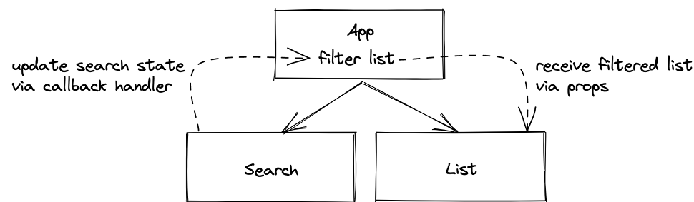

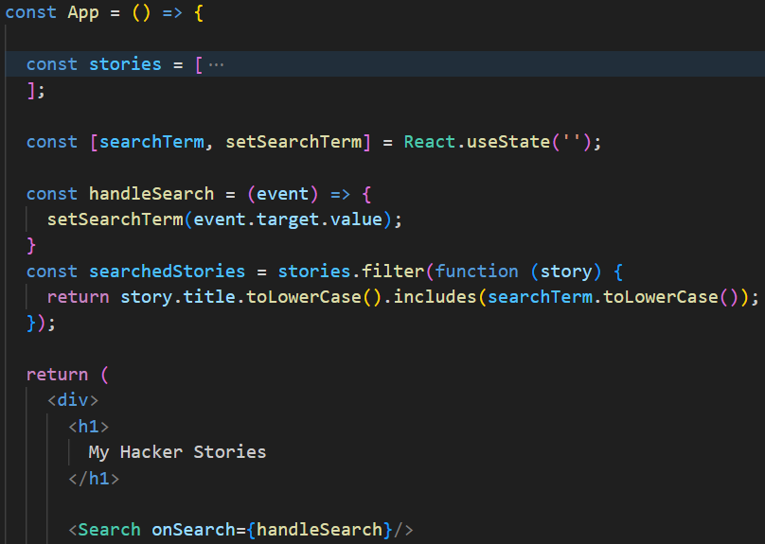

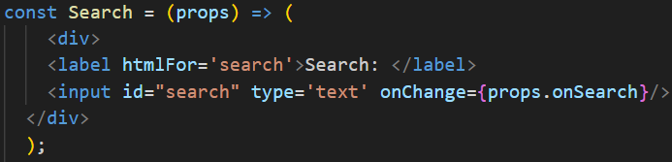

# 1.19 React Controlled Components

-Try use ‘React’ as initial state instead of empty string. HTML element should know about React stat, we provide the current state as **value** to it:

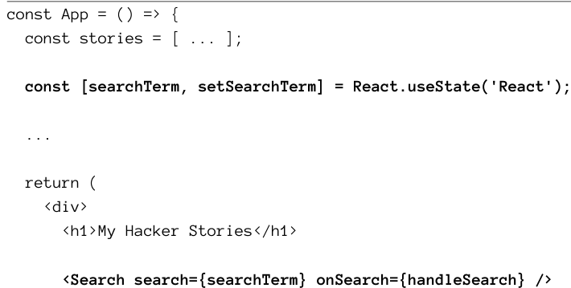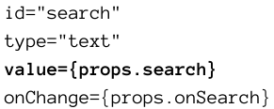

+Instead of giving HTML element the freedom of keeping track of its internal state, it uses React’s state by leveraging element’s value attribute. When HTML element emits a change event, new value is written to Reacts state and re-renders component. Then HTML element uses recent state as value

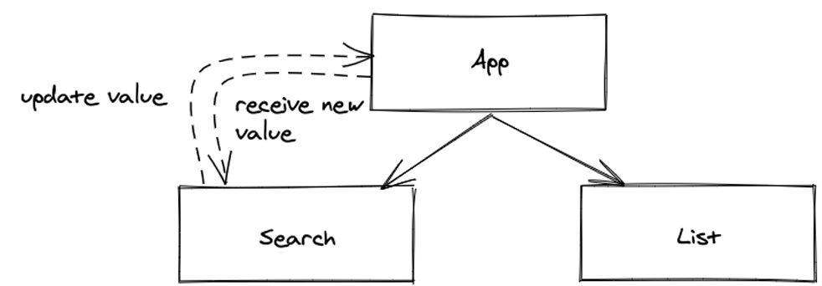

+Input field became **controlled element**, Search component became **controlled component**.

# 1.20 Props Handling (Advanced)

-Props are passed from parent to child down to component tree. It’s useful to know a few tricks to make passing props more convenient

1.21.1 Props Destructing via Object Destructuring

-JS object destructuring: https://mzl.la/30KbXTC

-Make use of props destructuring: refactor Search component’s arrow function from body into block body. Apply destructuring of props object in component function body:

+That’s a basic destructuring of props object in React component, so that object’s properties can be used in component.

+We can destruct props objects in function signature, omit function’s block body of component:

+Then we can access all information without dealing with props container. List and Item components can perform same props destructuring:

1.21.2 Nested Destructuring

-Even though item object has been destructured from props in Item component’s function signature, it isn’t directly used in Item component. item object only passes its information to elements.

-Nested destructuring:

+Nested destructuring helps us to gather all needed information of item object in function signature for its immediate usage in component’s element. It can still be useful in other scenarios:

1.21.3 Spread and Rest Operators

-Rather passing item as an object from List to Item component, we pass every property of item object:

+Now even though Item component function signature is more concise, the clutter ended up in List component instead, because every property is passed to Item component.

-We can improve by **JS spread operator**: https://mzl.la/3jetIkn

+JS spread operator allows us to spreadl all key/value pairs of an object to another object. This can be done in React’s JSX. Instead of passing each property once at a time via props from List to Item component, we cause JS spread operator to pass all object’s key /value pairs as attribute/value pairs to JSX element:

+This refactoring made the process of passing information from List to Item component more concise.

-**JS rest destructuring**: always at the last part of an object destructuring

+Use in List component to separate objectID:

+Rest operator happens on the left side, the spread operator happens on the right side. The rest operator used to separate an object from some of its properties

-Rules of thumb:

# 1.21 React Side-Effects

-React component returned output is defined by its props and state. **Side-effects** can affect this output too, they are used to interact with 3rd party APIs (localStorage, remote APIs for data fetching), with HTML elements for width and height, or with built-in JS functions (timers, intervals).

-Make Search remember recent search: use a side-effect to store recent search from browser’s local storage and retrieve it upon initial component initialization.

+Use stored value or default value:

-If we use setSearchTerm state updater function somewhere else in app, we break feature because local storage doesn’t get updated. Let’s fix by handling side-effect at a centralized place and not in a specific handler. We use React’s useEffect Hook to trigger the desired side-effect each time searchTerm change:

+1st arg: function that runs our side-effect. 2nd arg: a dependency array of variables. If one of these variables changes, function of side-effect is called. IF dependency array is empty array, function for side-effect is called once when the component renders for the 1st time.

# 1.22 React Custom Hooks (Advanced)

-useState(): for values that change over time, useEffect(): used to opt into lifecycle of your component to introduce side-effects

-React custom Hooks: create a hook

# 1.23 React Fragments

-React Fragment:

+A fragment wraps sibling elements into a single top-level element without adding them to rendered output. A more popular alternative is using fragments in shorthand version

# 1.24 Reusable React Component

-Since Search component doesn’t have any actual search functionality, we can make component reuseable for the rest of ap: Pass a dynamic id and label prop to Search component, rename actual value and callback handler to sth more generic, and rename the componenet:

-If we want to support numbers or phone numbers, type attribute needs to be accessible from outside:

-More Reusable React Components:

https://www.robinwieruch.de/react-button/

<https://www.robinwieruch.de/react-radio-button/>

<https://www.robinwieruch.de/react-checkbox/>

https://www.robinwieruch.de/react-dropdown/

# 1.25 React Component Composition

# 1.26 Imperative React

# 1.27 Inline Handler in JSX

# 1.28 React Asynchronous Data

# 1.29 React Conditional Rendering

# 1.30 React Advanced State

# 1.31 React Impossible States

# 1.32 Data Fetching with React

# 1.33 Data Re-Fetching in React

# 1.34 Memoized Functions in React (Advanced)

# 1.35 Explicit Data Fetching with React

# 1.36 Third-Party Libraries in React

# 1.37 Async/Await in React

# 1.38 Form in React