# Chapter 1: Structure

-HTML describes the structure of pages.

-HTML **elements**: characters that live inside angled brackets. Elements are usually made up of 2 **tags**: an opening tag and a closing tag.

-HTML uses elements to describe the structure of pages.

-<html>: anything between it is HTML code.

-<body>: anything between it should be shown inside the main browser window.

-<h1>: main heading

-<p>: a paragraph of text

-<h2>: sub-heading

-**Attributes** tell us more about elements. Attributes provide additional information about the contents of an element. They appear on the opening tag of element and are made up of 2 parts: a name + value, separated by an equals sign.

-Body, Head, Title

+<body>: Everything inside this element is shown inside the main browser window

+<head>: contain information about the page. You will usually find <title> element inside

+<title>: shown in top of browser or on the tab.

-Looking at how other sites are built: View->Source

-Summary:  
+HTML pages are text documents.

+HTML uses tags (characters that sit inside angled brackets) to give the information they surround special meaning.

+Tags are often referred to as elements.

+Tags usually com in pairs. The opening tag denotes the start of a piece of content; the closing tag denotes the end.

+Opening tags can carry attributes, which tell us more about the content of that element.

+Attributes require a name and a value.

+To learn HTML you need to know what tags are available for you to see, what they do, and where they can go.

# Chapter 2: Text

-When creating a web page, you add tags (markup) to the content of page.

+**Structural markup**: the elements that you can use to describe both headings and paragraphs.

+**Semantic markup**: which provides extra information; such as where emphasis is placed in a sentence, that something you have written is a quotation (and who said it), the meaning of acronyms, and so on.

-Headings:

+HTML has 6 levels of headings: <h1>-<h6>

-Paragraph: Create a paragraph: <p>

-Bold and Italic: <b> <i>

-Superscript and subscript: <sup> <sub>

-White space collapsing: When the browser comes across two or more spaces next to each other, it only displays one space.

-Line breaks and horizontal rules: <br /> <hr />

-Visual editors and their code views: Content management systems and HTML editors like Dreamweaver usually have two views of the page: a visual editor and a code view.

-**Semantic markup**: text elements that are not intended to affect the structure of web pags, but they do add extra information to pages.

+Strong and emphasis: <strong>: bold <em>:italic

+Quotations: <blockquote> longer quotes that take up an entire paragraph. <q> shorter quotes that sit within a paragraph.

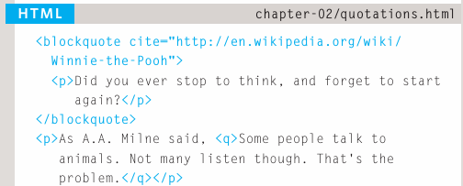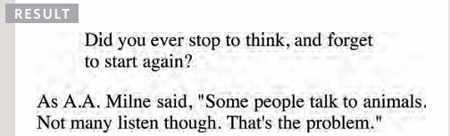

+Abbreviations & Acronyms: <abbr>

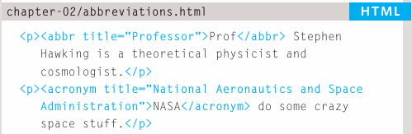

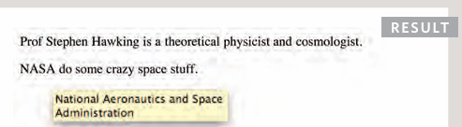

+Citations & Definition: <cite>: italics, <dfn>: italic or not change.

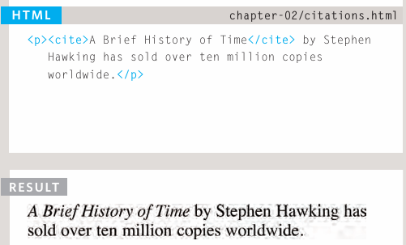

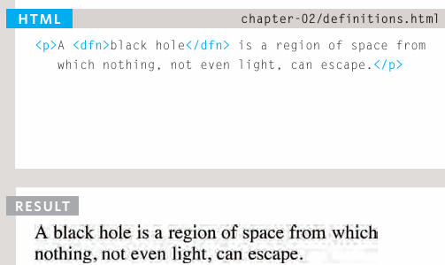

+Author details: <address>: italic

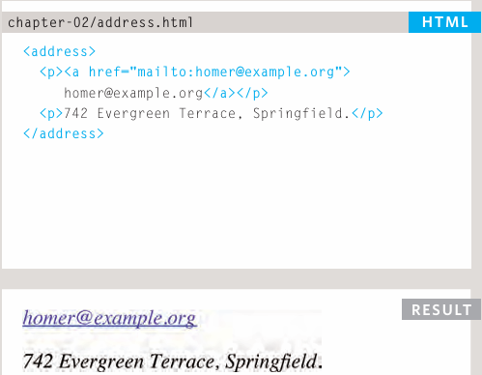

+Changes to content: <ins> <del> <s>

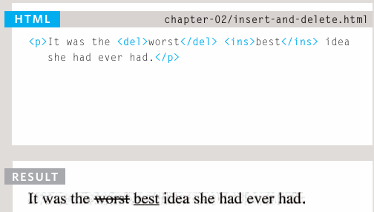

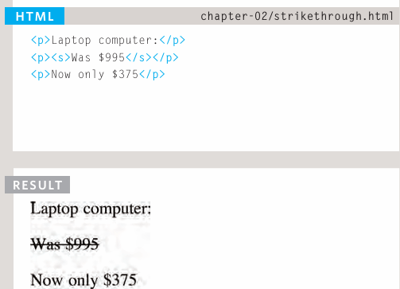

-Summary:

+HTML elements are used to describe the structure of page (headings, subheadings, paragraphs)

+They also provide semantic information (where emphasis should be placed, the definition of any acronyms used, when given text is a quotation)

# Chapter 3: Lists

-There are lots of occasions when we need to use lists. HTML provides us with 3 different types:

+Ordered lists: each item in the list is numbered.

+Unordered lists: begin with a bullet point.

+Definition lists: set of term along with the definitions for each of those terms.

-Ordered lists: <ol> <li>

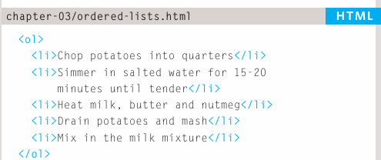

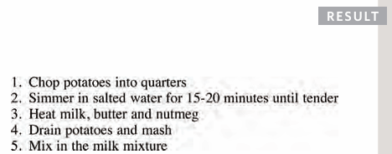

-Unordered lists: <ul> <li>

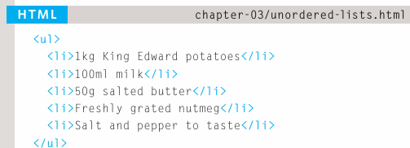

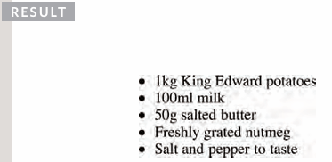

-Definition lists: <dl> <dt> <dd>

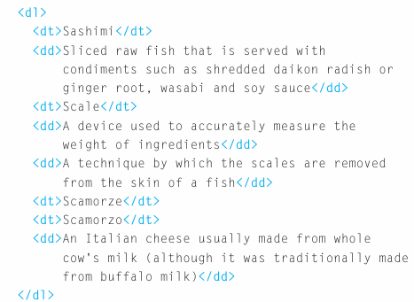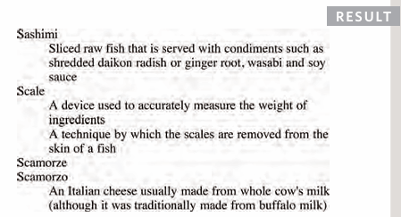

-Nested lists: You can put a 2nd list inside <li> element

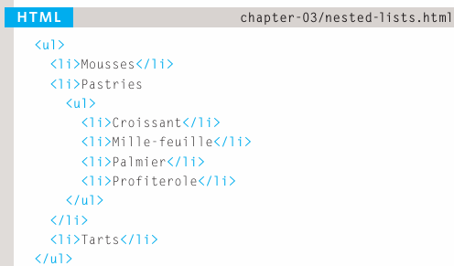

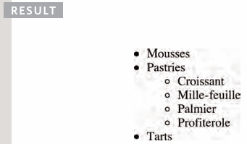

-Summary:

+There are 3 types of HTML lists: ordered, unordered, and definition

+Ordered lists use numbers.

+Unordered lists use bullets.

+Definition lists are used to define terminology

+Lists can be nested inside one another.

# Chapter 4: Links

-Links are the defining feature of web because they allow you to move from one page to another.

-Types of links:

+Links from one websites to another.

+Links from one page to another on the same website.

+Links from one part of a web page to another part of the same page.

+Links that open in a new browser window.

+Links that start up your email program and address a new email to someone.

-Linking to other sites: When you link to a different website, the value of href attribute will be the full web address for the site, which is **absolute URL**

+URL (Uniform Resource Locator): Every web page has its own URL. This is the web address that you would type into a browser if you wanted to visit that page. An absolute URL starts with domain name + path to page.

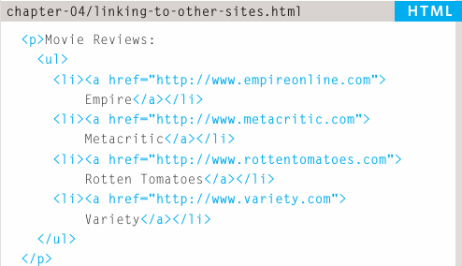

-Linking to other pages on the same site: Relative URL. If all the pages of site are in the same folder, the value of href attribute is just the name of file. If you have different page of a site in different folders, you can use more complex syntax to indicate where the page is in relation to the current page.

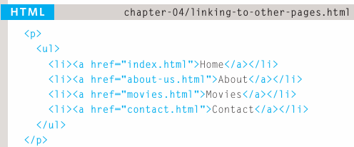

+Relative URLs: link to other pages within the same site. These are a shorthand version of absolute URLs because you don’t need to specify the domain name.

-Directory structure:

+Structure: The top-level folder is **root folder**.

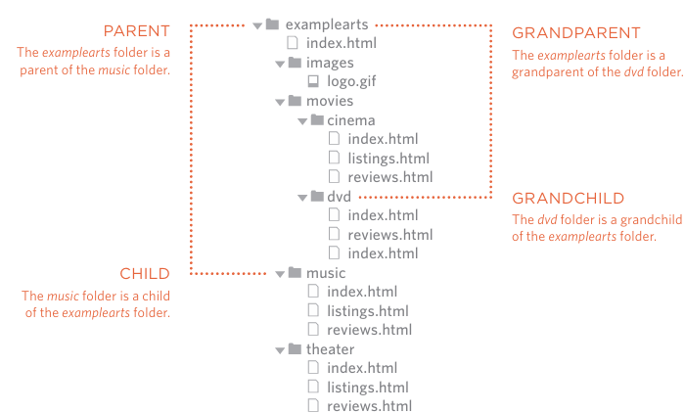

-Relative Urls:

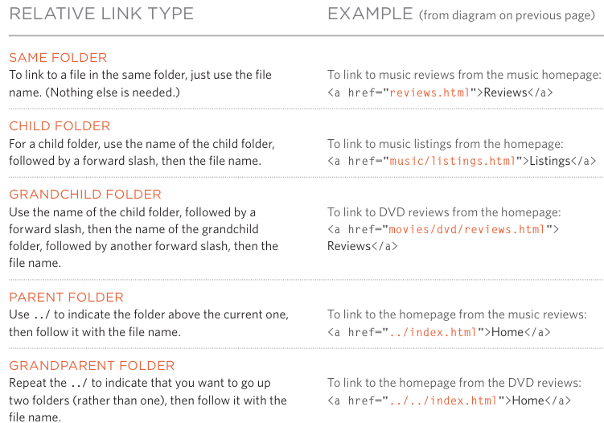

-Email links: mailto:

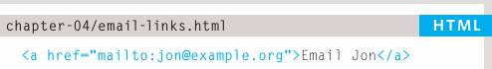

-Opening links in a new window: target

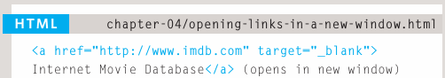

-Linking to a specific part of the same page:

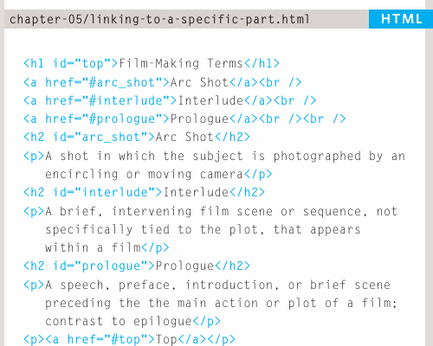

-Linking to a specific part of another page: Example to link to the bottom of homepage of website: 

-Summary:

+Links are created using <a> element

+The <a> element uses href attribute to indicate the page you are linking to.

+If you are linking to a page within your own site, it is best to use relative links rather than qualified URLs.

+You can create links to open email programs with an email address in “emailto” field.

+You can use id attribute to target elements within a page that can be linked to.

# Chapter 5: Images

-Choosing images for your site

-Storing images on your site.

-Adding images: <img>

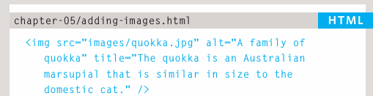

-Height and Width of images:

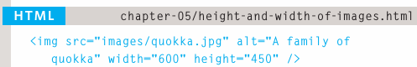

-Where to place images in code: before a paragraph, inside the start of a paragraph, in the middle of paragraph:

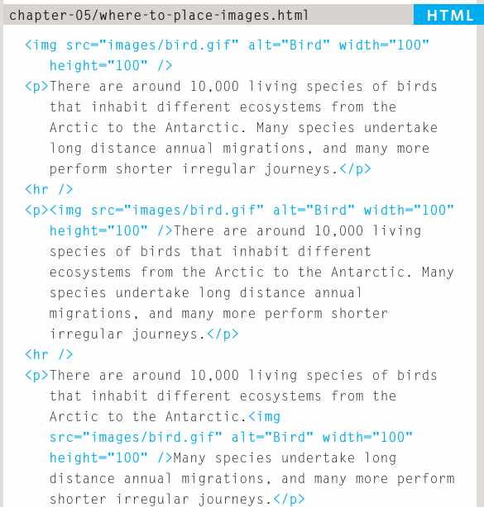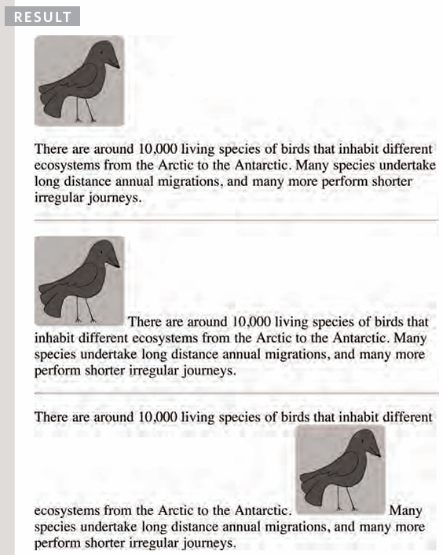

+Block elements always appear on a new line: <h1><p>

+Inline elements sit within a block level element and don’t start on a new line: <b> <em> <img>

-Old code:

+Align images horizontally: align + left/right

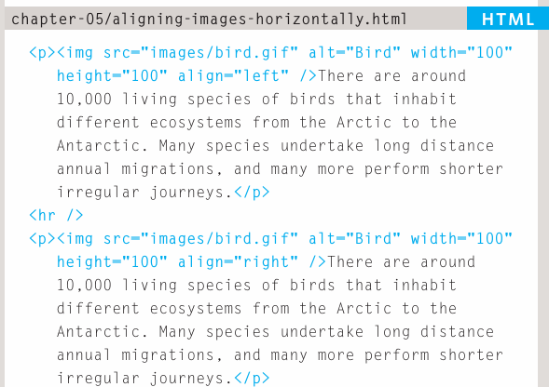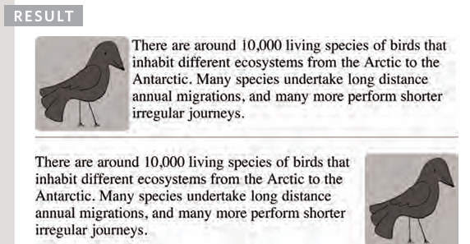

+Align images vertically: to/middle/bottom

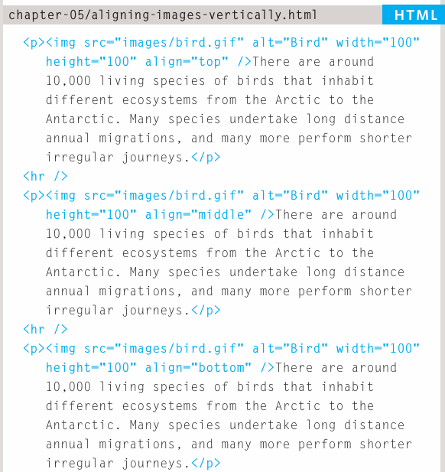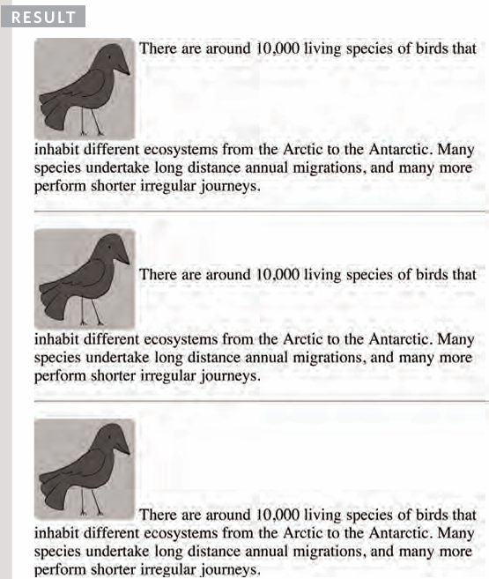

-3 rules for creating images:

+Save images in the right format: jpeg, gif, png

+Save images at the right size

+Use the correct resolution

-Tools to edit and save images: Adobe Photoshop

-Image formats:

+jpeg: have many different colors in picture

+gif/png: few colors or large areas of same color

-Image dimensions: The images you use on website should be saved at the save with and weight that you want them to appear on page

+reducing image size: quicker to download

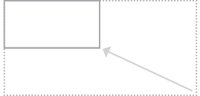

+increasing image size: look blurry or blocky

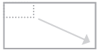

+changing shape: only some images can be cropped and still make sense

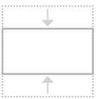

-Cropping images: When cropping images it’s important not to lose valuable information. It’s best to source images that are the correct shape if possible

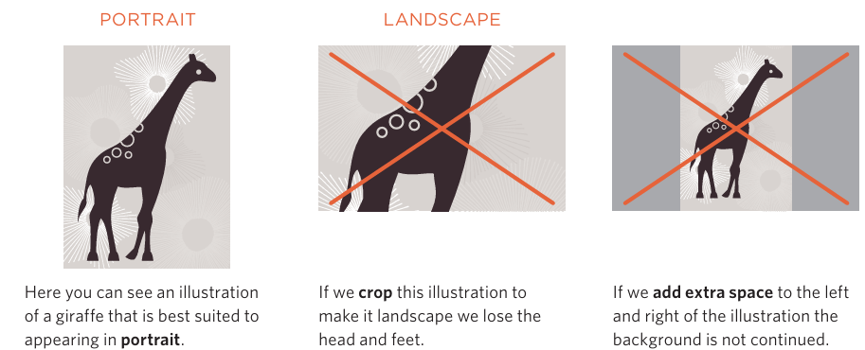

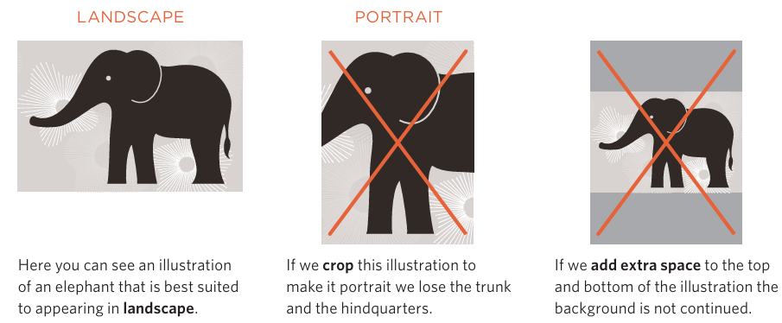

-Image Resolution

+Images created for web should be saved at a resolution of 72 ppi. The higher resolution of image, the larger the size of file

+JPGs, GIFs, PNGs belong to a type of image format **bitmap**: made up of lots of miniature squares. The resolution of images is the number of squares that fit within 1inch x 1nch square area

+Images appearing on computer screens are made up of squares called pixels. The web browsers on most desktop computers display images at a resolution of **72 pixels per inch** (ppi). Images in print materials (books, magazines) are made up of tiny circle called dots. These image printed at a resolution of 300 dots per inch (dpi)

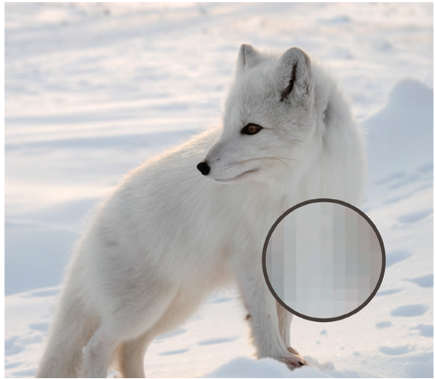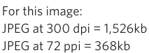

+Computer displays are capped at a resolution of 72 ppi, using images on web with higher resolution won’t result in better image quality.

-Vector images

+Created in programs like Adobe Illustrator.

+Image is a line drawing (logo, illustration, diagram).

+Vector images are created by placing points on a grid, and drawing lines between those points. A color can then be added to fill in the lines -> increase dimensions of image without affecting the quality

+SVG are format used to display vector images on web.

-Animated gifs

+Show several frames of an image in sequence and therefore can be used to create simple animations

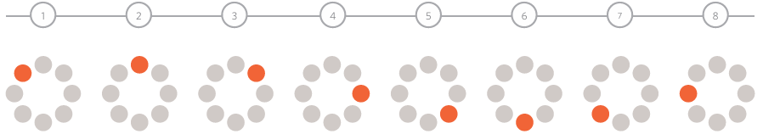

+Each extra frame of image increases the size of file.

+GIFs are only suitable for simple illustrations.

-Transparency (see-through): select one of 2 formats

+Transparent GIF: transparent part of image has straight edges and 100% transparent (not semi-opaque)

+PNG: transparent part of image has diagonal or rounded edges or if you want a semi-opaque transparency or a drop-shadow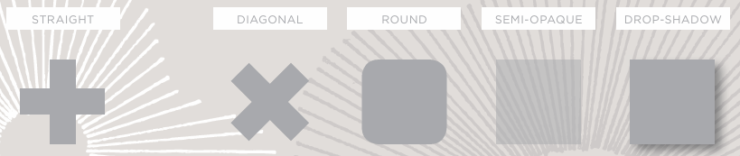

-HTML5: Figure and figure caption

+<figure>: contain images and caption so that the two are associated. You can have more than one image inside <figure> as long as they all share same caption

+<figcaption>: allow web page authors to add a caption to an image.

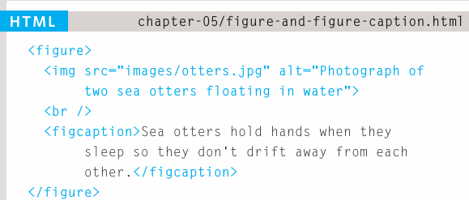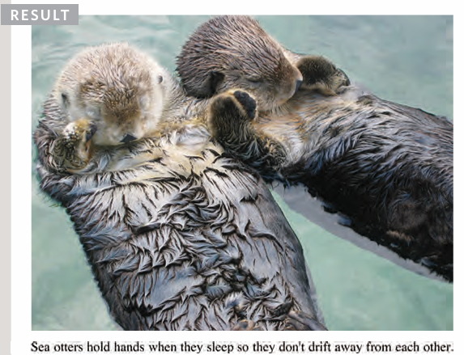

-Summary:

+<image> element is used to add images to a web page

+You must always specify a src attribute to indicate the source of an image and an alt attribute to describe the content of an image.

+You should save images at the size you will be using them on web page and in the appropriate format.

+Photographs are best saved as JPEGs; illustrations or logos that uses flat colors are better saved as GIFs.