# Chapter 10: Introducing CSS

-CSS allows you to create rules that control the way that each individual box (and the content of that box) is presented.

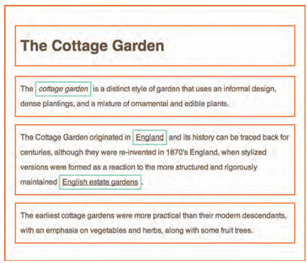

+Block level elements are red borders, inline elements have green borders

+<body> element creates 1st box, then <h1>, <h2>, <p>, <i> and <a> each create their own boxes

-Using CSS, you could add a border around boxes, specify its width and height, or add a background color. You could also control text inside a box (color, size, typeface)

-CSS associates style rules with HTML elements

+CSS rule contains 2 parts: selector + declaration

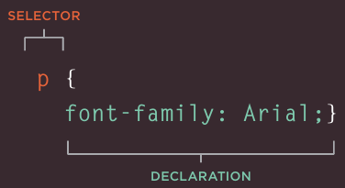

Selectors indicate which element the rule applies to

Declarations indicate how elements referred to in the selector should be styled. Declarations are split into 2 parts: a property and a value.

-CSS properties affect how elements are displayed

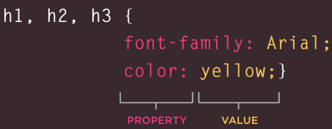

-Using external CSS: <link> tell the browser where to find CSS file used to style the page

+href: specify the path to CSS file

+type: specify the type of document: text/css

+rel: specify the relationship between HTML page and file it is linked to: stylesheet

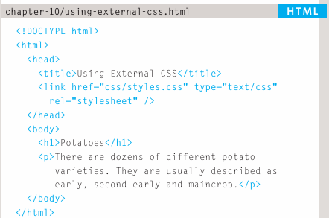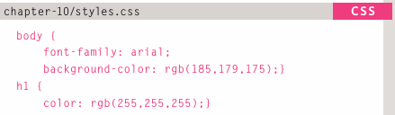  
-Using internal CSS: <style>

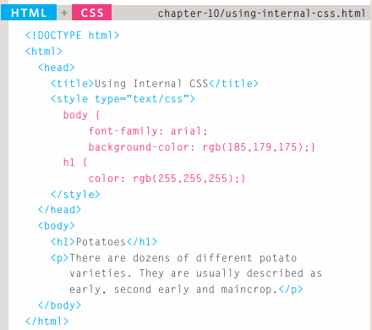

-CSS selectors:

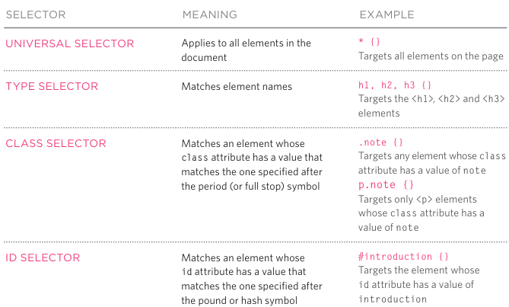

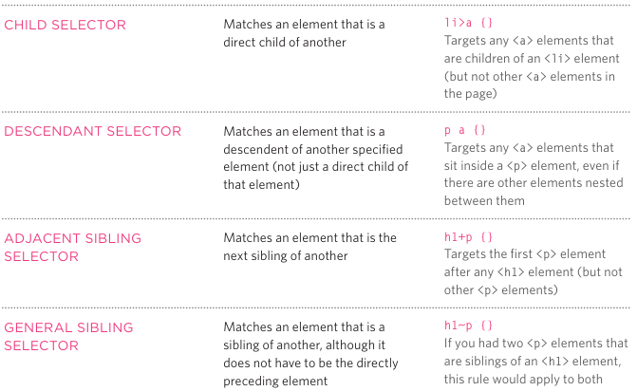

-How CSS rules cascade:

+If there are 2 or more rules that apply to the same element

+last rule: If 2 selectors are identical, the latter of 2 will take precedence

+Specify: If one selector is more specific than others, the more specific rule will take precedence.

+Important: Add !important after any property value to indicate that it should be considered more important than other rules that apply to the same element.

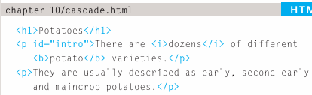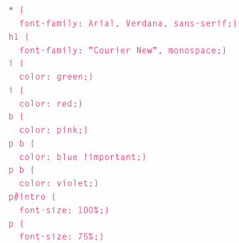

-Inheritance: The value of property can be inherited by child element.

+You can force properties to inherit values from their parent elements by using **inherit**

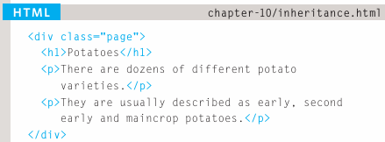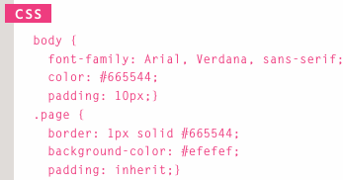

-Why use external style sheets:

+When building a website there are several advantages to placing your CSS rules in a separate style sheet.

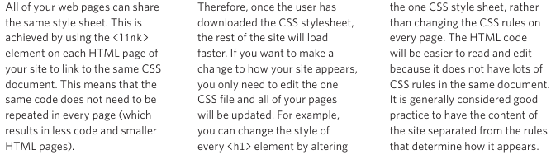

+Sometimes you might consider placing CSS rules in the same page as your HTML code.

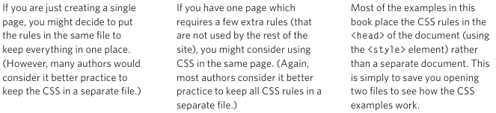

-Different versions of CSS & browsers quirks

+CSS1 was released in 1996, CSS2 in 1998. CSS3 in 2017. CSS4 in 2018. CSS 5 in 2025

+Some online tools to show what a page look like in multiple browsers:

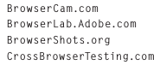

+When CSS property doesn’t display as expected, it generally referred to as a browser quirk or CSS bug

-Summary

+CSS treats each HTML elements as if it appears inside its own box and uses rules to indicate how that element should look.

+Rules are made up of selectors (specify the elements the rule applies to) and declarations (indicate what these elements should look like).

+Different types of selectors allow to target your rules at different elements.

+Declarations are made up of 2 parts: the properties of element that you want to change, and the values of those properties.

+CSS rules usually appear in a separate document, although they may appear within HTML page.

# Chapter 11: Color

-Foreground color: color property allows to specify the color of text inside element.

+RGB values: rgb(100,100,90)

+Hex codes: #ee3e80

+Color names: These are 147 predefined color names

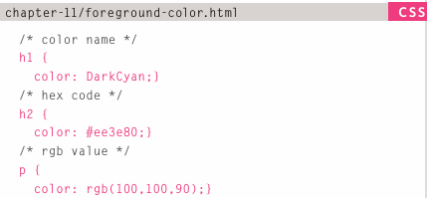

-Background color: background-color property sets the color of the background for the box.

+If you don’t specify a background color, then the background is transparent

+By default, most browser windows have a white background.

-Understanding color: Every color on computer screen is created by mixing amounts of red, green and blue. To find the color you want, use color picker

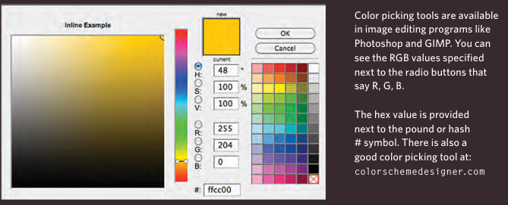

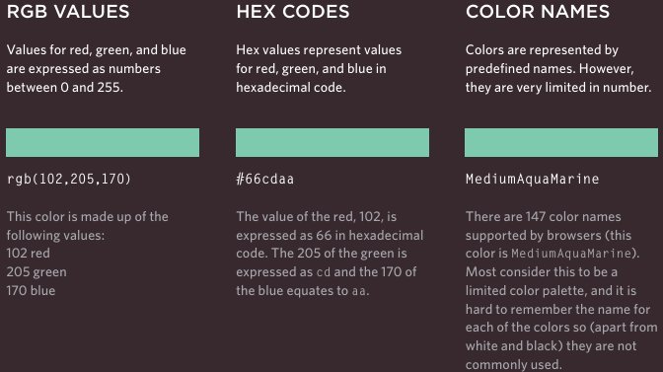

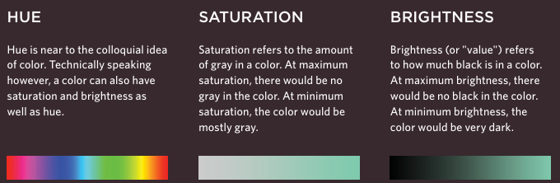

-Contrast:

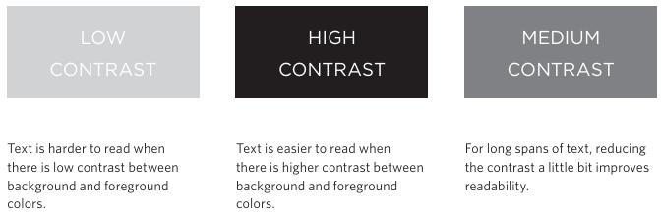

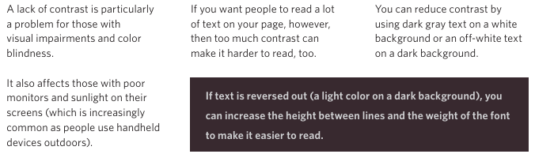

-CSS3: Opacity:

+opacity: specify the opacity of an element and any of its child element. The value is 0,0->1.0

+rgba: specify a color, add 4th value to opacity.

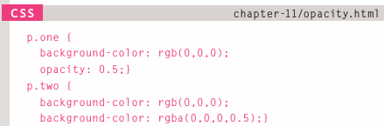

-CSS3: HSL Colors

+CSS3 introduces an new and intuitive way to specify colors using hue, saturation and lightness values.

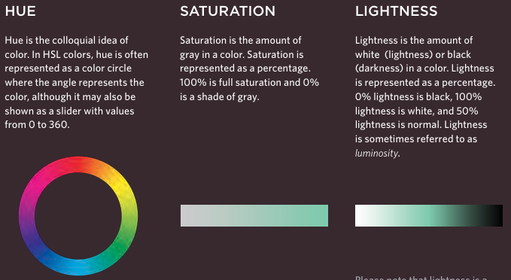

-CSS3: HSL & HSLA

+hsl property

hue: expressed an angle (0-360)

saturation: a percentage

lightness: percentage (0%-100%)

+hsla: hue, saturation, lightness, transparency (0-1.0)

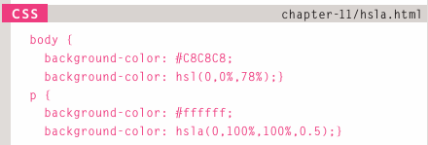

+a stands for alpha.

-Summary:

+Color not only brings site to life, but also helps convey the mood and evokes reactions.

+There are 3 ways to specify colors in CSS: RGB values, hex codes and color names.

+Color picker can help you find the color you want.

+It’s important to ensure that there is enough contrast between any text and the background color (otherwise people will not be able to read your content).

+CSS3 has introduced an extra value for RGB colors to indicate opacity. It’s known as RGBA.

+CSS3 also allows you to specify colors as HSL values, with an optional opacity value. It’s known as HSLA.

# Chapter 12: Text

# Chapter 13: Boxes

# Chapter 14: Lists, Tables & Forms

# Chapter 15: Layout

# Chapter 16: Images

# Chapter 17: HTML5 Layout

# Chapter 18: Process & Design

# Chapter 19: Practical Information