-PropTypes:
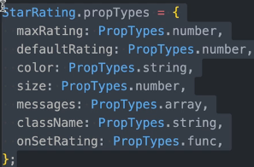
-useEffect(): synchronize a component with an external system.
