1. Introduction
-type safety:
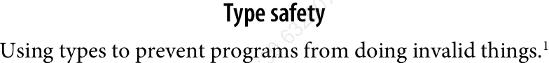
-TS gives error messages in text editor, as you type.

2. TypeScript: A 10_000 Foot View

2.1 The Compiler (TSC)
-AST (abstract syntax tree): a data structure that ignores things (whitespace, comments,…)
-Typechecker:
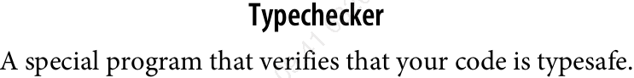
-Process of compiling TS:
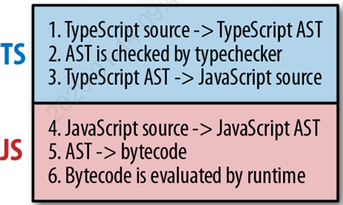
2.2 The Type System
-Type system
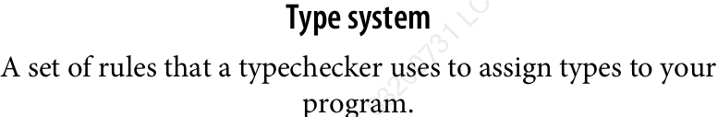
-2 kinds of type systems: explicit and infer. TS inspired by both kinds.
+Explicitly signal:
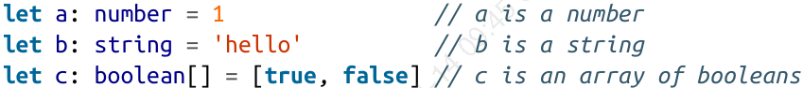
+Infer:
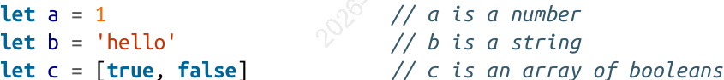
-Note:
-TS vs JS
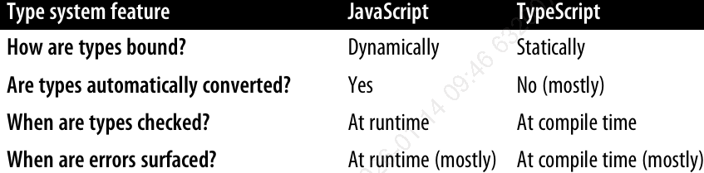
2.3 Code Editor Setup
-npm for TS:
2.3.1 tsconfig.json
-In root directory, define things like which files should be compiled, which directory to compile them to, which version of JS to emit.
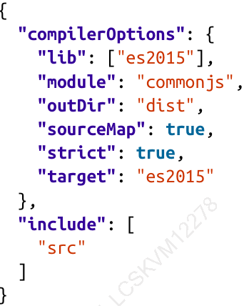
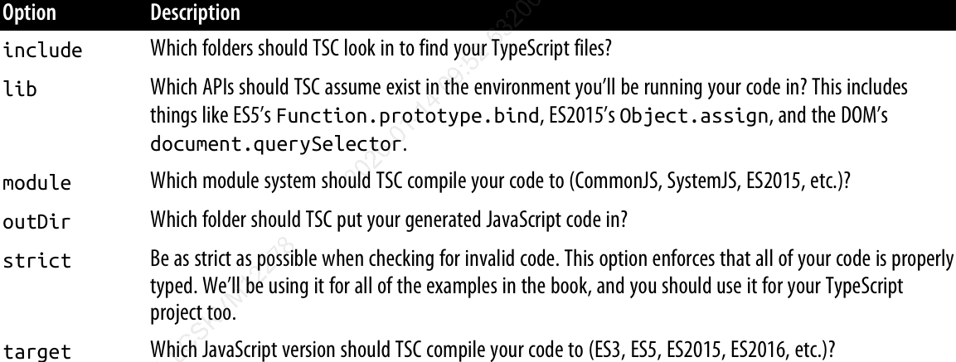
2.3.2 tslint.json
-TSLint configuration: codifying whatever stylistic conventions for code.
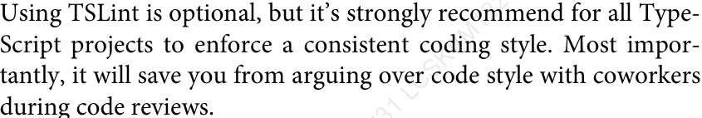
-Generate a default one:
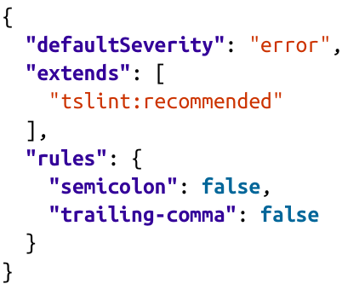
2.4 index.ts

3. All about Types
-Type:
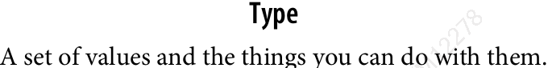
-TS type hierarchy:
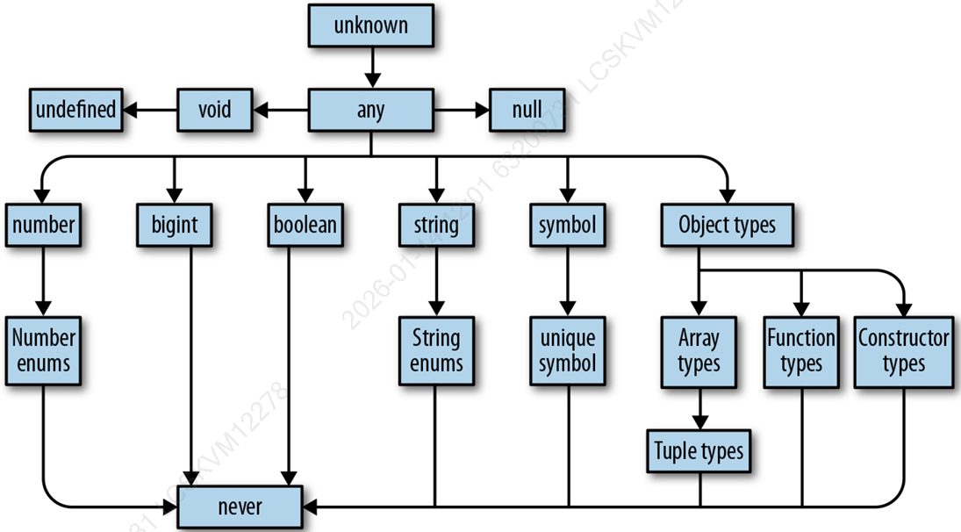
3.1 Talking about Types
-annotate parameter’s type:
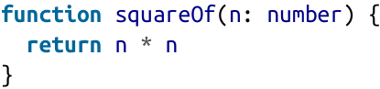
3.2 The ABCs of Types
-any
+The default type, you can do anything with any.
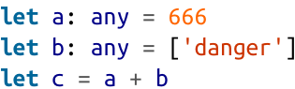
+Note:
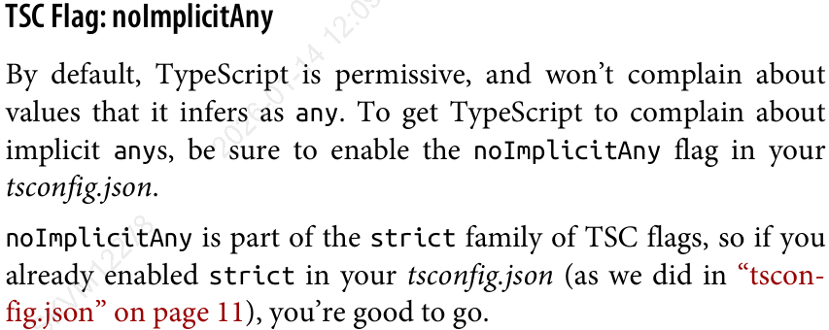
-unknown
+Represent any value, but TS won’t let you use util you refine it by checking what it is.
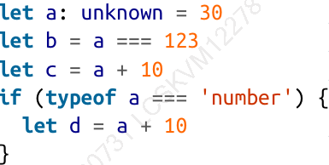
-boolean
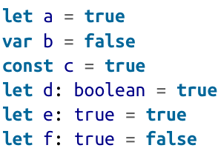
+Type literal: 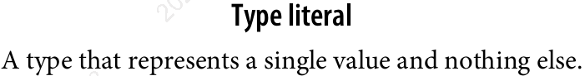
-number
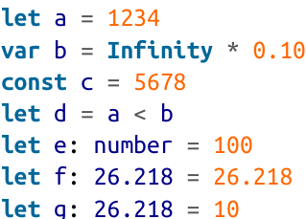
-bigint
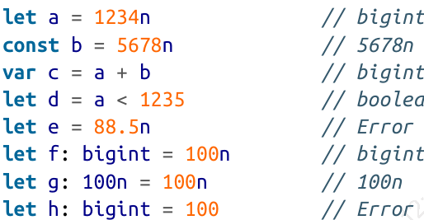
+Note
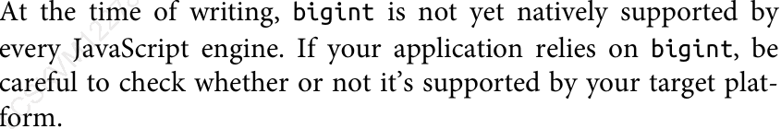
-string
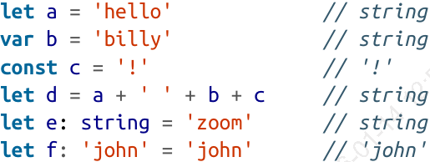
-symbol
+Alternative to string keys in objects and maps, where you want to be sure that people are using right well-known key and didn’t accidentally set key-think setting a default iterator for your object (Symbol.iterator), or override at runtime.
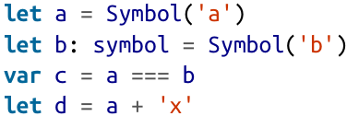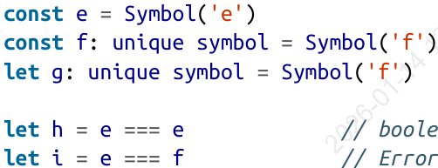
-Objects
+structural typing:
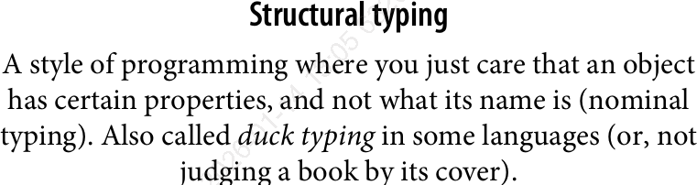
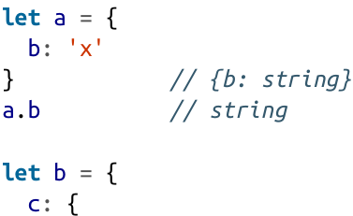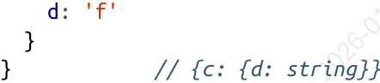
+You can use object literal or a class:
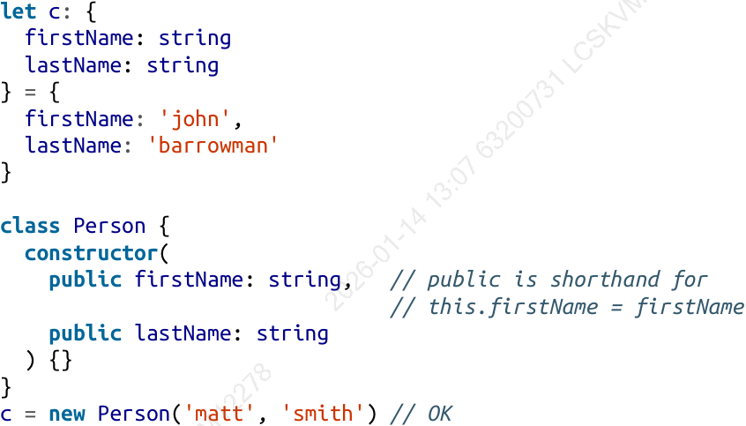
+By default, TS is strict about object properties, but you can make them optional:
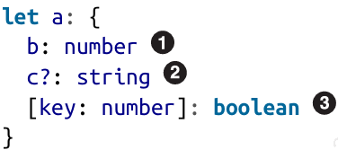
+readonly:
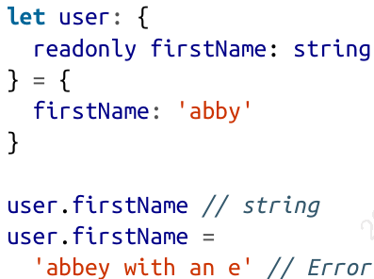
-Intermission: Type Aliases, Unions, and Intersections
+Type aliases: declare a type that points to a type
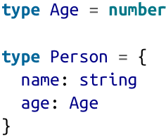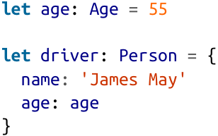
+Union and Intersection

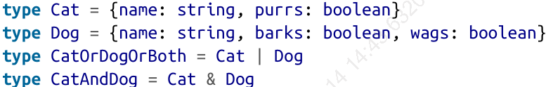
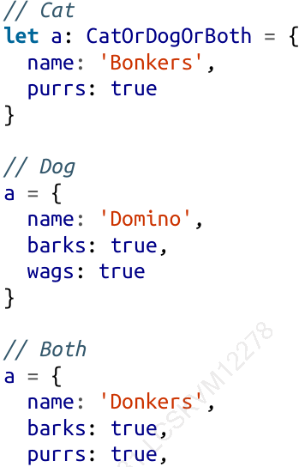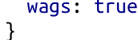
+Unions come up a lot more often:
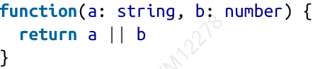
The return type is string | number
-Arrays
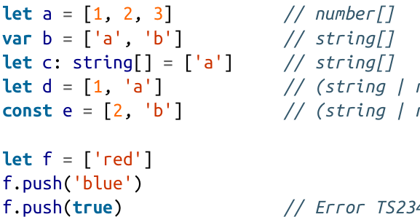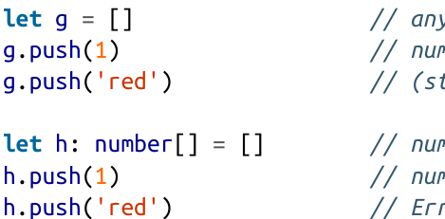
+You have to check which it is before using it:
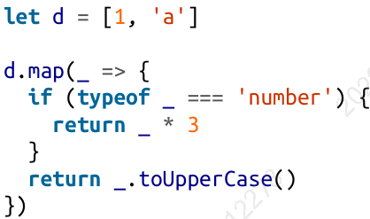
+Once your array leaves the scope it was defined in, TS will assign it a final type that can’t be expanded:
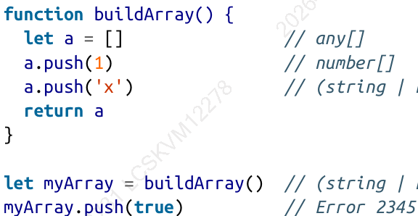
-Tuples
+subtype of array, have fixed lengths, where the values at each index have specific types
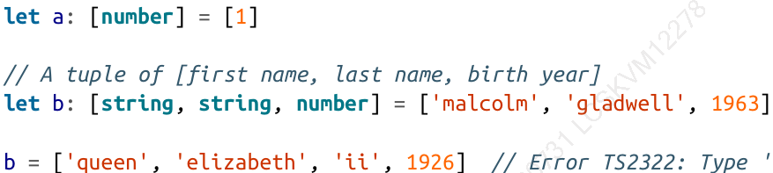
-null, undefined, void, and never
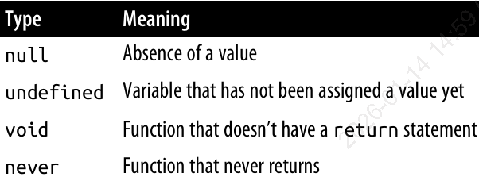
-Enums
+Map from string to number
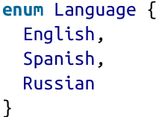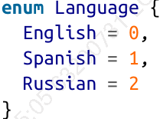
+Map from string to string
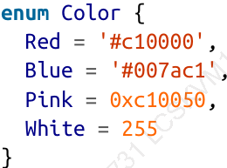
4. Functions
4.1 Declare and invoke functions
-Named function syntax:
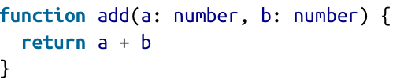
+The return type is inferred, but you can annotate it:
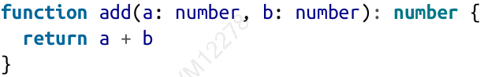
-All 5 ways:
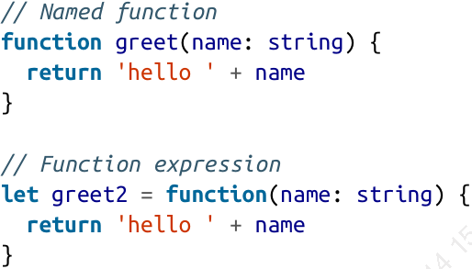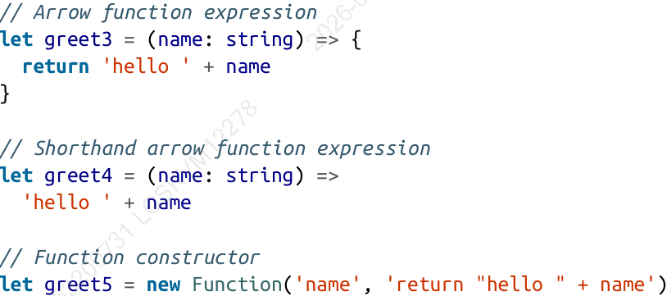
4.1.1 Optional and default parameters
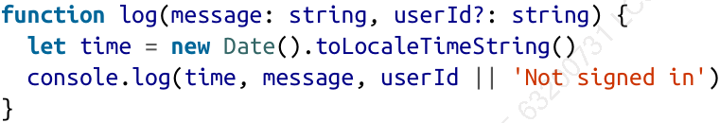
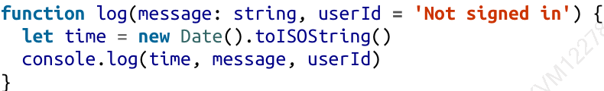
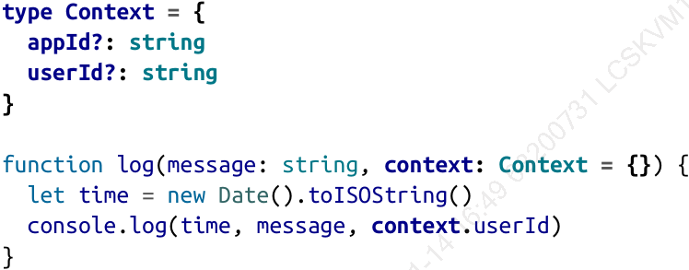
4.1.2 Rest Paramters
-Rest parameters: make function accept any number of arguments
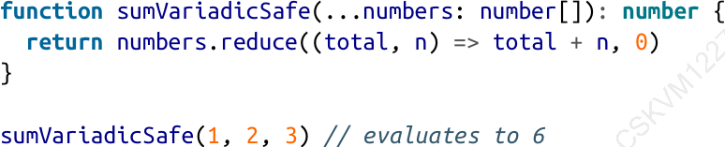
4.1.3 call, apply, and bind
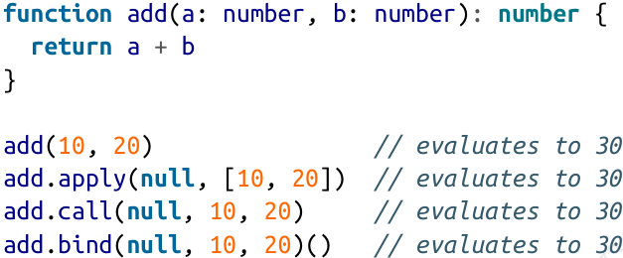
-apply() binds a value to this
4.1.4 Typing this
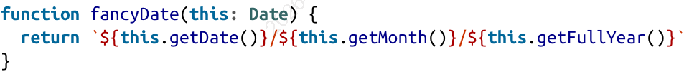
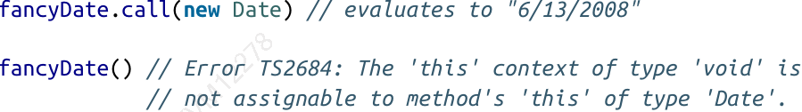
4.1.5 Generator Functions
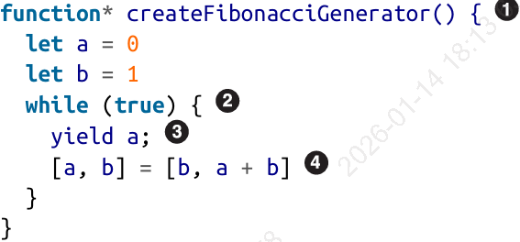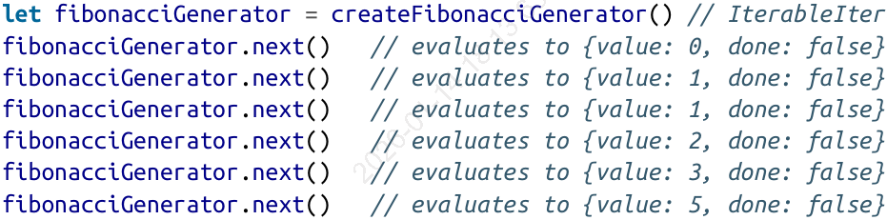
-Explicit annotate a generator:
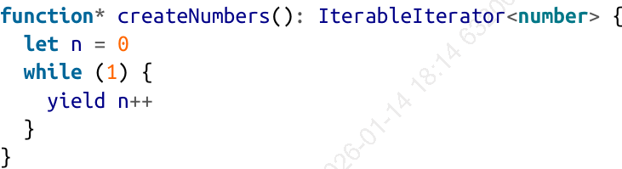
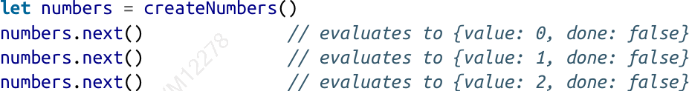
4.1.6 Iterators
-Iterable:
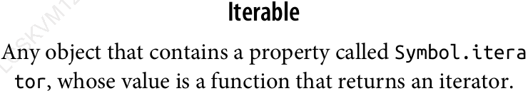
-Iterator:
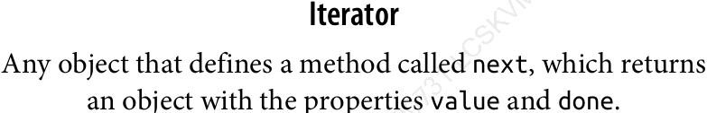
-Example:
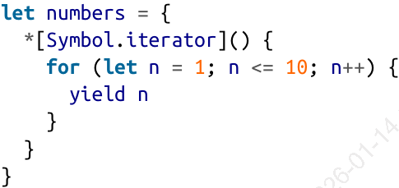
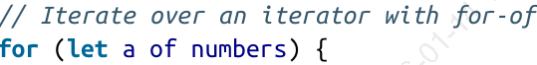
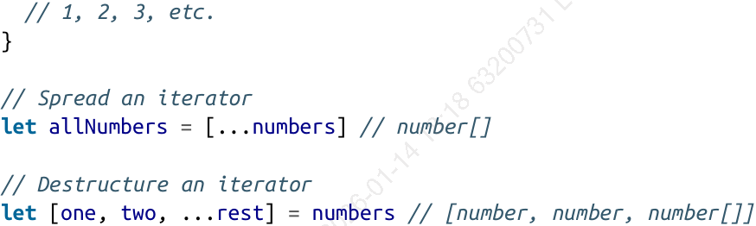
4.1.7 Calling Signatures
-call/ type signature: TS’s syntax for function’s type
-Example:
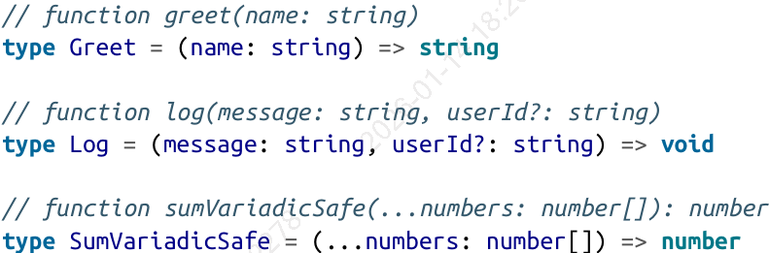
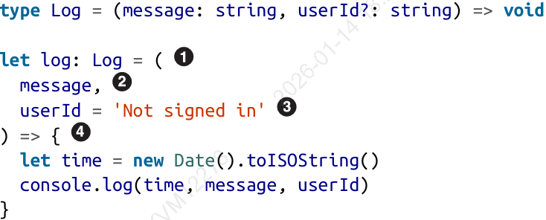
4.1.8 Contextual Typing
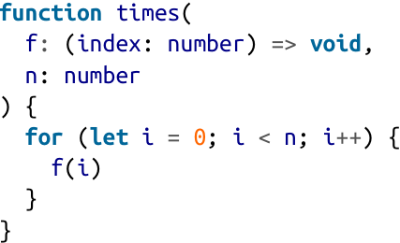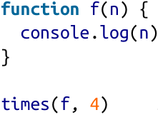
4.1.9 Overloaded function types
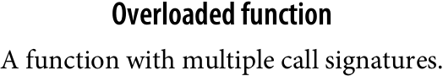
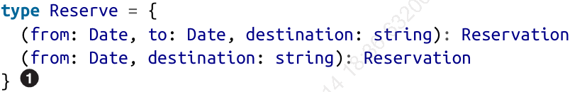
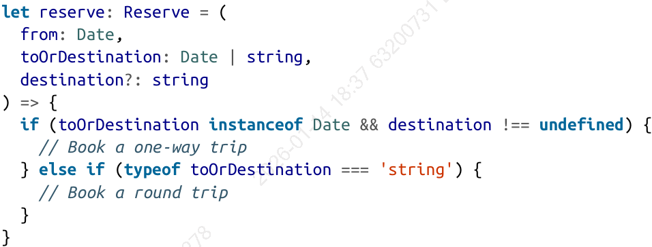
4.2 Polymorphism
-Generic type parameter:
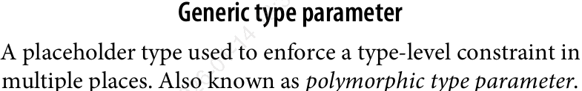
-Example:
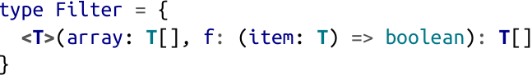
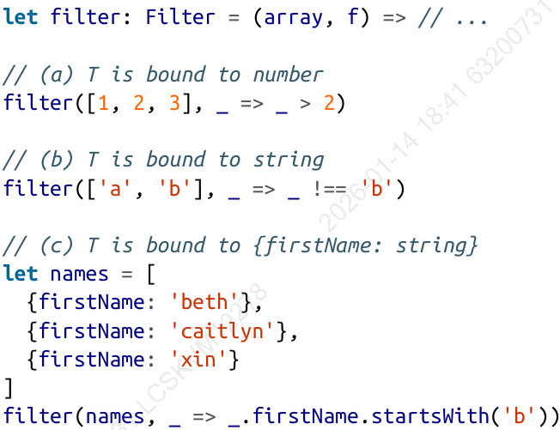
4.2.1 When are Generics Bound?

4.2.2 Where can you declare generics?

4.2.3 Generic Type Inference

4.2.4 Generic Type Aliases

4.2.5 Bounded Polymorphism

4.2.6 Generic Type Defaults

4.3 Type-Driven Development

