-Project Plan: slide 329
-Folder structures
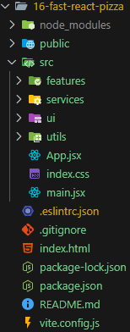
+features: features categories
+services: reusable code to interact with API
+ui: reusable UI components (buttons, inputs…)
+utils: helper function reuse in multiple places. These are stateless helper function that don’t create side effects (data or number manipulations,…)
-New way to implement Routes:
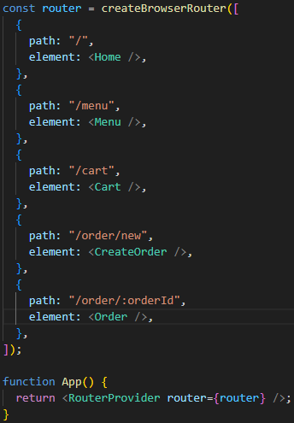
+Note: we have a new way to handle errors
+AppLayout and <Outlet />
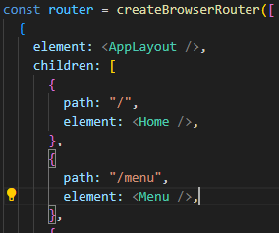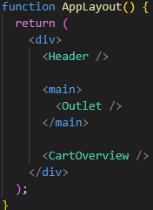
+Fetching Data with React Router “Loaders”:
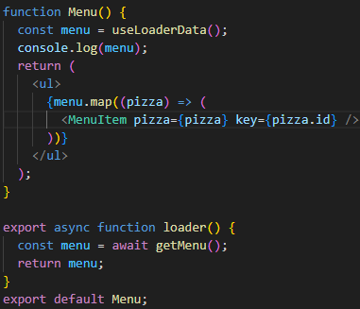
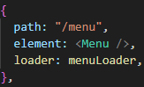
+Loading indicator:
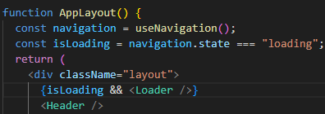
+Error Elements:
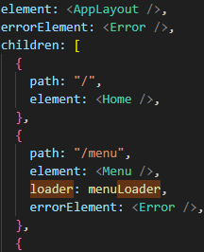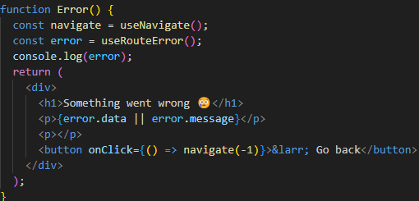
+Write Data with React Router “Actions”
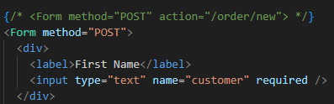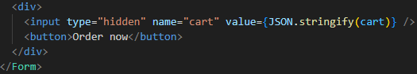
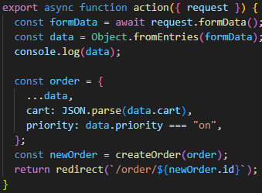
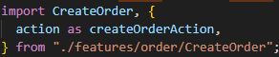
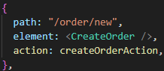
+Error Handling in Form Actions
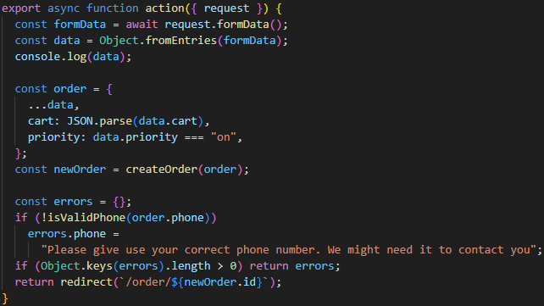
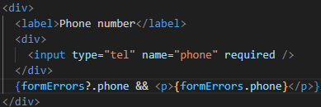
-Tailwind
+Color:
Overview: https://v3.tailwindcss.com/docs/customizing-colors
Text color: https://v3.tailwindcss.com/docs/text-color
Background color: https://v3.tailwindcss.com/docs/background-color
+Text
Text align: https://v3.tailwindcss.com/docs/text-align
Font size: https://v3.tailwindcss.com/docs/font-size
Font weight: https://v3.tailwindcss.com/docs/font-weight
Text transform: https://v3.tailwindcss.com/docs/text-transform
Letter spacing: https://v3.tailwindcss.com/docs/letter-spacing
+Box model
Margin: https://v3.tailwindcss.com/docs/margin
Padding: https://v3.tailwindcss.com/docs/padding
Border width: https://v3.tailwindcss.com/docs/border-width
Space between: https://v3.tailwindcss.com/docs/space
Display: https://v3.tailwindcss.com/docs/display
+Responsive design: https://v3.tailwindcss.com/docs/responsive-design
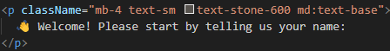
+Flexbox
Justify content: https://v3.tailwindcss.com/docs/justify-content
Justify items: https://v3.tailwindcss.com/docs/justify-items
+CSS Grid
Grid template columns: https://v3.tailwindcss.com/docs/grid-template-columns
Grid Column start/end: https://v3.tailwindcss.com/docs/grid-column
Grid template rows: https://v3.tailwindcss.com/docs/grid-template-rows
Grid Row start/end: https://v3.tailwindcss.com/docs/grid-row
Grid auto flow: https://v3.tailwindcss.com/docs/grid-auto-flow
Grid auto columns: https://v3.tailwindcss.com/docs/grid-auto-columns
Grid auto rows: https://v3.tailwindcss.com/docs/grid-auto-rows
+Overflow: https://v3.tailwindcss.com/docs/overflow
+Max-width: https://v3.tailwindcss.com/docs/max-width
+Container: https://v3.tailwindcss.com/docs/container
+Styling Buttons: element states and transitions
Hover: https://v3.tailwindcss.com/docs/hover-focus-and-other-states
Transition duration: https://v3.tailwindcss.com/docs/transition-duration
+Styling Form elements:
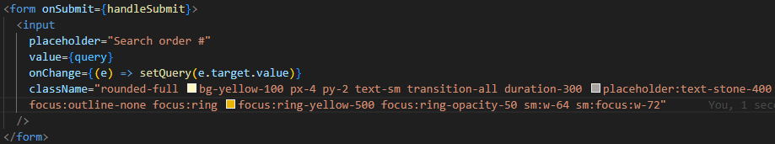
+Reuse Styles with @apply
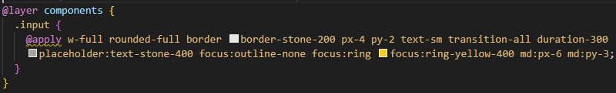
+Reuse Styles with React components
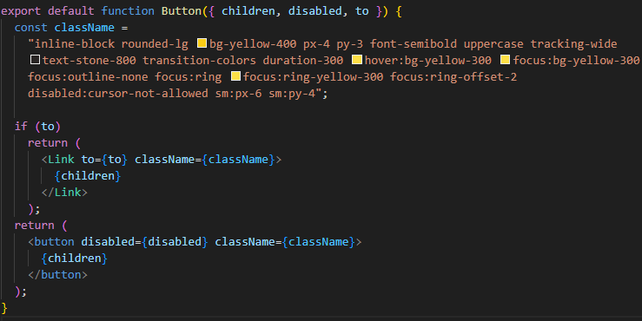
Then use:
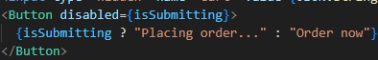
+Absolute Positioning, z-index, and more
Positioning: https://v3.tailwindcss.com/docs/position
Top/right/bottom/left: https://v3.tailwindcss.com/docs/top-right-bottom-left
Backdrop blur: https://v3.tailwindcss.com/docs/backdrop-blur
+Configure Tailwind: Custom font family
Configuration: https://v3.tailwindcss.com/docs/configuration
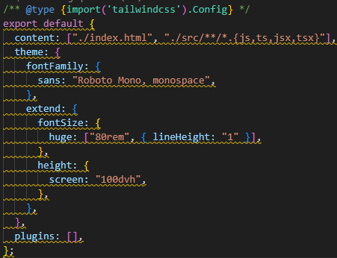
+Style the Menu
Grayscale: https://v3.tailwindcss.com/docs/grayscale
Menu:
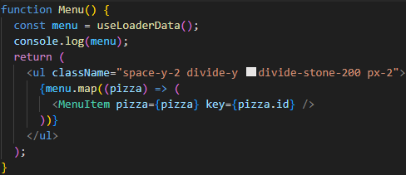
MenuItem:
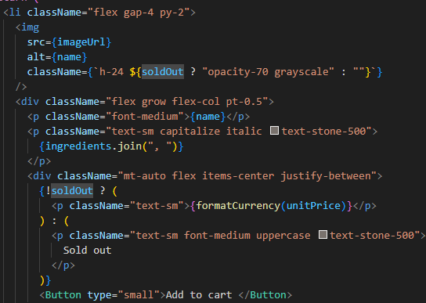
+Style the Cart
Cart
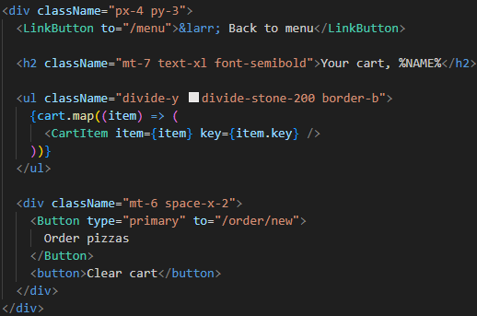
CartItem:
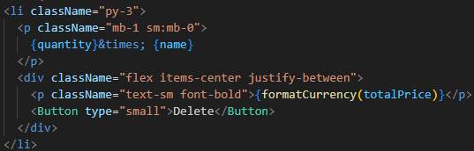
+Style the Order
Gap: https://v3.tailwindcss.com/docs/gap
Flex Basis: https://v3.tailwindcss.com/docs/flex-basis
Flew Grow: https://v3.tailwindcss.com/docs/flex-grow
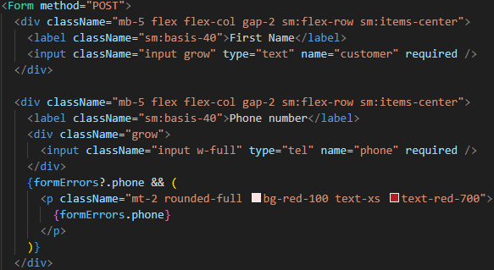
+Style the Order Overview
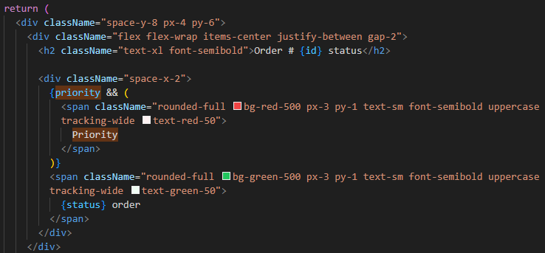
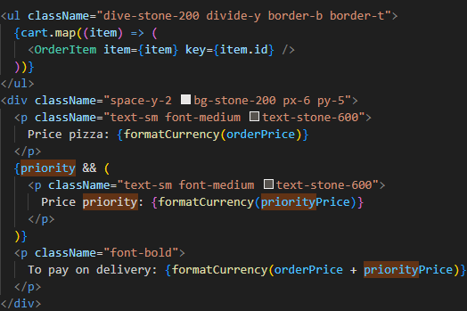
-Add Redux and advanced React Router
+Model User state with Redux Toolkit
userSlice:
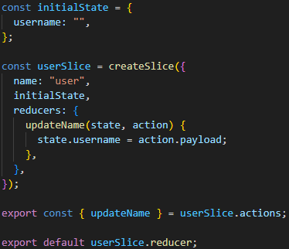
store.js
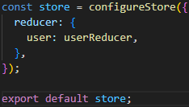
main.jsx
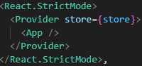
Used in Username.jsx:
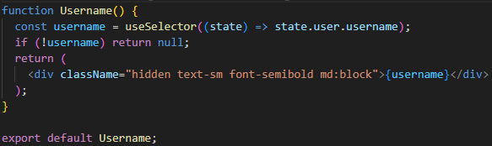
+Read and update User State
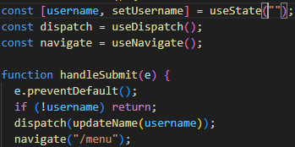
+Model the Cart State
cartSlide:
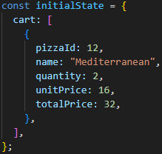
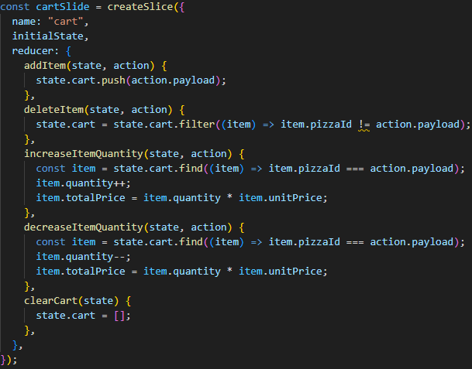
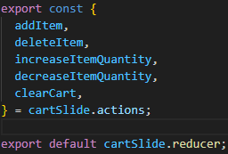
store.js:
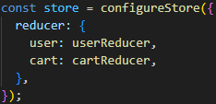
+Add Menu Items to Cart:
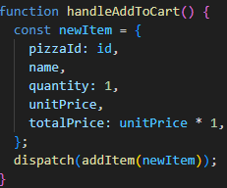
+Build the Cart Overview with Redux Selector:
cartSlide.js
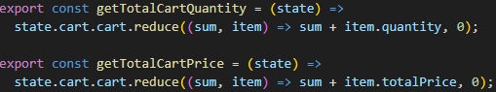
CartOverview.jsx:
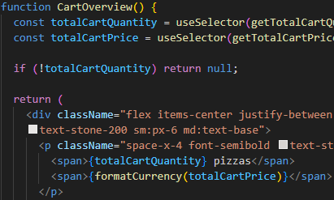
+Build the Cart Page
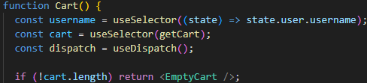
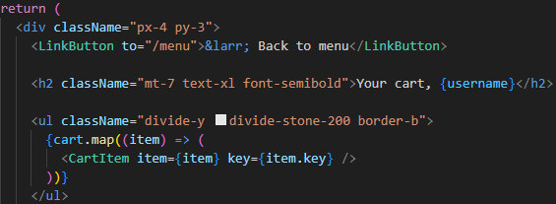
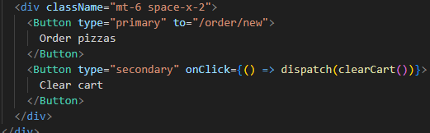
+Delete Cart Items
cartSlice.js:
DeleteItem.jsx
