8 week to practice: 17/2/2025-17/4/2025

# **1. Working with Java data types (10%)**

## **1.1 Operator, casting, unboxing-autoboxing**

### **1.1.1 Arithmetic Operators**

-Addition+, subtraction-, multiplication*, division/, integer remainder %

-**Note**: integer / 0 =exception, floating / 0 = NaN or infinite

### **1.1.2 Mathematical Functions and Constants**

-The Math class contains an assortment of mathematical functions.

-Almost methods in java.lang.Math return double, except: max, min, abs, round

### **1.1.3 Conversions between Numeric Types**

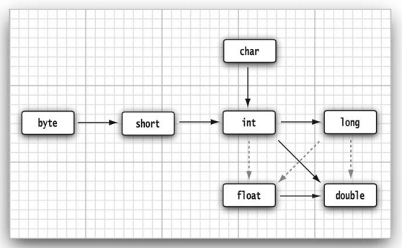

### **1.1.4 Casts**

 

Note: boolean->number: 

### **1.1.5 Combining Assignment with Operators**

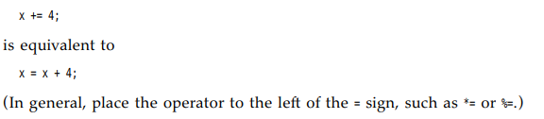

### **1.1.6 Increment and Decrement Operators**

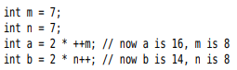

### **1.1.7 Relational and boolean Operators**

- ==, !=, <, &&, ||..

-The ternary ?: 

### **1.1.8 Bitwise Operators**

  
Note: ~ N = -(N+1)

-Shift operators: <<, >>

### **1.1.9 Parentheses and Operator Hierarchy**

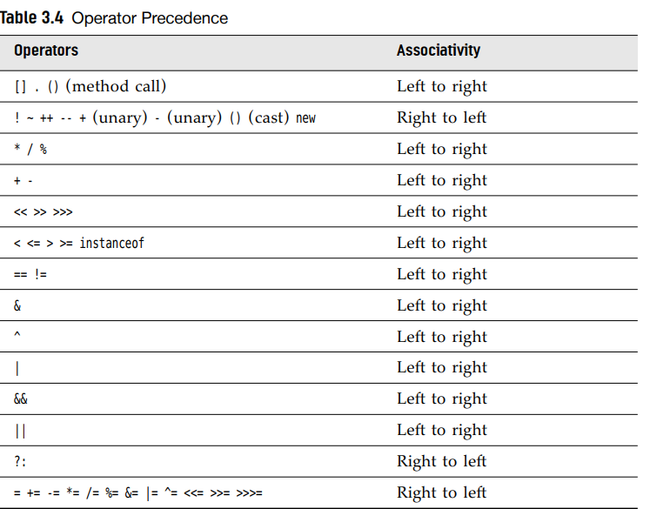

## **1.2 String-StringBuilder**

### **1.2.1 String**

-Constructor: (), byte[], char[], String, StringBuilder

- Static methods: join, valueOf, format

-Instatnce methods: charAt, concat, contains, startsWith, endsWith, equals, equalIgnoreCase, indexOf, indent, isBlank, isEmpty, lastIndexOf, length, repeat, replace, replaceAll, replaceFirst, split, strip, stripIndent, stripIndent, stripLeading, stripTrailing, subString, toLowerCase, toUpperCase, trim

### **1.2.2 StringBuilder**

-Constructor: (), String

-Instance methods: append, capacity, charAt, delete, deleteCharAt, indexOf, lastIdexOf, insert, length(), replace, reverse, subString

### **1.2.3 Text block:**

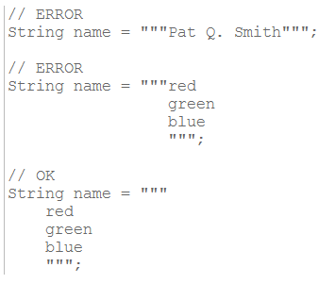

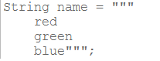

-Trailing white space:Incidental white space + essential white space

## **1.3 Typer inference with var**

-var is not a keyword, can use var as variable name

-Var can use in:

+static/instance initialization block

+as a local variable

+iteration variable in enhanced for-loop

+as looping index in for-loop

+as a return value from another method,

+as a return value in a method,

## **1.4 Controlling Program Flow (5%)**

-**break**: exit a switch and break out of a loop.

-label and break: break out of all nested loops

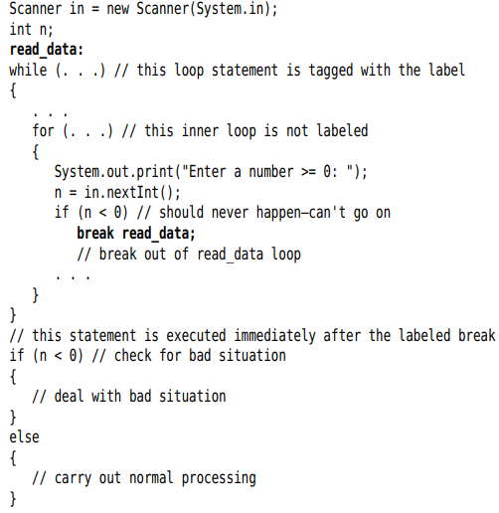

-**continue**: transfer control to the header of innermost enclosing loop

|  |  |
| --- | --- |
| |  | | --- | | -Note: labeled break or continue statement must always exist inside the loop where the label is declared | |

## **1.5 if/else, swith-case, loops**

### **1.5.1 Switch**

-works with: byte, short, char, int+ their wrap+ enumarted+String

-Switch statement

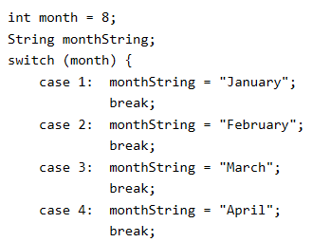

-Switch expression

+”case L->: Labels:

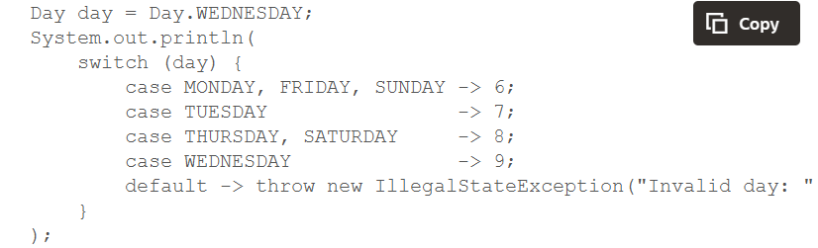

+”case L:” Statements and yield Statement

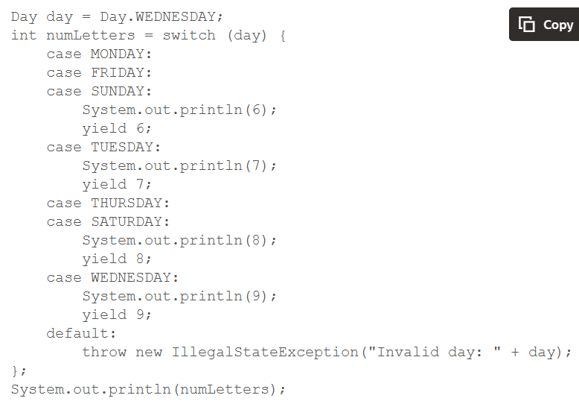

-Note:

+The default label is optional for switch statement and required for a switch expression only when the case labels are not exhaustive.

+Can’t mix switch expression+statement

### **1.5.2 If-else**

-An else clause belongs to the innermost if the first if() condition fails+there is no else associated to execute

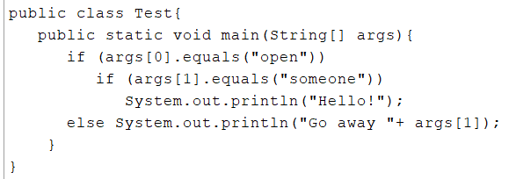

# **2. Java Object-Oriented (30%)**

2.1 Class-objects declaration, initialization, life cycles

2.2 Fields, methods with instance, static, overloading

2.3 Nested class, inner class, local class, anonymous class

2.4 Encapsulation and immutability

2.5 Subclass, super class, abstract class

2.6 Method call polymorphically

2.7 Interface, functional interface, private, static, default method

2.8 Enumeration

# 3. Exception handling (5%)

3.1 try/catch/finally

3.2 Single-catch, multi-catch statements

3.3 Throw, throws

3.4 Try-with-resource

3.5 Custom exception

# 4. Working with Arrays and Collections (10%)

4.1 Array, List, Set, Map, Dequeue

4.2 Comparator, Comparable

4.3 Generic, wildcards

# 5 Working with Streams and Lambda expressions (15%)

5.1 Functional interfaces using lambda expressions

5.2 java.util.function package

5.3 Java Streams filtering, transforming, processing, reduction, grouping, partitioning

5.4 Sequential and parallel streams

# 6. Java Platform Module System (5%)

6.1 Modular vs non-modular application

6.2 Named module, unnamed modules, automatic modules

6.3 Expose, compile, run, deploy module

# 7. Concurrency (4%)

-Deadlock, livelock, starvation recognition

-Runnable, Thread

-Callable, ExecutorService

-java.util.concurrent locking api

# 8. Java I/O API (5%)

8.1 I/O Streams

8.2 NI/O API

8.3 Serialization and deserialization

# 9. Securing Coding in Java SE Application (3%)

-Denial of service, code injection, data validation, data integrity

# 10. Database Applications with JDBC (2%)

## **10.1 Database connection, manipulation**

### **10.1.1 Connection**

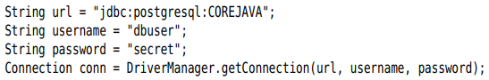

## **10.2 Working with JDBC Statement**

### **10.2.1 Executing SQL Statements**

-Execute a SQL statement, 1st create **Statement** object by **Connection** from **DriverManager.getConnection()**



-Place the statement into a string:

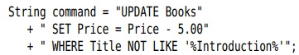

-**executeUpdate()** of Statement interface:



+**executeUpdate()** return a count of rows affected by SQL statement or zero.

+executeUpdate() can execute actions INSERT, UPDATE, DELETE, CREATE TABLE, DROP TABLE…

-**executeQuery()**: SELECT

+This method returns **ResultSet** object to walk through the result one row at a time:



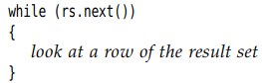

+The order of rows is arbitrary. You can specify with **ORDER BY**

+Take the contents of the fields:



There are accessors for various type, such as getString() and getDouble(). Each accessor has 2 forms: string (name column) and numeric (number column) argument.

Each get method make type **conversions**. Example: getString() convert any type to string.

-**execute()**: catch-all statement to execute arbitrary SQL statements. It’s commonly used only for queries that a user supplies interactively.

-API: p301

### **10.2.2 Managing Connections, Statements, and Result Sets**

-Every Connection object can create one or more Statement objects. You can use the same Statement object for multiple unrelated commands and queries.

-A statement has at most one open result set. If you want multiple queries concurrently, use multiple Statement.

-There is a limit to the number of statements per connection. Use **getMaxStatements()** of **DatabaseMetaData** interface.

-**close()** when you done using ResultSet, Statement or Connection. closeOnCompletion() on Statement close automatically as soon as all its result sets have closed.

-Use try-with-resource with short-lived connection:

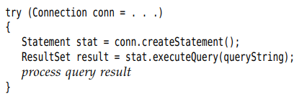

## **10.3 Query Execution**

### **10.3.1 Prepared Statements**

-Prepared statements:

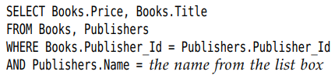

+We prepare a query with a host variable and use it many times, each time filling in a different string for the variable. -> improve performance

+Each host variable in a prepared query is indicated with a ?. If there is more than one variable, keep track of the positions of ? when setting the values

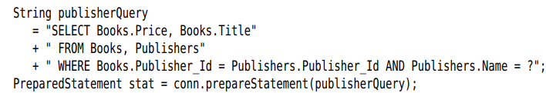

-You must bind the host variables to actual values with set(). There are different **set()** for various types

+ 1st argument is the position number of the host variable. 2nd argument is the value.

+If you reuse a prepared query that already executed, all host variables **stay bound** unless you change them with **set()** or **clearParameters()**.

-Once all variables have been bound to values, execute the prepared statement: 

-**Tip**: Building a query manually, by concatenating strings, is tedious and dangerous and injection attack. So use prepared statements.

-executeUpdate() return the count of changed rows.



-**Note**: PreparedStatement object becomes invalid after Connection object is closed. But many databases automatically cache prepared statements.

### **10.3.2 Reading and Writing LOBs**

-In addition to numbers, strings, dates, many databases can store large objects (LOBs) like images or other data.

-In SQL, binary large objects are BLOBs, character large objects are CLOBs.

-Read a LOB: execute a SELECT statement and call getBlob() or getClob() to return Blob or Clob object

+getBlob(): getBytes() or getBinaryStream()

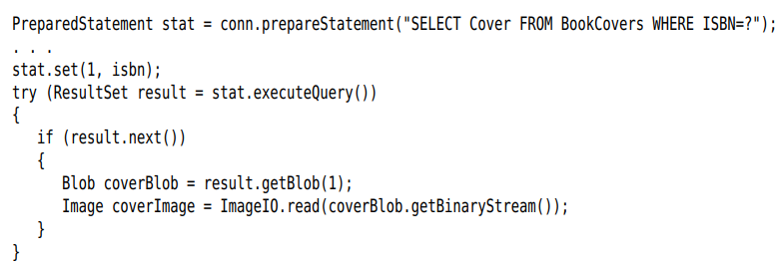

+getClob(): getSubString or getCharacterStream()

-Place a LOB into a database: createBlob() or createClob() on Connection object. Get an output stream or writer to LOB, write the data, store the object in database

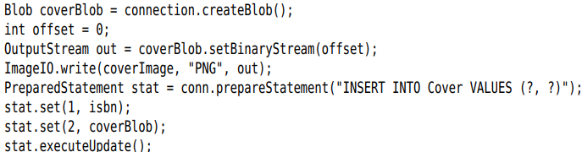

-API: p318

### **10.3.3 SQL Escapes**

-“escape” syntax features are supported by databases but use database-specific syntax variations. JDBC driver translates the escape syntax to syntax of database.

-Date and time literals: Use d, t, ts for DATE, TIME or TIMESTAMP values:

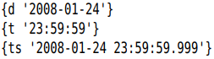

-Scalar function: function returns a single value.

+Embed the standard function name and arguments:



-Stored procedure: procedure that executes in the database. Use call escape. Use = to capture return value:

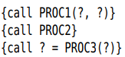

-Outer join

-_ and % in LIKE:

+No standard way to use them literally.

+Example: match all strings containing a _



### **10.3.4 Multiple Results**

-Return multiple results when executing a stored procedure, database that allow submission of multiple SELECT statements in single query.

-Retrieve all results sets:

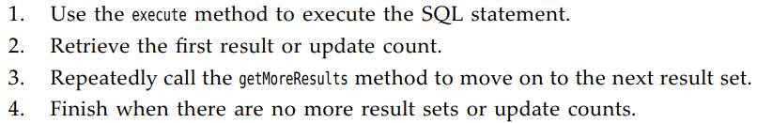

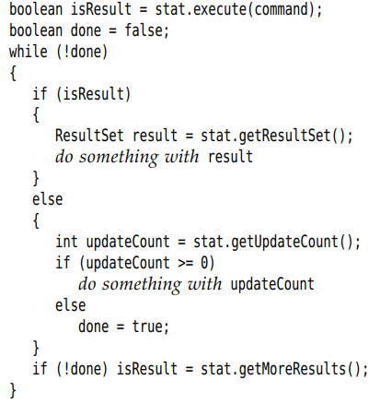

### **10.3.5 Retrieving Autogenerated Keys**

-Most databases support mechanisms for autonumbering rows in database. They differ among vendors. The automatic numbers are often used as primary key.

-Retrieving them:

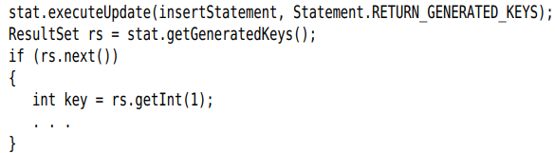

## **10.4 Scrollable and Updatable Results Sets**

-In a **scrollable result**, you can move forward and backward through a result set and jump to any position.

-In an **updatable result set**, you can update entries so that the database is automatically updated.

### **10.4.1 Scrollable Result Sets**

-By default, result sets are not scrollable or updatable.

-Must obtain a different Statement object with:



-For a prepared statement:



-**type** and **concurrency**:

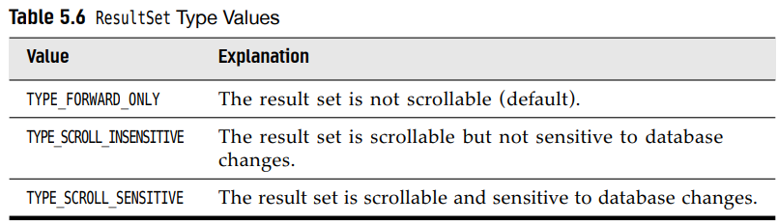

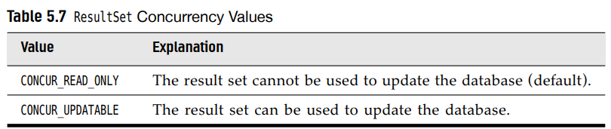

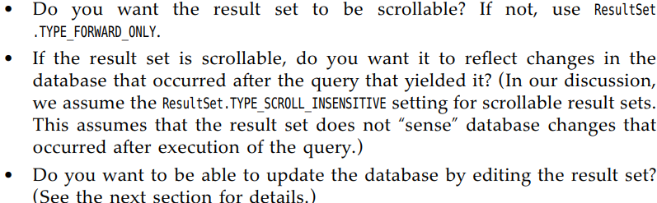

-Example: scroll through a result set but don’t edit data:



+Return the result sets: 

are now scrollable. A scrollable result set has a **cursor** that indicates the current position.

-Note: Not all database drivers support scrollable or updatable result sets

+supportsResultSetType() and supportsResultSetConcurrency() of DatabaseMetadata interface tell which types and concurrency modes are supported by a database using a driver.

+getType() and getConcurrency() of ResultSet interface to find out what mode a result set actually has.

-**Scrolling**:

+ return true or false

+ move the cursor by any number of rows

+ set the cursor to a row number

+ get the current row number

+first(), last(), beforeFirst(), afterLast()

+isFirst(), isLast(), isBeforeFirst(), isAfterLast()

### **10.4.2 Updatable Result Sets**

-Obtain updatable result sets:



-Note: Not all queries return updatable result sts

+The query is a join involves multiple tables not updatable

+The query involves only a single table or join multiple tables by their primary key: you should expect the result set to be updatable.

+getConcurrency() to find out.

-**Update**:



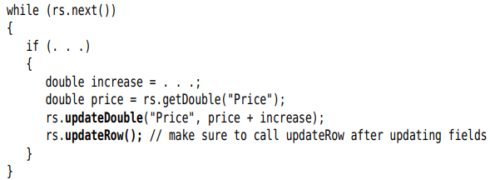

+There are updateXXX methods for all data types that correspond to SQL types: updateDouble(), updateString()

+**Note**: If you use updateXXX whose 1st parameter is the column number, be aware that this is the column number in the result set.

+updateXXX changes only the row values, not the database. Use updateRow(). You can also call cancelRowUpdates() cancel the updates to current row

-**Add** a new row to database:

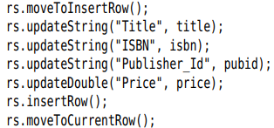

+You can’t influence where the new data is added in the result set or database.

+If you don’t specify a column value in insert row, it’s set to SQL NULL. If the column has a NOT NULL constraint, an exception is thrown and the row is not inserted.

-Delete the row under the cursor: 

-To sum up, java programmers might find it more natural to manipulate the database contents through result sets than by constructing SQL statements.

## **10.5 Row Sets**

-For scrollable results sets, you need to keep database connection open during the UI.

-**RowSet** interface extends the ResultSet, but row sets don’t have to be tied to a database connection.

-Row sets are also suitable if you need to move a query result to a different tie of a complex app, or to another device such as a cell phone.

### **10.5.1 Constructing Row Sets**

-**javax.sql.rowset** package provides:

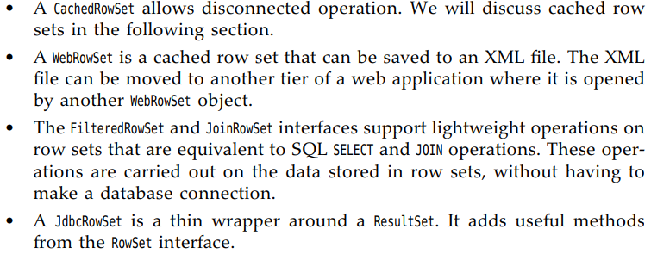

-As of Java 7, there is a standard way to obtain a row set:



### **10.5.2 Cached Row Sets**

-A cached row set contains all data from a result set. Since CachedRowSet is a subinterface of ResulSet, you can use a cached row set exactly as a result set.

-You can close the connection and still use row set.

-It’s possible to modify data in cached row set. The modifications are not immediately reflected in database, make an explicit request to accept the changes. The CachedRowSet then reconnect the database and issues SQL statements to write changes.

-Populate a CachedRowSet from a result set:

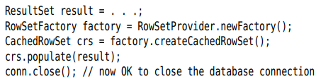

-Or you let CachedRowSet object establish a connection automatically:

+Set up database parameters:



+Set query statement and any parameters:



+Populate the row set with query result: 

-If the query results is very large, users will only look at a few rows. Specify a page size:

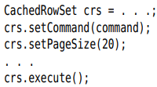

+Get the next batch of rows: 

-You can inspect and modify the row set with same methods you use for result sets. If you modified the row set contents, write it back to database:

 or 

-If the data in database have changed after you populated the row set. The reference implementation checks for **synchronization**.

-API: p332

## **10.6 Metadata**

-JDBC can give you additional information about the structure of a database and tables.

-In SQL, data that describe the database are metadata (to distinguish them from actual data). You get 3 kinds of metadata: database, result set, parameters of prepared statements.

-Database: request a DatabaseMetaData object:



+Get some metadata:



+Each row in result set contains information about a table in database. 3rd column is table name



-ResultSetMetaData reports information about result set

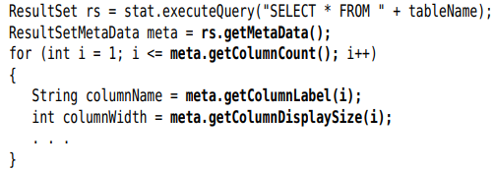

-Note: Many databases have more sophisticated tools for viewing and editing tables: DBeaver, Squirrel. These programs can view tables in any JDBC database.

-API: p343

## **10.7 Transactions**

-You can group a set of statements to form a **transaction**. It can be **committed** when all has gone well-or an error has occurred in one of them, it can be **rolled back** as if none of the statements had been issued.

-The major reason for grouping statements into transactions is **database integrity**.

### **10.7.1 Programming Transactions with JDBC**

-By default, database connection is in **autocommit mode** –each SQL statement is committed to database as soon as it is executed. Once a statement is committed, you can’t roll it back.

-Turn off the default: 

-Create a statement object in normal way:



-executeUpdate() any number of times:

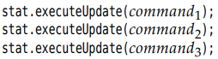

-If all statements have been executed without error:



-If an error occurred: 

+All statements since the last commit are automatically reserved. You issue a rollback when the transaction was interrupted by a SQLException

### **10.7.2 Save Points**

-Create a save point marks a point to which you can later return without having to abandon entire transaction.

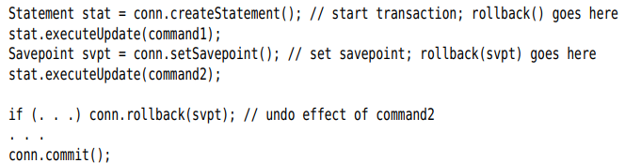

-If you no longer need a save point: 

### **10.7.3 Batch Updates**

-In a batch updates, a sequence of statements is collected and submitted as a batch.

-**Note**: use **supportsBatchUpdates**() of **DatabaseMetaData** to find out if the databse supports this feature.

-Execute a batch:

+Create a Statement object: 

+**addBatch**() instead of executeUpdate():

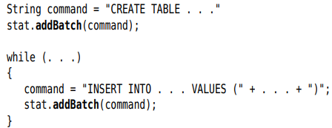

+Submit the entire batch: 

returns an array of row counts for all submitted statements.

-Treat the batch execution as a single transaction. If a batch fails in the middle, roll back to the state before the beginning of the batch.

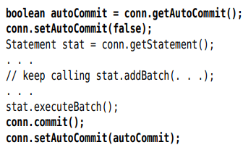

### **10.7.4 Advanced SQL Types**

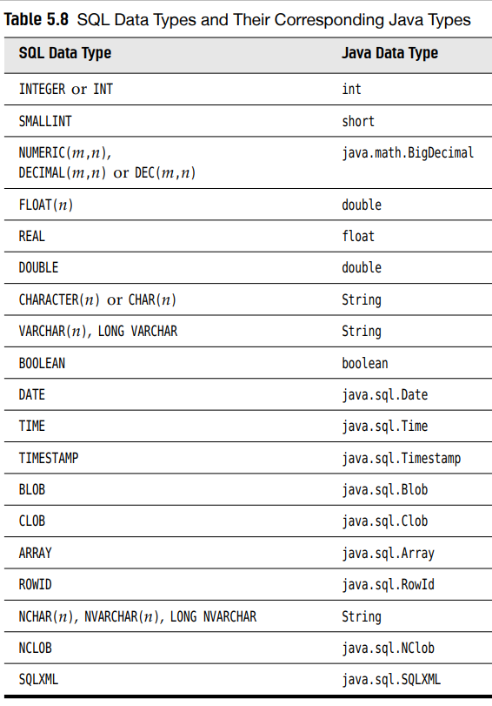

# 11. Localization (2%)

11.1 Locale

11.2 Resource bundle

11.3 Message format

11.4 Date format

11.5 Number format

# 12 Annotation (4%)

12.1 Built-in annotation

12.2 Annotation creation, applying