# 11. Validation, Formatting, and Type Conversion

-org.springframework.core.convert: convert any Java types within Spring application.

## 11.1 Converting String Values using PropertyEditors

-Record:

-Spring Configuration with Error:

-To fix this, We need to tell Spring how to do the conversion of text representations of calendar dates to LocalDate. We can do by an extension of PropertyEditorSupport:

-Registry custom property editor:

## 11.2 Introduce Spring Type Conversion

### 11.2.1 Implement a Custom Converter

-Implement Converter<S,T>



-To use this converter instead of PropertyEditor, we need to configure ConversionService interface:

+Declare conversionService bean with class ConversionServiceFactoryBean. This type of bean groups multiple conversion services: if no conversions service bean is defined, Spring will use PropertyEditor-based system.

-By default, type conversion service supports conversions between common types: string, number, enum, collection, map.

### 11.2.2 Converting between Arbitrary Types

-Spring MVC makes heavy use of conversion service (and Formatter SPI):

+@EnableWebMvc automatically register all default converters (StringToArrayConverter, StringToBooleanConverter, StringToLocaleConverter... in org.springframework.core.convert.support) and formatter (CurrencyStyleFormatter, DataFormatter, AbstractNumberFormatter in org.springframework.format)

## 11.3 Field Formatting in Spring

-Formatter SPI: configure filed-formatting aspects

-The main interface is Formatter<T>. It provides implementations: CurrencyStyleFormatter, DateFormatter, AbstractNumberFormatter, PercentStyleFormatter

-We extend FormattingConversionServiceFactoryBean and provide custom formatter. This is a factory class that provides access to FormattingConversionService

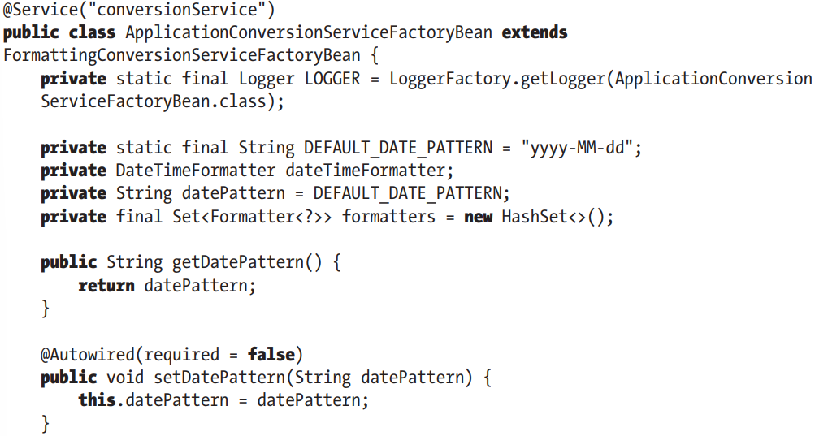

## 11.4 Validation in Spring

-Validation rules applied on domain objects ensure all business data is well structured and fulfills all business definitions.

-The ideal case is that all validation rules are maintained in centralized location, and the same set of rules are applied to same type of data, no matter which source the data comes from.

-**data binding**: extract data from source and perform conversion from sth to desired type. When data binding complete and domain object constructed, validation will be applied to object, and any errors will be returned and displayed to user. If validation succeeds, the object will be persisted to database

-Spring supports 2 main types of validation: Validator interface and via Spring’s support of JSR-349

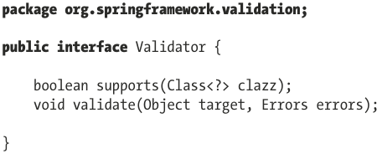

### 11.4.1 Use Spring Validator in Spring

-Implement Validator

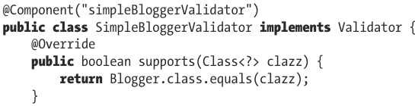

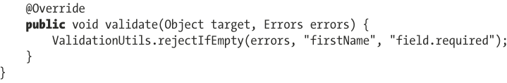

-Note: Converters, formatters and validators are necessary components for applications that handle user-provided data.

-More complex:

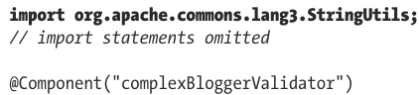

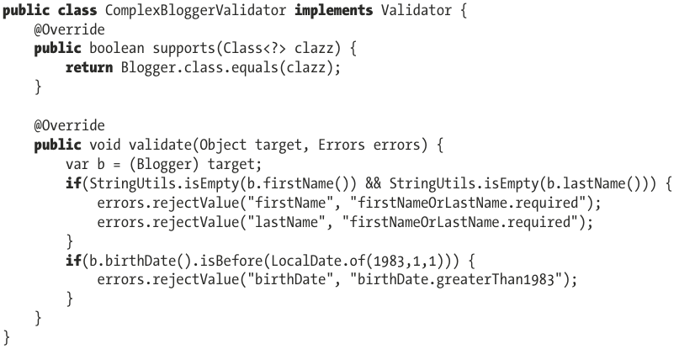

-Validator interface can be implemented to validate complex objects by reusing validation logic for nested objects

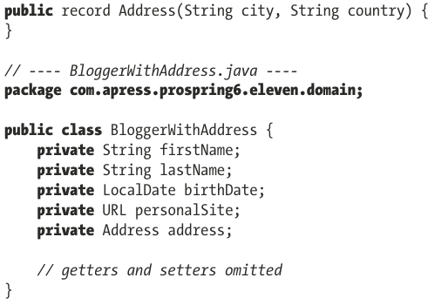

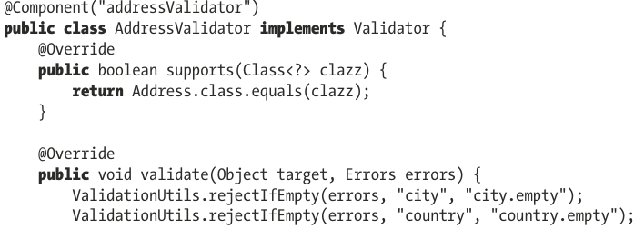

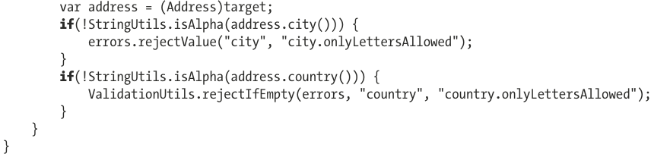

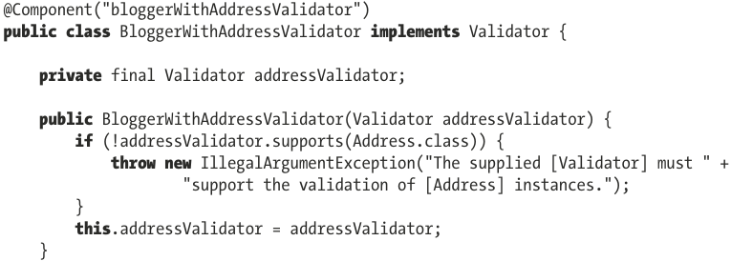

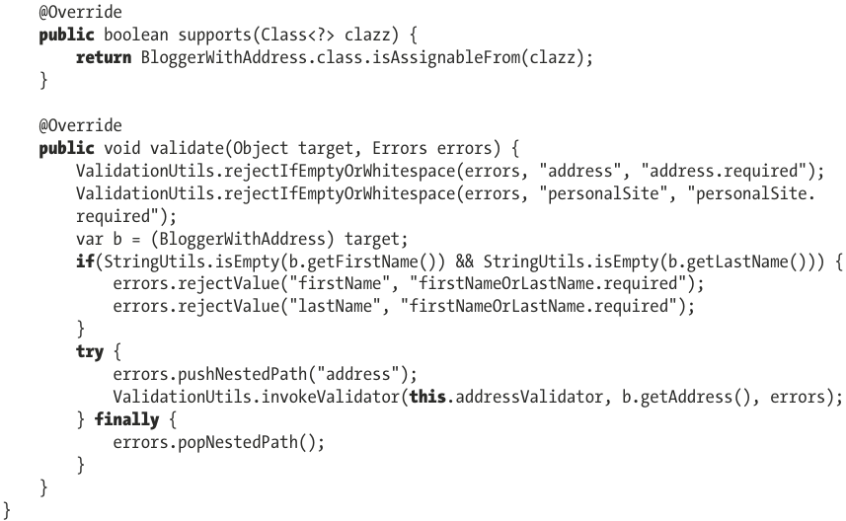

### 11.4.2 Use JSR-349/Jakarta Bean Validation

### 11.4.3 Dependencies

-hibernate-validator

### 11.4.4 Define Validation Constraints on Domain Object Properties

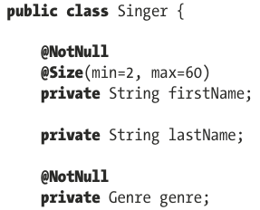

### 11.4.5 Configure Bean Validation Support in Spring

-To configure support of Bean Validation API in ApplicationContext, we define a LocalValidatorFactoryBean, then register all validation services needed.

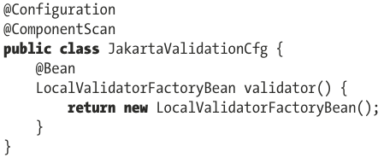

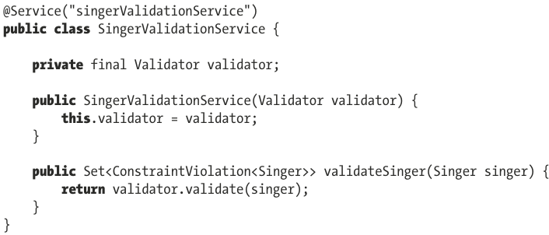

### 11.4.6 Create a Custom Validator

-Annotation interface for Custom Validator

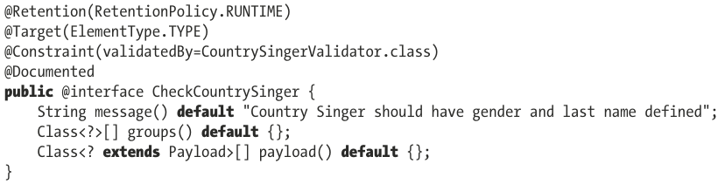

-Validation logic:

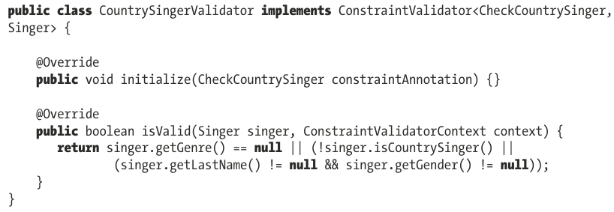

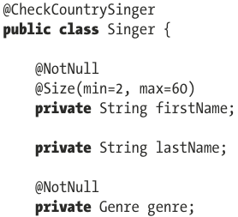

### 11.4.7 Use AssertTrue for Custom Validation

-See in book

### 11.4.8 Decide which Validation API to use

-See in book

### 11.4.9 Configure Validation in Spring Boot App

-spring-boot-starter-validation

# 12. Task Execution and Scheduling

-Task scheduling is composed mainly of 3 parts:

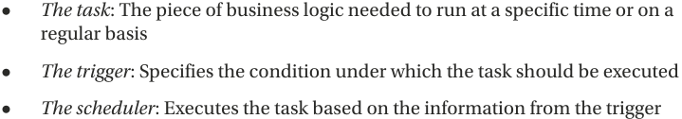

-Java app is described by code that JVM can run on one or multiple threads, and one of threads is non-daemon thread that calls main() of main class.

-In Java, the class to model an execution thread is java.lang.Thread. It can be created by extending this class and overriding run(). The resulting instance models an execution thread must be started by start()

-Another way to create threads: implement **Runnable**. It provides a common protocol for objects that wish to execute code. This means Runnable instances can be created and passed to some components (executors) that execute code in the way they were configured: sequentially, parallel, using threads provided by a thread pool.

-In Java app, a task is any instance of type Runnable

-**Executor** interface represents abstraction for **asynchronous task execution**. In **Spring**, there is an interface that extends this one: **TaskExecutor**. This interface is necessary for backward compatibility with JDK in Spring.

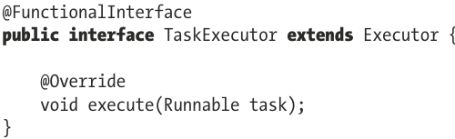

## 12.1 Task Executing in Java

## 12.2 Task Executing in Spring

## 12.3 Task Scheduling in Spring

### 12.3.1 Introduce Spring TaskScheduler Abstraction

### 12.3.2 Explore a Sample Task

### 12.3.3 Asynchronous Task Execution in Spring

# 13. Spring Remoting

## 13.1 Communication via HTTP using Spring REST

## 13.2 Use JMS in Spring

### 13.2.1 Working with Apache ActiveMQ Artemis

## 13.3 Use Spring for Apache Kafka