7. Creating REST services

-Nowadays, web browser no longer reigns as the primary means of accessing the I. Mobile devices, tablets, smart watches.. are commonplace. Many browser-based apps are running JavaScript apps rather than letting the browser be a dumb terminal for server-rendered content

-Many apps have adopted a common design where the user interface is pushed closer to client and the server exposes an API which all kinds of clients can interact with back-end.

# 7.1 Writing RESTful controllers

-REST APIs aren’t much different form websites:

+Both involve responding to HTTP requests.

+Instead of responding to requests with HTML, REST APIs responds with a data-oriented format: JSON, XML

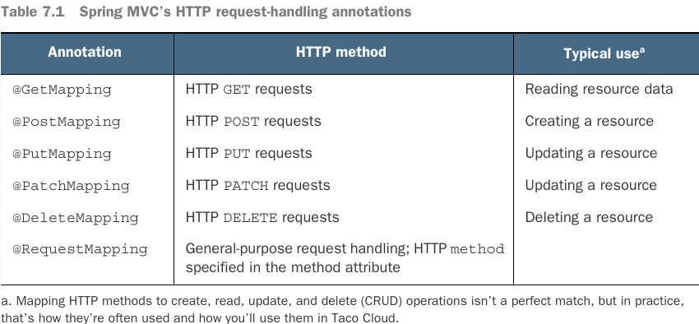

## 7.1.1 Retrieving data from the server

-We create an endpoint that handles GET requests for /api/tacos which include a “recent” parameter and responds with a list of recently designed tacos.

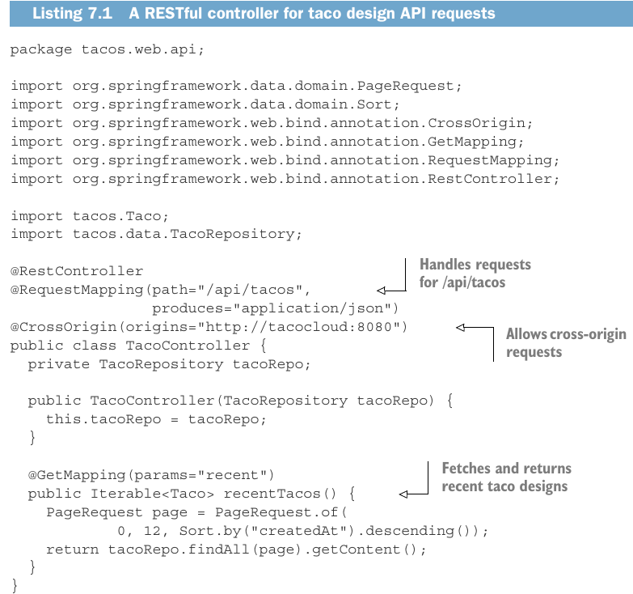

## 7.1.2 Sending data to the server

## 7.1.3 Updating data on the server

## 7.1.4 Deleting data from the server

# 7.2 Enabling data-backed services

## 7.2.1 Adjusting resource paths and relation names

## 7.2.2 Paging and sorting

# 7.3 Consuming REST services

## 7.3.1 GETting resources

## 7.3.2 PUTting resources

## 7.3.3 DELETEing resources

## 7.3.4 POSTing resource data

# -Summary